Written Methods Calculation Policy

Thousands | Hundreds | Tens | Ones | . | Tenths | Hundredths | Thousandths
1000s | 100s | 10s | 1s | . | 1/10s | 1/100s | 1/1000s
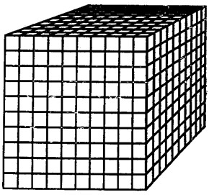 | 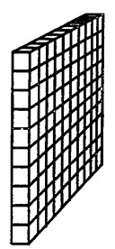 |  | 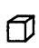 | .

Number Lines: regardless of which operation is being used, smallest & largest numbers must be at the ‘correct’ end (place value needed so children know which is the smallest & largest number).

Smallest Number |  | Largest Number

Formal Written Methods Must:

- show operation symbol
- carry underneath
- exchange by crossing through and rewriting above

Year 1:
Objects (concrete), number tracks (visual), written equations (abstract). Maths Mastery big picture. Show addition can be done in any order.
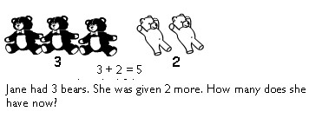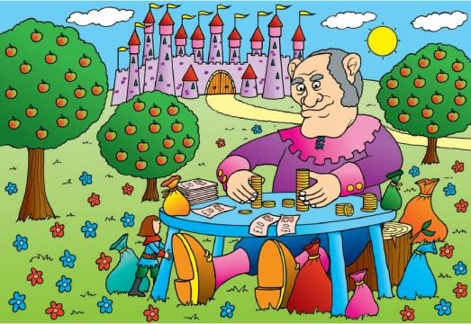

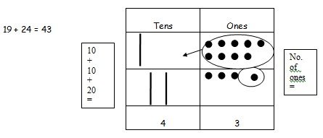

Exchange Game (to prepare for formal written addition): e.g. using dienes blocks or other objects:
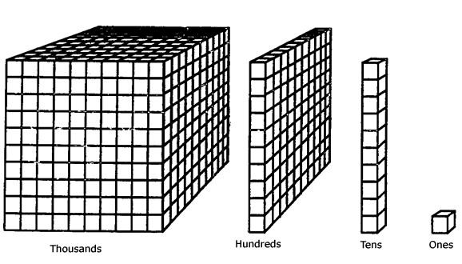
roll a dice & take 1-6 ‘ones’.
When have ten, ‘swap’ for a ‘ten’.
When have ten ‘tens’, swap for a ‘hundreds’.
When have ten ‘hundreds’, swap for a ‘thousand’.

Year 2:
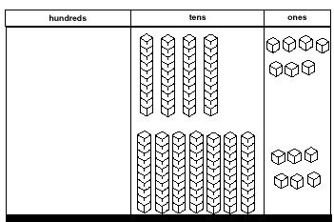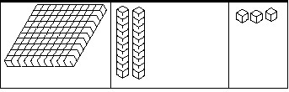 | Partitioning & recombining when exchanging - using concrete objects to support.  47 + 76 =  Use dienes blocks to represent the numbers in correct columns.  Add together, starting from the ones and exchange where necessary – carry over into the new column. Then recombine.

Partitioning and recombining.  42 → 40 + 2  +36 → 30 + 6  70 + 8 → 78  37 → 30 + 7  + 85 → 80 + 5  110 + 12 → 122 | 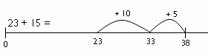  Number line  –  adding multiples of ten,  using numbers bonds to 10.

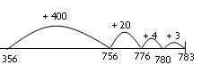  Number line addition  –  partitioning one  number.  Year 3: | Column Addition – adding ones first, then tens and recombining.  4 3 + 5 4  7  9 0  9 7
Year 4:
Compact Column Method –
adding from ones and carrying underneath.

3 5 8
+ 3 3
3 9 1
1

8 + 3 = 11. So place the one and carry ten.
50 _ 30 + 10 = 90
300 + no hundreds is 300
Column Addition – adding ones first, then tens, then 100s and recombining.

4 3 3 5 8
+ 5 4 + 3 3
7 1 1
9 0 8 0
9 7 3 0 0
3 9 1

Year 5 & 6:

Compact Column Method, extending to 4 digit numbers; 2 decimal places; different number of decimal places and adding more than 2 numbers.

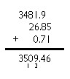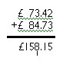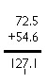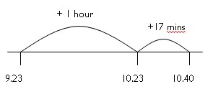

Number line method to add time, in minutes
and hours (as time is measured in 60 minutes,
not hundreds).

Subtraction:

Year 1
Subtract/take away:
Using moveable objects t o physically take away and pictures.

Write equations using symbols e.g. 5 – 2 = 3
6 in a bag. Take away 2 and there are 4 left in the bag → 6 – 2 = 4
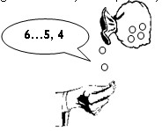
Objects (concrete), number tracks/drawings (visual), written equations (abstract).
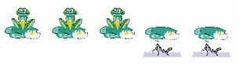
As with addition, concrete objects to shows tens and ones. Taking away objects and then starting to circle drawings for the pictorial representation.
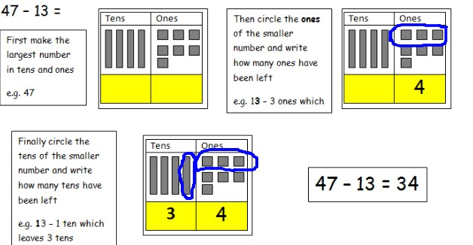
Find the difference:

Using moveable objects and drawings e.g. bead string, coins, cubes

Year 2
Use of concrete to consolidate but moving towards number lines and 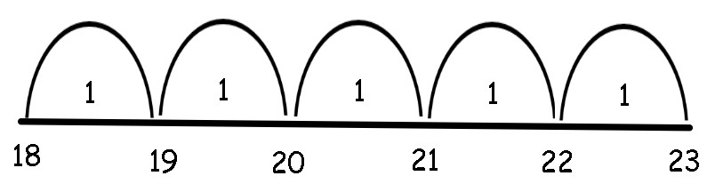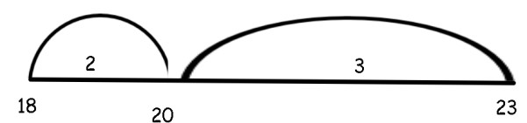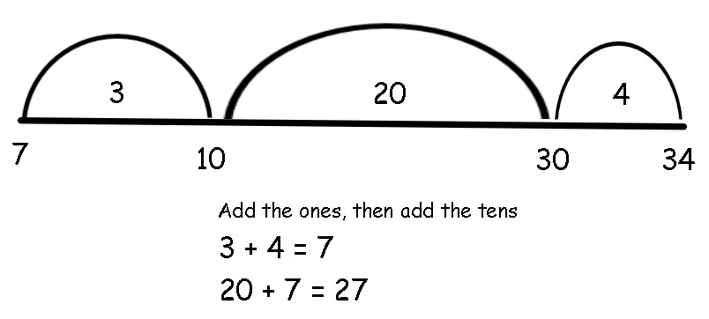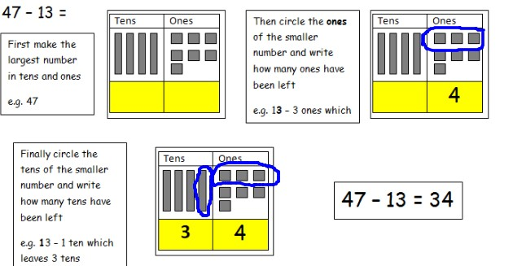
column

methods.

Find the difference:

Use place value knowledge to add to the nearest ten, add in tens and
then ones.

e.g.

What is the difference between 23 and 18? (Counting on)

e.g. what is the difference between 7 and 34?

Subtract/Take away:

Use partitioning and
column
method
(
supported
with
dienes blocks
)

when not crossing the tens boundary.

6
7
→

60
+
7

82
→

80
2
+

-

35
→

5
+
30

-

21

→

+
1
60

30
+
2

→

32

1
20
+

→

21

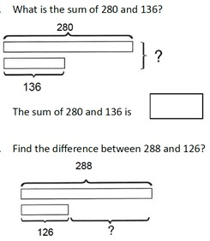
Bar modelling:

Use pictorial bars to represent numbers to find missing numbers.

Year 3
Continue pictorial methods (see above) moving onto the abstract formal written column methods, including HT1s – HT1s, with concrete objects to support (e.g. dienes blocks)
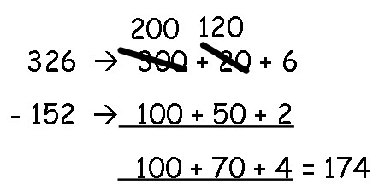

3
digit subtract 3 digits

(
using dienes blocks to consol
idate from Yr 2)

874

→

800 +
70 +
4

-

523
→

500 +
20 +
3

50 +
1
300 +

→

351

Including
exchanging
:

Year 4
Consolidate column method with partitioning, then move to compact method.
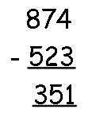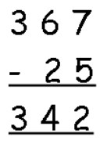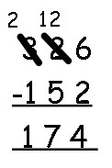
Always beginning with the ‘ones’ column,

Including
single exchange
:

(
children must be confident in the value of e
ach digit e.g. 2 = 20
–

two
tens)

Year 5 & 6: Use column compact method for a wider range of
applications.
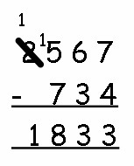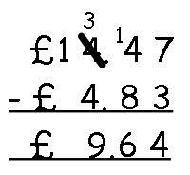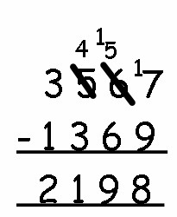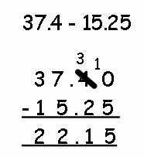

Different numbers of digits:

Decimals, including money &
measures:

Double exchanging:

Numbers with different numbers of
decimal places
–

use of a place
holder.

Multiplication:

X10 and x100
Years 2 and 3: move digits written method
Years 4 – 6: mental calculations (including decimals)
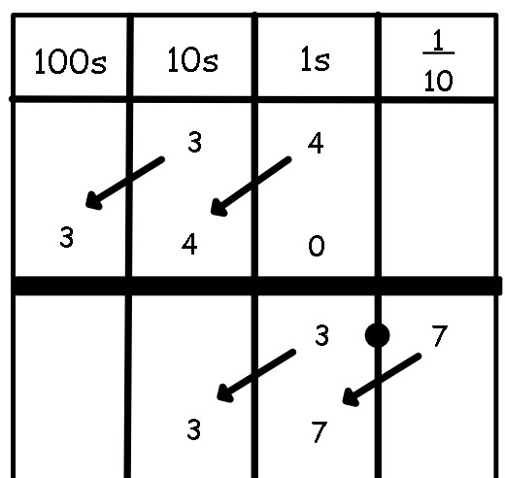

Year 1
Use of concrete objects and pictorial representation.

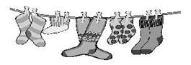
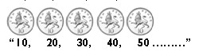
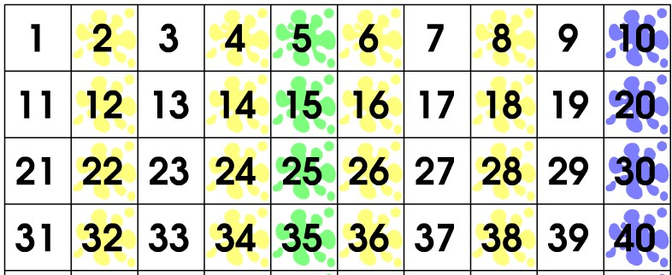
Find patterns on 100s squares for x2, x5, x10:
Counting in twos with pairs of objects:

Counting in 5s and 10s using money:

Year 2: (times tables- x2, x5, x10)
Building on skills of counting in 2s, 5s and 10s.
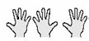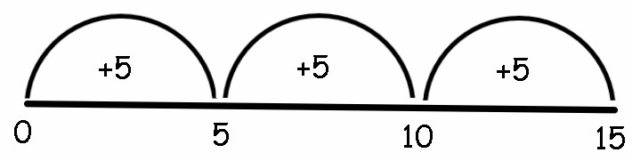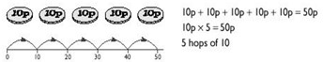
Repeated addition
:

3
x 5 (3 lots of
5)

5
x 10
(
5
lots of
10)

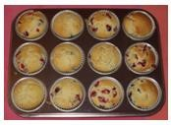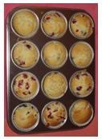
Arrays:

Support understanding that the multiplication of 2 numbers can be done
in any orde
r.

3
x 4 (3 rows of
4)

4
x 3 (4 rows of
3)

Year 3
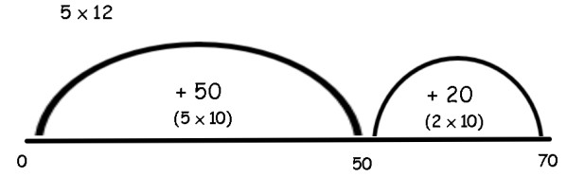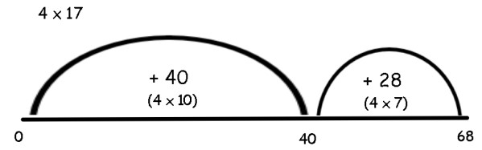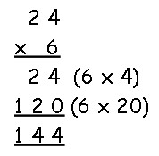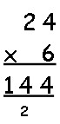

Year 4

Consolidate repeated addition, including larger jumps

Introduce multiplying with formal vertical method.

Begin by multiplying with the ‘ones’ digits.
Introduce
exchanging
underneath.

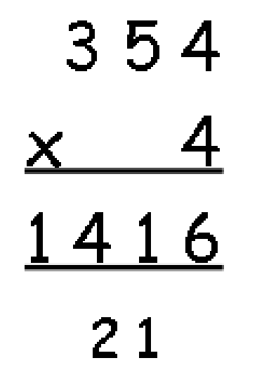
Consolidate
column

method from Yr 3
including

carrying
underneath (as in addition).

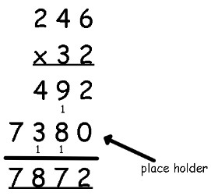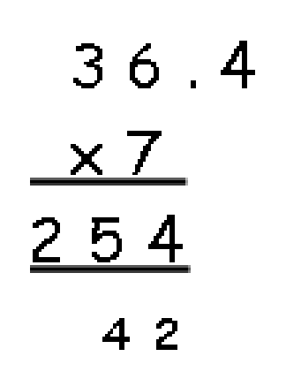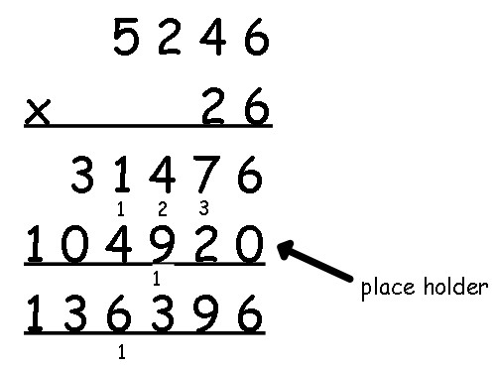
Year 5 & 6

Vertical Multiplication, including 4 digits x 2 digit numbers and decimals.

Doubling and x 4

Partition, x2 and then recombine:
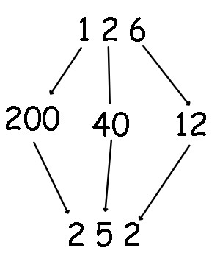
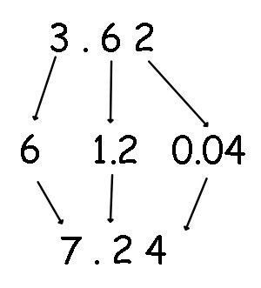
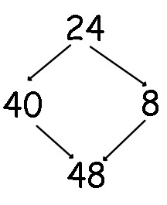

X4 → double and double again
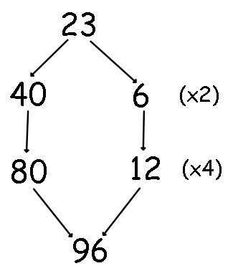
Division:

Year 1
Consolidate counting to prepare for formal division.
Using concrete objects (bead string, cubes, Numicon) and pictorial representations.

Halving – sharing concrete objects into two groups.

Year 2
Introduce the language ‘division’ and the symbol ‘÷’
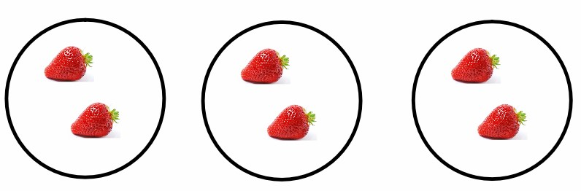
Sharing

equally
–

into 2s, 5s and 10s
→

moving

objects

e.g. 6 ÷ 3 = 2

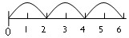
Grouping

–

into 2s, 5s and 10s
→
Cubes, bead strings
, pictorially

e.g. 6 ÷ 2 = 3

Represent using equal jumps on a number line:

3
jumps of 2. So 6 divided by 2 = 3

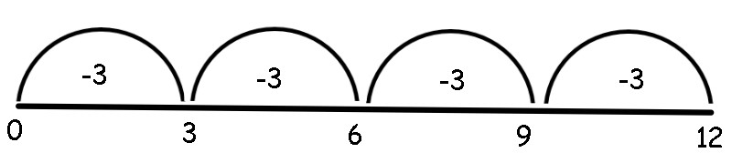
Year
3

Repeated Subtraction:

e.g. 4 groups of 3. So 12 ÷ 3 =
4

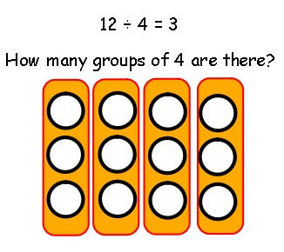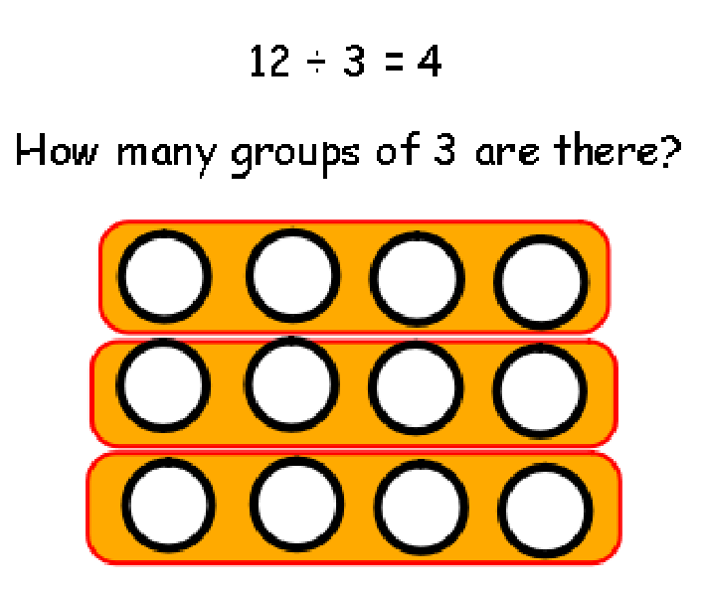
Arrays to show inverse:

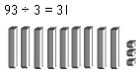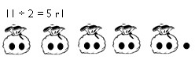
Sharing using concrete objects, introduce remainder:

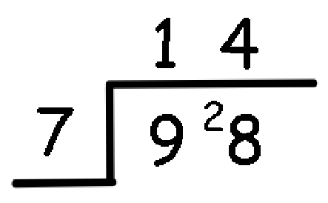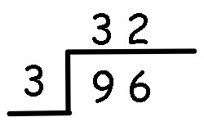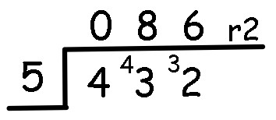
Year 4

Short division using times tables and remainder:

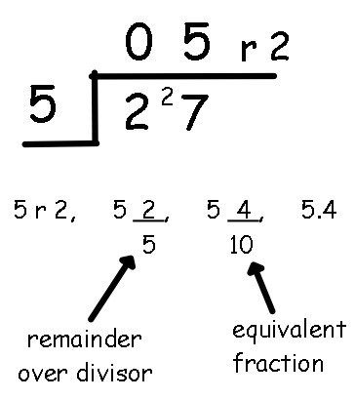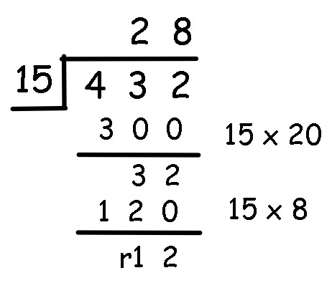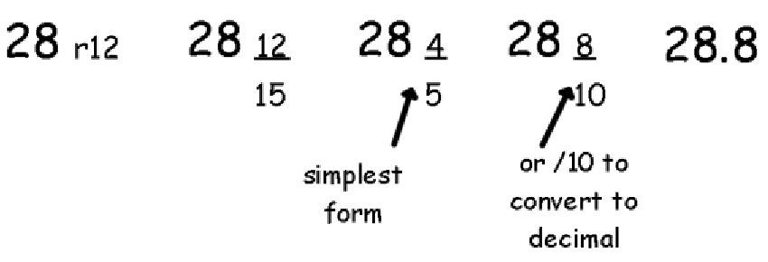
Year 5

Short division, including remainder as fractions and decimals:

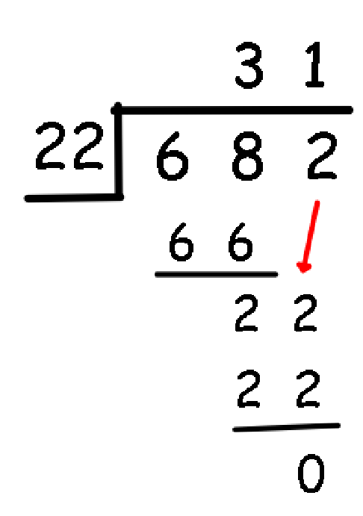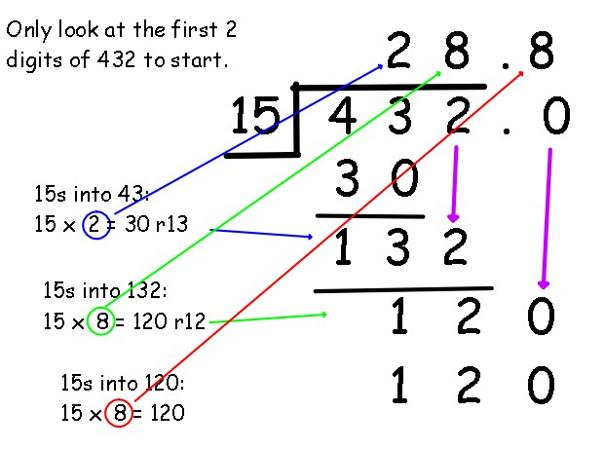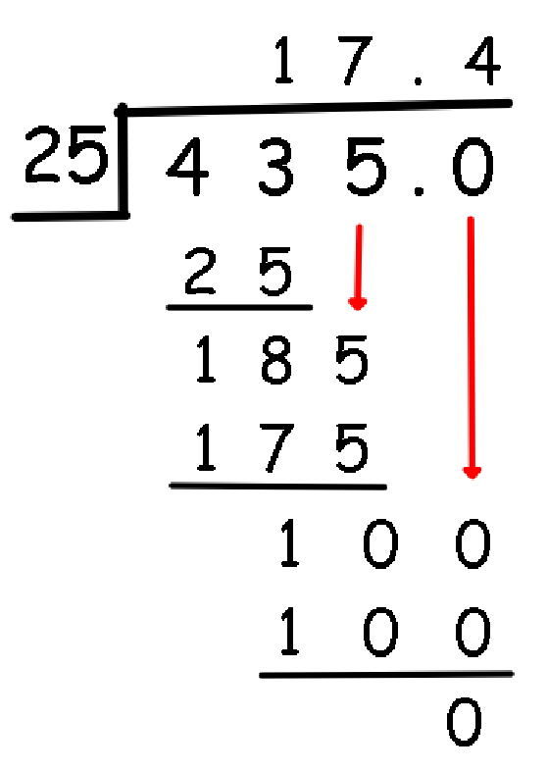
Year 6

Long division to give remainder as decimals
.

Halving
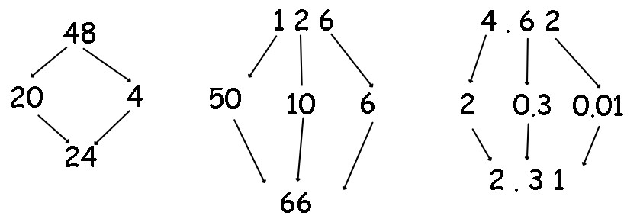
3

63

