DIY Sensory Ideas

Make easy crayon rubbings to explore texture.
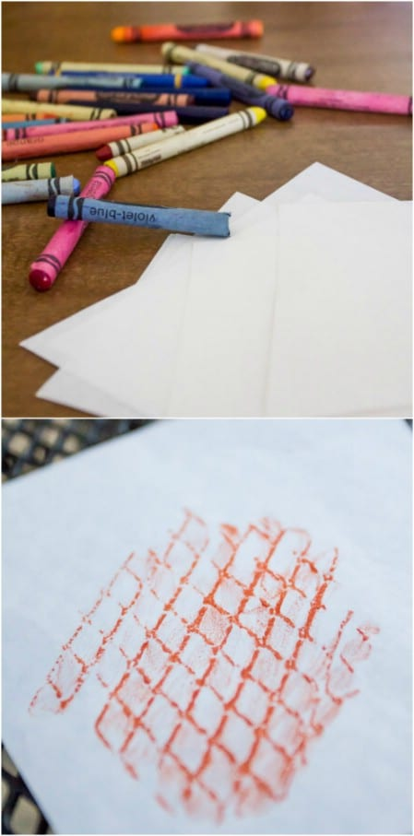

Play “What’s in the Bag?”

Just get a few brown paper bags and put some random objects inside them. The objects can be anything: cottonballs, toys, cereal, fruit, noodles, paperclips, whatever. Try to pick some “easy” objects and some “hard ones.” They can start by shaking the bag and squishing it and lifting it. Then they can stick their hands inside and feel for the objects.
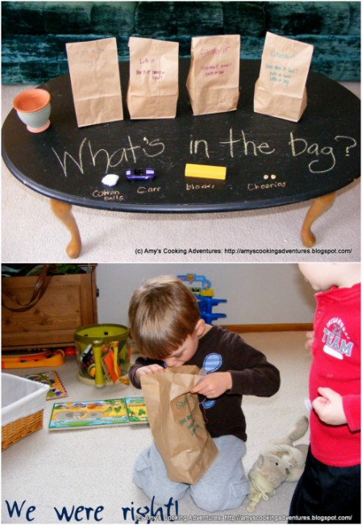
Another fun variation is “What’s in the Balloon?” Get some items from around the household like coffee beans or cottonballs and fill up some balloons. Hand them to your child and see if he can guess from touch, sound and smell what is inside each balloon. This activity works really well for tactile exploration because it is easy to feel through rubber.

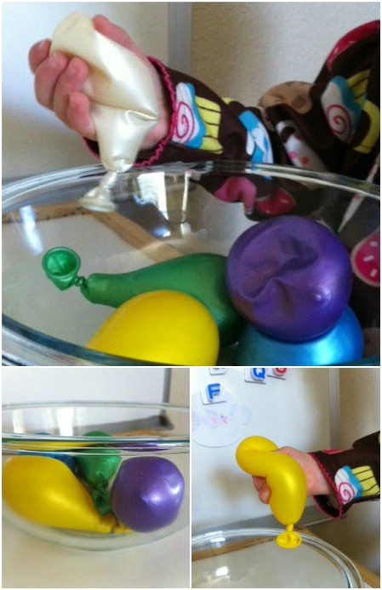

Make rainbow soap foam.

You just need dish soap and food colouring.

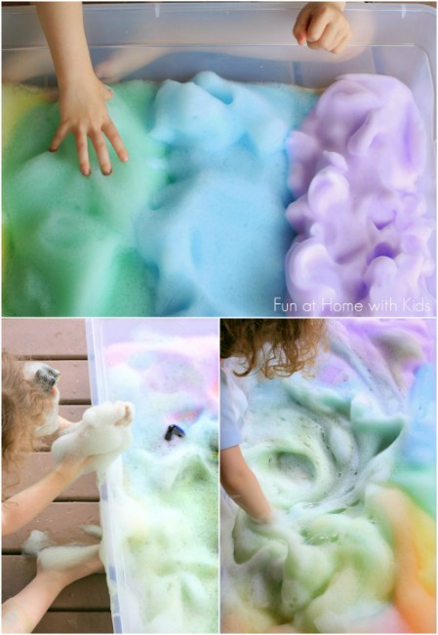

Play with glowing ice and oil.
Get an ice tray and mix up some glow in the dark paint and florescent paint with hot water. Pour it in and let it set. Once it is frozen, you will have glowing ice (depending on the type of paint you use, you may need to hold it up to the light to recharge it before you use it). You then fill a pan with oil and float the ice in it. As the ice melts, beads of glowing water will break off and float around inside.
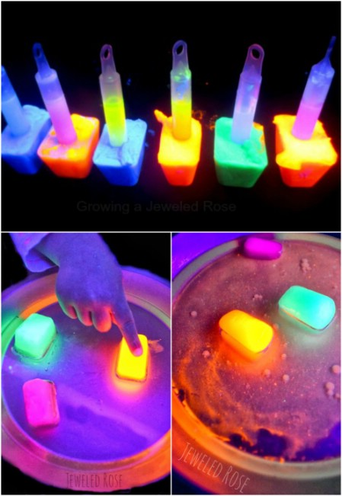

Guess the scent.

Make the scent cards with your child to teach which scents are which. But then mix up the cards, have your child close her eyes, and hold out each scent. See if they can guess which ones are which by smell alone.
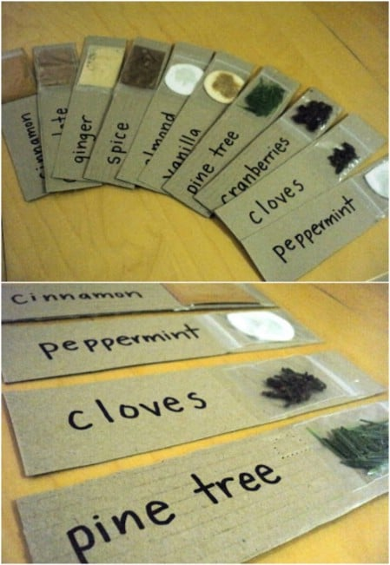

Make edible finger paint.

Ingredients:
• 220ml cornflour
• 650ml cold water
• 1 envelope unflavored gelatin
•60ml cold water
• Small jars with lids for storing your paint (we find it easier to dip the paint out of teacups)
• Food colouring
How we make it:
• Mix cornflour with 2¾ cups cold water to make a smooth paste in a saucepan until no lumps remain
• Meanwhile soak the gelatin in ¼ cup water to soften until it’s needed
• Cook cornflour mixture over medium heat stirring constantly until mixture boils and turns clear(ish)
• Remove from heat and stir in gelatin mixture
• Cool and divide into several different jars for various colours. Stir in food colouring until you have a pleasing colour that is well blended.

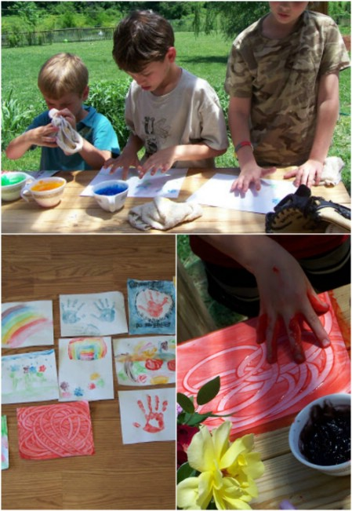

Make fizzy lemon suds eruptions.

Fill bowls with soapy water and add food colouring. Then pour in lemon juice. Add the liquid to baking soda and you get an eruption of soft, effervescent foam. The reactions last a long time, and kids can add in more food colouring in different colours to get a dazzling effect.

