How did Robert Dudley Change Kenilworth Castle?

The origin of the ‘bear and ragged staff’ symbol is a mystery, but it has been used by the Earls of Warwick since the 1300s. Robert Dudley used the symbol to leave his mark on Kenilworth Castle and Garden in Elizabethan times. The Oak Room on the ground floor of Leicester’s Gatehouse has the highest concentration of ragged staff symbols.

Gatehouse

One of the first buildings that the Earl of Leicester added to Kenilworth Castle was a gatehouse which Dudley began building in 1570.

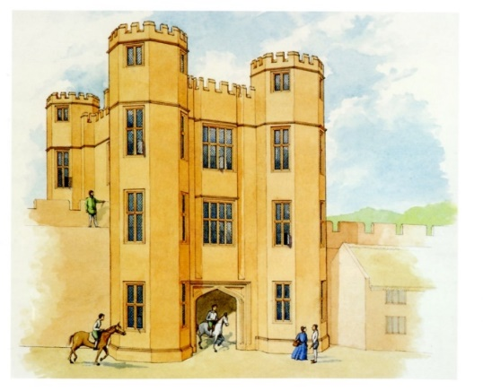
This was intended to be a grand new entrance to the castle. The entrance was wide enough for carriages to pass through at ground level and above the passageway were two floors of accommodation. This gatehouse was meant to impress visitors rather than be a defensive feature.

Leicester’s buildings had various aims but the main one was to provide Elizabeth with the luxurious accommodation which would meet her very high expectations. Queen Elizabeth was a well-known critic of the houses she visited. She had already reprimanded Leicester in 1570 about Kenilworth’s flaws so by the time of her visit in 1575 the Earl made sure that the new building work and improvements made Kenilworth Castle fit for a queen.

Leicester’s Gatehouse was also built at this time. Straddling the medieval curtain wall, it provided a grand new entrance for the castle from the Coventry direction and from Kenilworth parish church, where Elizabeth I attended a Sunday service in 1575. The gatehouse also gave access to the hunting in the chase by way of a wooden bridge across the north arm of the mere. Although battlemented, the building was a symbolic rather than defensive structure. It was secured only by a pair of gates and had many large windows. The entrance passage was wide enough for carriages at ground level and there were two floors of lodgings above.

Leicester’s Building and the Great Tower

The height of Elizabethan luxury, the three upper floors of this four-storey building were grand state rooms and bedrooms for the Queen and her ladies-in-waiting, each room being decorated and furnished in the most luxurious manner. The basement had tiny windows and no fireplaces, almost certainly only fit for storage. The rooms that Leicester built for Elizabeth were reached by walking from the Great Hall through the state apartments in the South Range.

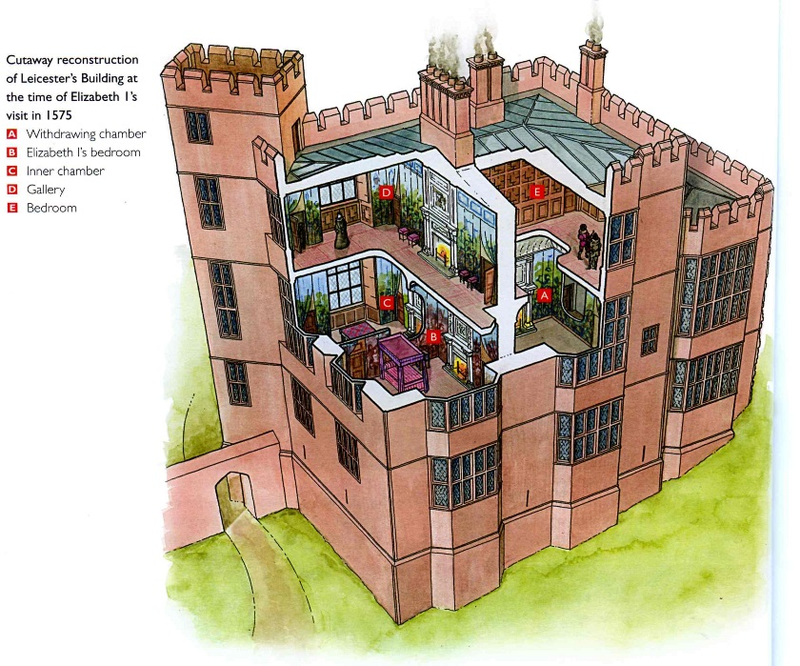
On the main floor there were five rooms. The easterly room (B) was well positioned to be Elizabeth’s bedchamber, with a fireplace and a large bay window to receive the morning light and a large southerly window as well. It was also the most private and secure room, having a withdrawing chamber at each end. The largest room in the Castle was the gallery on the upper floor with its own withdrawing chamber (E) and wonderful views across the lake from its large south windows.

The location and size of this room made it ideal for the queen’s entertainment, particularly dancing, and it became a model for the top-floor rooms at other great houses of the time.
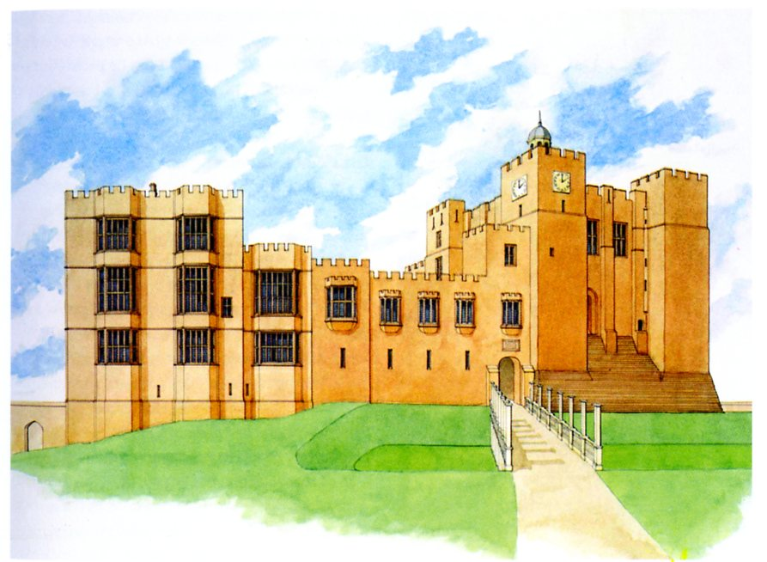
The rooms underneath the queen’s private rooms were used by her ladies. They may have been for Leicester’s own use but it is more likely that his rooms were in the east range from where he could have direct and discreet access to the main floor of the building through a door in the north wall of Elizabeth`s private suite. The basement rooms of the building were completely plain, unheated, and only lit by slit windows so were clearly designed for storage, which is shown by the width of the doors, to allow for the movement of the bulkier items of Elizabeth’s immense travelling wardrobe.

View of Leicester's Building

Leicester’s building is the size of a small country house and so to make enough space for it, the tower block was extended beyond the medieval curtain wall. Although a four-storey building at full height, the basement lay below ground level because the building was built within the former ditch.
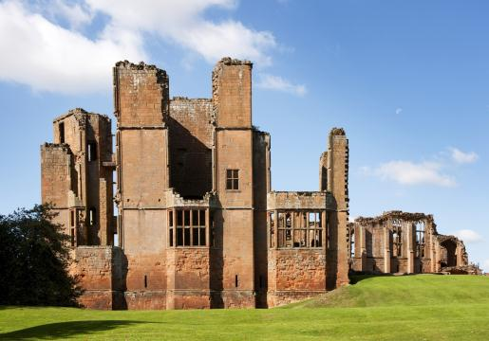
Leicester’s building was once linked to the great tower by an east range; the remains of the connecting walls for this can still be seen on the northern wall of the building. The tallest windows indicate the principal floor and spaces for doors and fireplaces still survive. Rows of small holes in the south and west walls once held the wooden pegs that supported a tall timber and plaster frieze beneath the ceiling. Large cracks in the south facing walls suggest the whole building threatened to collapse when the south-west turret was added between 1572 and 1575 – all to provide Elizabeth I with a private stair between the upper floors! Stone for some of this work had been re-used from a dissolved monastery, possibly Kenilworth Priory.

A Tudor Improvement

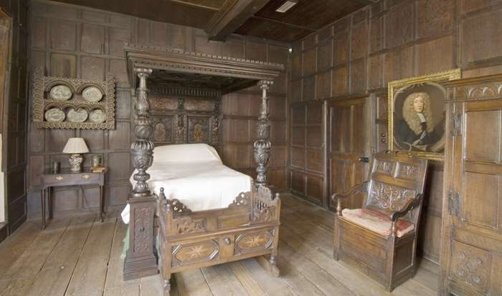
Through his building programme, Leicester sought to promote the medieval associations of the castle; significantly he left John of Gaunt’s great hall untouched and modelled the gatehouse on the gatehouse at Warwick Castle of his Beauchamp ancestors. However, his work also drew on the style and luxury of the northern Renaissance, exemplified in large glazed windows, plaster friezes and ceilings, classical fireplaces and a great garden. The image of the castle as a Renaissance country house was found elsewhere in the period, for example at Ludlow and Raglan castles, but the Kenilworth remodelling was the most extensive and remains the best preserved.

The work at Kenilworth is very significant in terms of Elizabethan architecture. By putting together Leicester’s Building with the medieval great tower meant that Leicester’s Building had to be of extraordinary height. This created the ‘midland high house style’ of which Hardwick New Hall is the ultimate statement. The brittle, thin walls and grids of windows are the prototypes for the High Elizabethan style of the 1580s and 1590s. By using the same red sandstone from quarries adjacent to the castle, Leicester helped create a sense of harmony between the buildings of the castle’s inner court, despite their wide range of dates.

