Background information for Kenilworth Castle

Kenilworth Castle is in Warwickshire in central England. It was originally built by the Normans in the twelfth century as an earth and timber motte and bailey castle on raised ground surrounded by marshes. During the Middle Ages different owners replaced the timber with local sandstone and extended the castle, protecting it with a large lake to the west and south. In 1563 Elizabeth I gave the castle to her favourite courtier, Robert Dudley, Earl of Leicester. Dudley built additions to Kenilworth Castle which made it a luxurious palace fit for Queen Elizabeth and her court. The Queen visited Kenilworth several times on her summer progresses away from London.

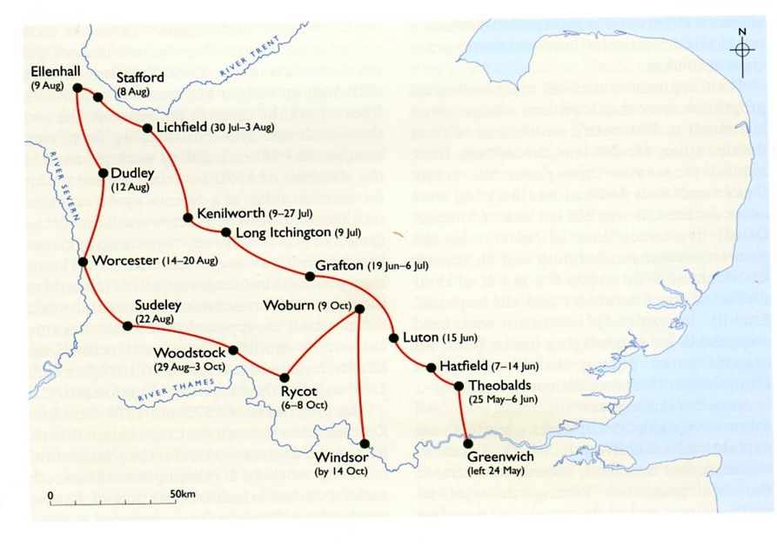
The route of Queen Elizabeth’s progress in 1575

In July 1575 Queen Elizabeth stayed for 19 days during her fourth and final visit to Kenilworth. The Earl of Leicester had arranged an elaborate series of entertainments for the Queen which he hoped would persuade her to marry him. While at Kenilworth, Queen Elizabeth stayed in spacious new apartments, built especially for her with large airy windows, superb views and massive fireplaces. Although there is debate amongst historians, there would be plenty of room here for one of the Queen’s great passions – dancing. Leicester also created a private garden for Elizabeth designed to be as magnificent as the new rooms he had provided for her.

Who was Robert Dudley, Earl of Leicester?
Robert Dudley was the fifth son of the Duke of Northumberland. He had been imprisoned briefly for joining his father’s plot to make Lady Jane Grey Queen after Edward VI died. Although his father was executed by Queen Mary I for his part in the plot, Dudley was released and returned to royal favour through his family’s skill at befriending the Spanish nobles who were with King Philip II, Mary’s husband. Further approval for Dudley came as he distinguished himself in battle when the English fought alongside the Spanish against the French in 1557. When Elizabeth came to the throne Dudley quickly became a great favourite of hers as a result of his good looks and charismatic personality, as well as the parallel tracks their lives had followed. His rise in Elizabeth’s Court was exceptional as, on the day after she became Queen, he was appointed her Master of the Horse, a post which involved assisting the Queen whenever she went riding. This was to be the first of Dudley’s many titles, posts, monopolies and grants of land which gave him a prominent position at court. It gained him as many friends as it did enemies. There was much court gossip about Elizabeth and Dudley’s relationship as Robert Dudley was married. He had married Amy Robsart in 1550. When Amy was found dead in 1560, rumours spread about Dudley’s involvement but it did mean that he was now free to marry the Queen. In 1562 she showed her trust and affection for him when, stricken with smallpox, she instructed her Councillors that Dudley was to become Protector of the Realm. In 1564 she made him Earl of Leicester but did not marry him. Instead she suggested that he should marry the widowed Mary, Queen of Scots. It was a political manoeuvre to improve relations between England and Scotland and lessen the influence of foreign powers, but Dudley refused.

The Dudleys were very sensitive about their ancestry and family honour with Robert displaying the family emblem of a bear and ragged staff on every suitable object including his armour, portraits, and even the buildings he added to Kenilworth Castle. They were an unusually close-knit family and loyal to each other and although Dudley’s commitment to his family never caused him to oppose the Queen’s authority, a strong sense of pride meant that he saw himself as Elizabeth’s near equal. In his relationship with the Queen, Dudley could be jealous and arrogant but he feared displeasing her and when he did, he became deeply depressed. It was probably the arrogance and presumption in parts of Dudley’s 1575 entertainment at Kenilworth Castle that led to the Queen’s early departure. However, Elizabeth’s refusal either to marry Dudley or let him marry anybody else had the serious consequence of preventing him from producing an heir. By 1573 Robert and Ambrose were the only Dudley brothers still alive and Ambrose had no sons. For a member of the proud Dudley family, being the last of his house would cause great sorrow.

How did Robert Dudley change Kenilworth Castle?

One of the first buildings that the Earl of Leicester added to Kenilworth Castle was a gatehouse which Dudley began building in 1570.
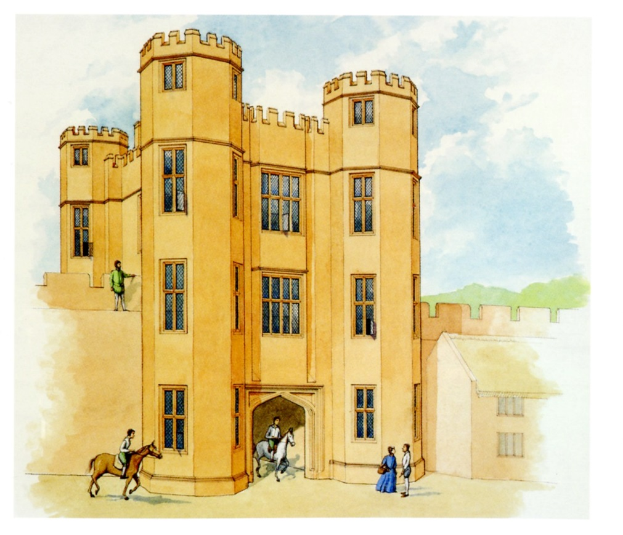

This was intended to be a grand new entrance to the castle. The entrance was wide enough for carriages to pass through at ground level and above the passageway were two floors of accommodation. This gatehouse was meant to impress visitors rather than be a defensive feature.
Leicester’s buildings had various aims but the main one was to provide Elizabeth with the luxurious accommodation which would meet her very high expectations. Queen Elizabeth was a well-known critic of the houses she visited. She had already reprimanded Leicester in 1570 about Kenilworth’s flaws so by the time of her visit in 1575 the Earl made sure that the new building work and improvements made Kenilworth Castle fit for a queen.

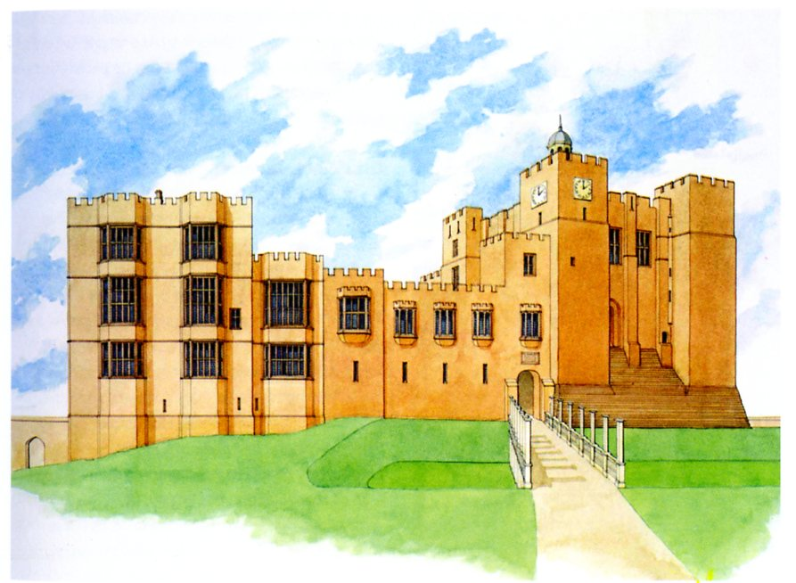

Leicester’s Building and the Great Tower

The rooms that Leicester built for Elizabeth were reached by walking from the Great Hall through the state apartments in the South Range. On the main floor there were five rooms. The easterly room (B) was well positioned to be Elizabeth’s bedchamber, with a fireplace and a large bay window to receive the morning light and a large southerly window as well. It was also the most private and secure room, having a withdrawing chamber at each end. The largest room in the Castle was the gallery (D) on the upper floor with its own withdrawing chamber (E) and wonderful views across the lake from its large south windows. The location and size of this room made it ideal for the queen’s entertainment, particularly dancing, and it became a model for the top-floor rooms at other great houses of the time.

The rooms underneath the queen’s private rooms were used by her ladies. They may have been for Leicester’s own use but it is more likely that his rooms were in the east range from where he could have direct and discreet access to the main floor of the building through a door in the north wall of Elizabeth`s private suite. The basement rooms of the building were completely plain, unheated, and only lit by slit windows so were clearly designed for storage, which is shown by the width of the doors, to allow for the movement of the bulkier items of Elizabeth’s immense travelling wardrobe.

.

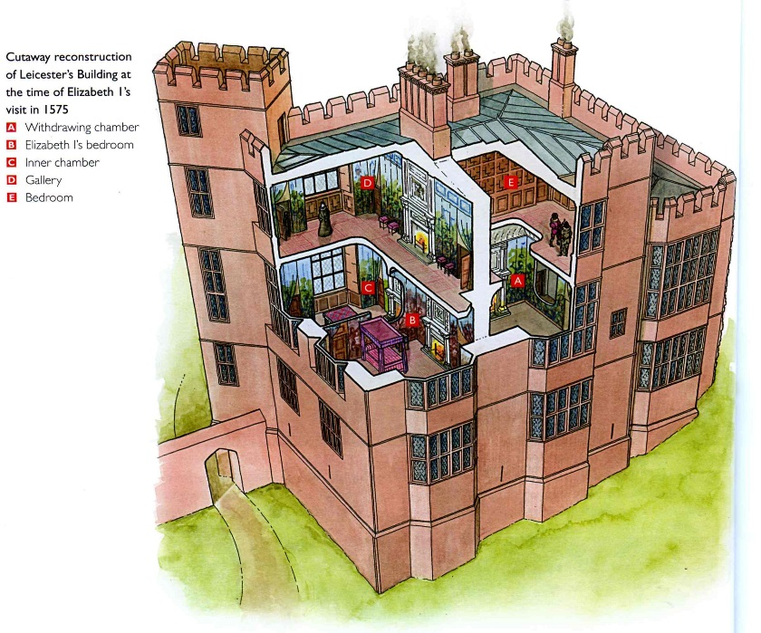

Kenilworth Castle resources

Resource A | An artist’s reconstruction of Kenilworth Castle in 1420.
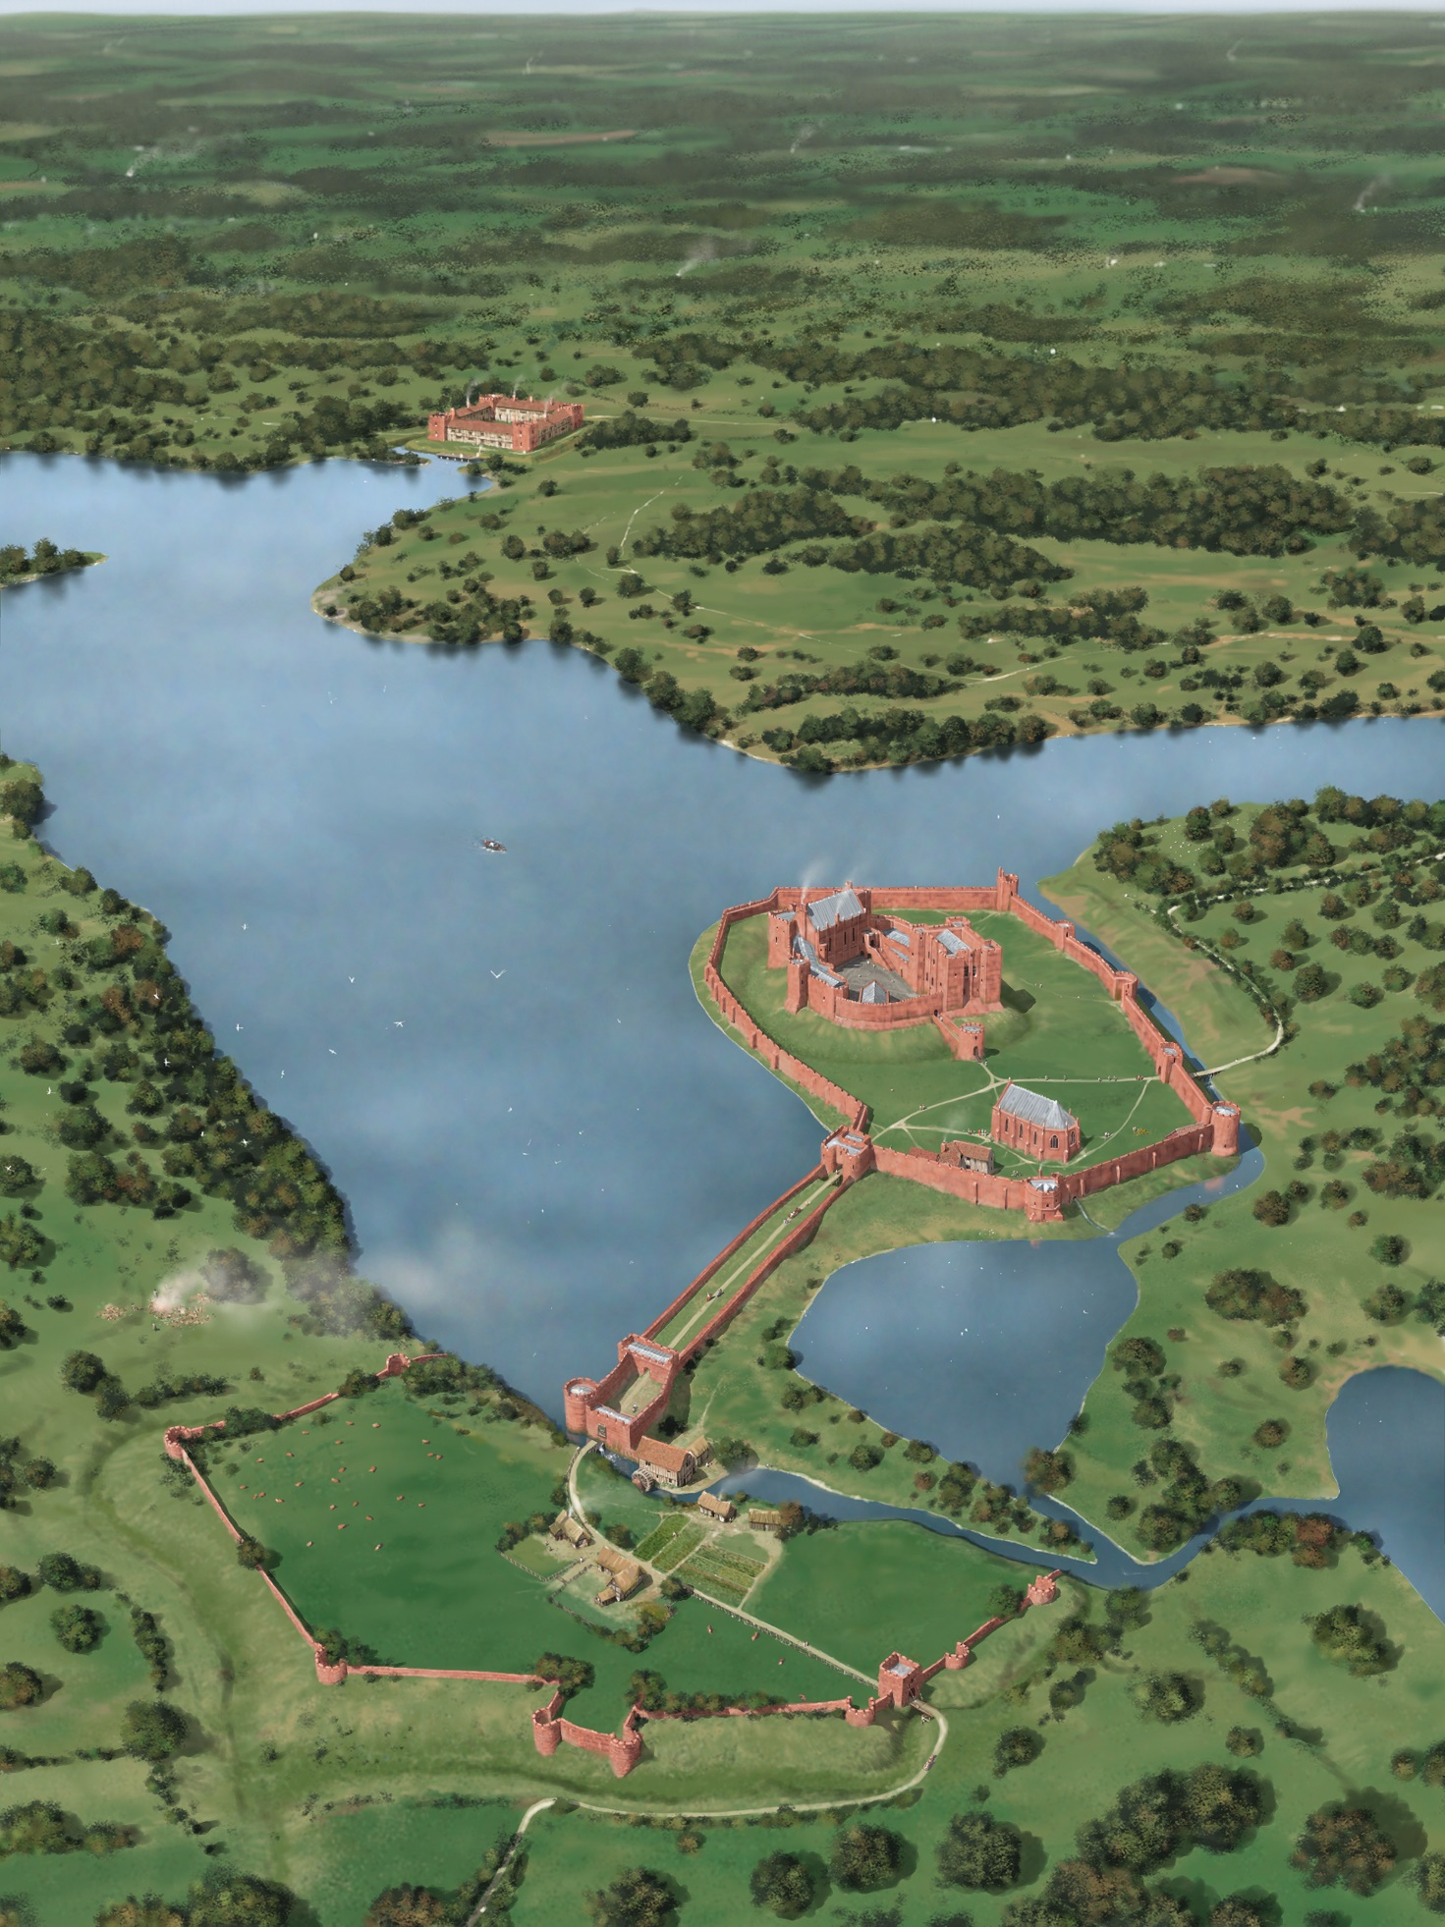

Resource B | An artist’s reconstruction of Kenilworth Castle in 1575.
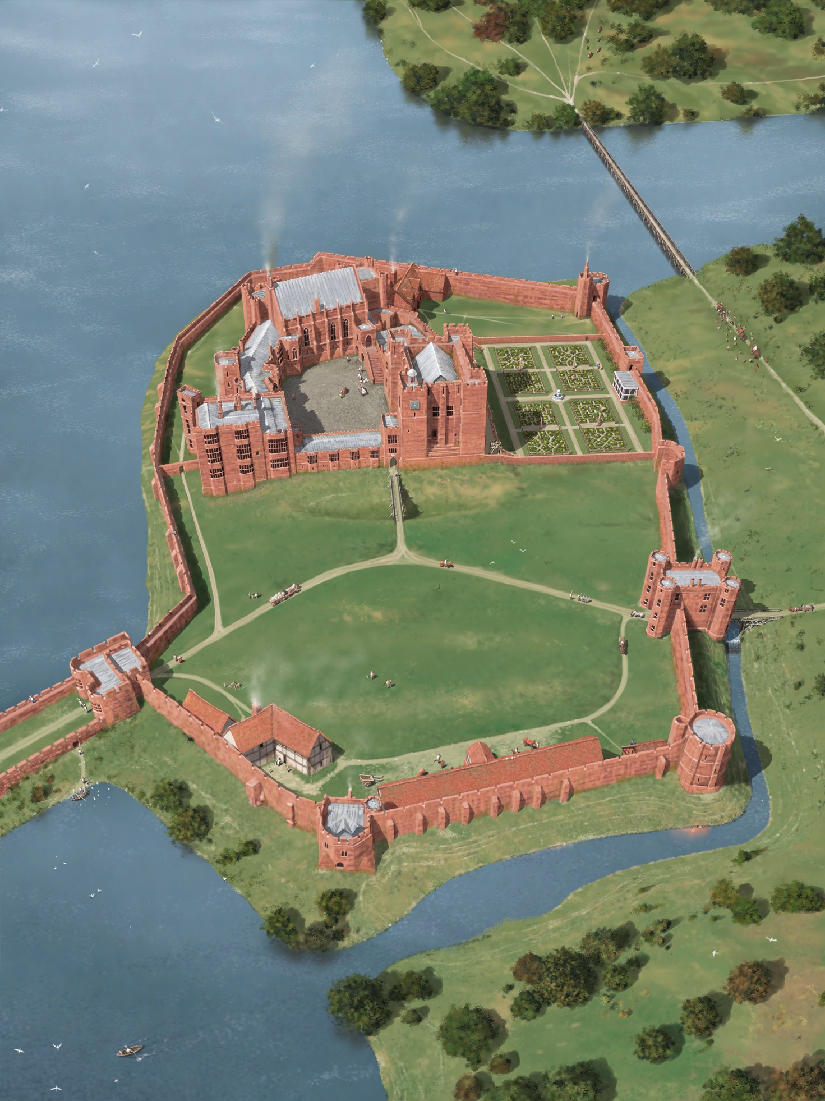

Resource C | A plan of Kenilworth Castle showing how it changed over the centuries.
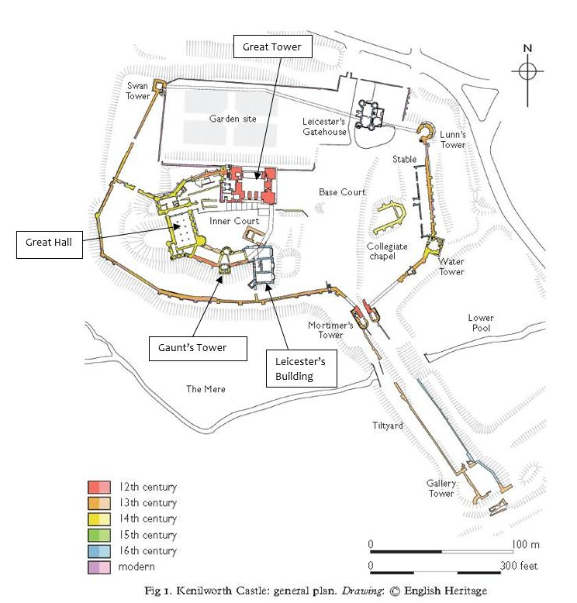

Resource D | An artist`s reconstruction of Kenilworth Castle in the C16th.
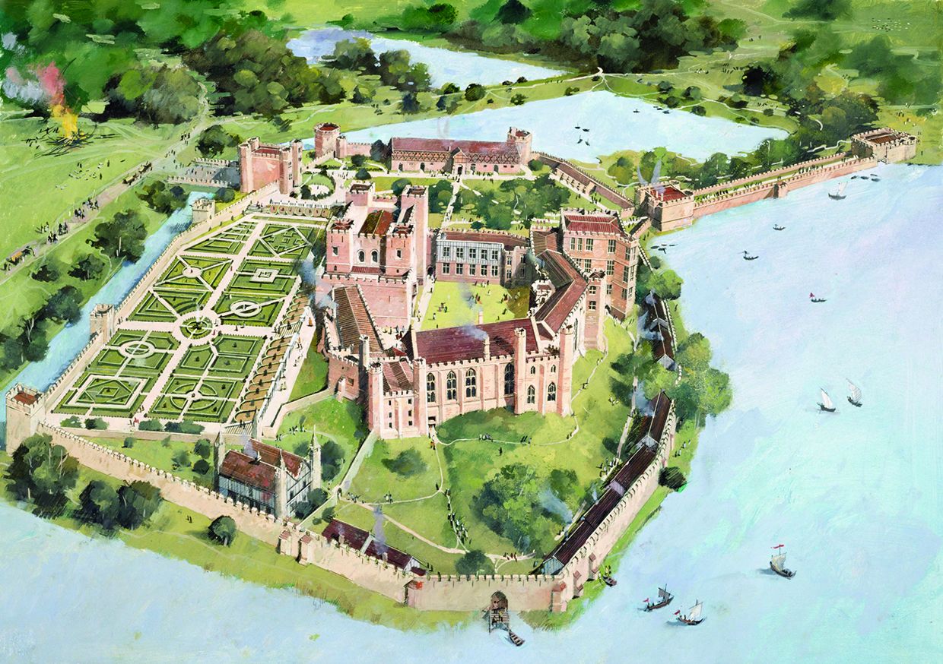

Resource E1 | A drawing of the gardens at Kenilworth Castle as they would have been during Elizabeth’s reign.
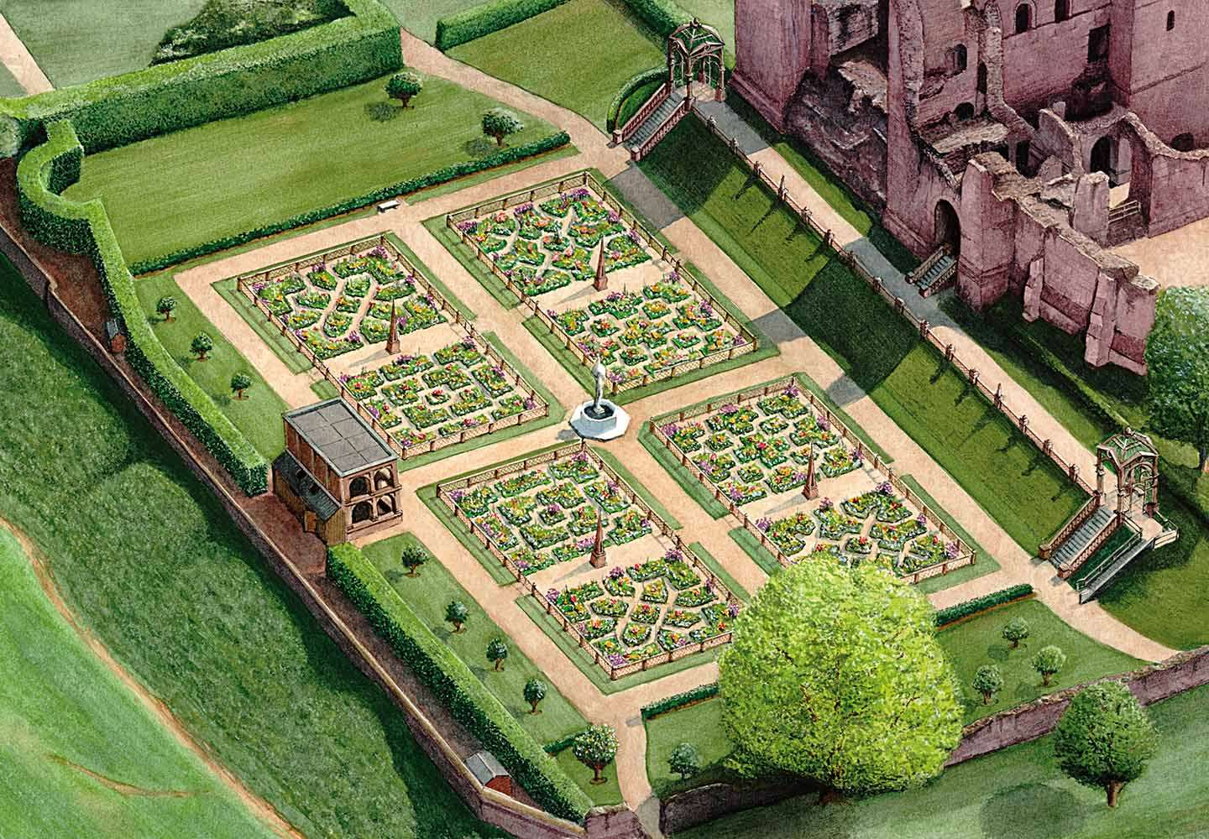

Resource E2 | A photograph of the gardens at Kenilworth Castle.
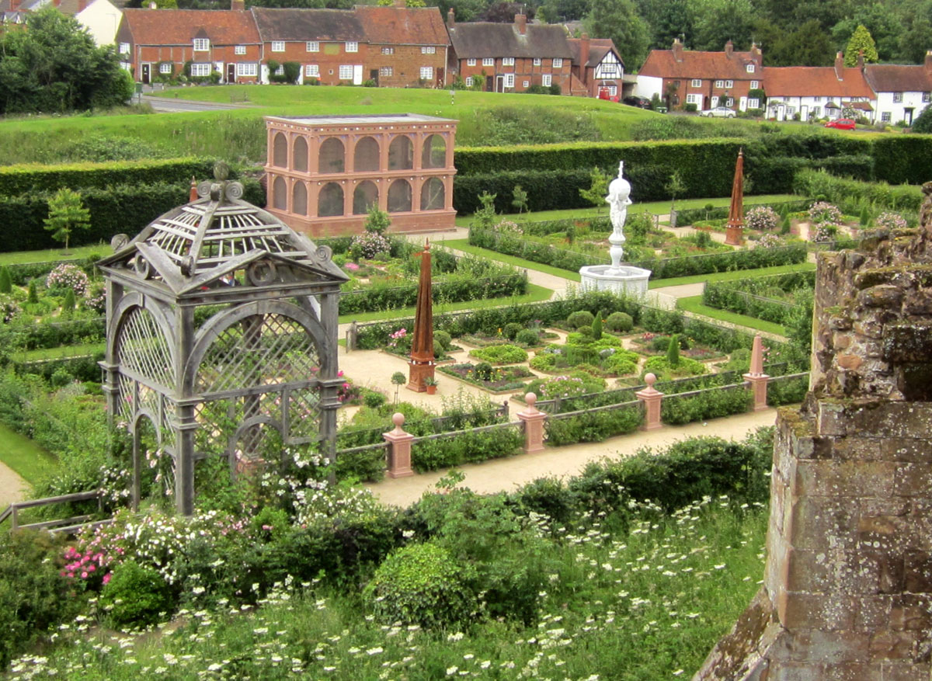

Resource F | A painting said to be of Queen Elizabeth and Robert Dudley dancing. It was painted in 1581.
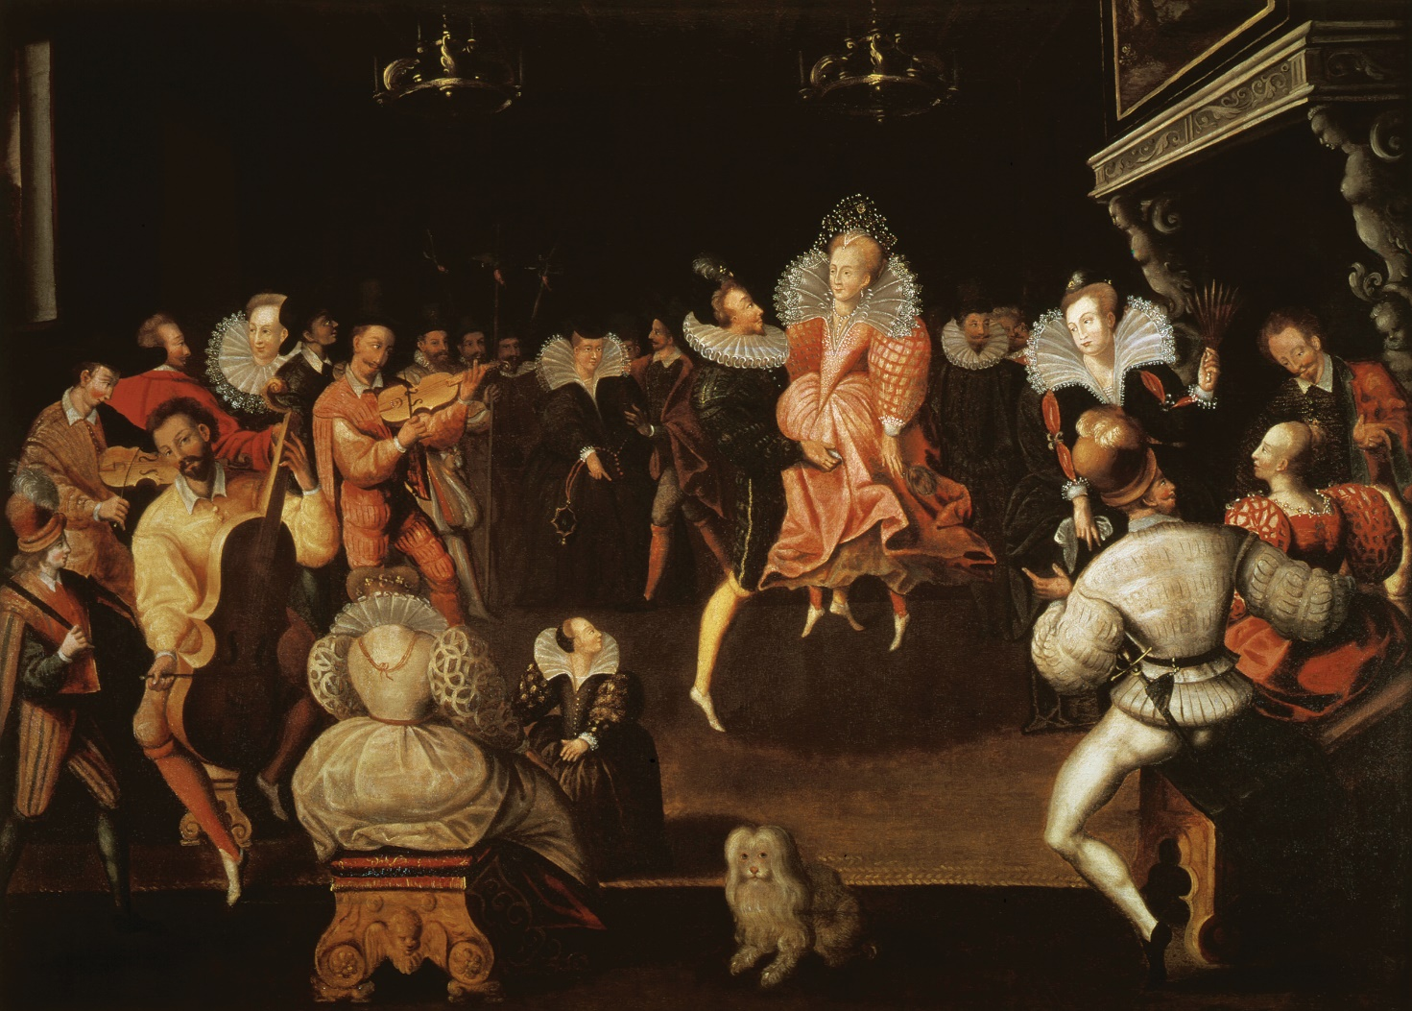

Resource G | An artist’s reconstruction of the Earl of Leicester at Kenilworth Castle.
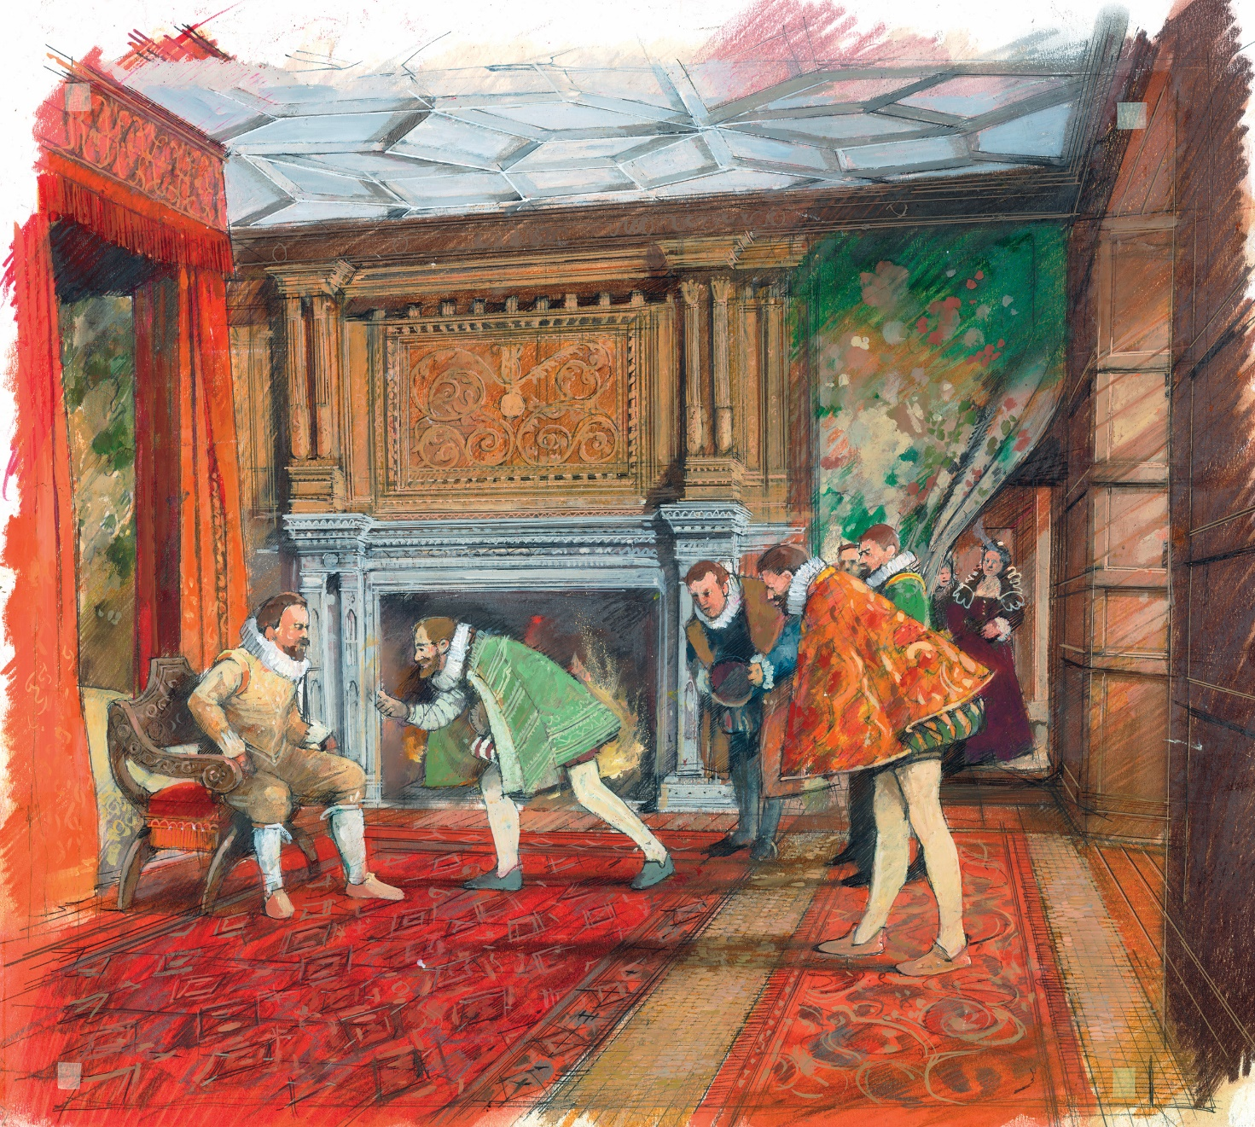

Resource H | An extract from ‘Princely pleasures at Kenilworth: Robert Dudley’s three-week marriage proposal to Elizabeth I’ by Elizabeth Goldring, published in History Extra in 2016.
Robert Dudley, described as Elizabeth’s great love, came closer than anyone to making the Queen his wife. On Saturday 9 July 1575, at about 8pm, Elizabeth arrived on horseback at Kenilworth Castle, the Warwickshire power base of her long-time favourite, Robert Dudley, Earl of Leicester. This began Dudley’s three-week long marriage proposal which was his last-ditch attempt, after nearly 15 years of trying, to win the Queen's hand. As she passed through the castle gates, and into the outer courtyard, she was met by actors reciting speeches of welcome and bearing symbolic gifts, including the keys to the castle. Trumpeters saluted her and when she finally reached the inner courtyard, dismounted her horse and made her way to her rooms, cannon were fired in her honour that could be heard 20 miles away.

For nearly three weeks the Queen, her ladies-in-waiting and leading courtiers were entertained at Kenilworth with music, masques*, dancing, jousting, hunting and bear-baiting. Elaborate banquets at which guests drank up to 40 barrels of beer and 16 barrels of wine per day were accompanied by firework displays. The stage for these splendours was Kenilworth Castle itself which Dudley had spent over £40,000 on preparing for the Queen’s visit. These July 1575 festivities, known as the ‘princely pleasures’ have gone down in history as the longest, most expensive party of Elizabeth’s 45-year reign.

Dudley and Elizabeth

Contemporaries described Dudley as the man who knew Elizabeth best and influenced her the most. They shared many interests, including riding and hunting but theirs was also an attraction of opposites: the Queen was indecisive while Dudley was impulsive. Although we don`t know how sexual the relationship was, there was undoubtedly a strong and lasting emotional bond between them and Dudley seems to have been the only one of her many suitors that she seriously thought about marrying.

The pair met as children at the court of Henry VIII, when each would have been about seven. Their friendship probably turned into romance sometime between 1550 – when Dudley married Amy Robsart – and November 1558, when Elizabeth became Queen. Certainly, the new Queen’s decision to appoint Dudley as Master of the Horse caused surprise at the time. Not only did the position come with lodgings at court but also, by requiring its holder to lift the Queen on and off her horse, involved regular, physical contact. By spring 1559, there were rumours that Elizabeth was visiting Dudley “in his chamber day and night” and that she was “waiting for [his wife] to die”. When Amy was found a year later with a broken neck at the foot of a staircase, Dudley’s enemies were quick to accuse him of plotting her murder so that he could marry the Queen and become king in all-but-name. However, as the coroner’s court at the time ruled, it was almost certainly an accident or suicide. There is no evidence of foul play and it is believed that Amy was suffering from breast cancer, depression or both.

Dudley was now free to marry Elizabeth, but he faced opposition at court. In 1566, William Cecil advised the Queen to choose the Catholic Habsburg Archduke Charles over Dudley, noting that Dudley’s grandfather had only been a solicitor. More damning was the fact that Dudley’s father, brother, and sister-in-law, Lady Jane Grey, had been executed as traitors for plotting to change the succession, as Edward VI lay dying. Despite this, Dudley continued to pursue marriage with Elizabeth. Between 1561, when the mourning period for Amy ended, and 1578, when he married the Countess of Essex, he actively courted Elizabeth while undermining the efforts of her foreign, royal suitors. Often, as at Kenilworth in the summer of 1575, Dudley’s feelings for the Queen were shown in the plays and paintings he organised for her pleasure.

The Kenilworth festivities were designed by Dudley as an extended marriage proposal made through a series of specially commissioned dramatic entertainments meant to show his “true love” for the Queen. During these festivities Dudley revealed two sets of newly commissioned, life-sized portraits of himself and Elizabeth. In one set Dudley is shown wearing a red doublet (a colour associated with love) while Elizabeth wears a jewel-encrusted white doublet that had been a gift from Dudley at New Year 1575.

Portraits of Robert Dudley, Earl of Leicester and Queen Elizabeth c1575

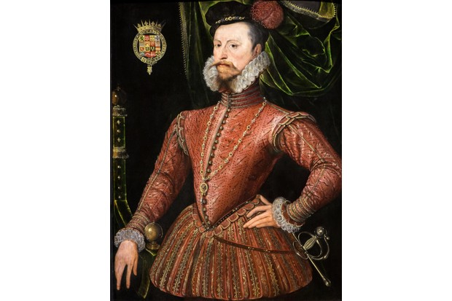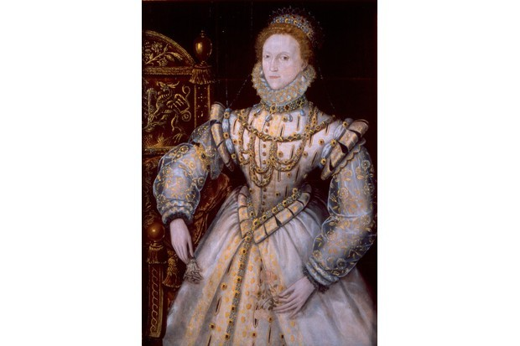

The other set was by a famous Italian painter of the time, Federico Zuccaro, who had been brought to England especially by Dudley in the spring of 1575. Dudley is shown in armour; the Queen surrounded by columns (representing dependability), a dog (loyalty), and an ermine (purity). As both sets are of Dudley and Elizabeth they were clearly meant to suggest that they were a couple.

Drawings of Robert Dudley and Elizabeth by Federico Zuccaro, 1575

(N.B. Zuccaro’s paintings do not survive, but these early drawings give an idea of what the finished works would have looked like.)

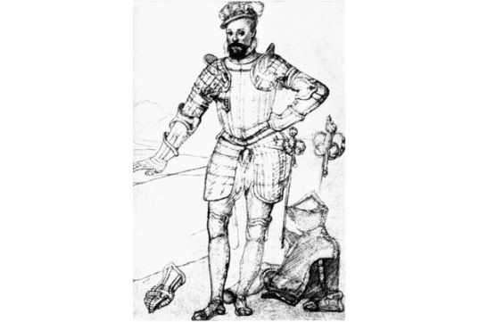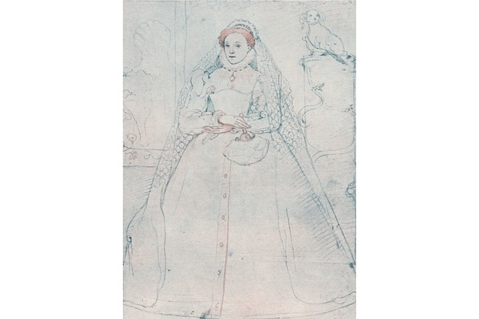

Elizabeth seems to have left Kenilworth earlier than expected. This may have been because of bad weather or because Dudley’s extravagant show of devotion to Elizabeth had gone too far especially as he had fathered an illegitimate son the previous year by the younger Lady Sheffield. After the 1575 Kenilworth festivities, Dudley seems to have abandoned any hope of Elizabeth ever agreeing to marry him. This was not the end of their relationship, however, as they remained close, even after Dudley’s 1578 marriage to the Countess of Essex. Elizabeth was so upset when Dudley died unexpectedly in 1588 that she spent several days alone in her room. Dudley had sent her a letter just before his death thanking her for some medicine and the Queen kept this last letter in a box by her bedside until her own death 15 years later. Dudley may not have won Elizabeth’s hand in marriage, but there can be little doubt that he won her heart.

* masque = a short piece of dance and drama by masked performers with scenery and music

Resource I | An extract adapted from ‘Because I am of that country and mind to plant myself there: Robert Dudley, Earl of Leicester, and the West Midlands’ by Simon Adams in ‘Leicester and the Court – Essays on Elizabethan Politics’, 2002.
Leicester’s enthusiasm for his country estates in the early 1570s is shown by the fact that contemporaries estimated that he spent about £40,000 on rebuilding Kenilworth Castle and providing entertainments there in 1566, 1572 and 1575.

The scale of the Kenilworth entertainment in 1575 is uncertain as Elizabeth had already visited in 1566, 1568 and 1572 and would never do so again. It was also the end of the major progresses around the country. Between 1579 and 1590 royal progresses were reduced to a circuit around Windsor and Hampton Court. This was partly because their expense had got out of hand. There were hostile comments on Leicester’s extravagance at Kenilworth, and Elizabeth had a more convenient way of being entertained by him. This was because between 1576 and 1588 she frequently visited his houses in London and at Wanstead just outside the capital. So if Kenilworth Castle had been rebuilt to house the Queen on her progress, then after 1575 that purpose had become redundant.

Leicester’s decision to spend so much money and effort on his country estates after 1570 may have been in response to the 1569 Northern rebellion as there were rumours that he was fortifying Kenilworth. There were also other rumours that Mary, Queen of Scots, was to be lodged there which might have explained further fortifications but, in fact, when completed the rebuilt Kenilworth did not show any defensive purpose.

However, Leicester’s relationship with his brother, the Earl of Warwick, and the future of their combined estates should also be considered. Warwick had received major grants of lands from the Crown in 1562 and 1564 but his first wife had died in 1552 and his second wife in 1563, both without producing any children. In 1563 Warwick was commanding the garrison defending Le Havre against a French siege and had he died there then Leicester would have been his heir and probable successor as Earl of Warwick.

In 1565 Warwick married the young Anne Russell, and might reasonably have been expected to father an heir, but by 1570 it was clear that he would remain childless, and Leicester must have been concerned that he too, like his brother, would have no heir. He did have a son in 1574 as a result of an affair with Lady Sheffield but the need for a legitimate heir was the reason for his marriage to the Lettice Knollys, Countess of Essex, in 1578. In June 1581 their only son was born but died of a fever three years later. After his son’s death Leicester became closer to his illegitimate son, Robert Dudley. Although he could not make Robert his rightful heir, he left Kenilworth and much of the West Midlands estate that he had inherited after the death of the Earl of Warwick to him. Therefore Leicester’s main aim in rebuilding Kenilworth Castle could be thought of as leaving an inheritance and permanent memorial in Warwickshire.

Resource J | An extract from ‘I was never more in love with an olde house nor never knew work could be better bestowed.’ The Earl of Leicester’s remodelling of Kenilworth Castle for Queen Elizabeth I by Richard K. Morris, published in The Antiquaries Journal, 2009.
By incorporating Renaissance architecture into the fortified site at Kenilworth, Leicester was copying examples from France, such as the chateau of Amboise. Kenilworth was also a major trend-setter for the sixteenth-century works at other medieval castles in England and Wales such as at Raglan and Ludlow. From the outside Kenilworth was to be seen as an ancient castle, with battlemented buildings rising from behind towered walls - even Leicester’s new buildings were topped with crenellated parapets. This was what Elizabeth would have seen as she rode into the castle on 9 July 1575, along the medieval fortified approach and tiltyard. The castle was to reflect the values of a chivalric, courtly society, familiar to contemporaries from medieval romantic literature. When Leicester’s brother-in-law told him how he ‘was never more in love with an old House’, he was surely referring to the setting of Kenilworth and the impressive nature of its medieval buildings with their historical associations. This probably explains why amongst all the building work, John of Gaunt’s Great Hall remained untouched as it was one of the largest medieval halls ever built and symbolised lordship and traditional hospitality. Keeping it unaltered may well have influenced the revival of large open-roofed halls at other major courtier houses such as Burghley House during Elizabeth’s reign.

Amongst new work done at Kenilworth, the traditional design of the north gatehouse, with its octagonal turrets, intentionally copied the towering fourteenth-century gatehouse at Warwick Castle, because Leicester took every opportunity to stress his descent from the medieval Earls of Warwick. Kenilworth was very significant for the architecture of the Elizabethan court but its description as a 'castle’ can be misleading as the amount of accommodation alone makes it the size of a country house, while its varied mix of features set the fashion for the Elizabethan style in the second half of her reign.

Leicester’s building appears plain from the outside compared with the carved exterior of other great houses of the time such as Longleat in Wiltshire. One important reason for this was probably the setting, for Leicester’s building was intended to be a pair with the fourteenth century Great Tower, with its enormous but simple exterior. This must also have led to the decision not to use classical columns on the exterior even though they were fashionable at the time. This simplicity may also reflect considerations of cost and the need to build quickly.

The most striking external feature for those who saw Leicester’s building must have been the enormous windows which were probably the tallest sequence of windows anywhere in England at the time. Large windows were an important feature of other great houses, but at Kenilworth the windows are far more dramatic because of the size of their glass panes, and the fragile tracery* set into what seem to be paper-thin walls.

Begun in 1570 and completed to its full height in 1572, Leicester’s building was to become the model for the Elizabethan 'high house’ which dominated architecture in the second half of the Queen’s reign and whose best known example was Hardwick New Hall built almost twenty years later. Elizabeth’s visit in 1575 would have given it major exposure to a national audience while the success of the Kenilworth works increased the reputation of its architect, William Spicer. Just as the Kenilworth revels of 1575 were the first great private entertainment for the Queen, so Spicer’s substantial remodelling of the castle between 1570 and 1572 produced the first truly great house of the royal progresses.

*Tracery = ornamental stonework in a window

Resource K | An extract from ‘Kenilworth, the Earl of Leicester’s Pleasure grounds following Robert Laneham’s letter’ by Elizabeth Woodhouse published in ‘Garden History’, 1999.
After Elizabeth gave Kenilworth Castle to Robert Dudley, later created Earl of Leicester, in 1563, he spent two years making an already superb and extensive natural landscape even more attractive, as well as creating an Italian style garden. Created to impress the Queen and tempt her into marriage, the garden was full of shady retreats, trees, fruits, flowers, and a sculptured hydraulic fountain containing fish. There was also a grass terrace, aviary and obelisks.

The Earl of Leicester was well-educated and had acquired a good knowledge of Latin and Italian in his youth. He had visited the court of Henry II and Catherine de Medici in France and became a patron of art, drama and literature. As a result the whole landscape at Kenilworth, both natural and created by Leicester, was to be the setting for symbolic, theatrical, earthly and spiritual pleasures that would be appreciated by the Queen and her court. Furthermore, the emblems and messages that the gardens contained were clearly understood by a public that had knowledge of mythology and were receptive to new Renaissance ideas.

Many of Leicester’s own heraldic symbols were displayed confirming his desire for immortality but also his greater wish to be the Queen’s husband. So much heraldry may have been included to convince Elizabeth of his suitability by emphasising his old and powerful ancestry. Leicester’s own emblem of a bear and ragged staff featured on every possible surface.

Like Italian gardens of the time, Kenilworth was made up of two complementary parts with a natural landscape being paired with more formally planted gardens. The site was a vast one, totalling 789 acres which included a pool of 111 acres and the garden, most of which was within the castle walls. Woods provided a stage for a favourite royal pastime as Elizabeth rode and enjoyed hunting, causing contemporaries to compare her to Diana, the Roman goddess of the hunt, moon and nature, who was also associated with wild animals and woodlands. This shows how the landscape was designed to link Elizabeth to the mythological gods.

Leicester’s garden was symmetrical to match his new buildings but could not be seen from the living quarters, so a terrace was created, the first of its kind in England, from which to view both the natural and formal landscapes that he had devised. Obelisks on the terrace would have added height and a sense of theatre to it. These prominent features of Leicester’s garden were possibly inspired by classical frescoes from Pompeii and were surrounded by fragrant herbs, flowers and fruit trees. The abundance of different flowers which were set in perfumed and colourful clusters would have included many new plants, such as the tulip, brought from abroad.

The garden at Kenilworth was clearly influenced by Italian ideas as its division into four quarters filled with fruit trees and flowers was similar to an Italian Renaissance garden. Leicester’s aviary also closely resembles an Italian design which itself was based on one from Ancient Rome. It shows perfectly the Renaissance idea of a work of art combining a man-made object (the aviary) with valuable natural things (decorations which were made to look like precious stones including diamonds and rubies). The fountain was a spectacular focal point to the garden and included both Roman and Italian Renaissance themes. It shows the Greek god, Atlas, carrying on his shoulders the Globe which has, on its top, Leicester’s emblem of bear and ragged staff. With a deep pool containing fish at its base this was yet another example of the natural world (the fish and bear) being combined with a man- made work of art (the fountain).

The landscape at Kenilworth Castle shows that the Elizabethans had a deep awareness of both Italian Renaissance ideas and the mythologies of Ancient Greece and Rome. Gazing on this landscape would, for contemporaries, have been looking at an earthly paradise, one created by a cultivated Renaissance nobleman.

Resource L | An extract from ‘The Royal Court and Progresses’ by Alison Sim published in History Today, 2003.
The Court was in reality a magnificent piece of theatre, and as in any theatre a large team of highly trained people was needed to produce the performance. Part of the problem was the size of the court. When the Queen was at one of the larger palaces, such as Hampton Court, there could be between 1,000 and 1,500 people in attendance. These would vary from household staff, such as cooks and bakers, to the highest courtiers in the land. They all had to be housed, fed and, in many cases, clothed at the royal expense. These problems were made worse in the summer, when the Queen went on progress which would last from eight to twelve weeks. In the summer of 1578, for example, the court stayed at twenty-five different places and dined at ten others.

Elizabeth did not travel light as everything went with her, from the Queen’s own wardrobe to legal documents. The whole court was expected to accompany her so 200-300 carts travelled with her. The cost of all this was considerable, at least £2,000 per year, so it did not save the Queen money.

The organisation of a summer progress started early in the year with Court officials inspecting the houses the Queen intended to visit, and checking that there were no local outbreaks of plague. Officials would firstly find places suitable for the Queen herself and later look for suitable lodgings for the rest of the court. Finally the planned itinerary would be published as a list of places where the Queen would stay, although without specific dates. These were then sent to the local officials who had to confirm that their areas were plague free. The next stage must have been dreaded by many as the local towns and villages were ordered to provide stocks of food, fuel and fodder.

As the time of the royal visit approached, a team of the Queen’s gentlemen ushers and an officer of the wardrobe would arrive. The job of the ushers was to manage Elizabeth’s public rooms and to make sure that only suitable people were allowed to enter them. On progress they, with the officers of the wardrobe, were responsible for making the Queen feel at home. Elizabeth expected her apartments to be completely ready when she arrived, and no packing up could start until after she had left. The ushers therefore had to work in relays, so that one team would be packing up after a royal visit while another was ready to receive the Queen at the next venue.

Elizabeth might have been well provided for, but life on progress was less easy for the rest of the court. Housing the courtiers could prove difficult and they frequently had to take whatever was on offer, which was often some distance from where the Queen was staying. Government business still had to go on, however, and many members of court found that they were spending most of the day travelling between their lodgings and their work which ended up with them having little time to carry out that business.

Despite such difficulties, progresses were stage-managed down to the smallest detail. Even the devising of entertainments for the Queen was not left up to the towns she visited. For example, during the 1578 progress Thomas Churchyard, who was responsible for court entertainments, was sent to Norwich three weeks in advance of Elizabeth`s visit to supervise the devising and production of the entertainments. These included not only suitable pageantry to celebrate the Queen’s arrival in the city, but also a number of smaller, more informal displays.

Churchyard’s hard work could be destroyed by a royal change of plan or the weather. On one occasion, a thunderstorm broke just as the Queen was about to arrive, forcing performers and spectators to run for cover. The rain not only stopped the show but also ruined the costumes, so that they were not even fit to re-use at a future date. However, the effort proved worthwhile, at least as far as the Queen was concerned. Elizabeth was at her best in front of a crowd and always knew how to behave to gain its admiration and respect. No doubt those who saw her on progress remembered her with awe and affection, but those who had to organise the events or follow her as part of the court must have had rather different memories.

Resource M | An extract from ‘Why Elizabeth I Never Married’ by Retha Warnicke, published in History Review, 2010.
Elizabeth I’s claim in her first parliamentary speech that she preferred to remain single was not unusual. Her sister, Mary Tudor, had said the same before instructing her privy councillors to negotiate a marriage treaty with Philip, the future king of Spain. Tudor society expected husbands to take charge of their wives’ property and business so it is not surprising that the Scottish ambassador at the time believed that Elizabeth remained unmarried because she wanted to be both king and queen. Modern historians have suggested that she possessed a psychological fear of marriage, due to the execution of her mother and step-mother as well as the death of Jane Seymour in childbirth.

However, political issues were surely more important in her decision to remain single. Furthermore, it is difficult to believe, given her character and personality that, had she married, Elizabeth would have given up her rights as monarch to her husband. Every British queen who married soon discovered that her husband and his family complicated her life politically. No marriage went unchallenged and Elizabeth would have been either aware of, or a victim of, every plot against her female relatives. The Duke of Northumberland had used Jane Grey’s marriage to his son in an attempt to prevent the succession of Elizabeth’s half-sister Mary. Elizabeth’s own life had been in danger during Mary Tudor’s reign because of plotters who aimed to put her on the throne.

Robert Dudley

Early in her reign many people commented that Elizabeth was attracted to Robert Dudley, son of the Duke of Northumberland and her Master of Horse. Rumours spread that she would marry Dudley if his wife, Amy Robsart, died. In September 1560, Amy did die under mysterious circumstances when she fell down a staircase, breaking her neck. Dudley was not there at the time but suspicion surrounded Amy’s death, although historians doubt that he plotted against her. As a result of the controversy and due to the unpopularity of the Dudley family, Elizabeth decided she could not marry him.

However, in 1564 Elizabeth did offer Dudley as a possible husband to Mary Stuart and made him Earl of Leicester to make his candidacy more attractive. Despite this many believed that they were still lovers and rumours circulated that Elizabeth gave birth to his children when the court went on its summer progresses. In 1575 the Queen visited Kenilworth where Dudley entertained her extravagantly with gifts labelled ‘tokens of true love,’ hunting parties and plays which glorified marriage. The four individual portraits of Elizabeth and Leicester, which he commissioned for the Queen’s visit were unique in their large scale and were meant to show his close relationship with her.

Elizabeth was expected to marry a high-ranking foreigner who would strengthen her own royal status rather than raise the status of her husband. Also, many councillors feared Leicester would influence her decisions about power and patronage while favouring his own family and friends. Believing that Elizabeth would never marry him, Dudley wed Elizabeth’s cousin, Lettice Knollys, in 1578. Elizabeth never forgave Knollys for marrying Leicester, frequently criticised her and only received her at court once, and that was after Leicester’s death in 1588.

A Foreign Match

Some councillors hoped that she would marry a foreign prince. However those who might strengthen her royal status were all Catholics and this proved to be a major stumbling block in marriage negotiations with members of the Austrian Habsburg and the French Valois dynasties. From 1563 to 1567, some councillors including William Cecil, supported the candidacy of Charles, Archduke of Austria, the younger son of the Holy Roman Emperor, Ferdinand I. During this courtship Elizabeth said that she could never marry someone she had not seen but it was beneath Charles’s dignity to travel to England without Elizabeth’s agreement to the marriage. However, the most hotly debated issue during the negotiations was his religion. Charles insisted on his right to worship at the English court as a Catholic. Elizabeth refused to agree to this. With neither side being prepared to compromise, the marriage negotiations ended.

In 1565, to counter these Habsburg negotiations, the French proposed marriage between the 14-year-old King of France, Charles IX, and Elizabeth. She refused but in 1570-71 did consider marrying his brother, Henry, Duke of Anjou. Again, the question of his right to follow the Catholic religion in England, among other issues, prevented an agreement being reached and by October 1571, the negotiations were over.

In August 1579, Catherine de Medici’s youngest son, Francis, Duke of Anjou and Alençon arrived in England, willing to make important concessions about following his Catholic religion. Many, including her Privy Council, opposed the possible marriage partly because he was a foreigner but also because of his religion. When Francis returned in 1581, still hoping for marriage, Elizabeth told the French ambassador and a group of courtiers that she would marry him, perhaps as a way of gauging the negative reaction of the Privy Council and courtiers. Once again, negotiations failed, and Francis left for the Netherlands. By this time, Elizabeth was in her late forties, causing fears that she was incapable of becoming pregnant or even surviving childbirth.

Conclusion

Elizabeth could have succeeded in putting down all challenges to her royal authority whoever she married but perhaps hesitated to take the chance, concerned that the bitter divisions among her councillors and courtiers over any marriage would spill over into the country at large. Besides her subjects’ possible dislike of her husband, there was the added problem of the consequences of marrying someone whom she would not know well. All these political and social issues would have worried Elizabeth and are probably the more important reasons why she remained single.

