Parkfield School
Year 8 assessment 3

Marks _____
53

60 minutes
NON – CALCULATOR
Q1.
What is the area, in cm², of a semicircle of radius 6 cm?
Circle your answer.
6π 12π 18π 36π
(Total 1 mark)
Q2.
Work out the value of 4(2x + 3y) when x = 8 and y = − 3
_______________________________________________________________________
_______________________________________________________________________
Answer _________________________________________
(Total 2 marks)
Q3.
Work out 4 + 3 × 5 − 1
Circle your answer.
16 18 28 34
(Total 1 mark)
Q4.
Factorise 15x + 35y − 40z
_______________________________________________________________________
_______________________________________________________________________
Answer _________________________________________
(Total 1 mark)
Q5.
Simplify 2⁵ × 2³
Circle your answer.
4⁸ 2⁸ 2¹⁵ 4¹⁵
(Total 1 mark)
Q6.
Circle the expression that is equivalent to 3a − a × 4a + 2a
8a² + 2a 12a² 5a − 4a² 3a − 6a²
(Total 1 mark)
Q7.
of the runners who started a marathon completed it.
of those who completed it are women.
180 women completed the marathon.
How many runners started the marathon?
_______________________________________________________________________
_______________________________________________________________________
_______________________________________________________________________
_______________________________________________________________________
_______________________________________________________________________
_______________________________________________________________________
_______________________________________________________________________
Answer _________________________________________
(Total 3 marks)

Q8.
Average speed of vehicles on a motorway
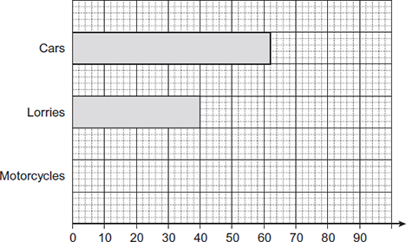
Average speed (mph)
(a) The average speed of motorcycles is 68 mph.
Complete the chart for motorcycles.
(1)
(b) Write down the average speed of cars.
Answer _______________________________ mph
(1)
(c) Work out the difference between the average speed of cars and lorries.
___________________________________________________________________
Answer _______________________________ mph
(1)
(d) Harry says,
’All cars travel faster than lorries on this motorway.’
Is he correct?
Give a reason for your answer.
___________________________________________________________________
___________________________________________________________________
___________________________________________________________________
___________________________________________________________________
(1)
(Total 4 marks)
Q9.
Estimate the value of 19.4² + 30
_______________________________________________________________________
_______________________________________________________________________
_______________________________________________________________________
_______________________________________________________________________
_______________________________________________________________________
Answer _________________________________________
(Total 3 marks)
Q10.
Make t the subject of the formula w = 3 +
_______________________________________________________________________
_______________________________________________________________________
_______________________________________________________________________
Answer _________________________________________
(Total 2 marks)
Q11.
The diagram shows three routes, A, B and C, between two towns, X and Y.
The distance and average speed for each route is shown.
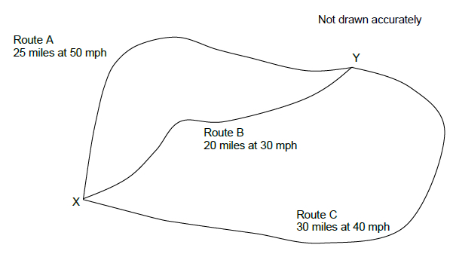
(a) Which of the three routes takes the longest time?
Assume the average speeds given.
You must show your working.
___________________________________________________________________
___________________________________________________________________
___________________________________________________________________
___________________________________________________________________
___________________________________________________________________
___________________________________________________________________
___________________________________________________________________
___________________________________________________________________
___________________________________________________________________
Answer _________________________________________
(4)
(b) Jon and Matt take the same time to travel from X to Y.
Jon travels along route B at 10 mph faster than the average speed.
Matt travels along route C.
Does Matt travel faster or slower than the average speed for route C, and by how much?
You must show your working.
___________________________________________________________________
___________________________________________________________________
___________________________________________________________________
___________________________________________________________________
___________________________________________________________________
___________________________________________________________________
___________________________________________________________________
___________________________________________________________________
Tick a box

Faster |  | Slower
Answer .................................................... mph
(3)
(Total 7 marks)

Q12.

Here is a drink container and a lunch box.
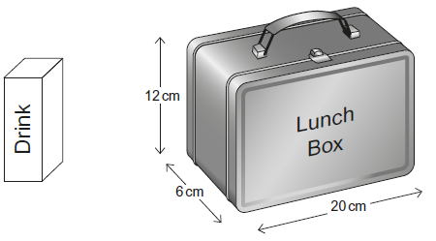
The drink container is a cuboid with a square base.
The area of the base = 25 cm²
The volume of the container = 400 cm³
Will the container fit inside the lunch box?
You must show your working.
_______________________________________________________________________
_______________________________________________________________________
_______________________________________________________________________
_______________________________________________________________________
_______________________________________________________________________
_______________________________________________________________________
_______________________________________________________________________
_______________________________________________________________________
_______________________________________________________________________
_______________________________________________________________________
(Total 4 marks)

Q13.
(a) Rob is going to drive 130 miles from Hull to Liverpool.
There are road works for 25 miles of the journey.
He assumes his average speed will be
50 mph where there are road works
70 mph for the rest of the journey.
Using his assumptions, work out his journey time.
___________________________________________________________________
___________________________________________________________________
___________________________________________________________________
___________________________________________________________________
___________________________________________________________________
___________________________________________________________________
___________________________________________________________________
___________________________________________________________________
Answer _________________________________________
(4)
(b) Rob’s assumptions about his average speeds are too high.
How does this affect his journey time?
___________________________________________________________________
___________________________________________________________________
(1)
(Total 5 marks)

Q14.
Bag A contains 10 blue balls and 20 red balls.
Bag B contains 8 blue balls and 12 red balls.
A ball is chosen at random from each bag.
Jo says,
“It is more likely that a blue ball is chosen from Bag A than Bag B because there are more blue balls in Bag A.”
Is she correct?
You must show your working.
_______________________________________________________________________
_______________________________________________________________________
_______________________________________________________________________
(Total 3 marks)
Q15.
A number is picked at random from the first four prime numbers.
A number is picked at random from the first four square numbers.
The two numbers are added to get a score.
(a) Complete the table.

 |  | Square numbers
 | + | 1 | 4 | 9
Prime numbers | 2
 | 3 |  |  | 12
 | 7
(4)
(b) What is the probability that the score is a prime number?
Answer _________________________________________
(1)
(Total 5 marks)
Q16.
Work out 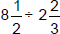
Give your answer as a mixed number.
_______________________________________________________________________
_______________________________________________________________________
_______________________________________________________________________
Answer _________________________________________
(Total 4 marks)
Q17.
Write 36 as a product of prime factors.
Give your answer in index form.
Answer _________________________________________
(Total 3 marks)
Q18.
Here is a circle touching a square.
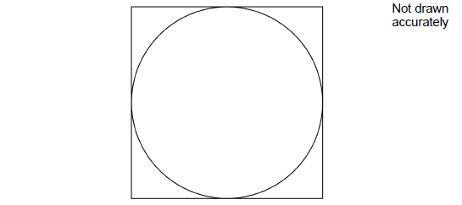
The area of the square is 64 cm²
Work out the area of the circle.
Give your answer in terms of π.
_______________________________________________________________________
_______________________________________________________________________
_______________________________________________________________________
Answer _________________________________________ cm²
(Total 3 marks)

