Parkfield School
Year 8 assessment 1

Marks _____
46

50 minutes
NON – CALCULATOR
Q1.
How many minutes are there in hours?
Circle your answer.
180.5 210 330 350
(Total 1 mark)
Q2.
(a) Solve x − 3 = 14
___________________________________________________________________
___________________________________________________________________
x = _________________________________________
(1)
(b) Solve 5y = 45
___________________________________________________________________
___________________________________________________________________
y = _________________________________________
(1)
(c) Solve 8 + w = 6
___________________________________________________________________
___________________________________________________________________
w = _________________________________________
(1)
(Total 3 marks)
Q3.
(a) How many edges are there on a square-based pyramid?
Circle your answer.
4 5 8 12
(1)
(b) How many faces of a triangular prism are triangles?
Circle your answer.
2 3 4 5
(1)
(Total 2 marks)
Q4.
Complete the table to show equivalent fractions and percentages.

Fraction | Percentage
 | 50%
 | 43%
(Total 3 marks)
Q5.
Work out the value of 4(2x + 3y) when x = 8 and y = − 3
_______________________________________________________________________
_______________________________________________________________________
Answer _________________________________________
(Total 2 marks)

Q6.
(a) Work out 9174 ÷ 11
Answer _________________________________________
(2)
(b) Work out 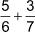
Give your answer as a mixed number.
___________________________________________________________________
___________________________________________________________________
___________________________________________________________________
___________________________________________________________________
___________________________________________________________________
___________________________________________________________________
___________________________________________________________________
Answer _________________________________________
(3)
(Total 5 marks)
Q7.
Simplify 2⁵ × 2³
Circle your answer.
4⁸ 2⁸ 2¹⁵ 4¹⁵
(Total 1 mark)

Q8.
A number is picked at random from the first four prime numbers.
A number is picked at random from the first four square numbers.
The two numbers are added to get a score.
(a) Complete the table.

 |  | Square numbers
 | + | 1 | 4 | 9
Prime numbers | 2
 | 3 |  |  | 12
 | 7
(4)
(b) What is the probability that the score is a prime number?
Answer _________________________________________
(1)
(Total 5 marks)
Q9.
By rounding each number to the nearest 10,
estimate the answer to 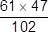
You must show your working.
_______________________________________________________________________
_______________________________________________________________________
Answer _________________________________________
(Total 2 marks)
Q10.
Work out 4 + 3 × 5 − 1
Circle your answer.
16 18 28 34
(Total 1 mark)
Q11.
Circle the expression that is equivalent to 3a − a × 4a + 2a
8a² + 2a 12a² 5a − 4a² 3a − 6a²
(Total 1 mark)
Q12.
Divide 405 in the ratio 4 : 11
_______________________________________________________________________
_______________________________________________________________________
_______________________________________________________________________
_______________________________________________________________________
_______________________________________________________________________
Answer ___________________ and ___________________
(Total 3 marks)
Q13.
Factorise 15x + 35y − 40z
_______________________________________________________________________
_______________________________________________________________________
Answer _________________________________________
(Total 1 mark)
Q14.
Work out 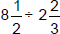
Give your answer as a mixed number.
_______________________________________________________________________
_______________________________________________________________________
_______________________________________________________________________
_______________________________________________________________________
_______________________________________________________________________
Answer _________________________________________
(Total 4 marks)
Q15.
Anil’s home is 1 km from a shop.
He walked from home to the shop at a constant speed in 10 minutes.
He stayed at the shop for 5 minutes.
He walked home at a constant speed in 8 minutes.
Anil drew this distance-time graph to represent his journey.
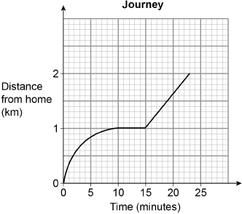
Make two criticisms of his graph.
Criticism 1 ______________________________________________________________
_______________________________________________________________________
_______________________________________________________________________
Criticism 2 ______________________________________________________________
_______________________________________________________________________
_______________________________________________________________________
(Total 2 marks)
Q16.
Circle the volume, in cm³, of a cylinder with radius 5 cm and height 8 cm
40π 80π 200π 1600π
(Total 1 mark)

Q17.
Write 36 as a product of prime factors.
Give your answer in index form.
Answer _________________________________________
(Total 3 marks)
Q18.
Here is a circle touching a square.
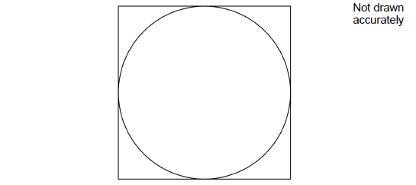
The area of the square is 64 cm²
Work out the area of the circle.
Give your answer in terms of π.
_______________________________________________________________________
_______________________________________________________________________
_______________________________________________________________________
_______________________________________________________________________
Answer _________________________________________ cm²
(Total 3 marks)

