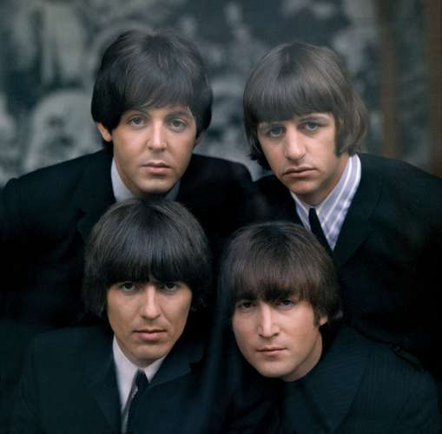
Music project 2 – due 18th May
Read the below text and answer the questions on the next page.
The Beatles were one of the most famous and influential English rock bands of all time, formed in 1960. In the first few years the band members included Pete Best and Stuart Sutcliffe, but ultimately the band gamed fame early in the 60s with members John Lennon, Paul McCartney, Ringo Starr, and George Harrison.
The Beatles were often referred to as the 'Fab Four', and by 1964 had reached international stardom, leading the way for British bands to enter and dominate the U.S. pop market in what was called the 'British Invasion'. The band became so famous with their mix of 50s rock, beat, hard rock, psychedelic, pop, and even Indian music, that they made 'Beatlemania', an intense fan frenzy that by 1966 made it impossible for them to perform live because of all the screaming fans in the audience. The Beatles released 20 albums that made it to No. 1 on the Billboard album charts.
Early members of the band included Pete best, Stuart Sutcliffe, Chas Newby, Norman Chapman, and Tommy Moore. Jimmie Nicol toured with the Beatles in 1964, playing the drums as needed. When the Beatles began recording in 1962 at Abbey Road Studios in London, England they had to replace the drummer Pete best. Ringo Starr was chosen, and the Fab Four was established with the four members who would go down in history as the Beatles.
Studio albums released by the Beatles included Please Please Me (1963), With the Beatles (1963), Beatlemania! With the Beatles (1963), Les Beatles (1963), Introducing...The Beatles (1964), Meet the Beatles! (1964), Twist and Shout (1964), The Beatles' Second Album (1964), The Beatles' Long Tall Sally (1964), A Hard Day's Night (1964), Something New (1964), Beatles for Sale (1964), Beatles '65 (1964), Beatles VI (1965), Help! (1965), Rubber Soul (1965), Yesterday and Today (1966), Revolver (1966), Sgt. Pepper's Lonely Hearts Club Band (1967), Magical Mystery Tour (1967), The Beatles (1968), Yellow Submarine (1969), Abbey Road (1969), and Let It Be (1970).

In 1970 the Beatles broke up, and all four former members recorded solo albums. In 1980 John Lennon was shot and killed outside his apartment building in New York City. The three remaining Beatles recorded All Those Years Ago in John Lennon's honour.

- Who were the main four musicians in the group?
- Within the group, who did what?
- When did the group first come into fame?
- What were the Beatles often referred as?
- The fanbase “Beatlemania” made it impossible for them to do what?
- What were the five previous band members called?
- Name six of their songs that has been listed.
- When did the group brake up?
- What year did John Lennon die?
- What song did they produce in honour of John Lennon?

Now that you have answered all of these questions, you need to create a booklet with facts and pictures of the Beatles. Use the text I have written as a base, but I would like to see you adding in new information if possible. This will be your assessment piece so please take you time and ask if you need help or have any questions. I would like you to aim these at someone who knows nothing about the Beatles so make it eye-catching and exciting to read.

If you have any questions or queries, please contact me via email and I will get back to you as soon as I can.
t.bray@parkfield.bournemouth.sch.uk

