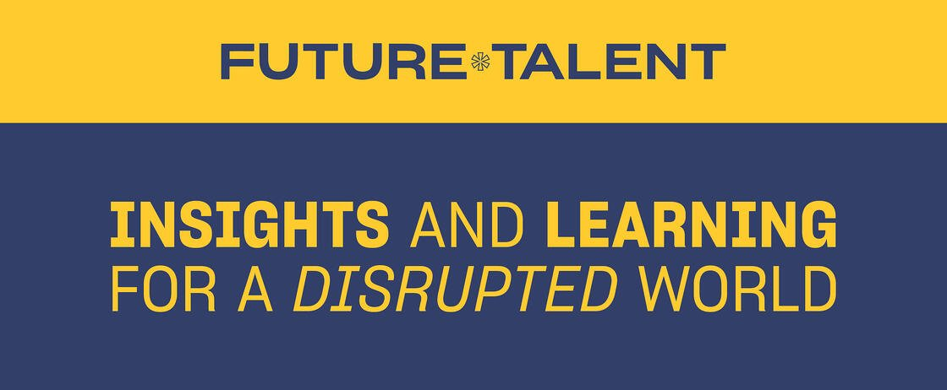

Join our live Q&A session for young people with Tim Peake

Find out more and register

Following his phenomenal session at the Future Talent virtual conference in November, we are delighted to announce that astronaut Tim Peake will be taking part in an exclusive free virtual Q&A session for young people on Thursday 21 January 2021 from 5-6pm GMT.

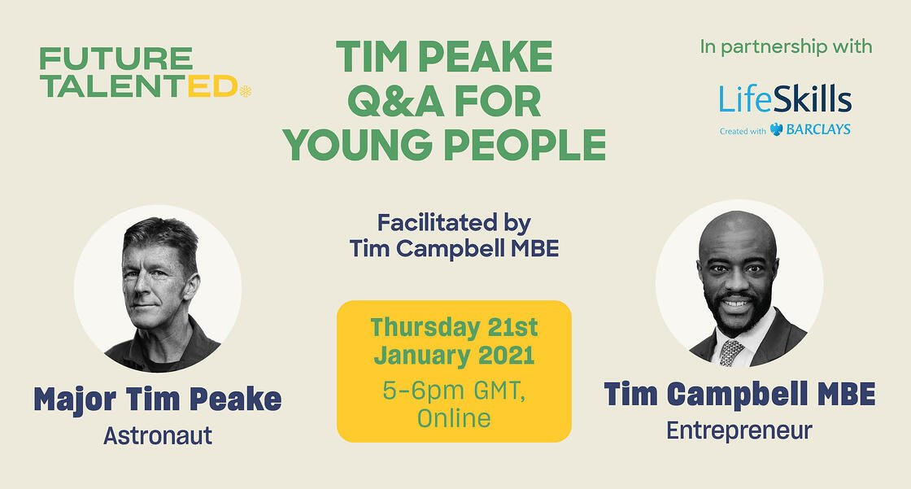
Facilitated by Tim Campbell MBE, the first winner of TV’s The Apprentice, Tim Peake will be answering questions from young people (aged 11-18) about space, STEM careers, and his chances of joining NASA’s Artemis Program to return astronauts to the moon by 2024.

Whether you’re a parent, carer, aunt, uncle, grandparent, school governor or you have links with education, please help us spread the word about what is set to be a fantastic event* , offering school students the opportunity to hear from one of our country’s greatest explorers.

We hope you can help us spread the word to young people.

Wishing you and your family a very merry Christmas on behalf of all at Future Talent Group. We look forward to connecting with you again in the new year.

Register here for Tim Peake Q&A

*please note that for GDPR purposes, parents/guardians/carers must register for the event on behalf of under-18s

