***Parkfield School Reception Handbook***

***2020***

Dear Parents,

Welcome to our school. We are delighted that your child will be coming into Reception in September.

We hope this booklet will give you some helpful information about the day to day running of the school.

We very much want to work in partnership with you and we also want our school to be a place where your child loves to come.

If you have any queries, please don’t hesitate to contact us and we will do our best to help.

Kind regards.

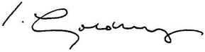

**Mr Ian Golding**

Principal of Parkfield School & Director of Secondary Education at Reach South

Starting School

We know that the first and most important teacher your child has is you. We can only continue what you have begun.

We want you to go on feeling responsible for your child’s learning, so that in partnership, we can give your child the security and confidence they need to succeed and see themselves as achievers.

We are often asked by parents what they can do to prepare their child for school. School will be able to continue and build upon the opportunities and experiences you have already shared with you child. To be happy and successful at school your child needs to be socially and emotionally secure. It would be very helpful if you could encourage your child:

* To be able to play happily and co-operatively with other children of a similar age
* To talk with and show trust in other familiar adults
* To listen and follow simple instructions
* To ask lots of questions and be curious and alert
* To dress and undress by themselves and to practise fastening buttons and zips
* To use the toilet without assistance

Talk about school at home. ‘Big’ school is not as scary as it seems! There are some excellent books available which help to prepare young children for school including, "Going to school” and "Topsy and Tim Start School”.

Reception Teaching Staff

Class Teacher: Miss C Richard

Phase Leader: Mrs C Claxton

*School Uniform*

There is a school uniform which we would like children to wear. We like children to feel proud of their appearance.

**Uniform:**

A white polo shirt with the school logo or a plain white polo shirt.

Green sweatshirt with the school logo.

Grey trousers (boys and girls) with grey socks.

Knee-length grey skirt / culottes (girls) with grey socks or tights.

Flat black sensible shoes, no trainers.

Green school book bag with logo.

In summer months, boys may wear grey shorts and girls can wear a green and white gingham dress. A cap or hat will be required in sunny weather.

**Sports kit**

Children in Reception will require plimsolls for PE lessons but do not

require a separate PE kit.

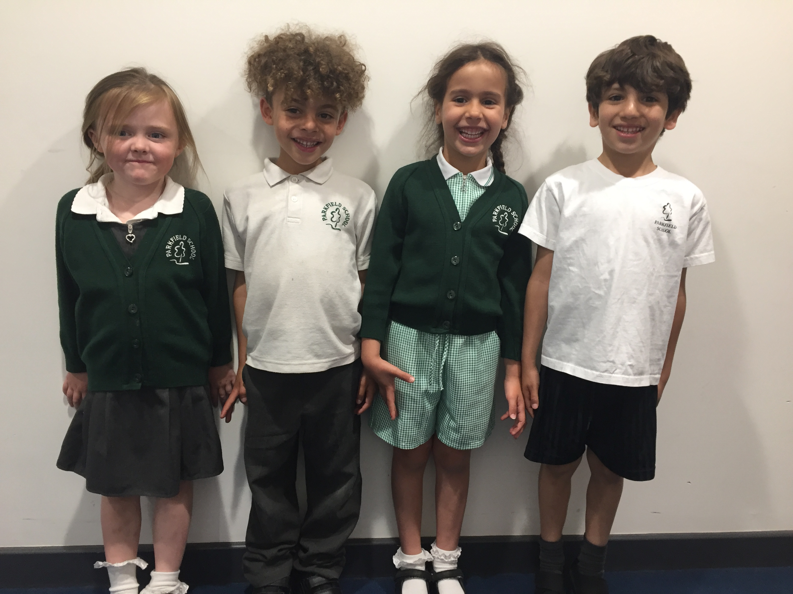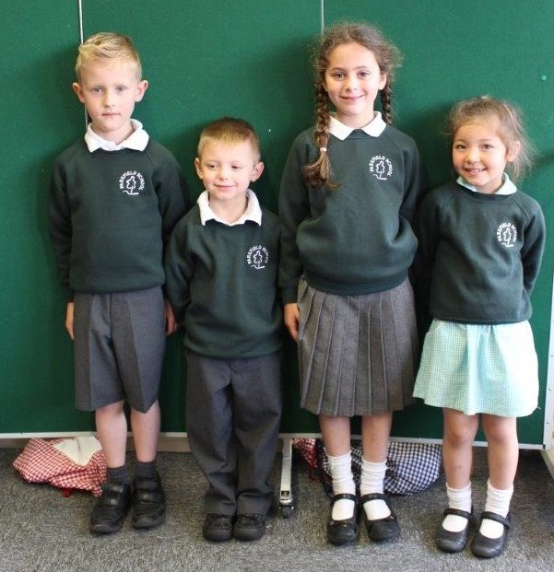

**Uniform Shop:**

Stevensons

148-150 Seabourne Road

Southbourne

Bournemouth

BH5 2JA

Or online at: [www.stevensons.co.uk/School/ParkfieldSchoolBournemouth/Browse](http://www.stevensons.co.uk/School/ParkfieldSchoolBournemouth/Browse)

Dressing and Self organisation

Please practise doing up and undoing buttons and zips on their coats. Velcro shoes are much easier for a four year old than laces.

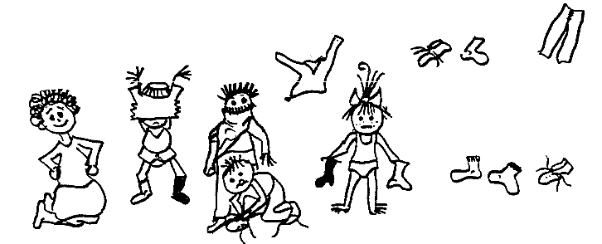**Please, please, please label all items.** Children find it very difficult to recognise their own clothes without labels, as they all wear the same uniform. It is also much easier to locate missing items if they have been named. Practise finding and reading the name label on their book bag and opening it to place things in it.

Please put spare pants, tights and socks in your child’s book bag so if any accidents happen we have clothes for them to change into.

Please ensure that your child can manage going to the toilet by themselves. Both classes share the toilets in Reception. When they come to ‘big’ school they will need to use the toilets on their own. We like to keep them clean and you can help by showing them:

• Flushing the toilet when you have finished

• If you are a boy lifting the seat before you go and aiming carefully!

• Washing your hands with soap afterwards.

Attendance and absence

Regular attendance at school is of paramount importance if your child is to achieve his/her full potential.

If your child is absent from school for any reason, please will you either telephone on the morning of the absence or send a brief note of explanation.

01202 592530

Absences can only be authorised for the following reasons:

1. Religious observance

2. Sickness – please phone if your child is ill.

3. Exceptional circumstances

All other absences have to be recorded as unauthorised. If children are consistently absent then we will investigate this further and take appropriate action if necessary. In extreme cases we will involve the Education Welfare Officer who will visit the home. Punctuality and attendance are closely monitored for all children.

Absence for holidays during school term time will not be authorised.

Accidents or illness

If your child is taken ill or has an accident at school, we will need to contact you as soon as possible. We keep a file in school with the appropriate information for each child. If your contact details change please let us know as soon as possible, this is particularly important if you change your place of work or telephone number. We also need an emergency contact person in case we can’t contact you. Please provide a minimum of two additional emergency contact numbers. If parents or additional contacts cannot be reached, then a member of the Senior Leadership Team will take responsibility if medical attention is needed.

Medical needs and Medication

If your child has a specific medical condition that may require particular attention then do please let us know. Email the office on [parkfieldadmin@parkfield.bournemouth.sch.uk](mailto:parkfieldadmin@parkfield.bournemouth.sch.uk)

If your child suffers from a severe allergic reaction which requires the use of an Epipen, one is required to be in school at all times.

The only medicine we administer is that prescribed by a doctor. If it is necessary to send medicine to school, please send the original bottle. You will also need to fill in a medicine form in the school office. If your child is off sick because he/she has been sick or has diarrhoea they must stay off school for 48 hours from the last bout of diarrhoea or vomiting.

Inhalers are kept in the medical room and given to the children when necessary. (Inhalers must be named)

Pupil Premium

If you are receiving benefits, we receive extra funding to support your child’s learning. However, we only receive this funding if eligible families register for pupil premium with the local authority. Information about eligibility and application forms are available directly from the school office. Please speak to us in confidence if you have any questions regarding this.

School Meals

All children in Reception are entitled to a free hot school meal.

If you would like your child to have a school meal, please note that Chartwells currently provide hot school lunches. All food orders are processed online through the Chartwells online system <https://dorset.mealselector.co.uk/>

Orders can be placed at any time up until the cut off time of midnight on a Sunday - 7 days before the full week in which the meal is to be served.

We aren’t allowed to provide any hot lunches unless orders have been placed a week in advance



Packed Lunch

If you’d prefer, your child may bring a packed lunch from home. Children can use their water bottles at lunchtime but you may wish to pack a healthy fruit drink for your child. Please be mindful that fizzy and carbonated drinks are not permitted. If you send yoghurt or similar, please will you provide your own spoon.

Please make sure that your child’s lunchbox, snack boxes and any other containers are clearly marked with his/her name on the outside.

Please do not send packets of sweets in the lunchbox. We are a healthy eating school so we would be most grateful if you could bear this in mind when sending children with packed lunch. We like to see the children eating fresh fruit and vegetables as these are vital for good health. We are a **nut free** school as a number of children have severe allergies.

Milk

Milk is provided free to Reception aged children until their 5th birthday by an outside company ‘Cool Milk’ – if you wish your child to have milk you need to register. You can register online or send the form enclosed direct to Cool Milk. Even if you are entitled to free school meals or your child is under 5 you still need to register to receive milk.

[www.coolmilk.com](http://www.coolmilk.com) Tel 08001422972 

Water

We like all children to bring a named bottle of water (not juice or flavoured water) into school daily, these will be sent home to be washed and refilled. Children can refill their water bottles throughout the day. This is also part of our commitment to encourage children to lead healthy lifestyles.

Early Years Foundation Stage Curriculum

OUNDATION STAGE CURRICULUM

Reception is the final year of the Foundation Stage. The EYFS curriculum is broad and balanced. It is divided into seven areas of learning. There are three Prime Areas and four Specific Areas. Each area having a set of developmental steps and ‘Early Learning Goals’ which determine what children are expected to achieve by the end of the Foundation Stage i.e. the end of Reception Class.

The Prime Areas:-

* Personal, Social and Emotional Development
* Communication and Language
* Physical Development

The Specific Areas:-

* Literacy
* Mathematics
* Understanding of the World
* Expressive Arts and Design

At Parkfield we use a combination of teacher assessment & the statutory Foundation Stage Profile to plan & monitor appropriate learning experiences for each individual child. Each term different topics form the basis for the curriculum.

1. Personal, Social and Emotional Development

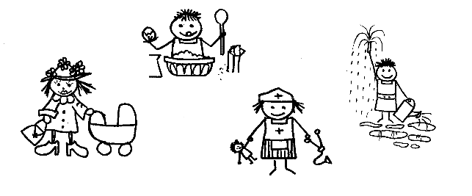We place a great deal of emphasis on this particular area because it is at the heart of all other learning. It takes into account the individuality of each child and the need for time and space to develop fully. During their time in Reception the children will grow in self-confidence. They will be encouraged to do things for themselves, look after equipment in class and learn to find their own way around the school.

2. Communication and Language

Speaking and listening forms a vital part of the children’s daily experience. Children learn to interact with others; listen attentively; speak clearly & audibly. They will explore the meanings of new words and use talk to organise and clarify their thinking and ideas. The children will listen to and follow instructions. They will develop such skills in a variety of ways including whole class sessions, circle time, news, role play, storytelling, reciting rhymes etc.

3. Physical Development



The children will enjoy a variety of activities, both inside and outside, aimed at improving their skills of co-ordination, control, manipulation and movement. The children learn about what they need to do to keep themselves healthy.

4. Literacy

Reading:

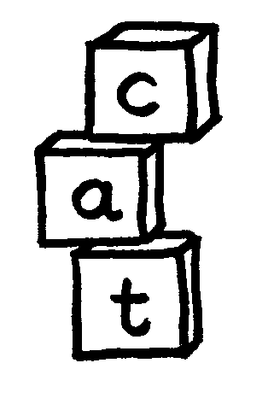We learn the sounds of letters through the Read Write Inc scheme, which introduces a new letter every day through stories and actions. Emphasis is placed on the phonetic sound each letter makes e.g. "a" as in apple (not apron); "c" as in cat (not cedar). This leads to a good foundation of sounds to assist the children in their reading and word building. The children also learn the alphabetic names of each letter.

Writing:

We teach the children to write with a good pencil grip. They are encouraged to attempt their own writing (lists, cards etc.) from an early age. The children also practise many skills to help strengthen and develop muscular control, including Disco Dough and other fine motor skills activities. If your child writes at home, please encourage them to use the correct pencil grip as bad habits can be hard to break.

5. Mathematical Development

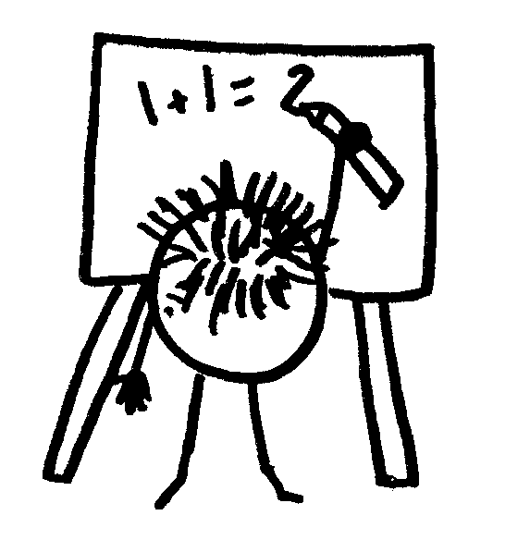We will develop your child’s mathematical

knowledge and skills through varied practical

activities including counting, sorting, making

patterns, games, early addition and subtraction, shape, money, measuring, weighing and capacity.

6. Understanding of the World

This area focuses on children’s developing knowledge and understanding of their environment, other people and features of the natural and man-made world. It provides the foundation for scientific, technological, historical and geographical learning. Most of the work is covered through topics such as “All about me”, “People who help us”, “Habitats” and the celebration of different festivals.

7. Expressive Arts and Design

The children are given many opportunities to explore and express their own ideas through art and design, movement, drama, music, stories and role-play. Many of their ‘creations’ will be displayed in the classroom.

We have qualified and Montessori based practitioners at Parkfield who will use the Montessori materials and ethos intertwined with the curriculum in the children’s daily learning activities.

The staff at Parkfield School will always be ready to answer any questions you might have as well as offer any support that you may need.

Helping in school

We would greatly appreciate your help in school. Below are listed just a few ways in which your help would be invaluable.

Please collect a form from the office if you think you are able to spare us a little time either occasionally or on a more regular basis.

1. Sending us useful materials i.e. card, paper, wool, ribbon, buttons etc.

2. Accompanying teachers and children on educational visits.

3. Helping with fund raising. You may wish to join the ‘PFA’ parents group. They always welcome extra members

Working Together

Your child will bring a book and a Reading Record home each day. There is an expectation that parents will read regularly with their children. Your help with reading is invaluable and ten minutes reading time in a quiet, calm atmosphere will make a tremendous difference to your child’s progress. It does not have to be the school reading book. Children can learn to read whilst looking at magazines, newspapers, comics, menu’s etc. The choice of reading materials are endless!

We welcome your comments in the Reading Record which is a valuable link between home and school. Please make sure your child brings the book back to school every day. If your child does not read their book in school on a particular day do not worry. The reading book is only one of the many reading activities that take place during the school day.

You will be invited into school twice a year to discuss your child’s progress and you will receive a written report in the summer term.

We are really pleased that you have chosen our school for your child and we will do our very best to ensure that your child’s stay with us is happy, fulfilling, and successful. We look forward to working in partnership with you.

Kind Regards

Parkfield EYFS Team