

Week 1 Home Learning Tasks

 | Task | Success criteria | Please complete the tasks in sequential order.
Literacy | Revise colons | Use colons between clauses  Use colons in a list | In this SPaG lesson you are going to revise how to use colons. Watch the video to help you before you begin.  https://www.youtube.com/watch?v=MNSrrIA8qoI  TOP TIP: remember that colons can be used after a main clause to add extra information e.g. Miss Wilcox enjoys desserts: ice-cream, cheesecake and banana cake.  Now complete the colon sheet. You may choose which level you want to complete. The levels are as follows:  D – Easy  E – Expected  GD – Hard | Extension: try and create your own colon sentences. Try and explain to someone at home how you have used the colon to separate the two clauses.
Literacy | Research into DDay | Find out what it what, where, why and when. | One of the main events in WW2 was DDay. Please read the powerpoint or watch the link https://youtu.be/WdpzPMPGa5Q and write notes on the following areas:  -What was DDay?  -Where did it take place?  -Who was involved in the attack?  -Why were the Allies attacking the Germans?  -What happened by the end of this military operation? | Extension: research some other interesting facts about this event.
Literacy  cy | Describe a setting | Use full sentences  Use double adjectives to describe detail.  Use hyphens  Use year 5/6 spelling words. | Children to look at the photograph below and play the following sound score of DDay landings. https://youtu.be/wqGVh7ODu7I  Tips to help you:  Use the sentence openers to describe how they may have felt as a soldier.  Use the adjective word mat in your learning pack to help you with your description. | Extension: Create a list of key vocabulary words that you can use to describe this event. Could you use a thesaurus to help you find some new interesting vocabulary?  If you do not have a thesaurus, you can use the following online thesaurus https://www.thesaurus.com/browse/kid
Literacy | Plan a letter | Informal language  (contractions and I or we)  Emotive language  Conjunctions  Colon in a list | Imagine you are a soldier who has survived the first attack on the beach at Normandy landings. Imagine you are hiding in a secret location and want to describe to someone back home what you have seen and experienced.  Tips to help you:  - Watch the 2 help videos Miss Wilcox has made on writing a letter.  https://www.youtube.com/watch?v=Y0f28U5dgtw  https://www.youtube.com/watch?v=id_JPexYFj8  - Read the model of the letter on DDay landings to help you.  - Use the planning sheet to help you write your plan. | Extension: use a thesaurus to add interesting vocabulary to your vocab box on the planning sheet.
Literacy | Write a letter  This piece is a submission piece which can be sent to your teachers for marking on | Informal language  (contractions and I or we)  Emotive language  Conjunctions  Colon in a list  Adverbials | Watch the 2 videos Miss Wilcox has made called Diary videos. Imagine you are a soldier who has survived DDay landings and is hiding in a secret location. You might be a soldier who has come in by ship or as a paratrooper.  Using the model version, try and write your own letter to someone who is back at home. Think about the following:  An introduction explaining that you are safe  Where you hiding at the moment.  What horrific things you saw when you were fighting.  Where you are going next. | Extension: add an extra paragraph to explain something you miss from back home.
Literacy | Edit and improve a letter | Reread your work  Edit and improve your work | Reread your letter and think about using a different colour pen or pencil to improve the following:  -spellings  -find more interesting words  -add in an extra conjunction  -use a colon in a list  -use 2 fronted adverbials to start your sentences or paragraphs | Extension: act out your letter to someone at home. Think about your use of voice and how you can exaggerate any exclamation sentences. Extension
Reading | Read and answer questions | Read a text.  Skim read the text to find the answers. | Read the non-fiction text about DDay landings. Use the text and answer the questions that follow.  You may choose which level text to complete. The 1-star sheet is the easiest and 3-star is the hardest.
Spellings | Revise spelling words |  | 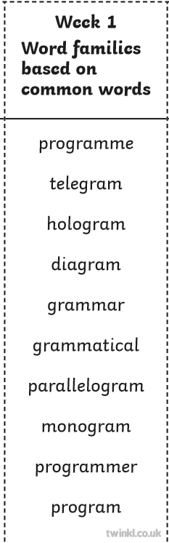
Maths | Day 1  Please look at the worksheet and supporting documents attached. | 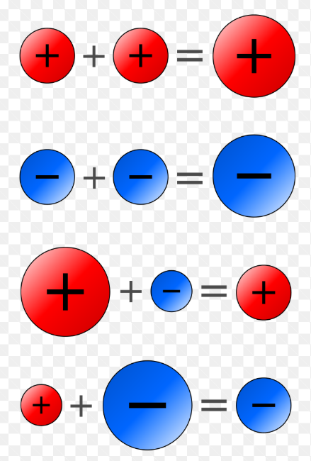 | Day 1 – Negative Numbers  Section A  Miss Wilcox’s Group  Section B  Miss Wilcox’s Group (challenge)  Miss Dunn’s Group (to build confidence)  Section C  Miss Dunn’s (challenge)
Maths | Day 2  Please look at the worksheet and the example provided on the sheet for support | A number that may be divided by another a certain number of times without a remainder | Day 2 – Multiples  Section A  Miss Wilcox’s Group  Section B  Miss Wilcox’s Group (challenge)  Miss Dunn’s Group (to build confidence)  Section C  Miss Dunn’s (challenge)
Maths | Day 3  Use the worksheet and link to support lesson | Prime numbers are special numbers that can only be divided by themselves and 1. | Day 3 – Prime numbers and factors  https://www.bbc.co.uk/bitesize/topics/zfq7hyc/articles/z2q26fr - supporting video  Section A  Miss Wilcox’s Group  Section B  Miss Wilcox’s Group (challenge)  Miss Dunn’s Group (to build confidence)  Section C  Miss Dunn’s (challenge)
Maths | Day 4  Use worksheet and supporting videos Miss Dunn has added | Use knowledge of common factors and multiples to simplify fractions | Day 4 – Simplifying Fractions  Section A  Miss Wilcox’s Group  Section B  Miss Wilcox’s Group (challenge)  Miss Dunn’s Group (to build confidence)  Section C  Miss Dunn’s (challenge)
Maths | Day 5  Use worksheet and supporting resource to explain how to find equivalent fractions | - You can make equivalent fractions by multiplying or dividing both top and bottom by the same amount.  - You only multiply or divide, never add or subtract, to get an equivalent fraction.  - Only divide when the top and bottom stay as whole numbers. | Day 5 – Equivalent Fractions  Section A  Miss Wilcox’s Group  Section B  Miss Wilcox’s Group (challenge)  Miss Dunn’s Group (to build confidence)  Section C  Miss Dunn’s (challenge)
Science | Understand refraction | Understand what is refraction.  Investigate how refraction happens.

