Year 2
Awesome Oceans
Week One | Week Two | Week Three | Week Four | Week Five
WALT: Understand where our oceans are  Use the map below to label the continents and the oceans  THIS IS THE PIECE OF WORK I WOULD LIKE YOU TO SUBMIT FOR MARKING BY 27th APRIL  Research one fact about each ocean i.e. what lives in the ocean, how big is it? | WALT: Understand what is happening to our oceans  Research what is happening to our oceans either online or watch these videos.  https://www.bbc.co.uk/newsround/31469290 https://www.youtube.com/watch?time_continue=52&v=Our5CZz5qoU&feature=emb_logo  Record your research as a mind map (which is the same as a story map), or bullet point list. | WALT: Create a poster, model or animation  - Use your research from last week to create a model of the oceans or a poster  - The model or poster should show the problems with plastics in the oceans.  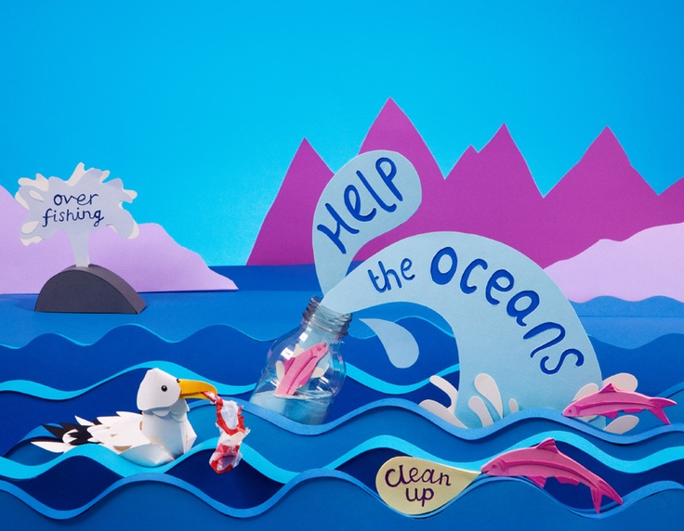  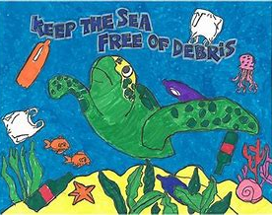 | WALT: Create a news report  What can people do to stop plastic in our oceans?  Use your own ideas and if you would like the ideas below in the poster.  Create your own news report (you can film this) to tell the rest of your class:  - What damage plastic is doing to our oceans.  - What they can do to stop this happening. | WALT: Create something amazing  Keep the plastic you have used this week, for example, your milk cartons. Make something amazing from your saved plastic.  Below are 10 ideas of what you can make.
Summer 1 – Environmental Studies

Week One
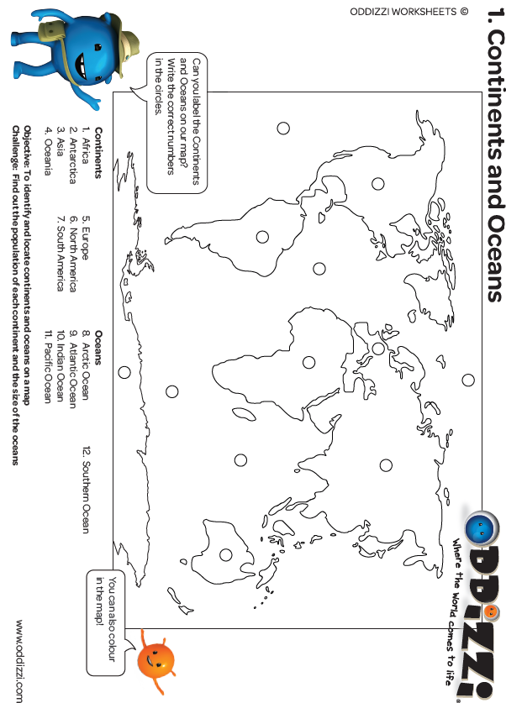

Week Two
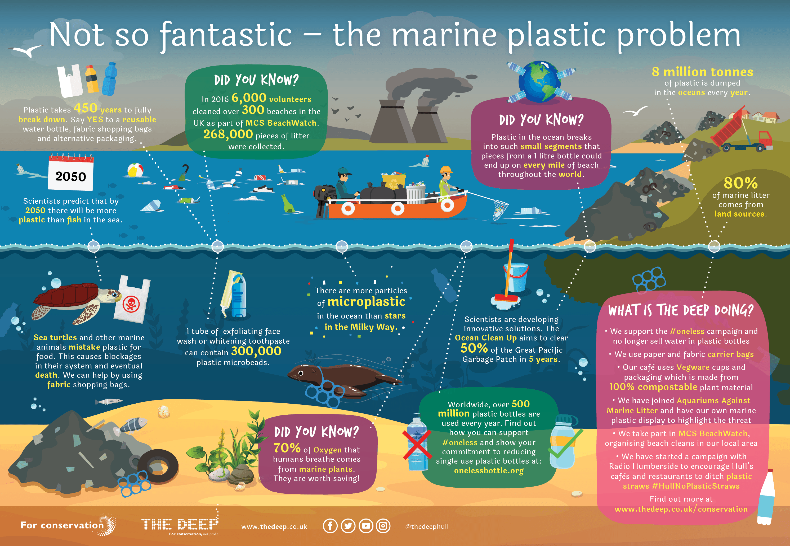

Week Four
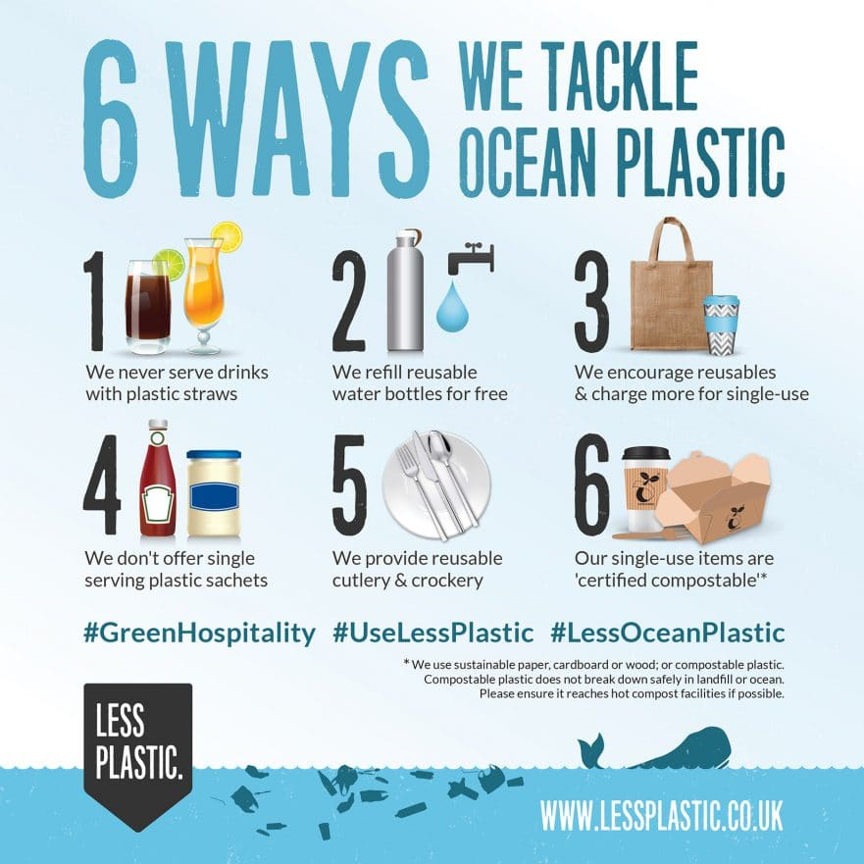

Week Five
