Please complete and bring this booklet to school in September for your new teacher.
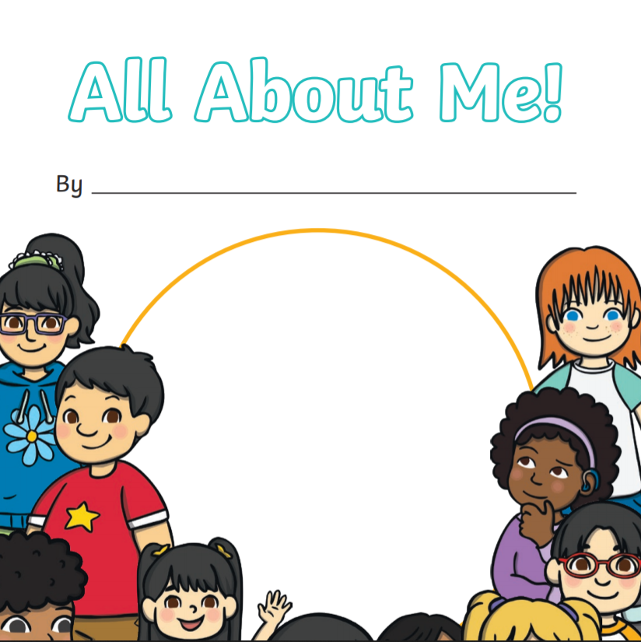

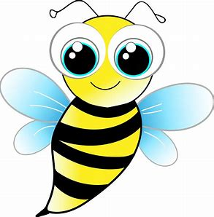

Describe your family and what you like to do.
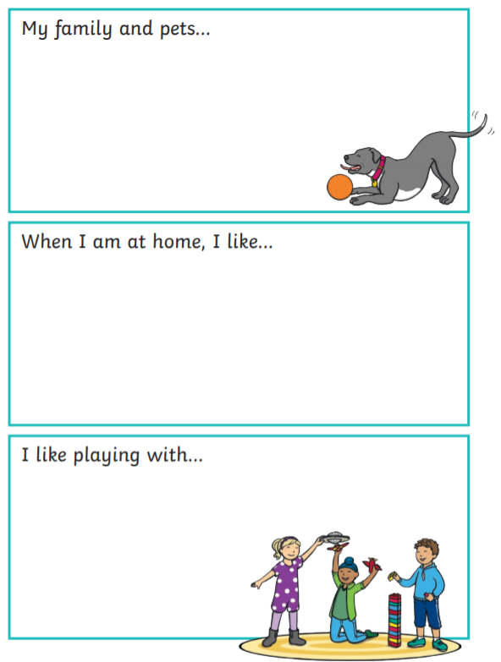
Draw your family.
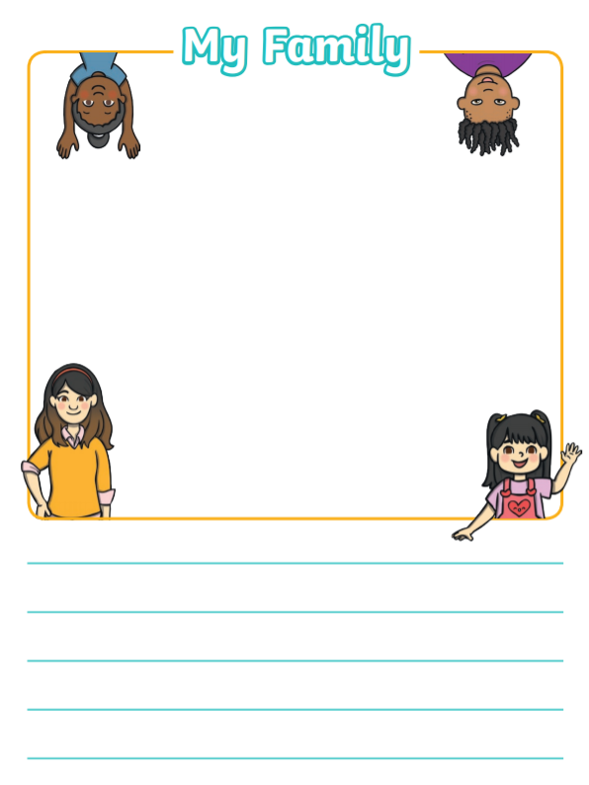
What is your favourite toy and why? Draw it. Describe it.
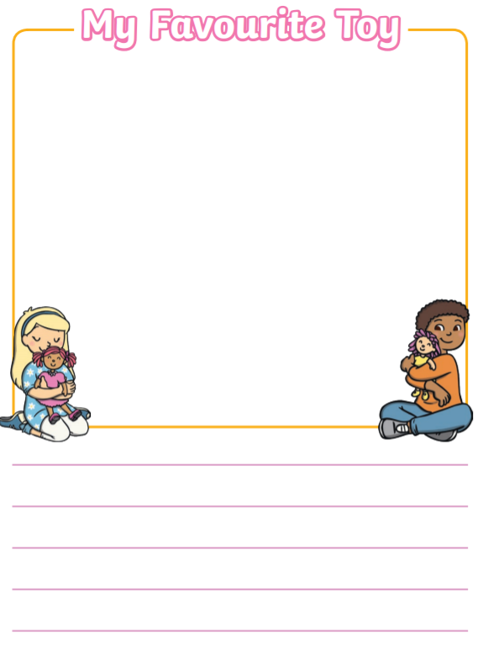
Tell us about “...”.
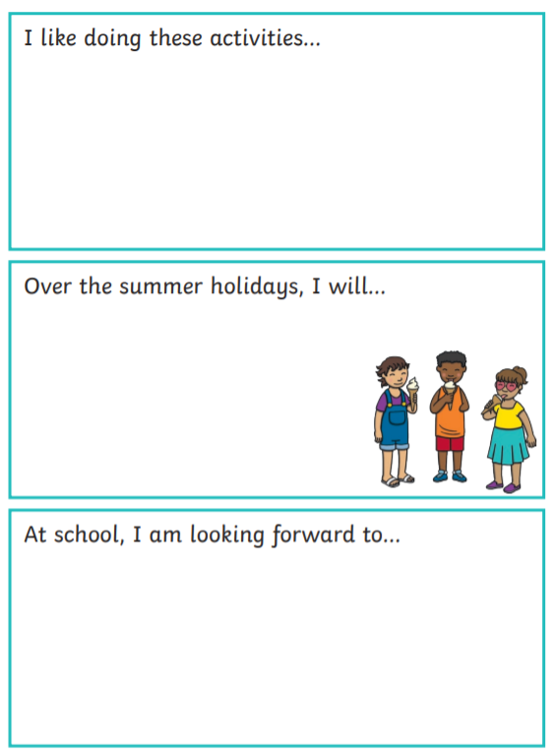
Draw it and explain why it was fun!
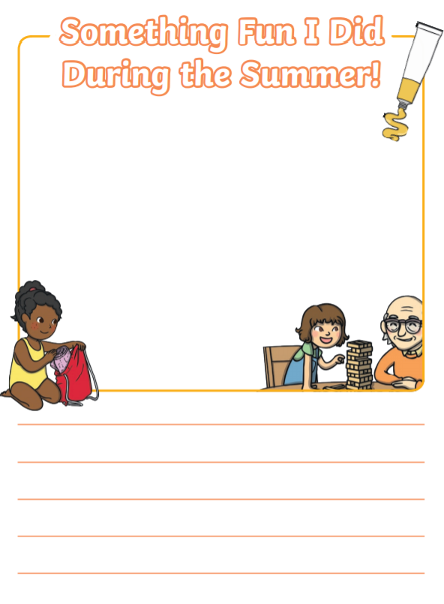
Draw it and explain why.
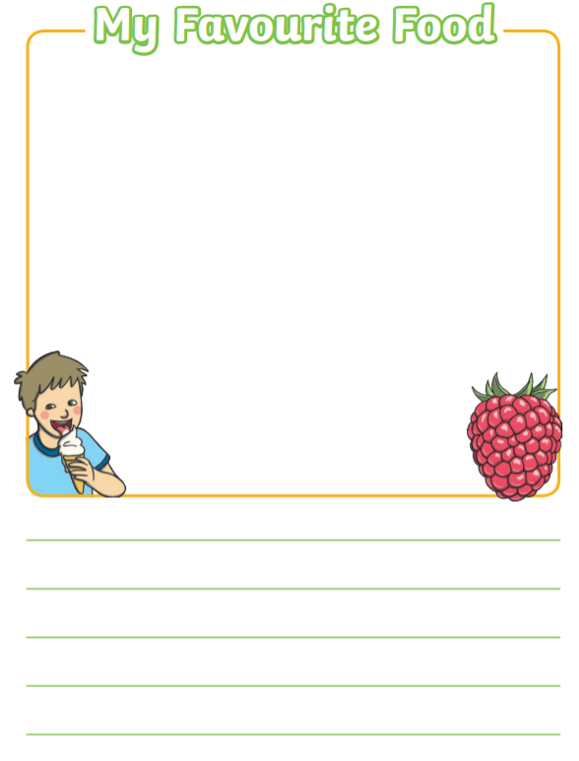
Draw something about your favourite book. Explain why it is your favourite book.
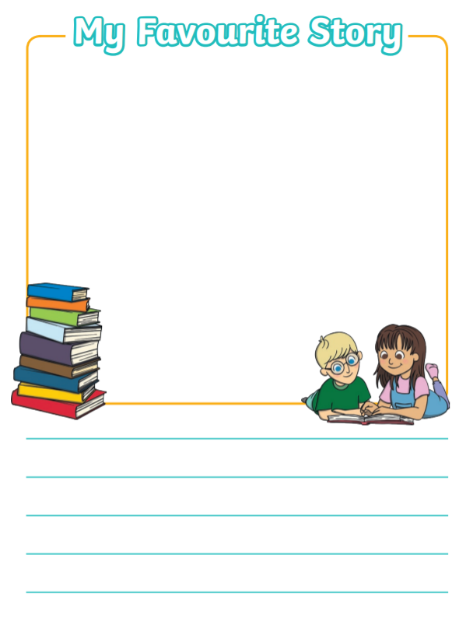
Draw something about your favourite film. Explain why it is your favourite film.
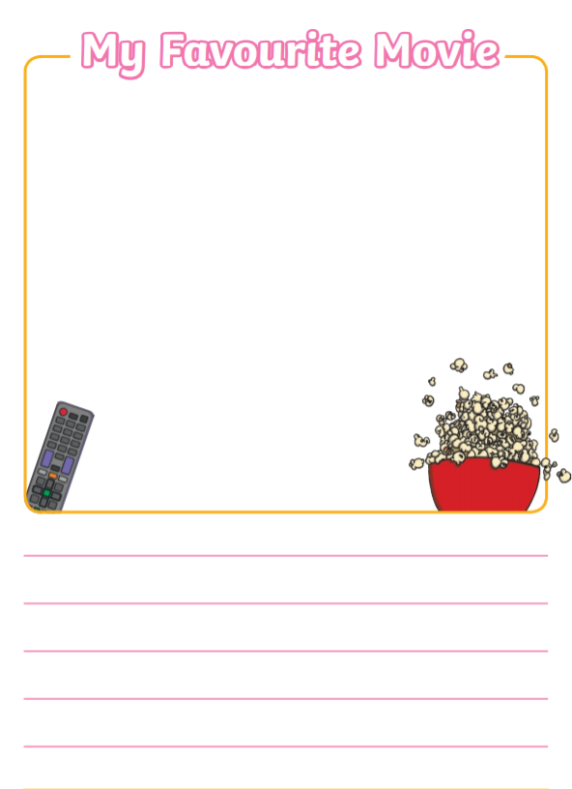
Draw a special picture for your new teacher!
The End.
Pick and choose any activities you would like to do during your holiday.

Activities | Resources
Sink and float.  Understand the vocabulary.  Experiment, observe and answer.  What is the object made from?  Does it sink? Why?  Does it float? Why?  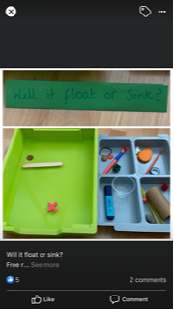 | A large tray  Items made from different materials  (plastic, fabric, wood, metal)  Extension:  Make a poster about the experiment.  Label it.  Write a fact.
PowerPoint  The food chain.  Understand the vocabulary.  What is a producer?  What is a consumer?  What is a predator?  Discuss about it and create a food chain using different resources.  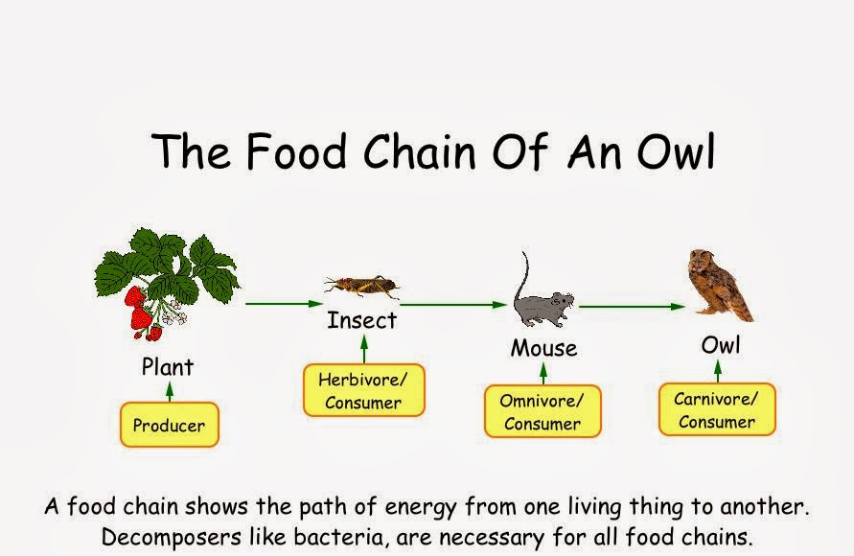 | Leaves  Sticks  Stones  Clay  Extension:  Classifying cards:  -Omnivore, herbivore, carnivore.  -Producer, consumer, prey, predator. 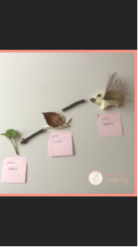
Physical properties- (Water)  Liquid to solid – Freezing  Experiment observe and answer questions.  Use different containers and feel them up with water.  Put them in the freezer for three hours. You can add some flowers or leaves.  Questions:  What happens to the water after being in the freezer for a long period?  What happens if you put the ice under the warm sun?  What happens when the water boil?  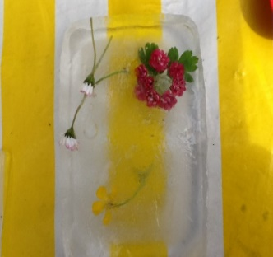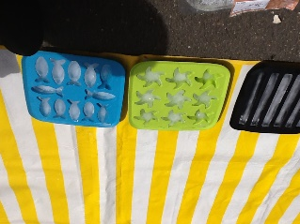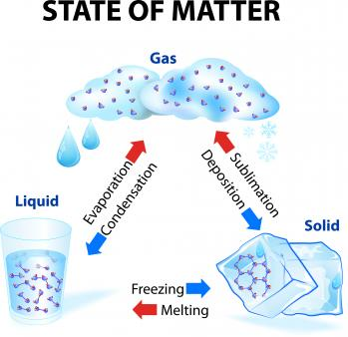 | Water, containers, leaves or flowers.  Extension:  Use key words; melt, liquid, evaporate, gaz.  Draw the experiment and your findings.  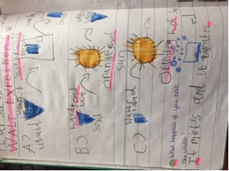  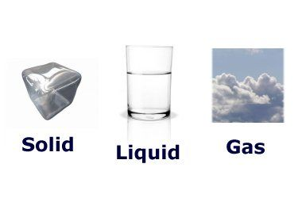
Paint  Paint a flowery tree. Use your finger to paint the trunk and branches. Use the botoom of a plastic bottole to paint the flowers. Choose the colour you want.  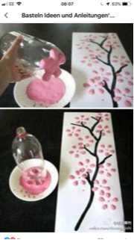 | Brown paint  Pink, yellow, light green paint  Plastic bottles  A4 or A3 paper  Extension:  Create a tree using the same technic.  Use different colours.
Make lamds  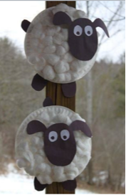 | Carton plate  Cotton whole  Black paper  White paper  Extension:  Draw the sheep and label it.  Write sentences and describe it.
Make a rainbow tree  Glue some green tissue paper at the bottom of the page.  Paint the tree trunk and branches.  Cut out butterfly using the line of symmetry.  Fold a paper in two and cut it (half a butterfly)  Stick one side of the butterfly.  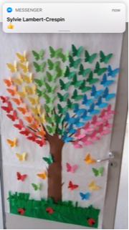 | Coloured paper  Tissue paper  Glue  Brown paint  White A3 paper  Extension:  Use some hearts shapes of different colours.  Use your imagination and create your own shapes.
Create flowers  Use paint.  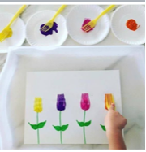 | Paint  Forks  Extension:  Use your imagination and create different flowers.
Rainbow leaves  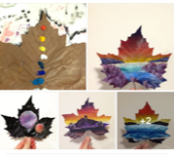 | Dry leaves  Paint  Extension:  Create some view from space.
Lady bird or butterfly - Shaker | Cylinder (Tin/ carton roll)  Red paint/ red paper  Black paint/ black paper  Carton  Black paper  (rice or buttons or pasta, anything to make noise inside the shaker)
Make a rabbit with junk modeling | Carton toilet roll  Stickers  Coloured paper or paint  Sticky eyes  Extension:  Create other animals
Create a diorama of the North Pole  Powerpoint  Discuss about the North Pole landscape.  Discuss about the animals that live there.  Use different materials to represent the landscape and the animals.  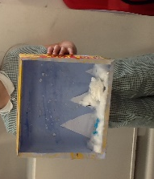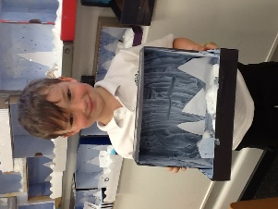 | Shoe box  Blue paint  White paper  Cotton whole  Extension:  Write a poster about the Artic.  What animals live there?  What is the habitat like?
Create your portrait using plants and flowers.  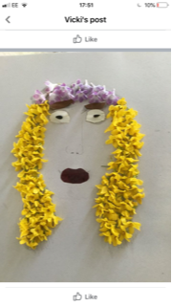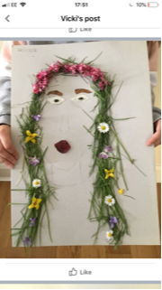 | PVC glue  Outdoor plants and flowers  Extension:  Create portrait of one member of your family or a friend.
Make a 5,4,3,2,1 cake  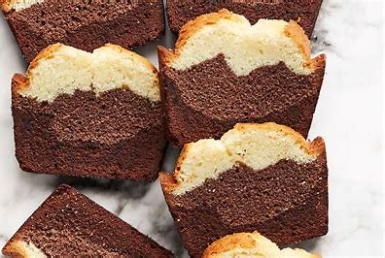  See Parkfield Facebook video for instructions.  In a large bowl, put the flour, add the sugar, add the milk and mix it with a whisk. Add the oil, mix it, add the egg, mix it (Do not forget to crack the egg!), add the baking powder and mix it. Put some of the mixture in another bowl, add the cacao powder (You can add an extra TBSP, if you like it very chocolaty.) Add the vanilla extract in the other mixture. Butter the tray and pour the vanilla mixture, then pour in the middle the chocolate mixture. With a chop stick or spoon put it in the middle and go from one side to the other and go back making zigzag shapes. Ask an adult to warm up the oven for 10 minutes at 170 C and them place the tray in the middle of the oven for 25 to 30 minutes. Ask the adult to check if its cook using a knife (if the there is a sticky residue then you need to cook it for a bit longer). | 5,4,3,2,1 cake ingredients:  5 cups of plane flour  4 cups of sugar  3 cups of milk  2 cups of vegetable oil  1 egg  1 TBSP of baking powder  2 TBSP of cacao powder  1 TSP of vanilla essence  Utensils:  1 large bowl  1 small bowl  1 cup  1 teaspoon  1 tablespoon  1 whisk  Oven

