Parkfield School
Year 10 assessment 2

Marks _____
53

60 minutes
CALCULATOR

Q1.
Here is a rectangle.
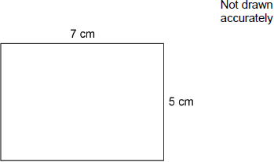
Work out the perimeter.
Circle your answer.
12 cm 24 cm 35 cm 70 cm
(Total 1 mark)
Q2.
Lucy works for 37 hours per week.
Her weekly wage is £303.40
She receives a pay increase of 25p per hour.
Work out her new weekly wage.
_______________________________________________________________________
_______________________________________________________________________
_______________________________________________________________________
Answer £ _________________________________________
(Total 2 marks)
Q3.
Circle the number greater than –0.9
–0.901 –0.89 –0.91
(Total 1 mark)
Q4.
Simplify 8x − 3 + 6x
Circle your answer.
2x − 3 11x 5 + 6x 14x − 3
(Total 1 mark)
Q5.
Here is a list of ingredients needed to make 6 pancakes.

Flour | 120 grams
Eggs | 2
Milk | 210 millilitres
(a) Complete the list of ingredients needed to make 9 pancakes.

Flour | ___________________
Eggs | ___________________
Milk | ___________________
(3)
(b) Convert 210 millilitres to fluid ounces.
Use 1 fluid ounce = 28.4 millilitres
Give your answer to 1 decimal place.
___________________________________________________________________
___________________________________________________________________
___________________________________________________________________
Answer _________________________________________ fluid ounces
(2)
(Total 5 marks)
Q6.
There are 240 cows on a farm.
(a) On the farm,
number of bulls : number of cows = 1 : 30
How many bulls are there?
___________________________________________________________________
___________________________________________________________________
Answer _________________________________________
(1)
(b) Assume
the 240 cows produce milk for 10 months each year
each cow produces an average of 25 litres of milk per day.
Estimate the total milk production, in litres, of the 240 cows in one year.
You must show your working.
___________________________________________________________________
___________________________________________________________________
___________________________________________________________________
___________________________________________________________________
Answer _________________________________________ litres
(4)
(Total 5 marks)
Q7.
An approximation for the value of π is given by
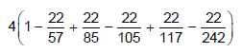
Use your calculator to show that this approximation is within 0.1 of 3.14
_______________________________________________________________________
_______________________________________________________________________
_______________________________________________________________________
_______________________________________________________________________
(Total 2 marks)
Q8.
The first four terms of a linear sequence are
7 11 15 19
Circle the expression for the nth term.
n + 6 4n + 3 7n + 4 n + 4
(Total 1 mark)
Q9.
What does (A ∩ B) represent in P(A ∩ B)?
Circle your answer.

A or B or both | A but not B
not A and not B | A and B
(Total 1 mark)
Q10.
A company uses this formula to work out the cost, £A, of a taxi ride.
A = 4 + 1.8m + b
£4 is a fixed charge
m is the number of miles travelled
£b is a charge for booking online
(a) Clare books a taxi online and travels 8 miles.
She pays £20 altogether.
How much is the charge for booking online?
___________________________________________________________________
___________________________________________________________________
___________________________________________________________________
___________________________________________________________________
Answer £ _________________________________________
(3)
(b) A different company
has a fixed charge of £3
charges £1.90 per mile
has no charge for booking online.
Write a formula for the cost, £C, of a taxi ride with this company.
Answer £ _________________________________________
(1)
(Total 4 marks)
Q11.
Lee wants to draw the graph of y = x for values of x from –5 to 5
Here is his graph.
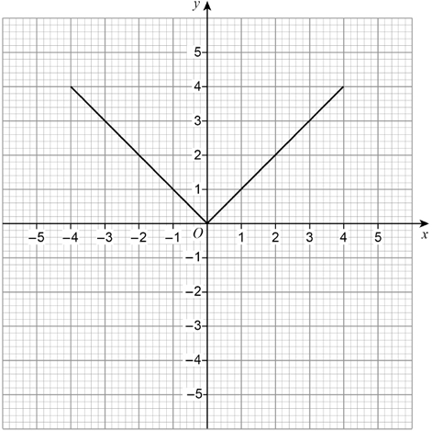
Make two different criticisms of his graph.
Criticism 1 ______________________________________________________________
_______________________________________________________________________
Criticism 2 ______________________________________________________________
_______________________________________________________________________
(Total 2 marks)
Q12.
A charity sends an appeal letter to 3000 people.
The letter asks for a donation of money.
Here is some information about the last appeal letter the charity sent out.

of the people who were sent the letter made a donation.
The average donation was £8.60
of the people who made a donation filled in a tax form.
The government adds 25% to the donations of these people.
(a) Using this information,
work out the amount the charity can expect to receive from this appeal.
___________________________________________________________________
___________________________________________________________________
___________________________________________________________________
___________________________________________________________________
___________________________________________________________________
Answer £ _________________________________________
(6)
(b) The average donation from the people who filled in a tax form was more than £8.60
How does this affect your answer to part (a)?
Tick one box.

It should be lower
It should be higher
It should stay the same
Give a reason.
___________________________________________________________________
___________________________________________________________________
(1)
(Total 7 marks)
Q13.
What is the angle of turn clockwise from South West to East?
Circle your answer.
45° 135° 225° 315°
(Total 1 mark)
Q14.
Each side of a square is made 3 times as long.
What happens to the perimeter?
Circle your answer.
×3 ×6 ×9 ×12
(Total 1 mark)
Q15.
The table shows the number of messages Sam received each day for five days.

 | Messages
 | Number of emails | Number of texts
Monday | 12 | 5
Tuesday | 8 | 6
Wednesday | 10 | 3
Thursday | 6 | 6
Friday | 12 | 4
(a) Sam draws a composite bar chart to represent the data.
He has drawn the bar for Monday.
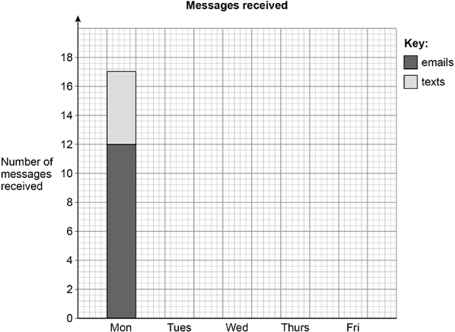
Complete the chart.
(2)
(b) In total, what fraction of the messages were emails?
Give your answer in its simplest form.
___________________________________________________________________
___________________________________________________________________
___________________________________________________________________
___________________________________________________________________
___________________________________________________________________
___________________________________________________________________
___________________________________________________________________
Answer _________________________________________
(3)
(Total 5 marks)

Q16.
(a) Complete the bank statement.

Date | Description | Credit (£) | Debit (£) | Balance (£)
01/09/18 | Starting balance |  |  | 1140.79
06/09/18 | Car repairs |  | 256.00 | _________
17/09/18 | Gas bill |  | 87.31 | _________
24/09/18 | Salary | 2069.75 |  | _________
(3)
(b) Write down the meaning of ‘Debit’ as used in the bank statement.
___________________________________________________________________
___________________________________________________________________
___________________________________________________________________
(1)
(Total 4 marks)
Q17.
Line AB is shown on the grid.
A is the point (0, 2)
B is the point (6, 5)
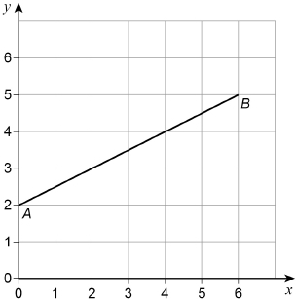
(a) Work out the coordinates of the midpoint of the line AB.
Answer ( ________ , ________ )
(1)
(b) C is another point on AB. C is closer to B than to A. The coordinates of C are whole numbers.
Work out the coordinates of C. Answer ( ________ , ________ )
(1)
(c) On the grid, draw a line from point (0, 0) that is
parallel to AB
and
two thirds as long as AB.
(2)
(Total 4 marks)
Q18.
Lena is at the gym.
(a) She will use each of these pieces of equipment once.

Rowing machine (R) | Stepper (S)
Treadmill (T) | Bike (B)
Lena will use the rowing machine first.
List all the possible orders in which she could use the four pieces of equipment.

(2)
(b) The table shows how long Lena spends on each piece of equipment.

Rowing machine | 15 minutes
Stepper | 13 minutes
Treadmill | 35 minutes
Bike | 1 hour 30 minutes
Lena starts on the rowing machine at 1.50 pm
She has a break for 4 minutes between pieces of equipment.
What time does she finish on her last piece of equipment?
___________________________________________________________________
___________________________________________________________________
___________________________________________________________________
___________________________________________________________________
Answer _________________________________________
(3)

