More about Materials – Selecting Materials -Section 3 – AQA GCSE
When selecting materials you need to think about the factors below.
Using google, technologystudent.com, BBC bitesize, explain how. Imagine you are making the product to sell.
You might need to find out the meaning first.
Functionality: What does this mean? Why is it important to know whether the material is functional?

Availability: What does this mean? Why is it important to know if the materials are widely available?

Aesthetics: What does this mean? Why is it important for a material?

Cost of materials: Why do you need to consider the cost of the materials?

Environmental factors: What does sustainable mean? What does biodegradable mean? Name the 6 R’s. what do they mean?

Social Factors: What are fairtrade materials?

Ethical Factors: What are ethically sourced materials?

Cultural Factors: What cultural factors do you have to take into account when designing a product?
Forces and Stresses – Section 3 – AQA GCSE
Forces and stresses are part of everyday life. Objects are designed to cope with different forces, in some cases they can used them to their advantage. Forces can cause objects to break or change shape.
Materials are strong if they are good at withstanding force without breaking. Force is measured in Newtons.
Find out about these different types of forces and stresses, using google, technologystudent.com, BBC bitesize :
Tension: What is tensile strength? Give two examples.

Compression: What is this? Give two examples.

Shear: What does this mean? Give two examples.

Bending: What type of force is this?

Torsion: what does this cause objects and materials to do?

Materials can be reinforced to help resist certain forces, they can also be made to be more flexible. Find out about these different processes:
Lamination: What does this mean. Give two examples and explain how it improves the material.

Interfacing: What does this mean? How does it improve the material? Give two examples.

Webbing: What is it? What does it do? Give two examples.
Scales of Production – Section 3 – AQA GCSE
The Scale of production is how many of a product you want to make. You would decide on the most suitable for the job. The rarer four main types you need to know about.
Find out about these different types of production, using google, technologystudent.com, BBC bitesize :
- One off production: Explain what this is and give an example.

- Batch Production: Explain what this is, what is the advantage over one off production? Give an example.

- Mass Production: Explain the type of process. Give an advantage and two examples.

- Continuous Production: Explain the process. How does it differ from mass production? Give an advantage and an example.

Quality Control: This ensures that products are manufactured to a high enough standard. This done by testing materials or products are every stage of the manufacturing process.
Find out what tolerance means. Why is this used?

Production Aids – Section 3 – AQA GCSE
Production aids are tools and techniques used to aid production. They often speed up or simplify a process, or to help accuracy.
Find out about these different production aids, using google, technologystudent.com, BBC bitesize :
Templates: What are they used for? What do they help you to do? Give an advantage. How are they used in quality control of a product?

Patterns: What materials are they usually used for? What are they normally made of? In industry how are the patterns made?
How are patterns used in casting and what materials would the pattern be made from?

Jigs: What is this used for? Find out about and give one example.

Production of Materials - Section 3 - AQA GCSE
Read through the information on Production of materials and answer the questions below:
- What is pulping?

- What is mechanical pulping?

- What is chemical pulping?

- How is wood dried (seasoned), in order to be cut down for timber?

- How is Medium density fibreboard made?

- How is Chipboard made?

- How is Plywood made?

- Explain the process of metal mining and extraction.

- What is the refining process in metal production? Explain.

- What are most plastics made of? How is it made?
More on the Production of Materials - Section 3 - AQA GCSE
Read through the two pages, More on Production of materials information and answer the questions below:
- What are fibres?

- What are short length fibres called?

- What are long length fibres called?

4. What are natural fibres?

5. How is wool made?

- How is cotton made?

- How is Silk made?

- What are Regenerated Fibres and how are they made?

- What are synthetic Fibres?

- Give two examples of synthetic Fibres
More on the Production of Materials - Section 3 - AQA GCSE
Read through the pages, More on Production of materials information and answer the questions below about how Material Production can impact the environment:
- What problems can cutting down wood for timber, paper or board cause?

- What problems can drilling for oil cause?

- What problems can the mining of metal cause? Give two problems caused.

14. What problems can the farming of natural fibres cause? Give two problems caused.

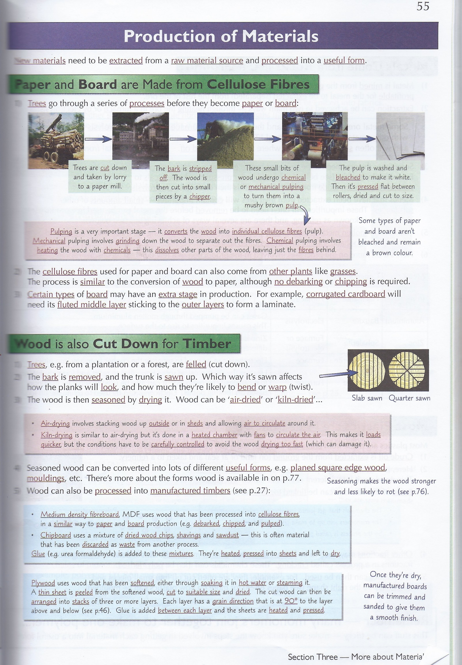
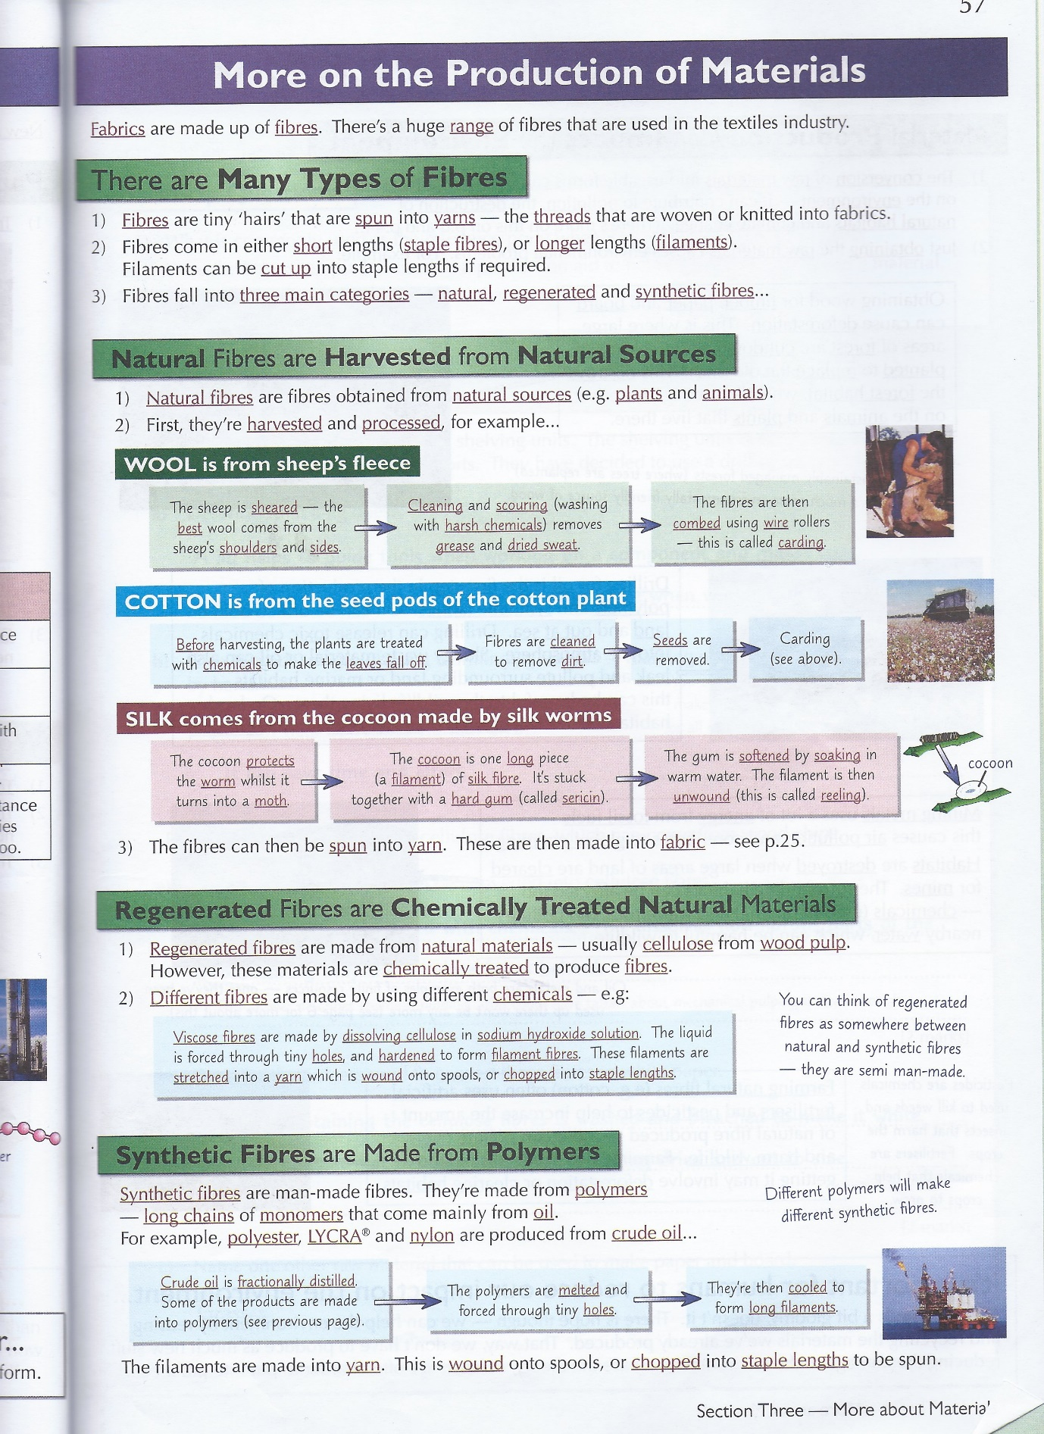
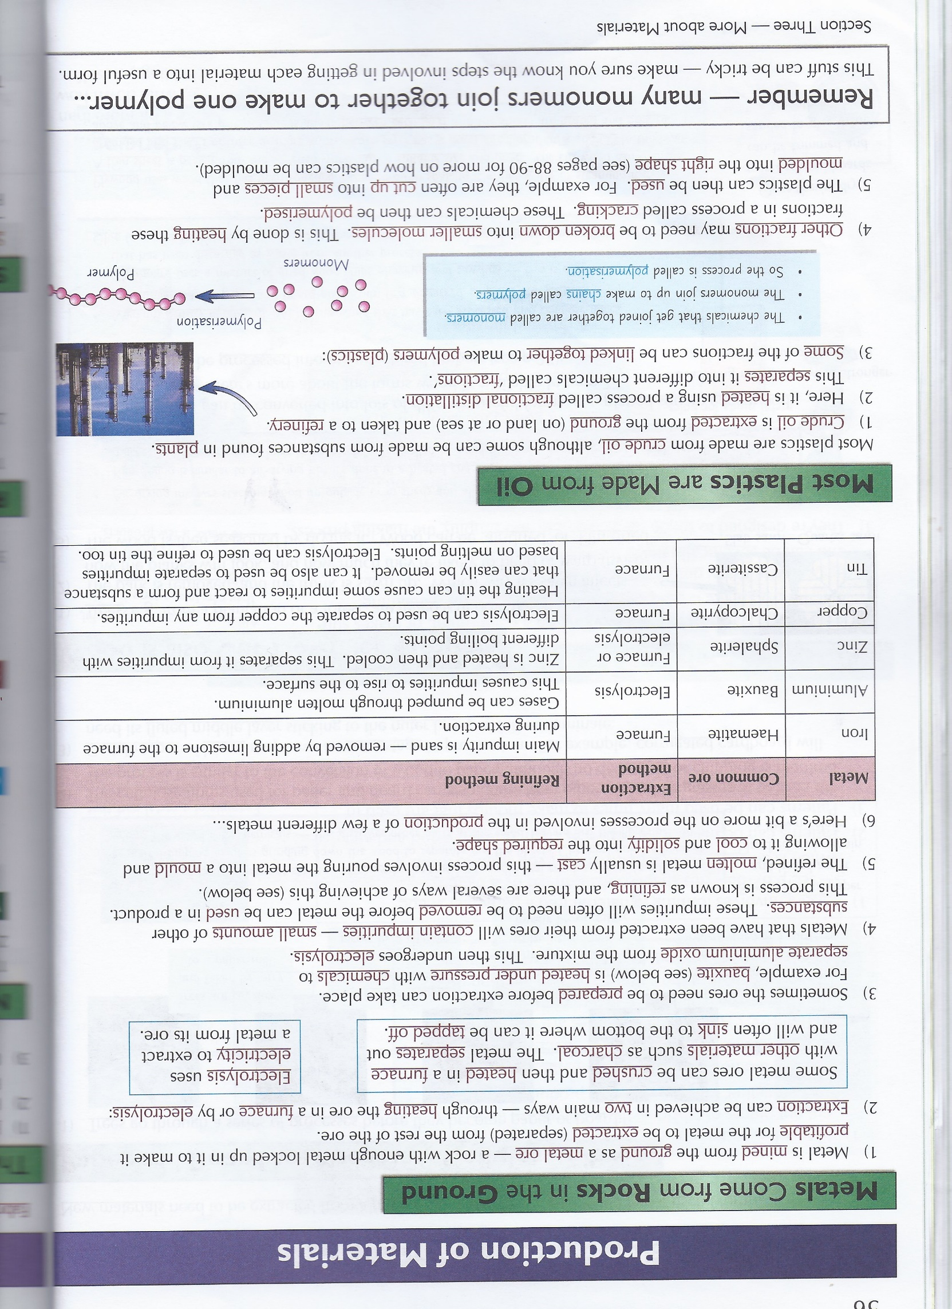
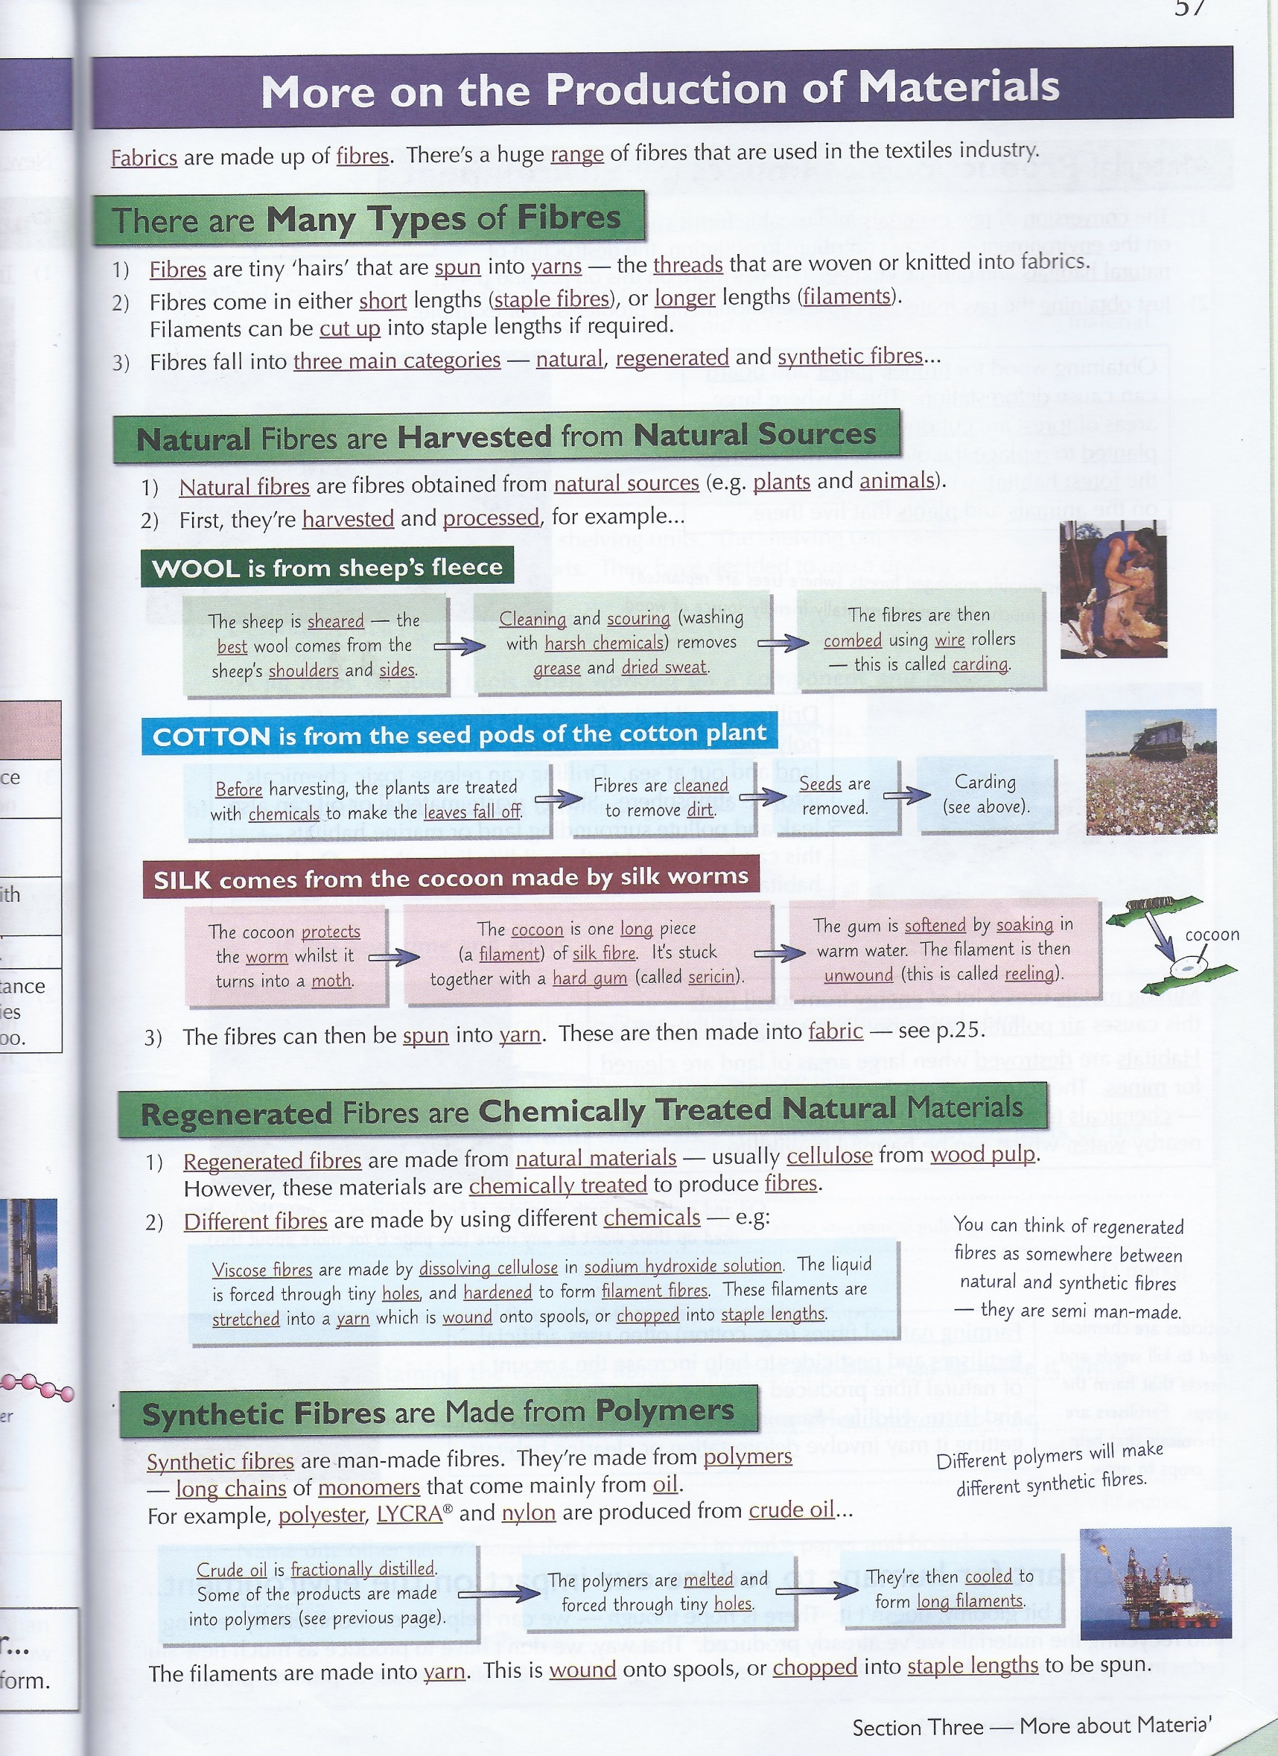

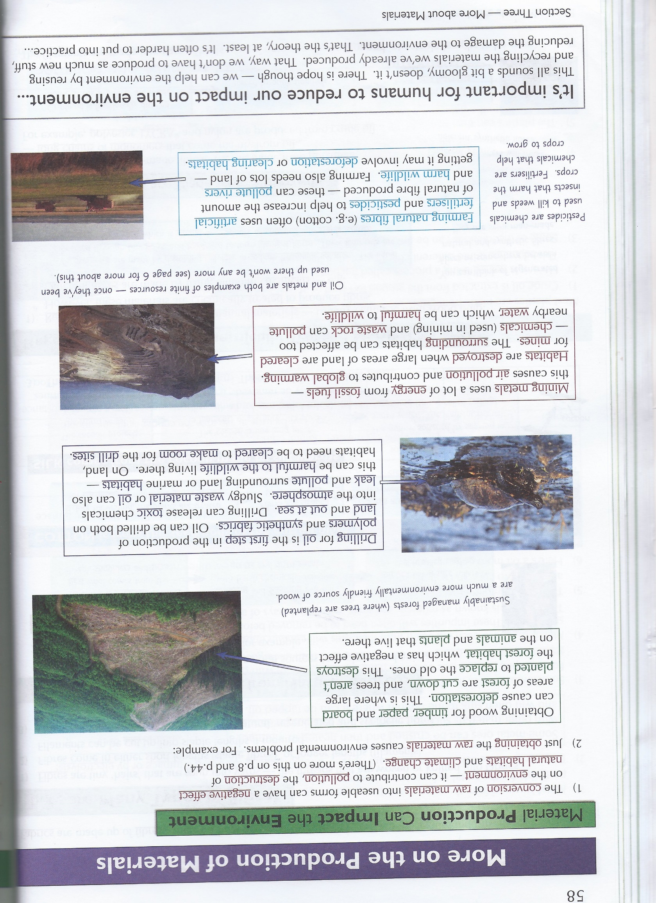

Section 3 Assessment
- What type of force would be used to twist the lid off a jar?

- A company wants to produce 100,000 identical nappies.
- What type of production would be best for this?

- What is the advantage of this type of production when it comes to hiring workers?

2a. What is the purpose of quality control?

- Explain why not all items are checked during quality control.

- Sheets of glass are usually produced by continuous production.
- What is meant by the term continuous production?

- Give one advantage of continuous production

4.The image to the right shows a man in a hammock.
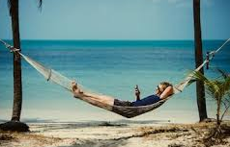
a. Force A acts on the ropes that attach to the hammock due to the weight of the man. Name these two types of force.
Force A:…………………………………….
Force A
Force B:……………………………………..

Force B

b. Some hammock straps are made from webbing.
i) What is webbing?

ii) Why is webbing sometimes used to make hammock straps?

- An outdoor company wants to sell a folding table to be used by campers.
- The designers of the table are trying to select a material for the legs and table top. Give two functional considerations that they should bear in mind.
1…………………………………………………………………………………………………………………………………………….
………………………………………………………………………………………………………………………………………………
2…………………………………………………………………………………………………………………………………………….
………………………………………………………………………………………………………………………………………………
WWW:
- You understand what different types of forces are.
- You understand what the different types of production are.
- You are able to identify the correct type of production for a job.
- You understand what quality control is and why it is necessary.
- Next Steps:
- Find out more about forces that are used in everyday life.
- Find out more about what types of production are used for an everyday household product of your choice.
- Find out what quality control measures are made for an everyday product of your choice.

