Music 3 Due 26th June
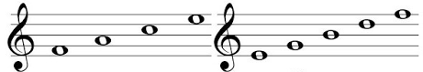
Task 1 - Using what you learnt last term, you need to fill in the notes on the piano score below.

Once you have done that, you need to fill out the name for each of the below notes and how long they last.
TOP TIP – Remember that all notes are in BEATS not seconds.
Name - ………………………………………………….
How long it lasts - ………………………………………………..

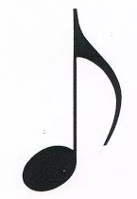

Name - ………………………………………………………….
How long it lasts - ………………………………………………..

Name - ……………………………………………….
How long it lasts - ………………………………………………
Name - ……………………………………………….
How long it lasts - …………………………………………………

Task 2 – Make your own theme tune.
Find different household items that create a different type of noise. Have a play around and see if you can come up with a 16-beat rhythm. If you are able to, please record and send me your rhythm. If not, write down the different items you used and what order you used them in.

You can email me your work on t.bray@parkfield.bournemouth.sch.uk

