AQA GCSE History- BRITAIN: HEALTH AND THE PEOPLE c1000 TO TODAY
Now that we have the foundations of knowledge about Ancient medicine, we are going to start the first part of our GCSE course.

Part one: Medicine stands still
- Medieval medicine: approaches including natural, supernatural, ideas of Hippocratic and Galenic methods and treatments; the medieval doctor; training, beliefs about cause of illness.
- Medical progress: the contribution of Christianity to medical progress and treatment; hospitals; the nature and importance of Islamic medicine and surgery; surgery in medieval times, ideas and techniques.
- Public health in the Middle Ages: towns and monasteries; the Black Death in Britain, beliefs about its causes, treatment and prevention.

10,000 bc- 500ad | 500 - 1500 | 1500- 1700 | 1700-1900 | 1900- today
Ancient | Medieval  Pt 1: Medicine stands still | Renaissance  Pt 2: Beginnings of change | Industrial  Pt 3: Revolution in medicine | Modern  Pt 4

This unit has been divided into lessons, and at the end of each lesson there is an assessment in the form of a quiz or an exam-style question.
These will be put in the assignment section of Teams. Alternatively, you can complete them on paper and send me a copy.

Lesson | Content | Assignment | Due
1 | What was life like in the Middle Ages? | Quiz | 8th June
2 | Why was the Catholic Church so powerful in the Middle Ages? | Exam question | 15th June
3 | How similar was the Islamic world? | Quiz | 22nd June
4 | Did surgery improve in the Middles Ages? | Exam question | 29th June
5 | Who treated the sick in the Middle Ages? | Quiz | 6th July
6 | Case study: The Black Death. | Exam question | 13th July

Britain: Health and the people: c1000 to the present day
This thematic study will enable students to gain an understanding of how medicine and public health developed in Britain over a long period of time. It considers the causes, scale, nature and consequences of short and long term developments, their impact on British society and how they were related to the key features and characteristics of the periods during which they took place. Although the focus of this study is the development of medicine and public health in Britain, it will draw on wider world developments that impacted on the core themes. Students will have the opportunity to see how some ideas and events in the wider world affected Britain and will promote the idea that key themes did not develop in isolation, but these ideas and events should be referenced in terms of their effects on the core theme for Britain and British people.
Students will study the importance of the following factors:
- war
- superstition and religion
- chance
- government
- communication
- science and technology
- the role of the individual (helping/hindering change)

The key questions that we will consider are:-
- Why has there been progress in the health of the British people?
- How and why has the pace and scale of medical development varied at different times?
- What impact has medical progress had on people and society?
- How and why have different factors been more important than others for individual medical developments?
- What is the significance of key individuals or events in the history of medical development?

There are 4 assessment objectives:
- AO1: demonstrate knowledge and understanding of the key features and characteristics of the period studied.
- AO2: explain and analyse historical events and periods studied using second-order historical concepts (continuity, change, cause, consequence, significance, similarity and difference).
- AO3: analyse, evaluate and use sources (contemporary to the period) to make substantiated judgements, in the context of historical events studied.
- AO4: analyse, evaluate and make substantiated judgements about interpretations (including how and why interpretations may differ) in the context of historical events studied.

On the next 2 pages you will find a glossary; you can start to complete this for reference.

GLOSSARY : Britain: Health and the People c1000 to present day.
Alternative medicine
anaesthetic
anatomy
Ancient World
anti-contagionism
antibiotic
antiseptic
aseptic
astrology
bacteria
bacteriologist
barber-surgeon
bloodletting
bubonic plague
Caliph
cauterisation
cholera
contagionism
contagious
diagnosis
dissection
DNA (deoxyribonucleic acid)
emetic
enema
epidemic
Germ Theory
health visitor
Human Genome Project
humours
hunter-gatherer
inoculation
keyhole surgery
laissez-faire
lavatorium
leech
legislation
leprosy
liberal
miasma
microbe
mould
parliament
pharmaceutical industry
philanthropist
pilgrimage
pious
pneumonic plague
positive health
privy
providence
public health
purgative
purge
quack
quarantine
Renaissance
rural
specificity
spontaneous generation
spore
temperance
trepanning/ trephining
urban
urbanisation
vaccination
vaccine
virus/viral infection
welfare state
workhouse

Lesson 1: What was life like in Medieval England?
The Middle Ages, Medieval period or the Dark Ages all refer to the time which began with the fall of the Roman Empire. It is so-called because the great civilizations of both Greece and Rome had been conquered. They signify the years between the Ancient and the modern. It was also marked by a distinct lack of discovery, invention, or any significant accomplishment.
The Roman Catholic church became the richest and most powerful institution of this era because of their system of tax collection. They also made laws and therefore had influence in political matters. Most of the population was Roman Catholic. The Church provided comfort, though they also ruled through fear to prevent disobedience, which was punishable by excommunication and eternal damnation!

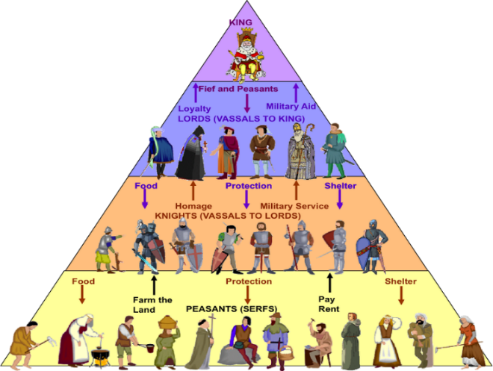
Life was very hard (and short) for most people during the Middle Ages. There was a lot of fighting and great suffering among the masses, which saw almost 60% (approximately 50 million people) of Europe’s population wiped out by the bubonic plague (the Black Death) in the 1300s.

The majority of people lived in the country and worked as farmers. Usually there was a local lord who lived in a large house, called a manor, or a castle. Local peasants would work the land for the lord. The peasants were called the lord's "villeins", which was like a servant. This was called the feudal system; as you can see from the diagram, the more land you owned, the more power you had.
The peasants worked hard all year long. They grew crops such as barley, wheat, and oats. They also had gardens where they grew vegetables and fruits. They sometimes had a few animals such as chickens for eggs and cows for milk. Although we often think of large castles when we think of the Middle Ages, most people lived in small one or two room homes. These homes were very crowded and usually everyone slept on the floor in the same room. In the country, the family animal would also live inside the home. The home was dark and smoky from the fire at the centre of the room and was uncomfortable because there was little furniture. There were no windows, no bathroom, and no fresh running water.

City life wasn't much easier. All the improvements that the Romans had made to public health, like toilets, baths, sewers and running water could not cope with the growing population and were left to decay. Miasma was everywhere but if you believed that illness was a punishment from God, prayer was much more useful than a bath! Families usually lived in just one room and waste was thrown into the street or the river- the same river used for drinking, cooking and washing water!
Peasants during the Middle Ages did not have a lot of variety in their food. They mostly ate bread and stew. The stew would have beans, dried peas, cabbage, and other vegetables, sometimes flavoured with a bit of meat or bones.. Since they didn't have a way to keep their meat cold, they would eat it fresh. Leftover meat was smoked or salted to preserve it. The nobles ate a wider variety of food including meats and sweet puddings. The bread eaten by people of the Middle Ages was gritty from the millstones used to grind the grain. This caused the people's teeth wear down quickly. People mostly drank ale or wine because water was bad and would make them sick.
Very few people attended school in the Middle Ages. Most peasants learned their job and how to survive from their parents. Some children learned a craft through apprenticeships and the guild system. Wealthy children often learned through tutors. There were some schools run by the church; here, students would learn to read and write Latin. The first universities also began during the Middle Ages; students would study a wide range of subjects including reading, writing, logic, math, music, astronomy, and public speaking.
Using the information you have just read and this source, summarise living conditions in the Middle Ages.
How would these conditions impact on health?
Stretch: How does this compare with Roman times? Does this surprise you?
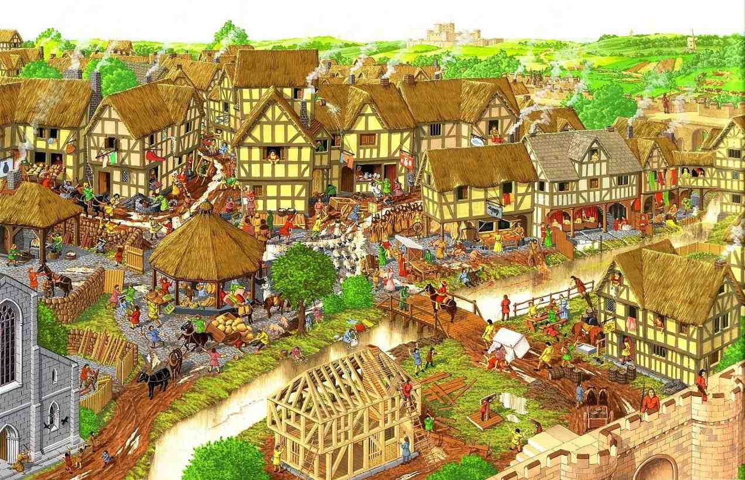

Quick Quiz

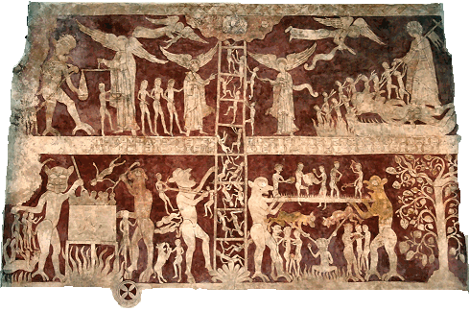
Lesson 2: Why was the Catholic Church so powerful in Medieval Britain?

As you have already read, the Roman Catholic church was the richest and most powerful institution in Britain during the Middle Ages. Most people were Catholic and went to Church at least once a week; because they didn’t have the scientific knowledge we do, they believed that God made everything happen so needed to keep Him happy. Life expectancy was short and it was important to go to heaven when you died; people would confess their sins to the priest and buy ‘indulgences’ so they would be forgiven, effectively ‘buying’ their way into heaven and making the Church very rich. Whilst the Church provided comfort, they also ruled through fear to prevent disobedience, which was punishable by excommunication and eternal damnation! Every family also had to pay a tenth of their yearly pay to the Church.

The Catholic Church liked the work of Galen; he had said that the human body was perfectly designed and this fitted with Christian beliefs about the Creation. The Church said doctors should use Galen’s ideas and discouraged them from looking at other theories.

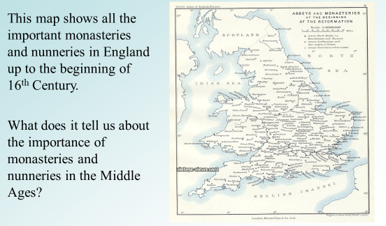
Some people devoted their lives to God; they were priests, monks and nuns, and they ‘married’ the Church rather than people. Monks lived in monasteries, while nuns lived in nunneries. The monastery was self- contained, meaning everything the monks needed was provided by the monastery community. They made their own clothes and grew their own food. There were monasteries spread throughout Europe during the Middle Ages.

The monks in the monasteries were some of the only people in the Middle Ages who knew how to read and write; they wrote books and recorded events. If it were not for these books, we would know very little about what happened during the Middle Ages.

Monks played an important role in the community. Monasteries were a place where travelers could stay during the Middle Ages as there were very few inns during that time. They also helped to feed the poor, take care of the sick, and provided education to boys in the local community. It was the church which set up the first ever schools in England.
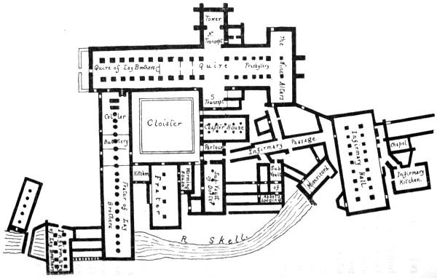
From this diagram you can see that public health was much better in monasteries; they had specific areas for praying, eating, and sleeping. They very usually built near a river, providing a fresh water supply and giving somewhere for waste to be disposed of.

There was often a herb garden and the herbs were sometimes used to treat the sick; however, treatment in monasteries was all about ‘prayer and care’.

Everyone believed that a patient would only recover if God made it happen.

You are now going to practice applying your knowledge to a GCSE exam-style question. Your answer should be submitted to Mrs. Brown by Monday 15th June 2020 for marking and feedback.
Compare public health in a Medieval town with public health in a Medieval monastery. In what ways were they different? [8]

Step 1: Answer the question in the first sentence. TIP : Divide your answer into categories…e.g. WATER SUPPLY. Give an example and explain WHY they were different.
One example of how public health in Medieval towns was different to public health in a Medieval monastery was…
The reason for this was…

This meant that…

Step 2: Give another 1-2 examples of how and why they were different:
DEALING WITH SEWAGE/ ATTITUDES TO CLEANLINESS
Another example of how public health in Medieval towns was different to public health in a Medieval monastery was…
The reason for this was…

As a result…

Step 3/stretch: Evaluate public health as a whole during this period; make comparisons with Roman public health and explain the influence of religion.
However, whilst public health differed between Medieval towns and monasteries, compared with Roman times public health was poor everywhere because…

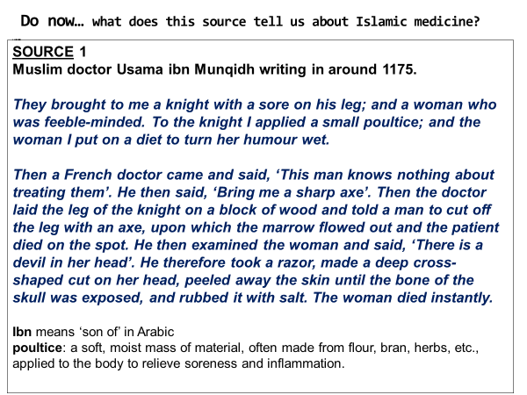
Lesson 3: How similar was medicine in the Islamic world?
What does this source tell us about medicine in the Islamic world?

https://www.youtube.com/watch?v=6EAMqKUimr8
At about the time that the Roman Empire collapsed in Western Europe, a new Empire was growing up in the East based on the teachings of Muhammad, who had been born in Arabia in AD570. This new religion, Islam, spread rapidly until by AD100 it covered parts of southern Asia, North Africa and southern Europe. The capital of this Empire was Baghdad. More importantly, at a time when we have seen how medicine was regressing in the West, this Eastern Empire not only preserved many of the Ancient ideas but actually showed progress in some areas of medicine too.

Whilst Western European civilisation collapsed into disorder and the teachings of Hippocrates and Galen could have been lost, Arab scholars translated their work into Arabic and these were studied by medical students. Arab doctors also increased their knowledge by learning from Indian and Persian doctors. At a time when much of this knowledge was being destroyed, the libraries in cities like Baghdad were able to collect and study manuscripts that belonged to Hippocrates and Galen and other classical medical writers and preserve them.

Hospitals were much more common in the Middle East. Hospitals existed in Sri Lanka in 500bc, and in India in 250bc. In Baghdad alone there were 60 hospitals in the 1100s (a time when Londoners were marvelling at their first!). These hospitals became known as ‘bimatistans’ and provided medical care for all. In Cairo, the Al- Mansur hospital was founded in 1283 and was one of the scientific wonders of the age. It had separate departments for patients with different diseases; a library and a lecture hall for students to be trained to become doctors. Kitchens were also built to help cater for patients’ special diets, along with wards where convalescent patients could stay as long as they wished. When they went home, they were given some money. Helping the poor and needy was, and still is, a central part of the Islamic faith.

However, in other ways Islamic medicine hindered new developments. Although Muslims believed that Allah had created every disease and a cure for that disease, Islamic law forbade the dissection of human bodies, much like the Christian Church.

Many doctors believed that understanding theory was more important than practical experience and they thought that doctors should not dabble in surgery. There was some surgery. The greatest surgeon was Albucasis who was born in Spain. He advised surgeons to only operate when they knew the cause of the pain and what to do about it. He wrote about amputations, removing stones from the bladder, dentistry, and described how to sew wounds, set fractures and deal with dislocations, but he warned that Allah would be watching and doctors must never operate for personal gain (to make money).
Other famous Islamic doctors included Avicenna and Rhazes:-

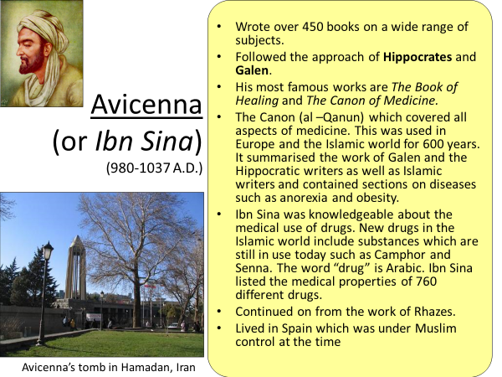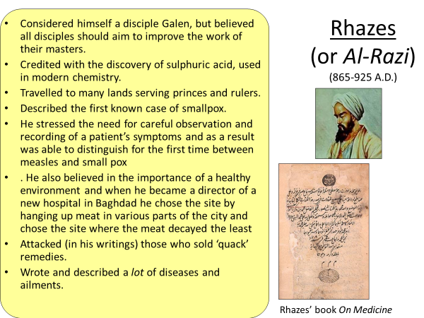

Quick Quiz

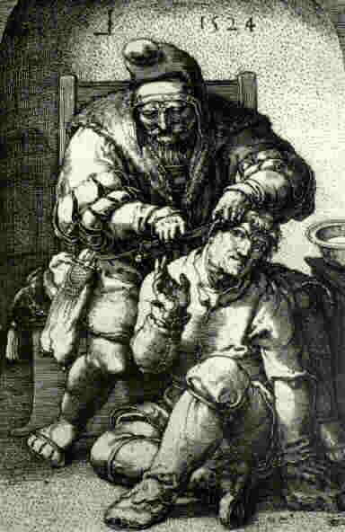

Lesson 4: Did surgery improve in Medieval Britain?

While rich people could afford to pay one of the few trained doctors, most people were treated by barber surgeons, quacks or a ‘wise woman’.

Most surgery was left to the barber surgeons. They were actual barbers or butchers, who did simple surgery on the side. They were not trained at the medical universities like doctors, but learned their trade as an apprentice.
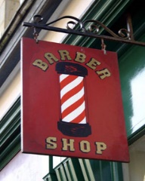

FACT! The red and white pole outside barbers’ shops is a throwback to Medieval times – the red represents blood, and the white for bandages.

Surgeries performed by barber surgeons:
- removal of teeth
- removal of arrows
- amputations
- removal of cataracts (eyes)
- simple operations on wounds
- trephining
- SOME internal surgery – removal of bladder stones
Armies also employed barber surgeons and they got a lot of practice because of all the European wars going on!
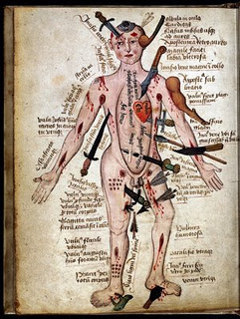

Medieval ‘Wound Man’
Charts like this helped surgeons treat different injuries.
Do you think this chart shows that people in the Middle Ages had a good understanding of anatomy? Explain.

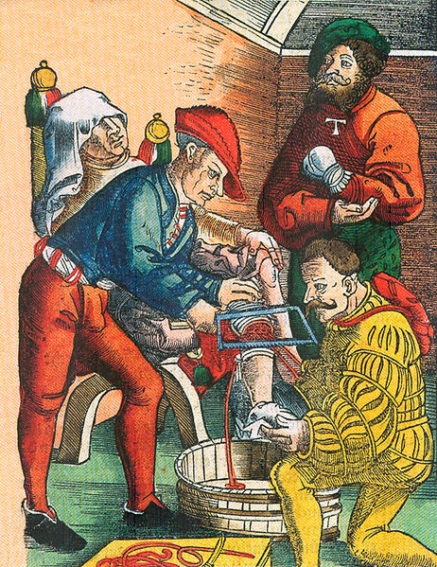
There are 3 main problems with surgery:
PAIN
BLOOD LOSS
INFECTION

How did they deal with these problems in the Middle Ages?
PAIN: patients would be given alcohol so that they were too drunk to realise what was going on. However, even the drunkest person would feel their leg being sawn off and they would have to be tied down to stop them moving too much. AMPUTATION was the most common approach to major wounds in the Middle Ages; it was painful, very risky, and many patients died…but it was quick!

BLOOD LOSS: Wounds needed to be close quickly to prevent the patient from bleeding to death. They burned the wound with a red-hot poker or boiling oil, which immediately sealed the skin. This is called CAUTERISATION. As you can imagine, the pain of this sometimes sent the patient into shock, leading to death anyway!

INFECTION: Because people in the Middles Ages did not know that infection was caused by germs, they did not worry about using dirty instruments and bandages, and cauterization only sealed the germs inside the body.

You are now going to practice applying your knowledge to a GCSE exam-style question. Your answer should be submitted to Mrs. Brown by Monday 29th June 2020 for marking and feedback.

EXAM QUESTION PRACTICE:
Compare surgery in Ancient Greece and in the Middle Ages. How were they similar? Explain your answer with reference to both time periods. [8 marks]
This question tests AO1 and AO2:
AO1: demonstrate knowledge and understanding of the key features and characteristics of the period studied.
AO2: explain and analyse historical events and periods studied using second-order historical concepts (continuity, change, cause, consequence, significance, similarity and difference).

2 x PEEL (Point; Evidence; Explain; Link back to question)
Use at least 2 connectives in each paragraph: because, this meant that, as a result, the reason for this was, consequently.

Tip: think about the categories that this question could be divided into…
The problem of PAIN
The problem of INFECTION
The problem of BLOOD LOSS
The restrictions of religion

One way that surgery in Ancient Greece and in the Middle Ages were similar was…

Another similarity was…

A further similarity was…

Lesson 5: Who treated the sick in the Middles Ages?
Although the majority of people were cared for in the home by family members, there were a range of people you could turn to in the Middle Ages if you were ill, depending on where you lived and how rich you were.

In the countryside, poor people might visit the village ‘wise woman’ - someone who had learned from her mother how to use herbs and plants to create treatments (like in Ancient times). However, because these treatments often worked, the Church thought it challenged God’s will and wise women were accused of heresy and labelled as witches.

We have already learned about the role of monks and nuns in caring for the sick; although they focused on ‘prayer and care’ and the will of God to make a patient better, the clean conditions, rest, and good food would help.

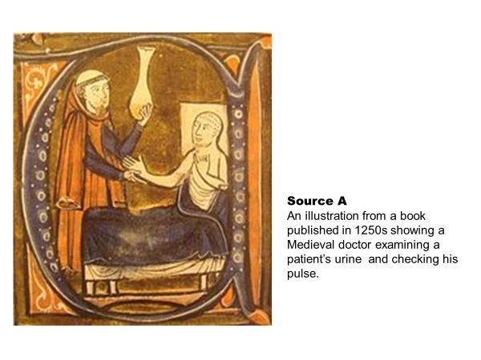
In towns and cities, rich people could visit a doctor who had trained for the role; they may have studied at one of the centres of learning in places like Padua, Italy, where they would have read the works of Hippocrates and Galen, and perhaps, Avicenna and Rhazes.

Medieval doctors followed the ancient Greek method of observation but rather than looking at all the symptoms, they focused on two things: taking the temperature and noting the colour, smell, and taste (yes taste!) of the urine. They would then prescribe medicines made from herbs and plants.

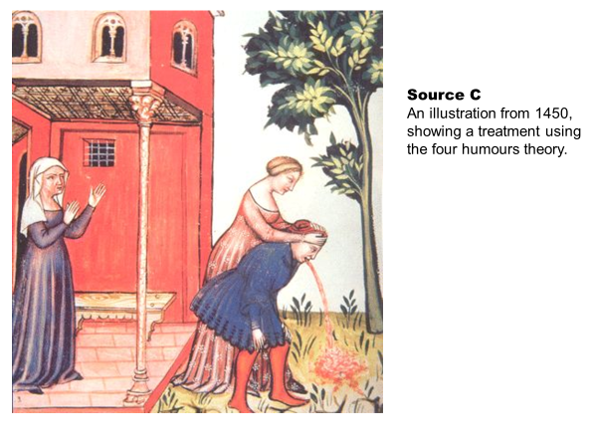

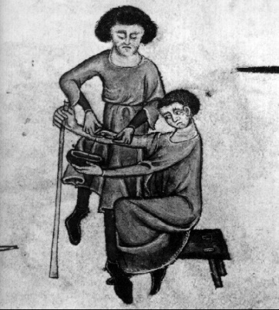
They continued to use the Theory of the Four Humours; they believed a person became ill when the humours were out of balance. They might use leeches to bleed the patient, or give them a purgative to make them vomit or go to the toilet.

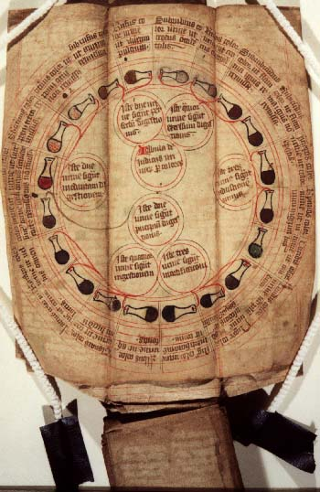
Some doctors also used astrology to treat their patients; they studied the movement of the planets and linked this to the patients symptoms and treatment.

Quick Quiz

Lesson 6: Case Study: THE BLACK DEATH

What can you remember about the Black Death?

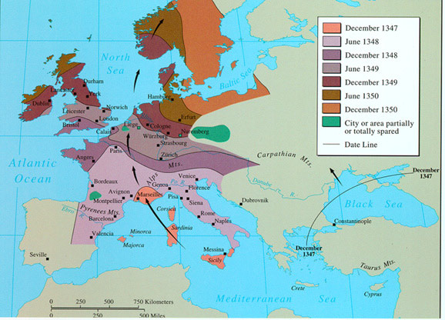
The bubonic plague, or Black Death, swept across Europe in the 1300s. It arrived in England in 1348; historians believe that sailors from a ship docked at Melcombe (today known as Weymouth), Dorset, were carrying the disease and infected others when they went into the town. The disease was originally carried by black rats and transmitted to humans by the fleas that fed on the blood of both; however, once humans caught the Black Death, it could be spread through bodily waste.

SYMPTOMS
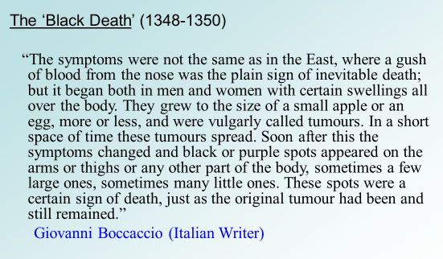
These tumours were called buboes.
Label the body with the symptoms of the Black Death.
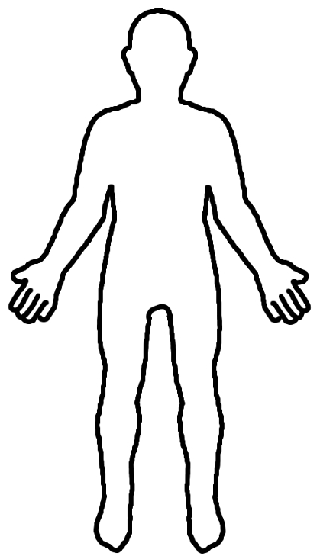
Stretch: Find out how long a person was likely to be ill for.

CAUSES & CURES
Today we know that diseases are caused by germs, however, in the Middle Ages they did not have this scientific knowledge. Beliefs about causes and cures can be divided into categories:-
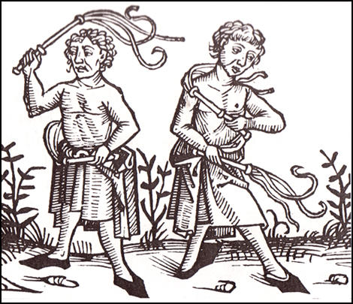
GOD:
Because most people were Christians and the Catholic Church was so powerful, many people believed that the Black Death was a punishment sent from God because people had sinned.

The cure was to pray to God that he might spare you and your family. Some villages paid FLAGELLANTS to help them. Flagellants were very religious men who would practice flagellation- whipping themselves- to atone (pay) for the sins of people.

MIASMA:
Since the time of the Romans, people believed that miasma- bad smells- made people ill and this continued during the Black Death.

The cure was to avoid miasma by carrying herbs and dried flowers in a pomander and holding it to the nose.

NATURAL/ OTHER:
Others blamed the Black Death on things like cats and dogs, the movement of the planets, disabled people, or Jewish immigrants.

There were many cures based on natural ideas: killing all the cats and dogs, drinking mercury, slicing the buboes or bursting them with a red-hot knife, or placing a shaved chicken’s bottom or a dried frog onto the buboes! Obviously, most of these cures didn’t work, and some even killed people. However, there were a few cures that may have helped: placing a poultice (a paste) of bread, softened onions and figs onto the buboes would have helped soothe the pain, and the antiseptic properties of the onions might help fight infection.

THE PLAGUE DOCTOR
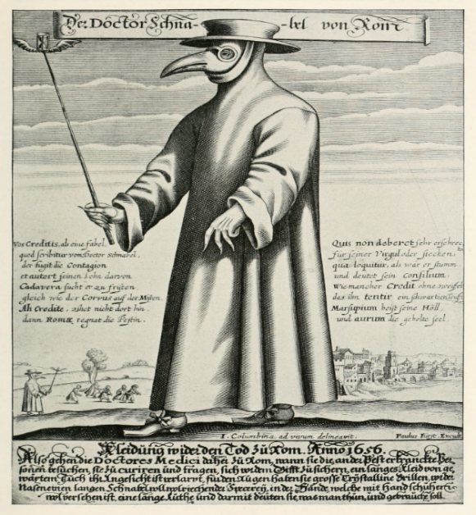
You may have seen the Plague doctor before. His outfit was designed to avoid the Black Death:
Beak – filled with herbs & dried flowers to avoid the miasma
Leather cloak, hat & gloves – to shield him from the miasma
Stick – used to touch the patient

Some of these items had the potential to protect the doctor; however, because of their lack of knowledge and the belief in miasma, they did not know that the germs could be spread from the stick or the clothing. The doctor could easily spread the disease to the next household they visited!
(Interesting fact: This is why many hospital doctors stopped wearing ties in the 1970s. Think about it….)
CONSEQUENCES

The Black Death was devastating and between 1/2 and 1/3 of the population of England died.
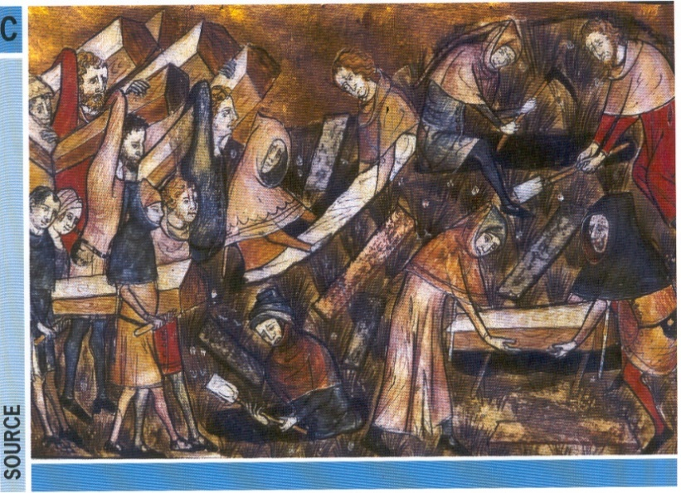
However, there were some positive and very significant consequences for the social structure of England.

There were fewer villeins (peasants) to work on the land, and they could demand higher wages for their labour. This meant that they could afford better homes and better food. Consequently, peasants had more power for a short time.

However, the King passed the Statute of Labourers in 1351, restricting the amount that peasants could earn.
The peasants fought back in the Peasant’s Revolt of 1381; while this did not bring about huge changes at the time, it did lead the way to greater democracy in the future for England.

You are now going to practice applying your knowledge to a GCSE exam-style question again. Your answer should be submitted to Mrs. Brown by Friday 13th July 2020 for marking and feedback.
EXAM QUESTION PRACTICE:
How to answer a source based question…
‘How useful is Source D to a historian studying the Black Death? Explain your answer using the source and your own knowledge. [8 marks]’

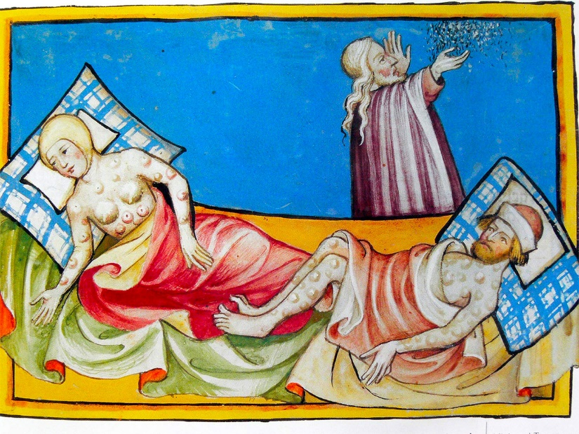
Source D: Miniature out of the Toggenburg Bible (Switzerland) of 1411. The disease is widely believed to be the bubonic plague.

Use DAFT to analyse the source:

This question tests AO1 and AO3:
AO1: demonstrate knowledge and understanding of the key features and characteristics of the period studied.
AO3: analyse, evaluate and use sources (contemporary to the period) to make substantiated judgements, in the context of historical events studied.

REMEMBER: all sources are useful in some way.
2-3 x PEEL (Point; Evidence; Explain; Link back to question)
Use at least 2 connectives in each paragraph: because, this meant that, as a result, the reason for this was, consequently.

Model answer:
One way that Source D is useful is that is shows that astrology was important at this time. In the background there is a man, who is probably a doctor, consulting the stars to help him treat the patients.
From my own knowledge I know that a popular theory about the cause of the Black Death that spread across Europe between 1340 and 1350, was that it was caused by the movement of the planets. As a result, some doctors looked for treatments linked to astrology.
Another way that Source D is useful is that is shows that there was little knowledge about the cause or spread of the disease as the two patients are sharing the same bed.
From my own knowledge I know that at the time there were many different theories about the cause of the Black Death; most popular beliefs were that it was a punishment from God or that it was caused by miasma. They also had theories about it being caused by cats and dogs; Jews or disabled people poisoning the water; or a plague victim giving you the ‘evil eye’. The reason they believed these ideas was that they did not have the scientific knowledge or technology to prove that germs caused the disease, and that poor hygiene and allowing people to come into contact with plague victims helped it to spread so quickly.

Over to you…
How useful is Source E to a historian studying the Black Death? Explain your answer using the source and your own knowledge.
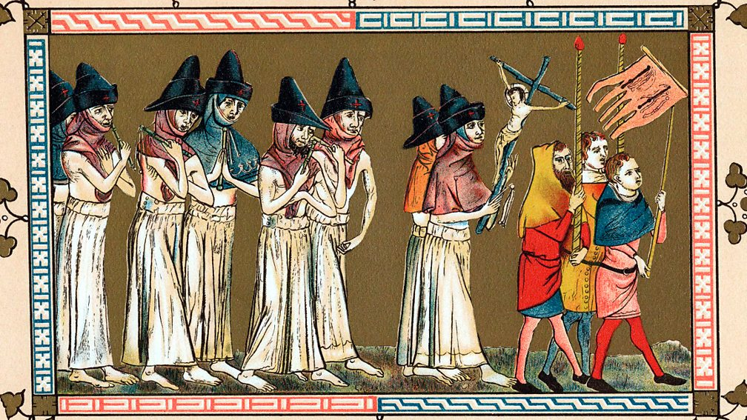
Source E: Medieval flagellants in procession in the town of Tournai, Netherlands in 1349. They believed that the plague was sent by God.
They thought that by whipping themselves, they would be purified and so avoid the plague.

One way that Source E is useful is…
From my own knowledge I know that…

Another way that Source E is useful is…
From my own knowledge I know that…
REVIEW
Remember that throughout the course we need to consider the importance of the following factors:
- war
- superstition and religion
- chance
- government
- communication
- science and technology
- the role of the individual (helping/hindering change)

Summarise the role of these factors in the Middle Ages. You could use a table like the one below, or a mind map, or your own methods.

 | war | superstition and religion | chance | government | communication | science and technology | role of the individual
MIDDLE AGES

Stretch…
- Did knowledge of health and illness progress or regress in the Middle Ages? Explain your answer.

