Year 10 RS: Summer 1
PILGRIMAGE
This unit of work is based on the BBC series Pilgrimage: The Road to Istanbul that was show earlier this month. It explores the concept of pilgrimage and the experiences of a group of celebrities who undertake a pilgrimage together.
Episode 1 is available on BBC iPlayer until 25th April 2020 https://www.bbc.co.uk/iplayer/episode/m000gpbk/pilgrimage-the-road-to-istanbul-episode-1
Episode 2 is available until 2nd May.
Episode 3 is available until 11th May
Note: each episode can be downloaded to a computer to watch at a later date.
Task 1: Define the concept of pilgrimage and explain an example you have studied e.g. Muslims and Hajj.
Task 2: Create a profile for each of the celebrities; include their name, age, profession and religion. Then summarise their experience of the pilgrimage: What did they enjoy? What did find most challenging? How did it affect their own faith? Do you think it will change their life in any way?
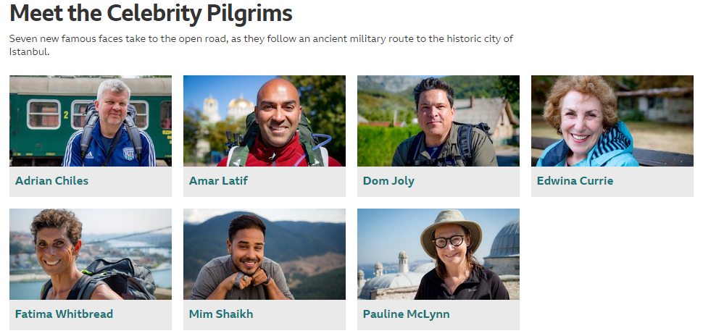
https://www.bbc.co.uk/programmes/profiles/3vsPTgFLcWH4ztG2DGJ2ctS/meet-the-celebrity-pilgrims
Task 3: ‘Only religious believers should go on a pilgrimage.’ Evaluate this statement.
In your answer you:
- should give reasoned arguments in support of this statement
- should give reasoned arguments to support a different point of view
- should refer to religious arguments
- may refer to non-religious arguments
- should reach a justified conclusion

The completed tasks should be submitted to Mrs. Brown for marking by the 22nd May 2020. Please contact Mrs. Brown if you have any questions.

