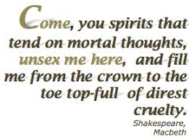
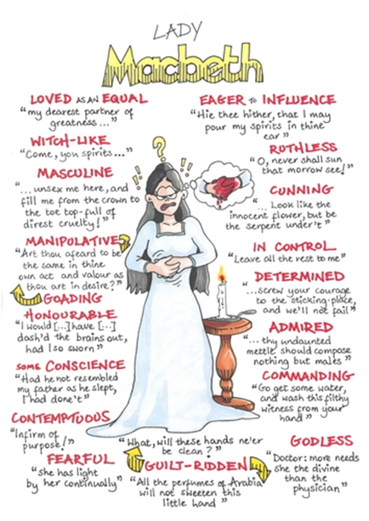
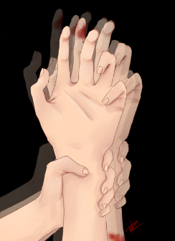

How does Macbeth present Lady Macbeth?

Task:
Watch the following Clip and answer the question
https://www.youtube.com/watch?v=zSYePeoGY8Y
(You will need to watch/listen to the clip several times and make notes before you answer the question.)
(Remember – how were women seen during the time that Shakespeare wrote the play?)

