RIVERS/31

ANSWER ALL QUESTIONS

RIVERS
Use your Knowledge Organiser to support you.
- Spend time learning the KO.
- Attempt the exam questions under test conditions
- Complete any missing parts that you didn’t understand using the KO
Submit your answers no later than Friday 8th May.

NAME

CLASS

Q1.The figure below shows four ways in which a river transports its load.
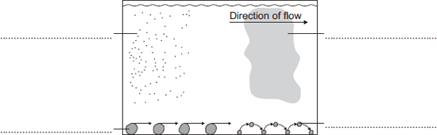
4
2
3
1
Using the figure above,
Choose the correct labels from the following list. EG, 1-B

 | A saltation | B suspension | C solution
 | D abrasion | E attrition | F traction

(Total 4 marks)

Q2. River channels are affected by different erosion processes.
Match each of the statements to the correct erosion process. EG, 1-B
D
C
B
4
A
3
2
1
Erosion process |  | Statement
Hydraulic action |  | occurs when some types of rock are dissolved in the river
Abrasion |  | occurs when material carried by the river knocks into other pieces of load
Attrition |  | occurs when the force of the water hits the bed and banks
Solution |  | occurs when the load carried by the river hits the bed and banks

(Total 4 marks)

Q3. Study the figure below which shows a long profile and cross profiles of a typical river.
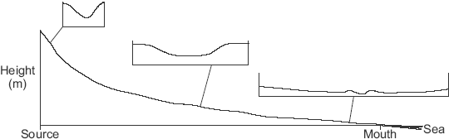

(a) Are the following statements about the long profile and cross profiles true or false?
Put a X the correct boxes.

 |  | True | False
 | The steepest part of the long profile is near the source.
 | The cross profile shows the shape of the valley from one side to the other.
 | The cross profile is narrower and deeper near the mouth.
 | Most lateral erosion occurs near the source.

(Total 4 marks)
(b) Complete the paragraph below to explain why deposition occurs along the course of a river. (Rewrite if easier)
Choose the correct words from this list.
energy increases transports
decreases sediment leaves behind
Deposition occurs when the river __________________ material. This happens when the speed of the river __________________ and the river has less __________________
(Total 3 marks)
Q4. Study the image below, a block diagram showing how river landforms change downstream.

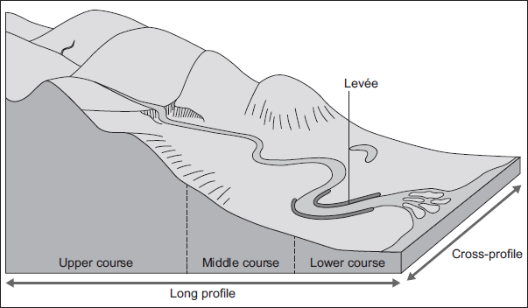

- With the help of the diagram, describe how the shape of a river valley changes downstream.
__________________________________________________________________________________________________________________________________________________________________________________________________________________________________________________________________________________________________________________________________________________________________________________________________________________________________________________________________________________________________________________________________________________________________________________________________(Total 4 marks)

- A levée is shown in the diagram above. What are levées?
_____________________________________________________________________________________________________________________________________________________________________________________________________________________________________________________________________________________________
(Total 2 marks)

- Explain the formation of levées.
______________________________________________________________________________________________________________________________________________________________________________________________________________________________________________________________________________________________________________________________________________________________________________________________________________________________________________________________________________________________________________________________________________________________________________________________________________________________________ (Total 4 marks)

Q5. Explain why a river deposits its load.
________________________________________________________________
________________________________________________________________
________________________________________________________________
________________________________________________________________
(Total 2 marks)

Q6. Draw a labelled cross-section to show how the inside bend of a meander is different from the outside bend of a meander.
You can scan this answer/upload a photo from your phone. At the very least, find a suitable annotated image from the internet.

(Total 4 marks)

END

