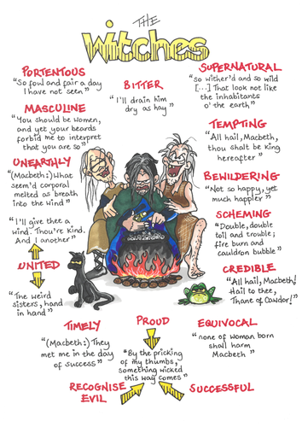
Starting with the extract below, show how Shakespeare presents the influence of the witches over Macbeth.
Write about:
- how Shakespeare presents the witches in this speech
- how Shakespeare presents the witches in the play as a whole.

Task 1: Look at this exam question – what is it asking you to do?
What does present mean?
What does influence mean?

Task 2 : Read the following extract from Act 4 Scene 1 of Macbeth and then answer the question.

At this point in the play, Macbeth meets the witches and demands to know what they are doing. https://www.sparknotes.com/nofear/shakespeare/macbeth/ (text + translation)

Second Witch: | By the pricking of my thumbs,  Something wicked this way comes.  Open, locks,  Whoever knocks!
 | Enter MACBETH
MACBETH: | How now, you secret, black, and midnight hags!  What is’t you do?
ALL | A deed without a name.
MACBETH: | I conjure you, by that which you profess,  Howe’er you come to know it, answer me:  Though you untie the winds and let them fight  Against the churches; though the yesty waves  Confound and swallow navigation up;  Though bladed corn be lodged and trees blown down;  Though castles topple on their warders’ heads;  Though palaces and pyramids do slope  Their heads to their foundations; though the treasure  Of nature’s germens tumble all together,  Even till destruction sicken; answer me  To what I ask you.
First Witch: | Speak.
Second Witch: | Demand.
Third Witch: | We’ll answer.
First Witch: | Say, if thou’dst rather hear it from our mouths,  Or from our masters?
MACBETH: | Call ’em; let me see ’em.
First Witch: | Pour in sow’s blood, that hath eaten  Her nine farrow; grease that’s sweaten  From the murderer’s gibbet throw  Into the flame.
ALL: | Come, high or low;  Thyself and office deftly show!

How to tackle the answer: –
- read then re-read the text
- annotate the text ( using the link and translation) https://www.sparknotes.com/nofear/shakespeare/macbeth/
- What are the witches doing? Saying? How do they come across
- Then refer to the other acts that they are seen in Act 1, scene1 – Act1, Scene 3 – Act 3, scene 5 and Act 4, scene 1
- Look at the mind map on the front page and use that in your analysis.
- Again, what are they doing? what are they saying, what is the impact on the play?? What is the impact on the characters (mainly Macbeth and Banquo)
- Why do you think Shakespeare put the witches into the play (context – who was interested in the play? What would the audience have made of the witches? What were the beliefs at that time? (Using the - link scroll up – further study and read the Witchcraft in Shakespeare’s England – put it into your own words)

If you struggle with an answer please contact me through Microsoft teams – I will respond as soon as I can – if you haven’t got access to teams then drop me an email.

