Park Community Academy
Behaviour and Pastoral Policy Policy



Updated September 2026

Contents

Rationale 3

Good Behaviour 3-4

Misbehaviour 4

Pupil Aggression 5

Managing Pupils 6 – 9

Child on Child Abuse 11

Racist Incidents 11

Banned Items 12

Behaviour Plans 12

Recording and Reviewing 13

Restrictive / Physical interventions 13

Rewards 13

Sanctions 14

Seclusion 15

Levels of action to be undertaken 17
when pupil’s behaviour affects
the learning of others.

Suspension 18

Behaviour Outside of the School Premises 18

List of Appendices 19-30

Park Community Academy Behaviour and Pastoral Policy

Rationale
The aims of this policy are to ensure that all members of the school community understand what is meant by good behaviour and the consequences of misbehaviour. The aims and objectives of Park Community Academy set out the conditions within which staff and pupils can enjoy an environment conducive to providing the best opportunities for learning. The School’s Behaviour and Pastoral Policy sets out to identify how the conditions for this environment can best be created within the School.

It is intended that staff and pupils should work together to create a safe and secure environment for all. That staff should operate in an atmosphere of relaxed vigilance to support pupils and to ensure that they can be helped to avoid trouble whenever possible. It is accepted that the calm, consistent and careful handling of situations will generally lead to a successful outcome at times of conflict.

As part of the range of approaches designed to ensure a safe, secure environment for all pupils the school’s Anti - Bullying Policy identifies strategies to reduce the harmful effects of such behaviour on those who are bullied and the perpetrators of bullying.

Racial abuse and Sexual abuse are not tolerated in the School and any reported incidents are dealt with swiftly by staff and recorded appropriately.

Pupils are carefully supervised at all times in the school day. When pupils leave the site they are appropriately supervised unless they leave without permission. It is the School’s policy to encourage the pupil’s safe return. In the event that this is not managed then parents and carers will be contacted using the emergency contact number provided to the School. In order to discharge its duty of care to pupils the School will then inform the police of the unauthorised departure from the School site.

In order to minimise the likelihood of conflict, staff promote a positive attitude to work and an appreciation of the value of cooperation and tolerance. Reward and praise are earned for success and good behaviour. Consequences for misbehaviour are clear, fair and applied appropriately, considering the needs and understanding of those involved.

The policy covers all pupils and the procedures contained should be adhered to by all staff to ensure continuity of approach and consistency of response.

Good Behaviour
This is defined as behaviour that tends to encourage success in work and building positive relationships. It is a framework of behaviour that encourages staff and pupils alike to work for the good of each and every member of the School community.

On starting at Park Community Academy each new pupil and parents/carers are required to read, understand and sign a copy of the School’s ‘Home-School Agreement (see appendix 1). This sets out the expectations of the School and what the School undertakes on behalf of the pupil. It also identifies ways in which the parents/carers can contribute to a successful experience.

Standards of behaviour are high and pupils are repeatedly encouraged to follow ‘The PCA Way’ (see appendix 2). These encourage good behaviour and an awareness of others’ rights. ‘The PCA Way’ has been modified to ensure that the terminology is appropriate for each Key Stage.

Good behaviour will be acknowledged in a way that enables the pupil(s) concerned to feel good about themselves. Praise will be delivered appropriately to avoid embarrassment.

A range of responses from an acknowledging glance to a tangible prize appropriate to each individual and age-related will be applied to reward good behaviour. Each Key Stage has a clearly defined scheme (stars, Dojo’s etc.) to acknowledge good work and behaviour both in class and around the School. There is a strong tradition of public recognition of good work and behaviour through the award of Certificates in Key Stages 2-5. Pupils in Key Stage 1 receive acknowledgement through a range of practical rewards.

Good behaviour and examples of positive attitude are celebrated during “Worth A Mention” assemblies to encourage and foster an atmosphere of ‘shared worth’. Pupil wellbeing and rewards days take place at the end of each term.

Good behaviour should be seen as a means to an end as well as an end in itself. Pupils need to learn that effort and hard work are prerequisites to making progress and as such are also praiseworthy. The PCA Way is structured to support PCA pupils to become Successful Learners, Responsible Citizens and Resilient Individuals as part of PCA’s golden threads.

Misbehaviour
This is seen as behaviour tending to upset, annoy or otherwise make others feel uncomfortable with a situation. The effect of misbehaviour is to diminish the likelihood that pupils and staff will be successful in their work.

All staff at Park Community Academy have agreed that misbehaviour must lead to consequences. Any consequences will be designed to lead to a reduction in the behaviour concerned. When a pupil misbehaves, a severe reaction will be less effective than earning a predictable, immediate consequence.

It is important that pupils behave well. Where misbehaviour occurs it is the behaviour involved that is addressed. The pupil concerned will not be treated in such a way as to make them feel they are under attack or viewed as being less valuable as a person.

It is often not possible to replace inappropriate behaviour – it is more realistic to target an increase in appropriate behaviour, as highlighted in The PCA Way. Any progress should therefore be measured from a baseline not against the norm of peers so that any progress is relative.

The School aims to develop a positive self-image among pupils. Staff endeavour to support appropriately those children who have misbehaved and to ensure that they recognise that the consequences they receive relate to their actions. However, the consequences of their actions need to be explicit to dissuade them from engaging in misbehaviour in the future.

After misbehaviour has occurred the pupil will be involved in working towards facing the consequences in order to develop a sense of responsibility and to undertake the process of reconciliation.

Pupil Aggression

Park Community Academy staff have been trained to understand that there are various reasons for pupil aggression. This area is regularly re-visited through participation in the on-going Team Teach re-training programme.
The reasons why pupils become aggressive are often varied and complex. The following is a list of some of the reasons identified by staff.

- Anger, anxiety, abuse.
- Confusion, cultural expectation.
- Depression, delusion.
- Fear, frustration, grief.
- Environmental stress.
- Hallucination, humiliation.
- Isolation, Institutional inflexibility, jealousy.
- Lack of personal space, low self- image/esteem.
- Medication, testing limits, “pecking order”.
- Manic excitement, pain.
- Feeling suicidal, violent coping strategy.

In addition, it is understood that how a pupil is managed, will have implications on their behaviour. Therefore, staff understand that there are a variety of behaviours that adults can display, that may cause tension and may result in pupil aggression. By identifying these behaviours, staff are actively looking for a better way of supporting and managing pupils.

Park Community Academy staff have identified the following as adult behaviours which challenge the feelings of pupils-

- Low expectation.
- Boring repetitive activities, routines and resources.
- Staff having favourites, inconsistency, moving the goal posts.
- Being taken for granted, “talking about them, not to them”. Personal space invaded, over-facing, dominating.
- Treating age inappropriately.
- Lack of tolerance, being shouted at: Hectoring and “finger-wagging”.
- Little sense of humour, not prepared to laugh at self.
- Lack of differentiation (personal and curriculum).
- Treated without dignity and/or respect.
- Not being consulted or listened to. Not being given choices.
- Inflexibility of attitude and behaviour, rigidity of expectation.
- Invasion of personal space / staff who come too close for comfort.
- Being belittled, humiliated, made fun of, both publicly and privately.
- Being bored, rejected and ignored.
- No effort from staff to make them feel special or valued, no advocacy for the children. The “me” and “them” approach.

Managing Pupils.

Some children may have individual support plans to help modify their behaviour; and, therefore, may have their own sanctions, rewards and procedures to follow.
If a child misbehaves during taught time, as a guide, the following procedure is followed:

Step 1
A reminder is given making it clear what type of behaviour is acceptable and expected, referring to ‘The PCA Way’ wherever possible. This should be communicated calmly and professionally, maintaining the dignity of pupil and adult at all times. De-escalation strategies should be used. Try to establish the cause with the child to suggest solutions. Supportive skills and strategies should be discussed with the child to encourage the child to modify their behaviour. Referring to the zones of regulation where appropriate. If the behaviour is modified and not repeated, ‘catch’ the child conducting the expected behaviour and praise them using an appropriate reward.

Step 2
If, during the same learning session, the behaviour is not modified accordingly and is repeated:
The child may be offered Thinking Time in the classroom for a short period of time (no more than 5 minutes) for them to reflect on the incident and modify their behaviour. The adult should remind and promote Step 1 above to ‘repair’ and ‘rebuild’ the adult-child relationship. Ensure that the child’s perspective is listened to and acknowledged.
An apology or short discussion regarding behaviour, if appropriate should be undertaken in a discreet manner and without audience. Depending on the situation a deferred discussion may be more appropriate.

Step 3
However, if the behaviour continues to be repeated in the same session:
The child may be offered to Walk and Talk with an adult outside the classroom for the minimum, necessary period of time. The child is expected to take the Time Out to reflect on their behaviour. It provides reflective space for the child as well as allowing effective learning pace to be maintained.
On return to the classroom, the child is expected to have used the time to reflect, calm down and be prepared to re-engage with their work. Returning with the right attitude and an apology or short discussion regarding behaviour, if appropriate should be undertaken in a discreet manner and without audience. Depending on the situation a deferred discussion may be more appropriate.

As part of the reparation and rebuild process, in discussion with the child, the Learning Time lost must be made up by the child in their own time, supervised by an adult. The teachers involved may need to record and report the incident on CPOMs.
The involved teacher, having discussed with their Team Leader, may wish to contact parents to discuss the incident.

Step 4
However, if the behaviour continues to be repeated in the same session:
The pupil may need to be removed from the classroom by the SSA, for a period of time to reflect on the behaviour displayed. When the member of staff feels the pupil is ready to re-join the class they are to do so.
If required, the ‘On Call’ system may be used to support the pupil.
It is important that if the ‘On Call’ system has been used, the initial member of staff involved, takes a primary role in follow up consequences. E.g. Supporting the pupil catching up work.

Levels of Crisis

Park Community Academy staff understand that there are six levels of potential crisis or behaviour difficulties, and that the identification of the most suitable method of pupil management will depend on the assessment of the pupil’s level of crisis.

The following is breakdown of the six levels, and how Park Community Academy staff manage pupils accordingly.

Level 1

Pupils may display various signs that they are at Level 1 of a crisis or behaviour difficulties. Examples of possible signs are-

- Not focusing on current activity
- Sweating, pupils dilated.
- Red or pale skin.
- Restlessness, fidgeting.
- Excitability / over excited.
- Lack of eye contact.
- Fast breathing.
- Pacing, argumentative.
- Body position and tension - arms crossed.
- Clenched jaws or fists.
- Jaw jutting and chest thrown out.
- Breathing- rapid/shallow/ audible.
- Eye contact increased or decreased.

When the signs are recognised as a potential crisis or behavioural difficulty, this needs to be managed in the least intrusive and most supportive manner.

Early intervention is important. It is at ‘level 1’ that a pupil can be refocused on their current activity.

Park Community Academy staff will-

- Try to defuse, distract and de-escalate a pupil at level 1 of crisis.
- Use both verbal and non-verbal methods of communication to refocus a pupil.

(i)Verbal- Staff will use language which is appropriate to the pupil.
The tone of voice determines how the message is perceived by
nuances in Tone, Volume and Cadence.
Staff understand that how words are said is as important as
the words spoken.

(ii)Non-verbal- Staff will use understood non-verbal signals to re-focus pupils
allowing them to continue their activity without distracting
other pupils.

Staff understand that inappropriate non-verbal communication can increase a pupil’s crisis level.
Therefore, staff will avoid- moving into personal or intimate body space, standing straight forward, in a square shouldered body stance, standing with arms crossed, unrelenting eye contact, finger pointing or shaking/waggling.

At level 1, the re-focusing of the pupil may be accomplished through distraction, humour or any suitable method which is understood to be successful with a specific pupil.

Level 2

Pupils may display various signs that they are at Level 2 of a crisis or behaviour difficulties. Examples of possible signs are-

- Belligerence, shouting, abusive.
- Defensive, making personal and offensive remarks.
- Withdrawing from the group.
- Refusing to speak / dismissive.
- Refusing to cooperate.
- Hiding face in hands or bent over / under the table.
- Breaking basic rules & refusing to comply with routines.
- “I won’t!” and “You can’t make me!”
- Indirect / direct physical threats.
- Clenched fists.
- Low level destruction of property.

Staff will employ the following methods to manage pupils at level 2 of a crisis or behaviour difficulties.

- Keep calm, seek support from another member of staff.
- Employ positive body language and non-verbal skills.
- Set clear limits by defining choices available and boundaries.
- Give clear, enforceable consequences.
- Avoid physical contact - may be perceived as an aggressive act.
- Avoid directives that elicit “No!”
- Give “get-out” clauses.

Level 3

Pupils at Level 3 of crisis or behaviour difficulties may need ‘positive handling’. This is undertaken using the ‘Team Teach’ approach. At all times the member of staff will-

- Remain calm.
- Keep talking to the pupil, using strategies adopted at Level 1 and 2.
- Request other adult support if not already present.
- Remove other pupils from the room if possible.
- Staff using positive handling techniques are trained and authorised in the first instance.

See ‘Restrictive / Physical Interventions.

Level 4

This is the recovery stage of managing a pupil who has had to be ‘positively handled’.
A dialogue between pupil and member of staff is important to ensure that relationships are maintained and not damaged by the use of ‘positive handling’.

Level 5

Following ‘positive handling’, there is a need for a structured review and forward planning process. The pupil will be placed on a ‘Behaviour Plan’. See ‘Behaviour Plans’.

Level 6

This is the ‘observation’ stage. Monitoring behaviour and implementing appropriate procedures to manage behaviour.

Child on Child abuse / Harmful Sexual Behaviours

This is most likely to include but not limited to: bullying (including cyber bullying), up-skirting (taking photos under clothing without permission or knowledge), gender-based violence/sexual assaults and sexting.

All PCA staff have a working knowledge of Keeping Children Safe in Education (KCSIE 2026) and follow a whole school approach in modelling respect for all and challenging any inappropriate behaviours consistently both in lessons and throughout the school day. Pupil understanding is consistently supported across the PCA curriculum with a particular focus in PHSE lessons.

Pupils with mobile phones hand them to their class teacher or Key Stage Team Leader for the duration of the school day.

There is a zero tolerance towards Child on Child abuse at PCA. Child on Child abuse is dealt with on a case by case basis. However, any incidents of Child on Child abuse are reported to a DSL immediately and all actions taken are logged onto the schools CPOMs system either directly or through Behaviour Smart.

DSL’s Liaise with other agencies where appropriate, such as the police and Children’s Social Care (CSC), following the DFE’s basic safeguarding principle: If a child is at risk of harm, is in immediate danger, or has been harmed, a referral should be made to CSC.

*Park Community Academy guidance for bullying can be found in the Anti-bullying policy.

Racist Incidents

At PCA we insist on providing a safe learning environment where all children feel valued and can enjoy and achieve. At PCA, staff consistently promote equality and good relations between people of different racial groups.

We believe that it is important to quickly and decisively respond to a single incident of racism if and as it occurs, to prevent potential further incidents.

Due to the differing needs of our pupils, racist incidents are dealt with on a case by case basis. Supporting the offending pupil’s understanding of equality and what racism means may be the first action. Whereas, another pupil may receive a consequence as severe as a fixed-term suspension if they are deemed to have a greater understanding and have made a racist comment maliciously. At the same time, the victim will be supported by staff members in a variety of ways, one of which may involve sessions with a learning mentor. PCA staff will ensure that both the victim and the perpetrator are aware that racism will not be tolerated.

If the trauma experienced from a racist incident is serious enough to be considered an assault or a breach of peace, parents will be advised to report the matter to the Police.
Following racist incidents, parents and carers of all pupils involved will be informed and made aware of the actions that are being taken.

All racist incidents are logged onto the school's incident recording system (behaviour smart) and are reported to the school governors.

Banned Items
Any items deemed dangerous by PCA staff will be confiscated. Parents will be informed of the item and asked to collect if necessary. If the school feel that there is a possibility of a banned item being brought into school again, a member of SMT, SLT or the family team will conduct a morning search for a period of time that has been agreed with the parents/carers.

Any pupil found to be in possession of an E-Cigarette will have this confiscated by staff. Parents / carers will be contacted and will be asked to collect the E-cigarette if necessary.

If drugs or alcohol are located on site at PCA/The Oracle, PCA staff will follow public health guidance: Process for Dealing with Drug & Alcohol Related Incidents in an Education Setting flowchart (Appendix 5).

Independent travellers are permitted to bring mobile phones into school. However, these are to be given to their class teacher or Key Stage Team Leader at the start of each day and returned to them at the end of each day.

In line with the Department for Education’s ‘Mobile phones in school’s’ guidance (April 2026), reasonable adjustments will be made in exceptional circumstances for example when a pupil’s mobile phone may support with a medical condition.

Please see the Sea View Trust Mobile Phone Policy for further information.

Behaviour Plans
(Individual Behaviour Plans. Appendix 3)
(Example of individualised target sheet. Appendix 4)

Pupils who are finding it difficult to manage their own behaviour may need to have a Behaviour Plan produced.
This may be done by either of two methods:

- The Class Teacher and one or more members of SMT will meet and discuss the most appropriate method of managing a pupil’s behaviour. The plan will be completed and saved centrally and updated / reviewed on a regular basis. All staff will then be e-mailed a copy of the plan.

- All staff who teach the pupil will be invited to a meeting to discuss strategies which have worked with that particular pupil and those that which have proved less effective. The Class Teacher, Key Stage Team Leader and Assistant Head Teacher who leads on behaviour will then produce the Behaviour Plan. All staff will be e-mailed a copy of the plan.

The Behaviour Plan will include-

  - Pupils name
  - The specific behaviours monitored
  - Key areas of need
  - Strengths and Triggers
  - Proactive, Active and Reactive strategies to be used

The strategies being employed may also include the use of a personalised target / reward sheet.
This is seen as an effective method of allowing the pupil to self-monitor their own behaviour throughout the day. The use of the target sheet should have rewards and consequences detailed on the Behaviour Plan.
The target sheet can be of various styles depending on the specific needs of the pupil. Working with the Class Teacher, the pupil can produce his or her own target sheet.
The targets the pupil is working towards are included on the target sheet to allow all staff to know which behaviours are being targeted. Success in achieving the targets can be recorded through either a tick or cross system or some other method depending on the target sheet produced in conjunction with the pupil.
The Behaviour Plan will indicate to whom the pupil should report to each day/lesson.
The Behaviour Plan will be discussed with the parents / carers of the pupil.
After a period of time, the pupil may have found that the completion of a target sheet has been useful for managing their own behaviour

Recording and Reviewing

Serious incidents of behaviour are to be recorded using the schools Behaviour Smart recording system.

The school's behaviour leads review incident forms/data regularly and work with key staff members to implement strategies and interventions to support individuals and class groups. These interventions are discussed during SLT, SMT and PIMs meetings, identifying where extra support may be provided by internal or external staff such as learning mentors or play therapist. Hot Spot areas are also identified by Team Leaders and shared with ‘on-call’ members of staff, to enable them to have a proactive presence in specific areas of the school at specific times where necessary.

A live analysis of behavioural incidents is available to leaders through Behaviour Smart, which is reported to the school governors and trustees regularly.

Restrictive / Physical Interventions
In the majority of instances when it is necessary to physically control a pupil there will be reasons that involve issues of Health and Safety. Pupils and staff need to be safe and protected and sometimes this will involve positive handling designed to bring control to the actions of a pupil who has lost control.
Such interventions are carried out within a legal framework agreed with the Local Education Authority and would be applied in the following situations, to prevent or stop a pupil from:

- Causing injury to themselves or others
- Committing a criminal offence
- Damaging property
- Causing disorder among pupils at school, whether during a teaching session or otherwise
Whenever staff use restrictive / physical interventions, parents and carers are informed of the reasons why and the subsequent action taken. A record of the event is maintained on the Behaviour Smart reporting system.

Classroom based staff have received training in TEAM TEACH together with regular up-dated training. This is a procedure that offers a safe and effective way of dealing with situations that may, or may not, end in physical confrontation. The staff are committed to using safe and effective forms of controlling pupils’ behaviour, and interventions are used under the guidelines adopted as part of TEAM TEACH.

Team Teach techniques seek to avoid injury to the service user, but it is possible that bruising or scratching may occur accidentally, and these are not to be seen necessarily as a failure of professional techniques, but a regrettable and infrequent side-effect of ensuring that the service user remains safe.

Please see PCA’s Restrictive/Physical intervention policy for further details.

Rewards
There are ample opportunities in the School for rewarding pupils.

Most likely to be used are the immediate rewards associated with praise and acknowledgement of success. All staff are encouraged to be alert for instances when pupils manage to achieve and then to give credit for progress.

Pupils' demonstrations of good behaviour or improved behaviour can be celebrated publicly through different ways if it is appropriate for the individual pupil to have his/her behaviour celebrated publicly. These can be through PCA Way tickets, telephone calls to parents, class celebration or through the ‘Worth a Mention’ assemblies.

End of term rewards are used to promote good behaviour. Pupils in each lesson are assessed on the effort they have employed in the lesson and their behaviour. They receive a score from 0-5 (5 being the highest), and this is recorded through our Dojo system. Each week the points are added up and pupils can decide whether to save or spend their points in their Key Stage shop, selecting from a range of items age appropriate to the Key Stage. At the end of each term there is a ‘Wellbeing / Rewards Day’ to celebrate achievement across the term. Activities are rated depending on the desirability of the activity. The more desirable the activity, the more points the pupil must have acquired during the term.

Sanctions
These are designed to encourage the pupil concerned to reflect on the consequence of their actions and are graded as a response to the perceived seriousness of the misbehaviour and its resultant effect on others.

The range of responses include:
- voiced disapproval and requests to cease the unacceptable behaviour
- removal from the classroom to reduce disruption to others working
- removal to the ‘Learning Support Room’ or an alternative room
- a period spent ‘On a target sheet’ to monitor behaviour
- isolation for a specified time
- lunchtime detention
- after-school detention
- placement on an Individual Behaviour Plan
- formal internal suspension
- fixed term suspension
- permanent exclusion (in the most extreme instances after other approaches have been tried unsuccessfully)

Park Community Academy values its relationship with parents and carers. When it is clear that misbehaviour has adversely affected the learning of pupils in a class (especially other, ‘innocent’ children) a child’s parents or carers will be contacted and an incident report will be completed to alert them to the problem. With this contact it is expected that a concerted approach to correcting the misbehaviour can be undertaken.

As the tariff of responses increases in seriousness, parents or carers will be increasingly involved through meetings in school or at home. Break and Lunchtime detentions can be authorised and issued by class teachers as a sanction. Any after-school detentions that are issued as a sanction will be authorised by a member of SMT or SLT and will be communicated with parents/carers through a phone-call in advance. The School will make every effort to support the pupil through counselling and input from other professionals (eg. The EPS, Educational Psychology Service or the PWS, Pupil Welfare Service) to understand the individual’s problem in modifying their behaviour and aiming to help them. An additional element in the process of improving behaviour is the contact between the School’s Family Support Team and home.

Ultimately there may be a need to live through disruptions and wait for maturation to occur before patterns of behaviour that are more acceptable develop. Under these circumstances, although the needs of the individual will be catered for it will not be at the expense of the majority. There will be situations, despite repeated and concerted attempts to correct behaviour, when the relationship between the School and a pupil may have deteriorated beyond recovery. The School has to ensure that it is fulfilling its duty to all pupils and this might lead to a suspension or possibly even a change in provision. Such decisions are not undertaken lightly and would include consultation and due reference to the governing body and the Local Authority.

Use of the Learning Support Room or Safe Spaces

There will be occasions when the Learning Support Room or a Safe Space needs to be used. The reasons could be to withdraw a pupil from a situation, a consequence of behaviour or due to the need for physical intervention. A recording of behaviour incidents or restrictive/physical intervention will be made. There will be a recording on Behaviour Smart that the Learning Support Room or a Safe Space has been used.

Seclusion

Seclusion - a non-disciplinary intervention involving keeping a pupil confined to a place away from others and prevented from leaving – should only be used as a safety measure to protect others from harm when a pupil is experiencing high levels of emotional or behavioural dysregulation. In such circumstances the pupil is not acting with intent.

All incidents of seclusion will be recorded on the schools Behaviour Smart system as soon as practicably possible after the event by the staff members involved who will endeavour to do this no later than the same day.

The following information will be recorded:
- Names of pupils and staff directly involved
- Time, date, location and approximate duration of the intervention
- Brief account of why the intervention was assessed as being necessary
- Details of any physical injuries sustained, if appropriate
- Any post incident support
Parents/Carers will be notified following any incidents of seclusion that have occurred. However, in some cases, the Local Authority will be notified as an alternative.

Written records of any incident involving restraint or seclusion will be shared with parents / carers following the incident.
Please see PCA’s Restrictive/Physical intervention policy for further details.

Example of the Progressive Levels of Action To be Undertaken When Pupil Behaviour Affects the Learning of Others

Stage 1

- In classroom – first warning by Teacher/SSA.
- Give pupil every opportunity to self-correct.
- See ‘Traffic Light’ System.
- Reminders of The PCA Way expectations.

Stage 2

- In classroom – second warning by Teacher/SSA.
- Further opportunity to improve behaviour.
- Offer strategies to pupil e.g. re-seat, time out, cool down within room, change of task, allocate short term SSA support etc.
- Reminders of the PCA Way expectations.

Stage 3

- 3rd and final low level of intervention.
- Withdrawal from classroom with SSA support.
- Set target of return to group ASAP.
- Or pupil remains out of classroom for remainder of lesson.
- IMPORTANT – work to be given to undertake out of room if appropriate.
- FOLLOW UP – possible options – pupil has completed work requested out of class
- (Repair & Rebuild – referencing expectations from The PCA Way)
- Pupil makes up time lost in lesson at break etc.
- Possible lunchtime detention, but only use at appropriate level of ‘offence’.
- Log as appropriate.
- Inform Team Leader as appropriate.

Stage 4

- Pupil does not respond to withdrawal – use on-call rota for additional support.
- The on-call member of staff may be used as a change of face or may work with the rest of the class whilst the class teacher stays with the individual.

Stage 5

- Inform a member of SMT/SLT
- Parents informed if a restrictive /physical intervention is used or to discuss the incident before the pupil arrives home.
- If it is the first incident of restrictive /physical intervention for the pupil, a behaviour plan with be created by key staff.
- Repair and rebuild if behaviour continues to escalate (referencing the PCA Way).

Stage 6

- Inform Headteacher (or representative).
- Headteacher to support as necessary.
- If appropriate Headteacher (or representative) may authorise a formal internal suspension. Parents/carers will be informed by phone, with a follow up letter sent.
- Repair and rebuild (referencing The PCA Way).

Stage 7

- If behaviour continues to escalate during the internal suspension, the Headteacher or representative may authorise the pupil to be taken home (fixed term suspension).

Stage 8

- Pupil placed on a target sheet if appropriate.
- Review behaviour plan.
- Head teacher issues a fixed term suspension warning letter if appropriate.

Stage 9

- Fixed term suspension.
- Pupil returns to school with parents for a meeting with the Headteacher or representative and members of staff as appropriate following the suspension.

It is important that the Teacher/SSA has ownership of levels of response and that sequential order is consistently followed.

Examples of extreme behaviour will, however, lead to intervention from stage 4 onwards.

Traffic Light System

The Traffic Light System is a visual method of behaviour management, and pupils will be made aware of where they are on the Behaviour Continuum if not on green.

- All pupils start on green – ‘Go For Green’
- Following a decline in behaviour pupil moves to Amber.
- Improvements in behaviour moves the pupil back to green.
Continuation of the negative behaviour moves the pupil to Red.
- Continuation of negative behaviour move the pupil to ‘Level 3 of Action to be
Taken.’
If behaviour improves pupil is returned to class and placed on the green section of the traffic lights.

Suspension

Although the School will go to great lengths to work with parents of a pupil who is presenting severe behavioural problems, eventually it may be necessary to suspend the pupil for a period of time. Usually there will have been regular contact with parents/carers to try to sort out the problem, so the decision to suspend will not be unexpected. The usual procedure will be:

A formal internal suspension will take place at Park Community Academy with a member of SLT/SMT. Parents and Carers will be invited into school for a meeting with a member of the Senior Leadership Team and a formal fixed term suspension warning letter will be issued.

- A formal suspension, with a letter to parents/carers. The information will also be shared with the Local Education Authority.

The letter will state the reason for the suspension, the date of return to School and the conditions for the return.

Fixed term suspensions and permanent exclusion

The decision to suspend or exclude is solely that of the Head teacher. In the letter to parents/carers they are reminded of their right to appeal to the Governors if they disagree with the suspension/exclusion.

Under current legislation fixed term suspensions may not total more than 45 school days in one school year.

Further information about suspensions and exclusions can be found on the DfE website at: https://www.gov.uk/government/publications/school-exclusion

Behaviour Outside of the School Premises

Whilst parents have the lead responsibility for managing the behaviour of their children outside the school premises, schools have the power to sanction pupils for misbehaviour outside of the school premises to such an extent as is reasonable.

Therefore, if a Park Community Academy pupil has conducted themselves inappropriately outside of the school premises in public or online, Park Community Academy will liaise with and support parents/carers.

Appendix 1 – Home / School agreements (parent and pupil friendly)


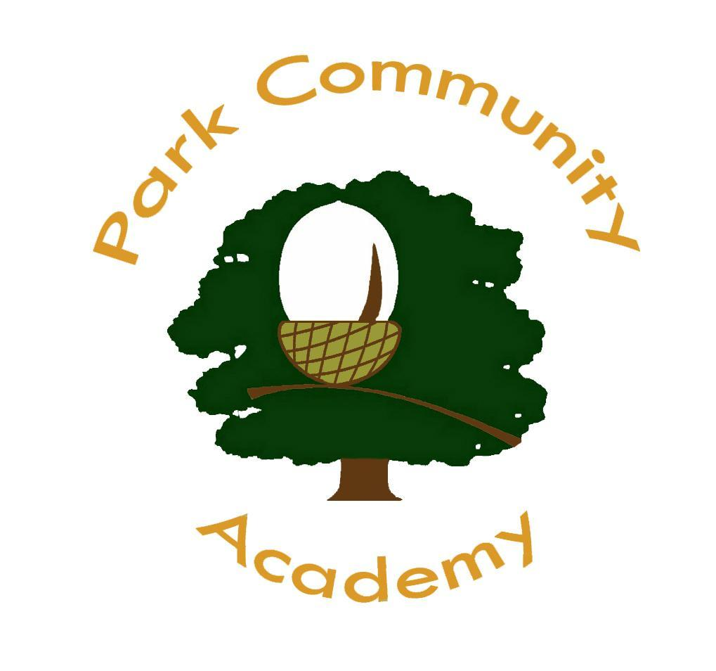

Home-School Agreement

Name: ………………………………..

Date: ………………………………..
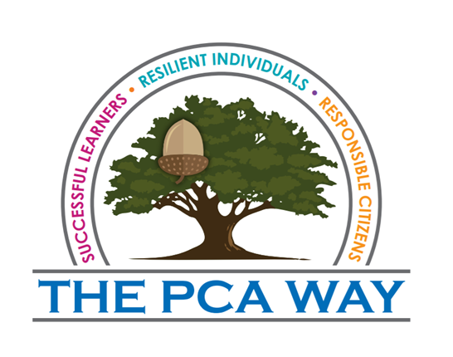
We are the best that we can be
We listen carefully and ask for help when we need it
We look after our school and wear our uniform with pride
We take responsibility for our own actions
We are helpful, respectful and supportive
We treat others how we would like to be treated

Mission Statement

‘We grow together, we learn together, we will achieve our best together’

SUCCESSFUL LEARNERS RESILIENT INDIVIDUALS RESPONSIBLE CITIZENS
Limited Company Registered by guarantee, registered in England No: 08597962
Ewood Campus, Clod Lane, Haslingden, BB4 8HQ

Park Community Academy

We will

- Respect your child as an individual and care for your child’s safety and happiness in a caring, safe and secure environment whilst at Park Community Academy.

- Encourage your child to take an active part in school life so that they make the most of the learning opportunities and extra-curricular activities that may be offered.

- Encourage your child to build good relationships with other pupils and staff, showing respect for all.

- Promote and expect high standards of behaviour and treat any incidents of bullying seriously, in line with the school’s Anti Bullying Policy.

- Promote the use of respectful language and we will not accept or allow offensive language or swearing by pupils at any time.

- Reward regular attendance, good behaviour, hard work and effort.

- Encourage all children to do their best at all times to achieve their full potential.

- Regularly check and monitor your child’s progress and prepare them for external examinations where appropriate.

- Talk to you about your child’s progress during Parents Evenings, their Annual Review, and end of year School Reports.

- Contact you if there is a problem with attendance, punctuality or bringing equipment into School.

- Keep you up to date about general school matters through the school Newsletter and other letters that inform you about any other events happening in school.

Signed: ………………………………... Date: …………………….

Designation: ………………………….
SUCCESSFUL LEARNERS RESILIENT INDIVIDUALS RESPONSIBLE CITIZENS

Parents/Carers

I/We will

- Make sure that my child attends school regularly, on time with the correct equipment and in a smart, clean uniform.

- Provide an explanation if my child is absent (Medical/Hospital appointment), giving advance notice to school whenever possible. This can be done by note, telephone call or through the Passenger Assistant.

- Encourage my child to be friendly, co-operative and respectful to all members of staff and pupils at Park Community Academy.

- Support the School’s Policies and Guidelines for behaviour, offensive language and school uniform.

- Help and support my child with homework and other opportunities for home learning by providing a suitable work environment.

- Inform the school of any concerns or problems which may affect my child’s work or behaviour.

- Attend every Parents Evening, Annual Review and other meetings to discuss my child’s progress. (Appointment times will be arranged with you in advance, however, if you need to cancel in the event of an emergency you will need to contact school and make a mutually alternative appointment time.)

- Respond to communication from School promptly.

- Fully support the school’s policy on travelling to and from school, whether that is independently, by car or on school transport.

Signed ………………………….. (Parent/Carer) Date: …………………

SUCCESSFUL LEARNERS RESILIENT INDIVIDUALS RESPONSIBLE CITIZENS

Pupil

I will

Follow the PCA Way.

- Behave responsibly on my way to and from school.

- Arrive at school and lessons on time and try my best to come to school every day.

- Bring all my school equipment and will look after school equipment and others people’s things.

- Wear the school uniform correctly and be tidy in school and when travelling to and from school.

- Always try my best, behave well in class, not distracting others.

- Be polite, helpful and respectful to everybody.

- Help to keep school clean and tidy.

- Help to keep school safe.

- Do all my homework to the best of my ability and bring it back to school on time.

- Embrace and enjoy all that PCA has to offer.

Signed ……………………………….. (Pupil) Date …………………..

Home School Agreement for Younger Pupils

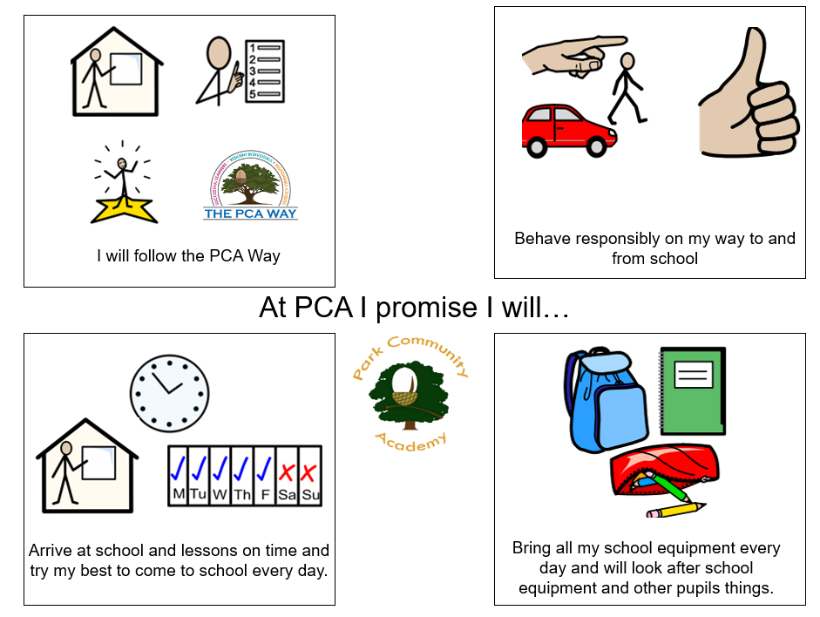

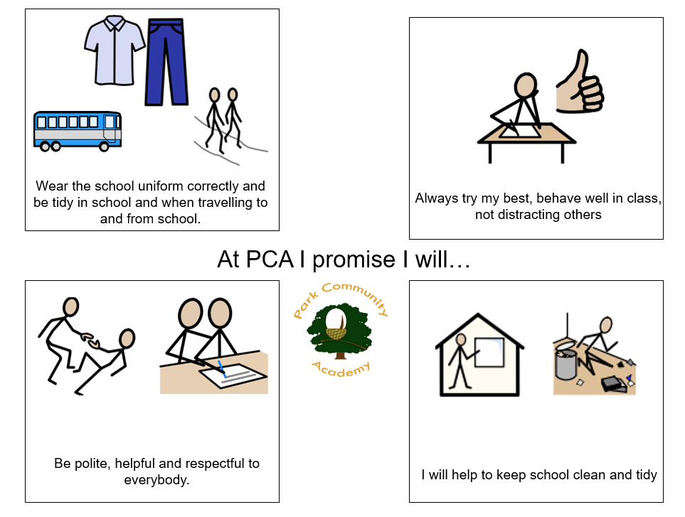

At PCA I will…

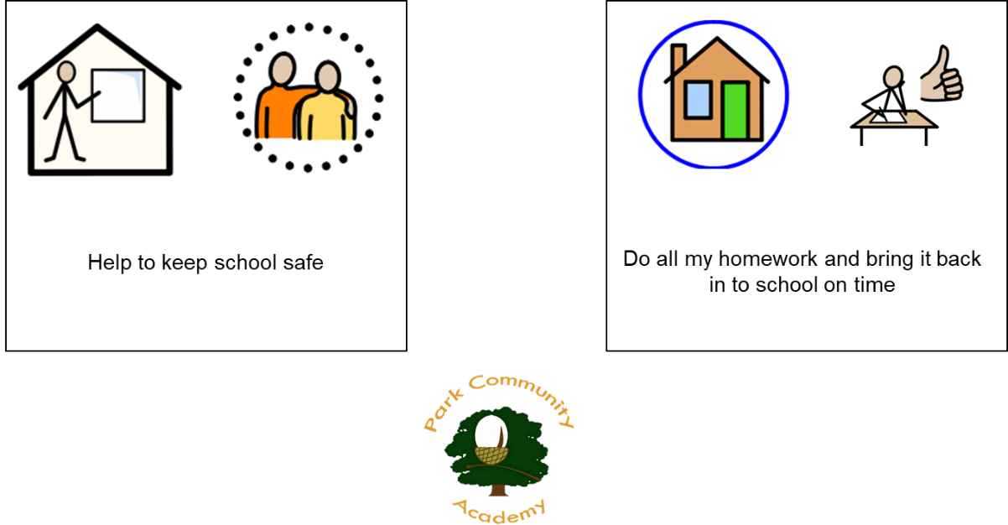

Appendix 2 – The PCA Way

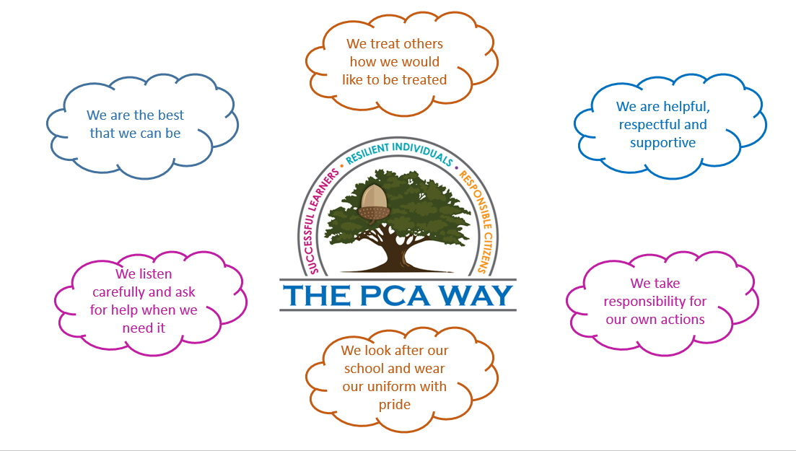

Appendix 3 Behaviour Plan Template

Appendix 4 – Individual Target Sheet example

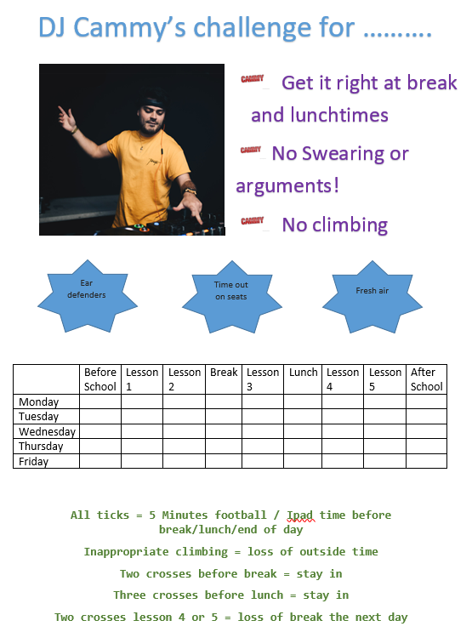

Appendix 5 - Process for Dealing with Drug & Alcohol Related Incidents an in Education Setting

