Park Community Academy - Home Learning

This document is to share relevant information with pupils, parents and carers about how we will provide remote education during periods of school closure, pupil illness or a suspension.
All pupils that attend Park Community Academy have an EHCP and we therefore understand that pupils may not be able to access remote education without support from adults at home. We acknowledge the difficulties this may place on families, and we will continue to work with parents and carers to provide support as and when required.
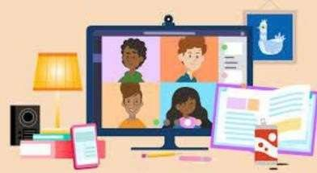
Home learning provision: information for parents
Park Community Academy Home Learning Plan also includes useful information about remote learning. This is available on the school website.

What should my child expect from Home Learning?
Pupils learning from home can access any of the following at any time:

Park Community  Academy Website  (Home Learning tab) | 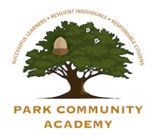 | Numbots | 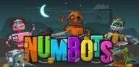
Oak Academy | 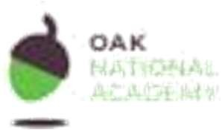 | Oxford Owl | 
BBC Bitesize |  | My Maths | 

Following the first few days of home learning, will my child be taught broadly the same curriculum as they would if they were in school?

Although some lessons are easy to access from home, we would need to make some changes in some subjects. For example, some Science based activities may be altered due to scientific equipment not being accessible offsite. Dance and Drama may also be taught through other subjects.
How long can I expect work set by the school to take my child each day?
Pupils who are working from home will receive a simplified timetable for their class which sets out three lessons per day to include English, Maths and other subjects across the curriculum, which will include Physical Education and PSHE. They will also have daily access to the online learning platforms such as Oxford Owl. It should be noted that pupils who are ill will only be given work at parent/carer request and should only be done if pupils are well enough to do so.

If my child does not have digital or online access at home, how will you support them to access learning from home?
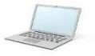
We recognise that some pupils may not have suitable online access at home. We take the following approaches to support those pupils to access learning:

Parents are encouraged to inform us if their child needs additional access to a laptop or a router to support them with learning from home.
Usernames and passwords can be given out again for access to online subscriptions if these have been lost. We will be happy to give them out again.
Pupils can also be provided with home learning work packs where necessary which will be sent home with pupils, posted out to families or hand delivered by Park Community Academy staff.

Other examples of how pupils can work from home include:

- All of the digital platforms mentioned above. 
- Recorded teaching (e.g. Oak National Academy lessons, video/audio recordings made by teachers) 
- Reading books pupils have at home 
- Commercially available websites supporting the teaching of specific subjects or areas, including video clips or sequences 
- Long-term project work and/or internet research. 

- Home Learning Packs where necessary. 

- Suggestions for fun and accessible activities
and tasks that can be completed at home. 

Engagement and feedback:
- If it would support parents/carers whilst their pupils is learning from home, example timetables can be given by classroom staff, alternatively examples are available on the PCA website. 
- An area of the website has been dedicated to home learning with all relevant information accessible, this is under the ‘Students’ tab and ‘Home Learning’. 
- We expect our children and young people to engage with remote education and complete work if they are in a position to do so. 
- We ask our parents and carers to support with home learning in setting routines such as finding a quiet space for them to work and keeping in touch with school. 
- PCA will keep in contact with our families and pupils as and when required. 

The use of AI to support with home learning
Where appropriate, pupils may use AI tools to support their learning at home for research and idea generation provided this is transparent, safe and compliments their own learning, it should not be used to replace the pupils' own work. (This may be more suited to our older pupils)
The use of ICT to support home learning should be closely monitored and supervised by parents and carers, any concerns should be reported.

If your child is learning from home for any reason, please feel free to contact school at any time for advice or support. We will be more than happy to help.

