

Restrictive / Physical Intervention Policy



Reviewed September 2020
Reviewed/updated July 2021
Updated January 2020 (section 7 Covid -19) – to be reviewed September 2021
Reviewed / Updated September 2021
Reviewed June 22
Reviewed/Updated September 2022
Reviewed / Updated November 2023
Reviewed / Updated January 2025
Reviewed / Updated September 2025
Updated March 2026
Reviewed / Updated September 2026

CONTENTS

Date for Policy review

The Legal Context

Accepted Physical Interventions to be used

Placing Physical Intervention in context / Risk Assessment

Reporting and Monitoring of Incidents

Seclusion

Reporting and Recording Seclusion

Training and Authorisation of Staff

Appendices
Appendix 1 – Letter – Use of physical interventions and positive handling
Appendix 2 – Behaviour Plan
Appendix 3 – Individual Risk Assessment proformas
Appendix 4 – Written notification following a restrictive / physical intervention

Physical Intervention Policy

1. Introduction

“The Governors and staff of Park Community Academy aim to provide high quality educational provision in a caring, safe and secure environment for all pupils.”

This policy provides a framework for the use of Restrictive and/or Physical Intervention within Park Community Academy and takes into account information provided in both Section 93 of the Education and Inspections Act 2006, and Restrictive Interventions, including use of reasonable force in schools (guidance in England) April 2026.

The school has trained tutors in the Team Teach method; aims and guidelines central to this approach are incorporated within this policy.

Central to this policy is the understanding that any Physical Intervention used by staff must be in accord with the idea of “Reasonable Force and/or other Restrictive Interventions” and used only as a last resort once all other strategies have been exhausted.

Key Terminology to be considered:

Restrictive Intervention: a means to prevent, restrict or subdue movement of the body or part of the body, of a pupil. The term ‘restrictive interventions’ can be describing both physical and non-physical actions aimed to restrain pupils in different ways.

Reasonable Force: a term used in legislation which includes physical restrictive interventions. All members of school staff have the legal power to use reasonable force in limited circumstances. Reasonable means using no more force than is necessary for the least amount of time, the application of which will depend on the circumstances.

Seclusion: A non-disciplinary intervention involving keeping a pupil confined to a place away from others, and preventing them from leaving either by physical obstruction, blocking, or making them believe they will be punished if they try to leave.

Restraint: a term used in legislation referring to a non-disciplinary intervention which immobilise a pupil or limits their movement. This may or may not include direct physical contact. For example, holding a pupil’s arms to their sides or removing a pupil’s crutches would both be considered forms of restraint.

These terms are not necessarily mutually exclusive categories. Depending on the circumstances, more than one definition could be relevant.

The use of force can only be regarded as reasonable if the circumstances of the particular incident warrant it and the degree of force employed is proportionate to the level of challenging behaviour presented or the consequences it is intended to prevent.

It is essential that any discussion of Physical Intervention is set in the wider context of education and behaviour management; it should not be seen as an isolated technique. For the majority of the time there will be no need for physical intervention and other proactive and reactive strategies can be used to de-escalate situations or prevent inappropriate behaviour.

Parents are fully informed of the school policy on ‘Restrictive/Physical Intervention’ at initial non-prejudicial visits and are given information setting out the context for use at their Home School Agreement with a member of the school’s family team or a member of SMT. (See appendix 1)

2. The Legal Context

The documents that concern us most are the Education and Inspections Act 2006 (Section 93) which sets out guidelines for the use of reasonable force. Alongside the Department for Education’s (2026) Restrictive interventions, including use of reasonable force in schools (guidance for England).

With regards to these documents. When circumstances justify, staff can:

• Hold a pupil using agreed Team Teach techniques,
• Physically interpose between pupils,
• Move a pupil using agreed Team Teach techniques.
- Use force as is reasonable to search for legally prohibited items (as described in PCA’s Search, Screen and Confiscate policy)

Decisions on whether the precise circumstances of an incident justify the use of significant force must be reasonable. Sometimes such decisions have to be made quickly, with little time for reflection.

Examples of situations.
- a pupil attacks a member of staff, or another pupil;
- pupils are fighting, causing risk of injury to themselves or others;
- a pupil is committing, or on the verge of committing, deliberate damage to property;
- a pupil is causing, or is at risk of causing, injury or damage by accident, by rough play, or by misuse of dangerous materials or object;
- a pupil absconds from a class or tries to leave school other than at an authorised time. Refusal of a pupil to remain in a particular place is not enough on its own to justify use of force. It would be justifiable where allowing a pupil to leave would;
  - entail serious risks to the pupil’s safety (taking into account age and understanding), to the safety of other pupils or staff, or of damage to property; or
  - lead to behaviour that prejudices good order and discipline, such as disrupting other classes;
- a pupil is behaving in a way that seriously disrupts a lesson; or
- a pupil is behaving in a way that seriously disrupts a school sporting event or a school visit.
- A pupil is committing a criminal offence

PCA Staff members will complete a dynamic risk assessment before the use of physical/restrictive interventions ensuring that the intervention is Reasonable, Proportionate, Necessary and in the best interests of the pupils.

Where Restrictive/Physical intervention is necessary staff members will use the least amount of force or least restrictive intervention necessary for the least amount of time required to reduce the relevant risks.

3. Accepted Physical Interventions to be used

Listed below are the accepted Team Teach strategies that have been taught to staff. The Team Teach strategies and techniques that each individual member of staff has covered are logged on the Team Teach connect system

A range of personal safety responses to deal with:

Wrist, clothing & Hair grabs
Neck holds
Bites
Punches & Kicks

Guides, escorts and restraints:

These provide a graded and gradual response aimed at intervening with the appropriate amount of reasonable force. Restraints where 2 people are used will be deemed as a more restrictive hold. As the level of physical intervention increases so does the risk of injury to all concerned; staff need to make a dynamic risk assessment based on the situation as to the level at which they are going to intervene.

It is important to note that staff are trained to use the least amount of force or least restrictive intervention necessary for the least amount of time required to reduce the relevant risk.

Techniques for one person.
1 Person Standing / Walking
Acceptable touching
Guiding away
Friendly Hold
Double Elbow
Help Hug
Half-shield / Shield
Small Person Hold to seat (towards beanbag- then accompanied by another adult)

Techniques for two people.
Single Elbow (stationary hold, not to be used to move pupils)
Figure of Four (stationary hold, not to be used to move pupils)
Double Elbow – This can be used to move pupils, but every effort should be made to allow the pupil to sit in an appropriate chair.
Small Person Hold

NB. Ground Recovery holds are the most restrictive and carry the highest risk. Therefore, apart from advanced Team Teach tutors, staff are not taught floor holds. Exceptions may occur if the child is already on the floor when a Physical Intervention has begun.

Training on Physical Intervention given to staff will include sections on the background, theory and rationale behind the Team Teach approach as well as an understanding of personal space and body language before any physical intervention techniques are taught.

Any Physical Interventions used will need to take account of age, cultural background, gender, stature, any medical conditions and/or sensory impairments, and any previous traumas/adverse life events known in relation to the student involved.

4. Placing Physical Intervention in Context / Risk Assessment

Physical Intervention is never seen in isolation at Park Community Academy. It is but one strategy available to staff and should always be seen as a last resort when all other strategies have failed. Physical interventions can be placed in 2 broad categories:

Emergency Interventions

Emergency Interventions will involve staff employing, where necessary, one or a combination of the strategies mentioned in the previous section in response to an incident. This will occur when all other strategies have been exhausted, or the incident requires a rapid physical response.
As outlined in this guidance, Park Community Academy makes Risk Assessments where it is known that force is more likely to be necessary to restrain a particular pupil. These Risks Assessments are undertaken as part of the completion of behaviour plans and Individual Risk assessments.

Planned Interventions and Behaviour Plans

Planned interventions involve staff employing, where necessary, one or a combination of the strategies mentioned in the previous section as an agreed response to an identified behaviour. This will be documented in pupil risk assessments (see appendix 3) and pupil specific behaviour plans (see appendix 2). These plans will be written jointly by the class teacher/key stage leader and a Team Teach trainer where appropriate.

Behaviour Plans will not be needed for all pupils. However, if a pupil has had to be restrained on one or more occasions, a behaviour plan must be put into place for them. Pupils may demonstrate certain behaviours which are causing concern and it is these behaviours which are targeted. Pupils may behave in a manner other than that identified on the Behaviour Plan and in such circumstances Emergency Interventions would need to be undertaken.

Pupil risk assessments and behaviour plans in place for pupils are accessible on share point and are circulated to all Team Teach trained staff by e-mail. Any changes to pupil behaviour plans and/or risk assessments are also shared with staff promptly via email and are discussed with parents/carers periodically and following any significant incident to ensure their input and understanding is taken into account.

Reducing the likelihood of situations arising where use of force and/or restrictive interventions may be required.

At Park Community Academy the use of strategies designed to deal with situations in a non-physical manner are at the forefront of all pupil management.
This can be evidenced by:

- The work undertaken as part of the Team Teach training and ongoing re-training, which focuses on the 95% use of non-physical pupil management methods.
- The Behaviour and Pastoral Policy, which outlines the schools use of positive pupil management, interaction and de-escalation techniques.
- The embedded school ethos of expectations (The PCA Way) to support learners with their choices
- Continual consideration and adaptation to the school and classroom environments to support the needs of the learners
- Closely working with parents/carers to support individual pupils.
- Emotional regulation support e.g. Zones of Regulation
- Ensuring support towards EHCP targets are supported with a pro-active approach with Universal, Targeted and Individualised strategies in each class.
- The development and continual monitoring and adaptation of individual behaviour plans to support pupil’s individual needs.

“Team Teach techniques seek to avoid injury to the service user, but it is possible that bruising or scratching may occur accidentally, and these are not to be seen necessarily as a failure of professional technique, but a regrettable and infrequent “side-effect” of ensuring that the service user remains safe” George Matthew – Team Teach Founder

5. Reporting and Monitoring of Incidents.

Incidents involving Physical Intervention are to be recorded using the school's behaviour-smart recording system.

The Deputy Head teacher responsible for behaviour, reviews the behaviour-smart data termly. The review identifies if additional procedures such as an ‘Individual Behaviour Plan’ need to be implemented or adapted.

When a Team Teach Physical Intervention has taken place (other than ‘acceptable touching’ and ‘friendly hold’) a behaviour smart physical intervention report will be completed, detailing:

- Date, time, location and approximate duration of intervention,
- Name of child,
- Pupils class and year group,
- Name of staff involved,
- Brief account of the incident
- Reasons for intervention (why was physical intervention deemed necessary),
- Description of lead up to intervention (with identified or potential triggers if known),
- De-escalation techniques used,
- Forms of physical intervention used,
- Details if pupil was injured during intervention and medical treatment given,
- Follow up action taken (including any post incident report),

Incidents will be recorded as soon as practicable after the event by the staff member(s) involved and they will endeavour to do this on the same day.

PCA staff record all incidents of inappropriate conduct on the schools chosen reporting system following the ABCD model:

A – Antecedents
B – Behaviour
C – Consequence
D – Next steps (this allows staff the opportunity to reflect and put forward how the future use of restrictive/physical interventions may be avoided in the future).

Parents/carers or in some cases the Local Authority will be contacted on the day of the incident (or as soon as practicably possible) and informed of:
- Time, date, location and approximate duration of the intervention
- Brief account of why the intervention was assessed as necessary in that instance
- Brief account of what type of force was applied, and the degree of force
- Details of any physical injuries sustained, if applicable

A written notification (See Appendix 4) with these details will be communicated through either the school's Arbor system, email or the pupil's home school diary.

6. Seclusion

Seclusion is a non-disciplinary intervention involving keeping a pupil confined to a place away from others and prevented from leaving.

Seclusion is only used as a safety measure to protect others from harm when a pupil is experiencing high levels of emotional or behavioural dysregulation. In such circumstances the pupil is not acting with intent.

If seclusion takes place, the area used will be one of the safe spaces at PCA. In the event of seclusion taking place, as soon as the immediate risk of harm has reduced the pupil will be supported to leave the safe space.

7. Recording and Reporting Seclusion

All incidents of seclusion will be recorded on the schools CPOMs system as soon as practicably possible after the event by the staff members involved who will endeavour to do this no later than the same day.

The following information will be recorded:
- Names of pupils and staff directly involved
- Time, date, location and approximate duration of the intervention
- Brief account of why the intervention was assessed as being necessary
- Details of any physical injuries sustained, if appropriate
- Any post incident support

Parents/Carers will be notified following any incidents of seclusion that have occurred. However, in some cases, the Local Authority will be notified as an alternative.

8. Training and Authorisation of Staff

The staff to which the power to use reasonable force are defined in Section 95 of the Education and Inspections act 2006. They are-

- any teacher who works at the school,
- any person whom the head teacher has authorised to have control or charge of pupils, This:
  - Includes support staff whose job normally includes supervising pupils and learning mentors
  - Can also include people to whom the head teacher has given temporary authorisation to have control or charge of pupils, such as paid members of staff whose job does not normally involve supervising pupils.

Only staff who have satisfactorily completed Team Teach training are authorised to use the taught Physical Intervention techniques. A list of staff who have completed this training is held on both the Team Teach connect system and also the school’s internal training log. Once staff have received their full training, refresher training will take place annually in accordance with Team Teach guidance.

Training is treated as a high priority for newly appointed staff. Staff who are not trained are offered guidance and support by trained members of staff during the interim period in relation to de-escalation techniques and behaviour management strategies. Staff do not engage in the physical side of Team Teach at all until fully trained to do so.

Appendix 1 - Letter – Use of physical interventions and positive handling


Successful Learners, Resilient Individuals, Responsible Citizens
Headteacher: Mrs G Hughes
Deputy Headteacher: Miss H Gardiner
Deputy Headteacher: Mr B Whittaker
158 Whitegate Drive
Blackpool FY3 9HF

Telephone: (01253) 764130

Fax: (01253) 600670

Email Address: admin@park.svt.org.uk

Website: www.park.blackpool.sch.uk
Dear Parent/Carer,

Use of Restrictive and/or Physical Interventions

All Staff at Park Community Academy have completed a rigorous training programme in the positive management of child aggression and disruption. This includes a variety of supportive strategies to help a child who has lost control and is in crisis. Staff will take control of the situation using safe physical intervention methods designed specifically for children. Such interventions are carried out within a legal framework agreed with the Local Education Authority and would be applied in the following situations:
To prevent or stop a pupil from:
- causing injury to themselves or others
- Committing a criminal offence
- Damaging property
- Causing disorder among pupils at school, whether during a teaching session or otherwise

Wherever staff use physical interventions, you will always be informed in writing, and staff will also discuss the reasons for the interventions and the restorative steps taken after the incident.
Park Community Academy has a Restrictive / Physical Intervention Policy which is available to all parents/carers.
If you wish to discuss this matter further, please do not hesitate to contact me at school.
Yours sincerely
G Hughes
Headteacher


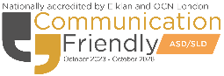


Registered Charity No 1091560
Limited Company Registered by guarantee,
registered in England No: 08597962
Ewood Campus, Clod Lane, Haslingden, BB4 6LR



Appendix 2 - Behaviour Plan

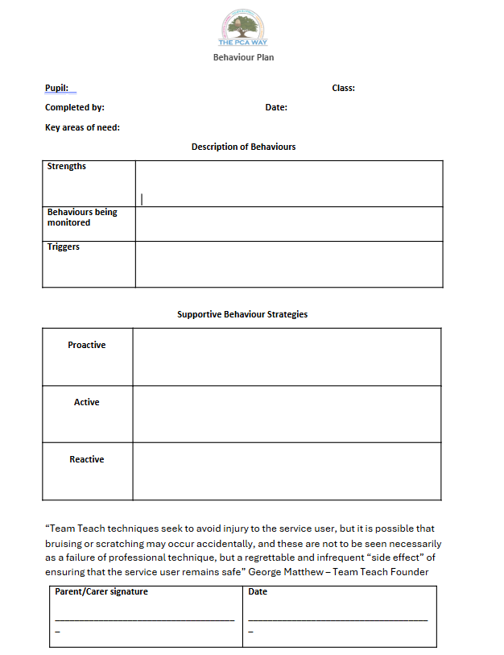

Appendix 3 - Risk Assessment template

Park Community Academy Individual Pupil Risk Profile
CHILD’S NAME: COMPLETED BY: |  | DATE:
NATURE OF RISK | CHARACTERISTICS WHICH MAY LEAD TO RISKS | ACTIONS OR PRECAUTIONS REQUIRED
Date Reviewed: Signature |  | Essential Requirements:  School Medical records to be provided prior to any medical treatment being administered.  Assigned adult during off site activities.

Appendix 4 – Example of a written notification following and incident of Restrictive / Physical intervention

Name:
Date:
Time:
Location:
Approximate duration of intervention:
Reason/s for interventions:

Type of restrictive/physical intervention applied:

Were there any physical injuries?

