

**Park Community Academy**

**Apprentice Teaching Assistant**

**Candidate Information Pack**



“We grow together, we learn together, we will achieve our best together”

**CONTENTS**

|  |  |
| --- | --- |
| Advert | 3 |
| Welcome from the Chief Executive Officer – The Sea View Trust | 4 |
| Letter from the Chair of Governors - Park Community Academy | 5 |
| Letter from the Headteacher – Park Community Academy | 6 |
| Application Procedure | 7 |
| Overview of the Trust and Academy | 8 |
| Appendix 1 Job Description | 13 |
| Appendix 2 Person Specification | 14 |



**Applications are invited for:**

**Apprentice Teaching Assistants**

**x 5 positions working in the Primary/Secondary department**

**Temporary 18 month training contract**

**37 hours per week TTO**

**Pay scale Apprenticeship rates:**

**£4.81 - £9.50 per hour dependent on age**

An apprentice in the first year of their apprenticeship is entitled to an hourly rate of £4.81. An apprentice who has completed the first year of their apprenticeship is then entitled to a minimum hourly rate dependant on their age as follows:

| **23 and over** | **21 to 22** | **18 to 20** | **Under 18** | **Apprentice** |
| --- | --- | --- | --- | --- |
| £9.50 | £9.18 | £6.83 | £4.81 | £4.81 |  |

* **OFSTED May 2018 – Judged to be an ‘Outstanding School’ in all areas**

***‘This school, above all else, is a happy and life affirming place in which to learn and work’***

* **“*The school’s values radiate from every member of the school community’***
* ***‘All groups of pupils make exceptional progress at this remarkable school’***

These posts are to work with teachers as part of a professional team to support teaching and learning for pupils with SEND providing specialist assistance to pupils who need particular help to overcome barriers to learning, such as those with moderate, severe, profound and multiple learning difficulties and/or behavioural, social, communication, sensory or physical disabilities.

The successful candidates will need to have:

* Good Maths and English skills
* Good communication skills
* A knowledge and/or specific interest in working with pupils of Primary and/or Secondary age.
* A willingness to undertake training and actively seek learning opportunities
* The skills and flexibility to work within other Key Stages of the School when required,to facilitate a staff rotation programme which will meet the changing and challenging needs of the pupils.

The school has an outstanding record for the career progression of Support Staff through Foundation Degree Study, HLTA status and the Graduate Teacher Training Programme.

***Applications will be welcomed from Recently Qualified Graduates who are considering careers in teaching and looking to initially enhance their school based experience.***

**Closing date: 13th June 2022 at 9.00am**

**Shortlisting: 13th June 2022**

**Interview dates: 16th and 17th June 2022**

**Start date: September 2022**

|  |  |
| --- | --- |
| **The Sea View Trust**  **Ewood campus, Clod Lane, Haslingden, BB4 6LR**  **Tel: 01706 214640**  **Chair of the Trust: Mr D Wallbank**  **Chief Executive Officer: Ms A Y Holdsworth**  **Company Secretary: Mrs N Wilkinson** | **O:\Academy Folder\MERGER\Logos\sea_view_trust_1.png** |

Dear Prospective Candidate,

**LETTER FROM THE CHIEF EXECUTIVE**

Many thanks for considering a role with the Sea View Trust and we are delighted that you are interested in working for us. We envisage that you will share our interest in improving education for all, and our passion for making a difference, so that together we can ensure that we provide the best possible outcomes for all of our learners.

The Sea View Trust is a relatively young organisation and we strive for continuous improvement. Although we are a newcomer, we constantly engage with new initiatives and are already growing our reputation locally, regionally and nationally as an inclusive and collaborative Trust where children and young adults can thrive.

Please be assured that the entire Trust team, both class and non-class based staff, are energetic and enthusiastic about our schools. Our Trust works with many children and young adults who are disadvantaged, either through deprivation or because of additional needs causing barriers to learning. We therefore welcome opportunities to work collaboratively together, maximising skills and available resources to make an even greater difference to all of our learners and their families.

Our Trustees, Governors, Central Team and Academies all recognise that welcoming new staff broadens and deepens our pool of expertise. We therefore hope that the information contained within this application pack will be useful to you and will inspire you to apply. Meanwhile, I would like to thank you once again for expressing an interest and we hope to welcome you as a new member of our team.

Yours sincerely,



**Angela Holdsworth MEd SEN, PGCert Academic Practice, NPQH**

CEO Sea View Trust



Dear Candidate,

**LETTER FROM THE CHAIR OF GOVERNORS**

Thank you for your interest in the position of Apprentice Teaching Assistant at Park Community Academy. Our governors, staff, pupils and their families are incredibly proud of our school. In 2018 OFSTED said, “All groups of pupils make exceptional progress at this remarkable school because governors, leaders and staff ensure that every effort is made to provide each individual pupil with the personalised support necessary for them to thrive”. At PCA, we aim to provide high quality education for all our children in a safe and secure environment which reflects care, happiness, enjoyment, and success.

Park Community Academy is a member of The Sea View Trust and first converted to Academy status in September 2013. It is a Special Academy catering for children and young people aged from 2 to 19 years. There are currently 307 pupils on roll and Blackpool Children’s Services are the Admissions Authority. The children all have an Education Health and Care Plan and have a range of learning needs. The school is set in a pleasant area, close to Stanley Park.

Our inspirational Headteacher, Mrs. Gill Hughes, took over her role in January 2021, following seven very successful years as our Deputy Headteacher. Staff turnover is extremely low, so this is a rare opportunity to join a vibrant, thriving, happy and successful school, which has been judged as Outstanding by OFSTED on four occasions. We are very excited about the future of the school and look forward to working with our leadership team to see it develop further within the Sea View Trust.

As a governing body, you can be assured that we are extremely dedicated to the school and highly supportive of our leadership team and all our staff, who are a major strength of the school. This will be a challenging and rewarding role for the successful candidate and the Governors are fully committed to providing the successful candidate with all the challenge and support needed to be effective and successful in the post. The Governing Body encourages and supports the take up of opportunities for continuing professional development.

Visits to our school will be offered to shortlisted candidates, where social distancing can take place. To find out more detailed information about our wonderful school, please take time to view our website and have a look at our Twitter feed @PCABlackpool.

On behalf of the Governing Body, thank you again for your interest in this position and we look forward to receiving your application.

Yours faithfully,



**Mrs S Fielder**

Chair of Governors



Dear Candidate,

**LETTER FROM THE HEADTEACHER**

Thank you for your interest in the position of Apprentice Teaching Assistant at Park Community Academy, I am delighted that you are considering joining us.

Park Community Academy is a vibrant, happy and successful school with dedicated staff who provide high quality education for all of our children and young people in a safe and secure environment which reflects care, happiness, enjoyment and success. Pupils who attend PCA have a wide range of learning needs including moderate to severe learning difficulties, complex learning difficulties associated with Autistic Spectrum Conditions and speech and language difficulties, sensory impairment, some complex medical needs and varying degrees of social, emotional and behavioural needs associated with their Special Educational Needs and Disability. All of the children and young people have an Education, Health and Care Plan. PCA caters for pupils aged between 2 and 19.

Our curriculum is designed to enable the children and young people to be the very best they can be. The curriculum not only provides our children and young people with a broad and balanced academic offer, leading to a wide range of accreditation opportunities, but also one which prepares them for adult life. Throughout their time at PCA children and young people are introduced to the world of work, taught independence skills and encouraged to live an active and healthy lifestyle. Learning outside the classroom, residential opportunities, extra curricular activities and a wide range of after school clubs are a key component of our offer, alongside enrichment opportunities through the creative and performing arts, National Citizenship Award, student leadership and the D of E award scheme.

If you wish to discuss the post, or to find out more about Park Community Academy, I would be delighted to hear from you. Please do contact me directly via e mail ([gill.hughes@park.blackpool.sch.uk](mailto:gill.hughes@park.blackpool.sch.uk)) or the school office: 01253 764130. Meanwhile, we very much look forward to receiving applications from outstanding practitioners with relentless drive, enthusiasm and resilience, who would enjoy working with a highly motivated and effective staff team.

Best wishes,

**Mrs Gill Hughes**

Headteacher

**Application Procedure**

**Further Information**

For a confidential discussion about The Sea View Trust, please do contact:

**Angela Holdsworth (CEO)**

Telephone: 01706 214640

Email: a.holdsworth@theviewtrust.org

For an informal discussion about the academy, you are warmly invited to contact:

**Mrs Gill Hughes (Headteacher)**

Telephone: 01253 764130

Email: gill.hughes@park.blackpool.sch.uk

**Application Form**

Please complete the Park Community Academy’s application form, available from recruitment@park.blackpool.sch.uk

Completed application forms, with a covering letter of application, are returnable to:

Louise Gilligan, Academy Business Lead - recruitment@park.blackpool.sch.uk

**Application Deadlines**

Closing date: 13th June 2022 at 9.00am

Shortlisting: 13th June 2022

Interviews: 16th and 17th June 2022

Start date: September 2022

Prospective candidates are advised that they will be contacted with details of the interview process as soon as possible after the shortlisting process.

**Safer Recruitment**

The Sea View Trust is an equal opportunities employer and welcomes applications from all sectors of the community. We are committed to protecting our students and staff and therefore have a rigorous recruitment process that includes assessing candidates’ suitability to work with children.

The academies within our Trust are committed to safeguarding and promoting the welfare of pupils and expects all staff and volunteers to share this commitment.

All staff will be required to hold an enhanced DBS Disclosure.

*To ensure compliance with Safer Recruitment Guidelines, CVs will not be accepted.*

**Equal Opportunities**

At our Trust we believe that all individuals are of equal value and we are committed to equal opportunities for all. All people who work and study in the Trust have the right to be respected and valued within a safe and secure environment and not to be discriminated against on the grounds of age, class, sex, race, disability, sexual orientation and religion or belief.

**Overview of Park Community Academy**

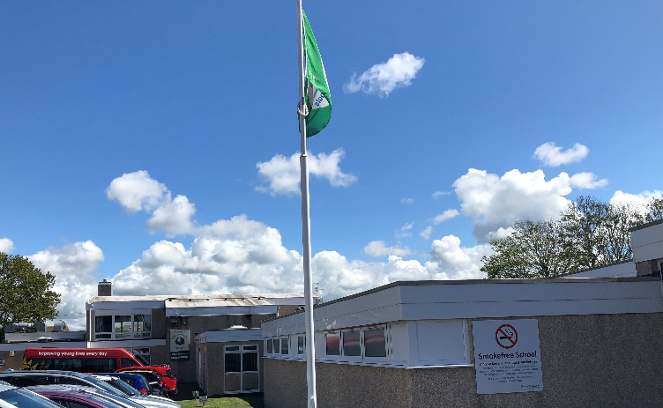

**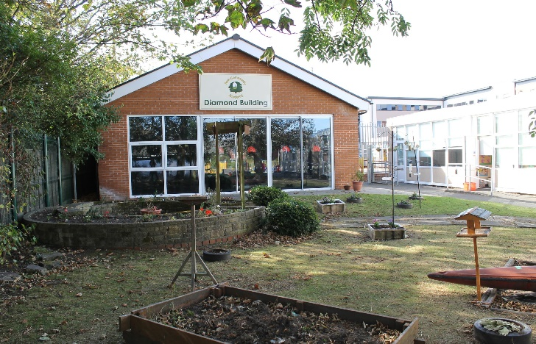**

**INTRODUCTION**

Park Community Academy is a Community Special Academy for pupils aged 2 - 19 years from Blackpool and surrounding areas. Blackpool Council’s Children and Young People’s Department have retained their statutory duties with regards to admitting children into the Academy and there are currently 323 pupils on roll.

From September 2015, the Local Authority commissioned Park Community Academy to deliver post-16 provision for pupils with Special Educational Needs. This is co-located provision with Woodlands School situated off site, based at Westbury Sixth Form Centre.

**LOCATION**

The Academy is situated in a pleasant area of the well-known seaside resort of Blackpool, approximately one-mile inland from the town centre and sea front. Nearby is the large open space and recreational and sports area of Stanley Park, and in close proximity to the Whitegate Drive Health Centre and Woodlands School for pupils with SLD/PMLD.

**WESTBURY SIXTH FORM CENTRE**

Westbury Sixth Form Centre provides a nurturing environment in a strong pastoral setting. It utilizes a holistic learning approach to maximize inclusivity and provides real opportunities for students to develop those all-important employability skills. WSFC’s mission is to provide students with outstanding teaching and learning that will prepare them for the start of their adult life.



**THE PUPILS**

All pupils attending PCA have an Education, Health and Care Plan. The children and young people have a range of learning needs associated with moderate to severe learning difficulties, complex learning difficulties (including autistic spectrum disorders), sensory difficulties and associated social emotional and behavioural difficulties and challenging behaviours. Many are admitted from local mainstream Schools or Nurseries. However, because of the nature of Blackpool, there is a significant transient population, and some pupils move into the area with only partly completed statements or EHCP’s. Children are regularly admitted at any time throughout the academy year.

 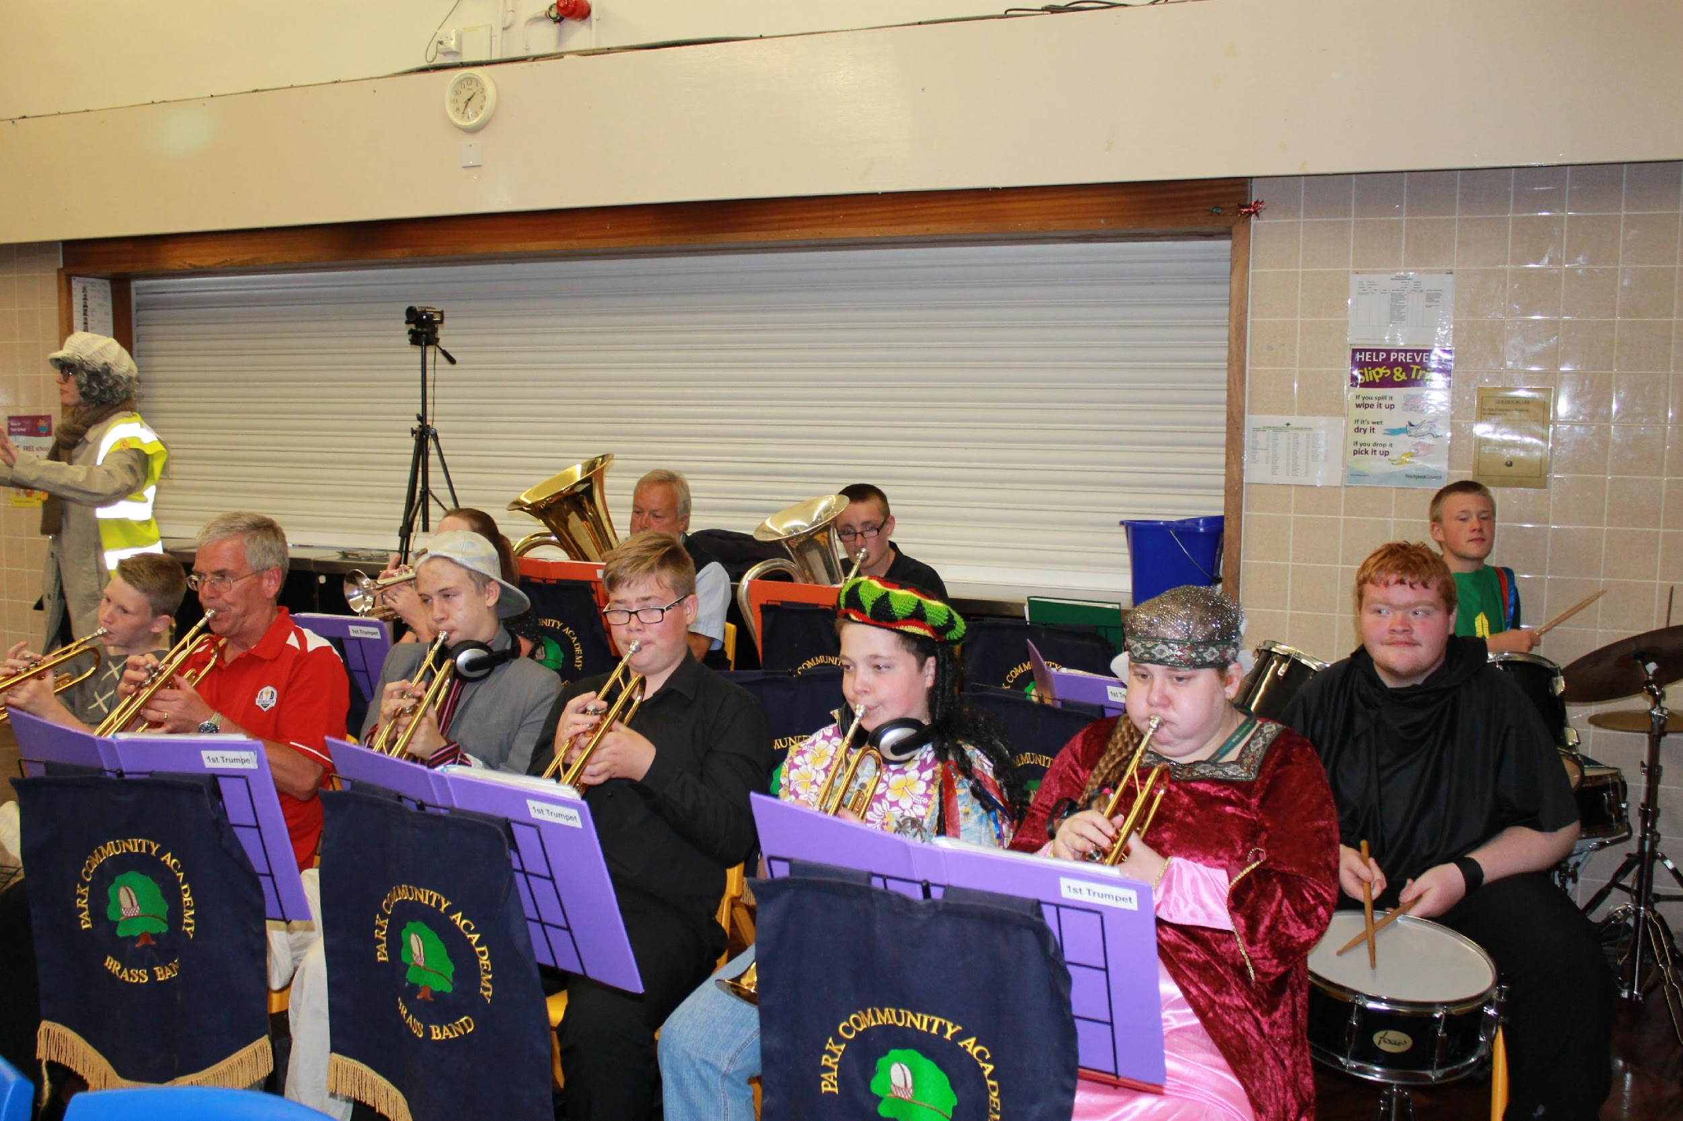

Our pupils have access to a broad and balanced curriculum, adapted to meet the needs of each individual. In addition to gaining language, mathematical, scientific, technological, artistic, and physical skills, our aim is for children to build confidence, develop self-reliance, learn to make decisions, and develop the ability to express feelings and ideas.

We attach great importance to the personal, social and moral development of pupils, seeking to enable them to build positive relationships with other pupils and adults, and to be sensitive to the feelings and needs of others. We work hard to ensure that all pupils feel good about themselves, acquiring a high level of self-esteem to promote self-confidence.

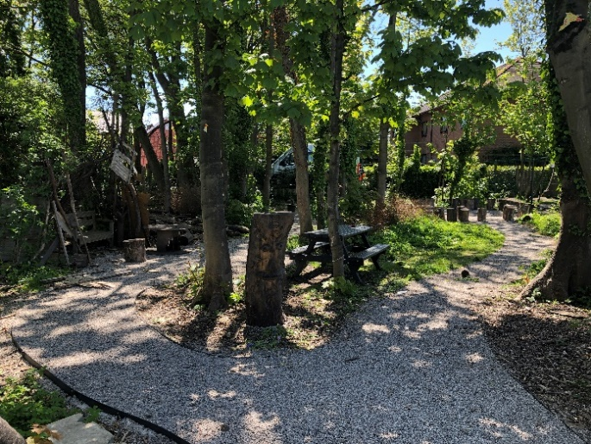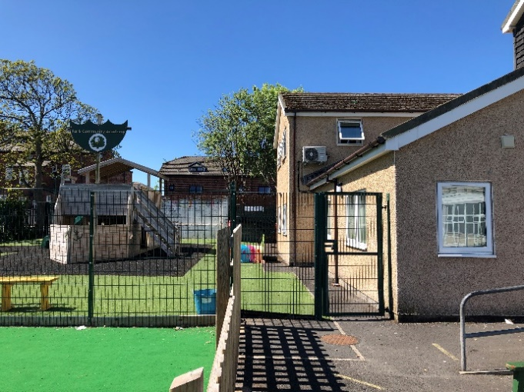

**THE BUILDINGS AND SITE**

The original school opened in September 1960, and the architecture reflects the style of that period. Since this time, there has been significant investment and development, resulting in a site that now has numerous specialist areas, located both in integrated and outlying teaching spaces.

Outside is a large playing field, a floodlit Multi Use Games Area (MUGA), a smaller MUGA for primary pupil use, a trim trail, a separate playground for early years, primary and secondary pupils and 3 separate car parking areas.

Subject to availability and Covid restrictions permitting, interested candidates are invited to tour the academy site and buildings with the Headteacher who can further explain any recent developments.

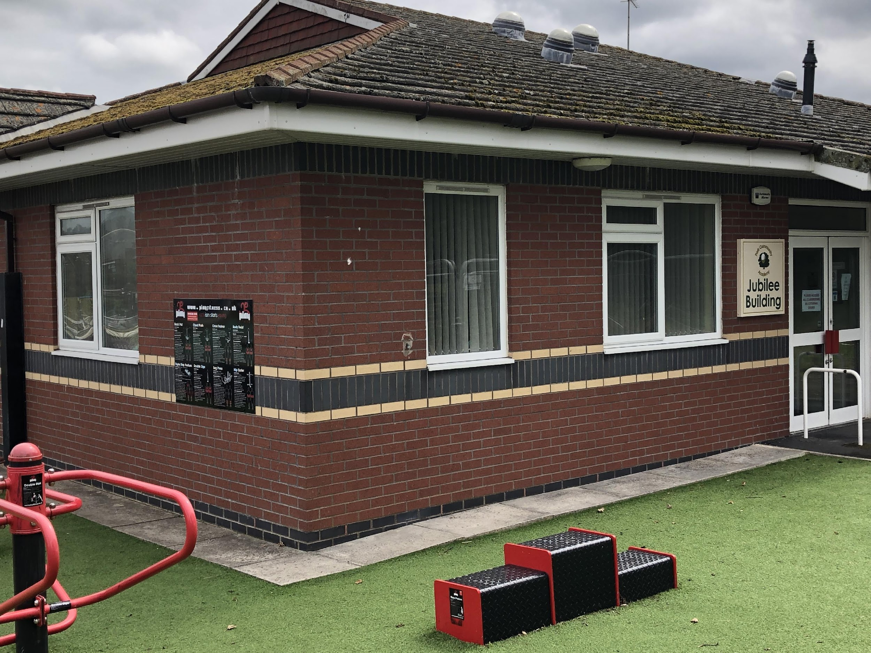 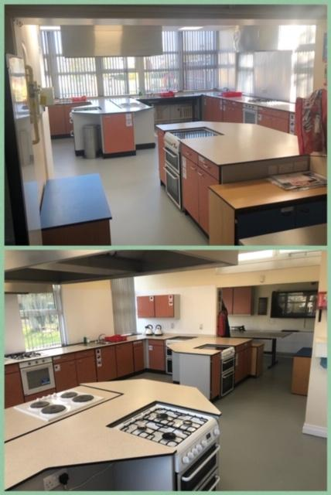

**OFSTED INSPECTION**

The academy was last inspected in May 2018 and was judged as **‘Outstanding’**. It was also judged as ‘Outstanding’ in its previous full Inspections in May 2015, October 2009 and May 2007.

For further information about the strengths of our academy, please visit the Ofsted website to read the full report: [www.ofsted.gov.uk](http://www.ofsted.gov.uk) – ‘schools’

**ACADEMY ACHIEVEMENTS**

Park Community Academy is proud to have received several accolades and more information about this can be found on the Park Community Academy website.

**TRUST CURRICULUM STATEMENT**

The Park Community Academy curriculum is driven by the curriculum statement of The Sea View Trust. This places emphasis on providing a formal developmental and additional curriculum, relevant to each learner’s needs.

Pupils will have access to the Foundation Stage and the full breadth of the National Curriculum, having due regard for the relevance to each pupil at their particular age and development level.

**ACADEMY ORGANISATION**

The Academy is organised into the five stages of education defined by the National Curriculum:

KEY STAGE 1: Yrs. R, 1 and 2 Lower Primary

KEY STAGE 2: Yrs. 3 to 6 Upper Primary

KEY STAGE 3: Yrs. 7 to 9 Lower Secondary.

KEY STAGE 4: Yrs. 10 and 11 Upper Secondary.

KEY STAGE 5 Years 12, 13 and 14 Sixth Form

**THE STAFF**

The teaching staff compliment is organised into five teams, one for each of the Key Stages. The teams also include Nursery Nurses or Special Support Assistants and Apprentice Teaching Assistants who work closely with the teachers. The work within each Key Stage is organised by a senior team member, a Team Leader.

All teaching staff have leadership responsibilities for curriculum areas across the whole academy, at either primary or secondary level. Class based support staff are integral members of the teaching teams and all are supported by dedicated groups of non-class based staff. The academy also promotes, in conjunction with a partner training agency, a highly successful apprentice Teaching Assistant training programme.

**Pupils**

The pupils are organised into tutor groups or “classes” with children of similar age and need. The class teacher (or form tutor) has direct day to day responsibility for maintaining an overview of the pupil’s well-being, together with their progress and care. Older learners experience a number of subject specialists, in line with mainstream models.

*Every effort is made to promote the inclusion of our pupils within the mainstream sector where appropriate and this work is developing still further.*

**Break-times**

During break times, the pupils and students mix socially within their own age bands.

**College Link Courses** **and Accreditation**

Students in Years 11 to 14 access mainstream college link courses and the academy offers a range of accreditations.

**Parents and Carers Partnership**

PCA works in close partnership with families.

**Children and Family Support Team**

The Children and Family Support Team is a key team within the pastoral care system of the academy, comprising of a Children and Family Support Manager and a support worker. Both work with academy based colleagues, individual families, and external agencies to further develop home school relations. This promotes a high-quality educational provision for all pupils, in an environment that reflects care, happiness, enjoyment and success. The academy also has Lead Learning Mentors to further support the mental health and wellbeing of our learners.

**Other Multi Agency Staff**

PCA has access to a School Nurse Practitioner (SNP), for one day per week, who supports the academy in addressing health related issues. The SNP delivers health related programmes across the academy to promote healthy lifestyles and good health, conducts health assessment of individuals, maintains a ‘health surveillance’ and leads on health promotion; this ensures that both local and national Public Health initiatives are met.

**OUT OF SCHOOL CARE**

The academy is an OFSTED registered provider of Out of School Care and, in normal circumstances provides clubs three nights per week, completely free of charge. A variety of sessions are offered, including a range of sports, leisure, recreational, musical, art and technology based activities for pupils of primary and secondary age. In July 2007 the academy’s Summer Activity Scheme was also inspected by OFSTED. The overall quality and standards of care provided by the academy were judged as ‘Outstanding’ in all areas. The full report can be viewed at [www.ofsted.gov.uk](http://www.ofsted.gov.uk) – ‘out of school care.’

|  |  |  |
| --- | --- | --- |
| **JOB DESCRIPTION**  Duties will include the following:-   * Work with individuals or groups of pupils in the classroom * Assist with delivering learning activities * Provide feedback to pupils * Support pupils to understand instructions * Support the teacher in behaviour management and keeping pupils on task * Physically assist pupils in activities * Responsible for the careful and safe use of specialist equipment e.g. standing frames, sensory equipment. * Support children’s learning through play   Skills Required   |  | | --- | | * Good numeracy and literacy skills * Basic understanding of child development and learning * Good communication skills * Willingness to undertake training and actively seek learning opportunities * Ability to relate well to children and adults * Work constructively as part of a team, understanding classroom roles and responsibilities and your own position within these | | * Punctual * Reliable * Excellent attendance record * Team Player * Friendly and approachable | |

**Person Specification**

**Apprenticeship – Teaching Assistant Post**

|  |  |  |
| --- | --- | --- |
| **Post title** | **Apprenticeship – Teaching Assistant** | |
| **School** | **Park Community Academy** | |
| **Hours/contract type** | **37 Hours per week, Term time only** | |
| **Skills**  Basic understanding of child development and learning  Willingness to undertake training and actively seek learning opportunities  Ability to relate effectively to children and adults  Ability to work constructively as part of a team, understanding classroom roles and responsibilities and your own position within these | | **Essential/**  **Desirable**  E  E  E  E |
| **Knowledge**  Effective use of ICT to support learning  Use of other technology  Knowledge of relevant policies/codes of practice/legislation  General understanding of National Curriculum and other basic learning programmes | | E  E  E  D |
| **Experience**  Working with or caring for children of relevant age within the 2 – 19 age range  Previous experience of providing in class support on an individual or whole class basis | | E  D |
| Qualifications  Good Maths and English skills  A Level 2 Qualification in Teaching Assistance | | E  D |