Before 9am | Wake up | 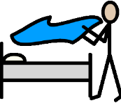  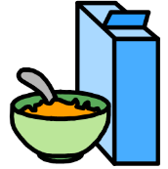 | Have breakfast  Get dressed  Brush your teeth  Make your bed  Tidy your room
9 – 10am | Exercise time |  | If possible – morning walk. See ‘Being Active at Home’ ideas.
10 – 11am | Learning time |  | No electronics  Complete a Maths and/or English activity from ‘Primary learning ideas’.
11 – 12pm | Creative time |  | Lego, drawing, colouring, craft activities, singing, music, cooking/baking together.
12 – 1pm | Lunch time |  | After eating – controlled electronics  iPads/tablets, computers and games consoles. Please remember online safety and supervise your children.
1 – 1:30pm | Exercise time |  | See ‘Being Active at Home’ ideas.
1:30 – 2:30pm | Learning time |  | No electronics  Complete a Maths and/or English activity from ‘Primary learning ideas’.
2:30 – 3pm | Quiet time |  | No electronics  Read a story together or play a board game
3 – 4pm | Fresh air |  | If possible – spend time outside and get some fresh air.
4 – 5pm | Electronics time |  | Supervised electronics  Supervised educational games/apps – see your child’s logins and password for links.
5 – 6pm | Tea time |  | Have tea, relax and prepare for bed time with a bath/shower and story.

