Welcome to our information report for pupils with Special Educational Needs and Disabilities (SEND). All governing bodies have a legal duty to publish information on their website about the implementation of the policy for pupils with SEND. This information is updated annually and is done so in accordance of the Equality Act 2010 and the SEND Code of practice 2014
At Penwortham Priory Academy we value all members of our school community. Our Local Offer has been produced with pupils, parents and carers, governors and members of staff. We welcome your comments on our offer, so please do contact us. The best people to contact are.
Special Educational Needs Coordinator (SENCO) – Mrs A Holland Principal – Mr M. Eastham
SEND Trustee – Mrs S Brown

- Our approach to teaching learners with SEND
At Penwortham Priory Academy we ensure that all pupils are equally valued by having equal access to a broad and balanced curriculum, which is differentiated to meet individual needs and abilities.
  - We have effective management systems and procedures for SEND, taking into account the current Code of Practice (2014) and the Equality Act 2010.
  - We have successful communication between teachers, children with SEND, parents / carers of SEND children, intervention group leaders and outside agencies.
  - We acknowledge and draw on parents’ knowledge and expertise in relation to their own child.
  - Pupils are encouraged to take an increasingly active role in their review cycle, in line with their readiness to do so.
  - We are committed to develop the knowledge and skills of all staff to manage and meet the range of needs within the school, and to ensure that all support is of a high quality.
  - We have an effective review cycle which allows us to monitor, review and plan for the next steps in an individual’s development.
  - We ensure that consideration of SEND crosses all curriculum areas and all aspects of teaching and learning.

- Special Educational Needs Coordinator
The Special Educational Needs Coordinator, Mrs Amanda Holland is responsible for co- ordinating the provision of special educational needs throughout the school. This includes:
  - Overseeing the day to day operation of the SEND policy.
  - Providing leadership, advice and support to staff in the area of special educational needs.
  - Working alongside staff to assist them in identifying and planning for children’s needs and ensuring that pupils make progress.

  - Assisting in the monitoring and evaluation of the progress of pupils with SEND, through use of existing school assessment information, e.g. termly assessments, CATs, FFTD, Internal tracking etc.
  - Overseeing and maintaining specific resources for special educational needs.
  - Liaising with outside agencies and providing a link between these agencies, class teachers and parents/carers.
  - Contributing to and, where necessary, leading the in-service training of staff.
  - Monitoring, evaluating and reporting on the provision for pupils with SEND to the governing body, in conjunction with the Governor for Special Needs.
  - Overseeing the management of the school’s SEND register and SEND records.
  - Ensuring that pupils identified with SEND are listed in the SEND Register and in SIMS.
  - Co-ordinating access arrangements for SEND pupils during CATs, GCSEs and internal assessments.
  - Carrying out detailed assessments and observations of pupils with specific learning difficulties.
  - Liaising with the Learning Manager, the Inclusion Manager, and the Learning Support Assistants.
  - Liaising with the SENCOs in feeder primary schools and Further Education Providers to ensure a smooth transition from one stage of education to the next.
  - In conjunction with class teachers, liaising with parents/carers of pupils with special educational needs, so that they are aware of the strategies being used and encouraging them to be partners in the process.
  - Leading SEND Reviews and managing all statutory documentation relating to special educational needs.

Staffing
Based within school the SEND department has four SEND staff, responsible for the 1:1 and small group interventions.
  - SENCO – Mrs Amanda Holland
  - Learning Manager – Mrs Jan Naylor
There are also four Teaching Assistants whose role is to support within the classroom setting.
Teaching Assistants – Level 2 | Teaching Assistants – Level 3
Mrs Janet Ali  Miss Jennifer Atkinson  Miss Emily Whaite  Miss Lucy Courtney-Brindle  Mrs Sarah Kolacz | Mrs J Simpson  Mrs Fiona Whalley  Mrs Sarah Dixon  Mrs Sarah Eastham

Identifying the Special Educational Needs of pupils
At different times in their school life, a child or young person may have a special educational need. The Code of Practice 2014 defines SEND as follow:

“A child or young person has SEND if they have a learning difficulty or disability which calls for special educational provision to be made for him or her. A child of compulsory school age or a person has a learning difficulty or disability if he or she:
- Has a significantly greater difficulty in learning than the majority of others the same age, or
- Has a disability which prevents or hinders him or her from making use of facilities of a kind generally provided for others of the same age in mainstream schools or mainstream post-16 institutions”
Where a pupil’s progress is significantly slower than that of their peers, or fails to match their previous rate of progress, despite high quality teaching targeted at specific areas of difficulty, it may be that the child has SEND. Information will be gathered, including seeking the views of the parents and the pupil, as well as from teachers and assessment data.
There can be a number of reasons for concerns regarding a pupil’s progress. Theses may include absences, attending lots of different schools, difficulties with speaking English or worries that distract them from learning. The schools understand that children who experience these barriers to learning are vulnerable however this does not mean that all vulnerable pupils have SEND. Only those with a learning difficulty that requires special educational provision will be identified as having SEND.

– Penwortham Priory Academy SEND profile

In 2024-25 our SEND profile of pupils is as follows –

SEN Status | No. of Students | % of SEN Students with this Status | % of Students with this Status
Education, Health and Care Plan | 21 | 9.8% | 2.8%
School Action Plus and Statutory Assessment | 0 | 0.0% | 0.0%
SEN Support | 86 | 40.2% | 11.5%
Monitoring | 107 | 50.0% | 14.3%

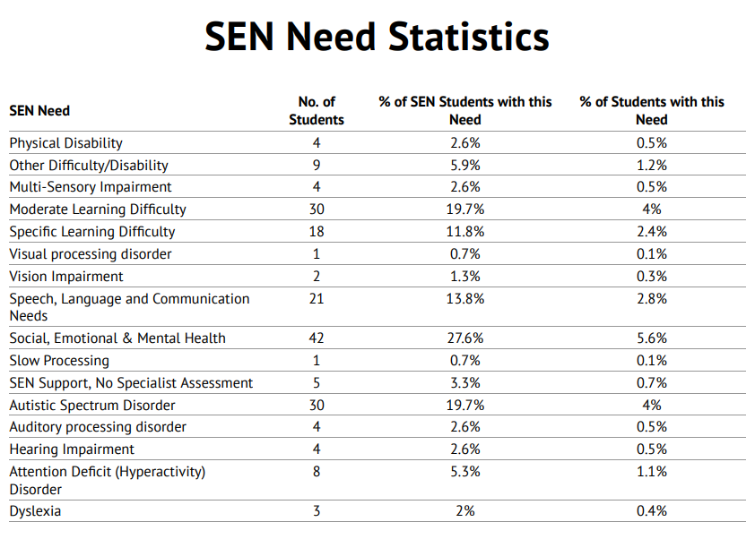

– Support for pupils with Special Educational Needs
If a pupil is identified as having SEND, we will provide support that is ‘additional to’ or
‘different from’ the differentiated approaches and learning arrangements normally provided as part of a high quality, personalised teaching, which is intended to overcome the barrier to their learning. This support is set out in the school Provision Map.
Our provision map is shared with other schools through the Chorley and South Ribble SENDCO Cluster group, as are our assessment tools. In this way we are able to learn from and support each other, develop a wider understanding of different SEND and share training opportunities to improve the support we offer our pupils.
In accordance with the Code of Practice (2014) we engage in a four stage process as outlined below –
  - ASSESS – this involves taking into consideration all the information from discussions with parents or carers, the child, class teachers and assessments.
  - PLAN – this stage identifies the barriers to learning, intended outcomes and details what additional support will be provided in order to help the pupil overcome these barriers. Decisions will be recorded and will be form the basis for review meetings arranged with the parents / carers, the child and members of the SEND department including the SENDCO, Learning Manager and Inclusion Manager.
  - DO – providing the support, extra assistance for learning or learning aids as set out in the plan.
  - REVIEW – measuring the impact of support provided and considering whether changes to that support need to be made. All of those involved including parents / carers, the child and members of the SEND department including the SENDCO, Learning Manager and Inclusion Manager contribute to this review. Comments on progress are also gathered from class teachers and Teaching Assistants and contribute to the review.
This additional intervention will be tailored to meet the child’s needs and will target the area of difficulty. This support may be provided for in class or within the LEAP (Learning, Enhancement and Progress) department, either on a 1:1 or small group basis. The support provided and its impact will be monitored closely and shared regularly with all parties involved.
While the majority of pupils with SEND have their needs met in this way, some may require an EHCP needs assessment to determine whether it is necessary for the Local Authority to make provision in accordance with an EHC plan.

Removal from SEND Register
Some pupils make good progress, and are removed from the SEND Register, following a review meeting. Parent/carer views play an important role in this process.

- Wider Provision to Meet Complex Needs
In addition to supporting pupils with academic work, SEND team provides a variety of activities/support work to help address the wider needs of some pupils. Passes are issued, to vulnerable pupils, to ensure that they can access the base at break/lunchtime if needed.
Homework clubs run both before and after school and Games Clubs are scheduled for lunchtime. Nurture Groups for each Key Stage 3 operate to help those pupils with behaviour issues and/or emotional and social difficulties.
Dyslexia programmes, such as IDL reading programme, Accelerated Reading and Toe by Toe, are also provided.
A Vocational curriculum has been developed for some Key Stage 4 pupils, which includes work experience and weekly classes at local colleges.

– Assessing the impact of intervention
The interventions used will be those that are proven to make a difference for most learners.
A baseline assessment will take place at the beginning of an intervention – this will provide a point of reference for measuring a pupil’s progress and a target outcome can be set. Regular reviews will take place to ensure the intervention is having the intended effect. Should progress be less than expected consideration will be given to adapting the frequency / intensity. Regular updates are provided to the parents / carers and the child and a record is kept of any agreed actions.
Where difficulties persist despite high quality interventions, advice and support may be
requested from other professionals, with parents’ consent. This might involve: Speech and Language Therapy services, Occupational Therapist, Physiotherapist, Advisory Support teacher, Educational Psychologist or health services.
Where a pupil has a Statement of SEND or an Education, Health and Care Plan (EHC), there will be an annual review held in addition to the termly review meetings, taking into account the views of the child, their parent or carer and all other professionals involved with the child.

9- SEND funding within school
The SEND budget is spent on additional resources and staffing costs which are allocated to support individual pupils. Learning Support Assistants may be targeted to work with identified pupils, under the guidance of a teacher, and in consultation with the SENDCO. Occasionally, children may be allocated a special needs allowance by the LA to enable them to receive further individual support. An EHCP (Education, Health, Care Plan), and high access funding, usually determine this.

Differentiated resources are used to ensure access to the curriculum; resources are easily accessible in the Support Base and classrooms. Additional resources such as the IDL Reading Programme can be accessed from computers within school and also from home.
We have access to the expertise of LA services, and other agencies if, and when, required.
Additional training for teachers and Learning Support Assistants is made available, when appropriate.

- Evaluating SEND Provision
The effectiveness of provision is measured by the following:
  - Teachers’ planning reflecting the learning objectives for pupils with special educational needs.
  - Parents/carers being aware of individual targets set for children.
  - Pupils being involved in discussing, contributing to and reviewing their individual targets.
  - Progress being monitored closely to ensure that pupils progress through specific, measurable, achievable, realistic, time-bound targets (SMART).
  - Analysis of pupil tracking data and assessment results.
  - Ensuring that outside agencies, where appropriate, are fully informed and involved.
  - Formative assessment (e.g. through observations and work scrutiny).
  - Levels of Progress data for pupils on the SEND Register.
  - Monitoring of procedures and practice, by the SEND Governor
  - The number of children identified on the SEND Register.
  - School self-evaluation.
  - Any external evaluation, or inspection, which also enables us to evaluate the success of our provision.

-Partnership with Parents/Carers
Parents/carers are important partners, in the effective working relationship with the school, in raising their child’s achievement. They are fully involved in the identification, assessment and decision-making process and are encouraged to discuss any concerns with class teachers if they arise. We regularly update parents/carers with relevant information and consult with them before involving outside agencies.

-Pupil Voice
We show Sensitivity, honesty and mutual respect in encouraging pupils to share their views and we value their contributions. Pupils are involved in the decision-making process, whenever possible, and we help them to participate in their learning by encouraging them to discuss targets and steps for improvement. For pupils with SEND, this includes discussing the strategies for success outlined in Provision Maps and in targets set by subject teachers. Pupils participate in reviewing their progress and in setting new goals and challenges.

-Links with external agencies and support services
Close links are maintained with the LA support services to ensure that the school makes appropriate provision for pupils with special educational needs. Where it is necessary to contact external agencies, the SENDCO/Learning Manager/Inclusion Manager will make the necessary arrangements and consult with parents/carers accordingly. These agencies normally include:-
  - Educational Psychologists
  - Special Educational Needs Teaching and Support Service
  - Speech and Language Service
  - ASD specialist services
  - School Health/National Health Service
  - Educational Welfare Service
  - Children and Young People’s Services
  - Social Care

-Links with other schools and transition arrangements
Links are maintained to ensure a smooth transfer, on school entry, through liaison and visits to local Primary Schools, by the Transition Manager and the SENDCO. Pupils are invited to visit us for induction visits in the term before they start school. If necessary, the school liaises with other agencies at this stage.
To ease transition, vulnerable pupils are carefully located in tutor groups and may be paired with a ‘buddy’ or a pupil of a similar level of need. Teachers liaise closely when pupils transfer to another class within the school and/or another Key Stage. Meetings are arranged, wherever possible, between teachers and the SENDCO/Transition Manager / Learning Manager/Inclusion Manager, to ensure smooth transition.
The Academy SENDCO attends Year 6 Statement Reviews, to become fully informed about individual pupil needs, and additional visits to the Academy are provided for SEND pupils. Some pupils are allocated a Learning Mentor to assist with transition issues and all SEND records and information are transferred as part of the transition process.
Pupils transferring here, mid year, are offered visits; their SEND information is sought from their previous school and they are given a ‘buddy’ to help them to settle in.

- Continuing Professional Development
Through the monitoring and evaluation of SEND provision, the Deputy Headteacher and the SENCO identify the professional development needs of staff. CPD, where appropriate, is closely linked to the School Improvement Plan and Appraisal Objectives and can either be school based (delivered by the SENCO/ Learning Manager/Inclusion Manager) or delivered through specialist agencies externally. Staff who attend additional courses disseminate information at staff

meetings. Whole school in-service training sessions are arranged, as appropriate, in response to particular needs within the school.
Examples of recent training include:
  - Ongoing Safeguarding training (for all staff).
  - Supporting pupils with ASD (for all staff)
  - Dyslexia training (for all staff)
  - Higher Level Teaching Assistant Course
  - Chorley and South Ribble SENCO Cluster meetings and training (for SENCO)
  - Weekly training meetings, delivered by SENCO
  - ASD training for HLTA and some LSA’s
  - Managing Anxiety Within School (HLTA)
  - Provision mapping (SENCO)
  - Access Arrangements / Exam Concessions (Learning Manager)
  - HI training for all Support staff
  - Mental Health and Wellbeing basic training – All staff
  - Mental Health First Aid – members of the Pastoral Team
  - Lead Mental Health Practitioner – A Holland

– Any comments or questions
This report details our annual offer to pupils with SEND. To be effective it needs the views of all: Parents / carers, pupils, staff and governors.
Please engage fully with our annual process to ‘assess, plan, do and review provision for SEND.
If you have any comments or questions, please contact Mrs Holland (SENCO) at a.holland@priory.lancs.sch.uk

