

Our Rules


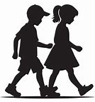

- Kind hands, body and actions
- Walk calmly and quietly
- Right place, right time
- Stay safe in and out of school and online
- Ready for school
- Ready in 3,2,1
- Ready for learning

Eyes looking
Ears Listening
Body ready
Safe
Respectful
Ready
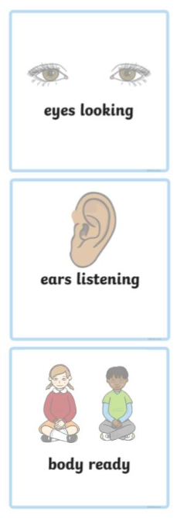
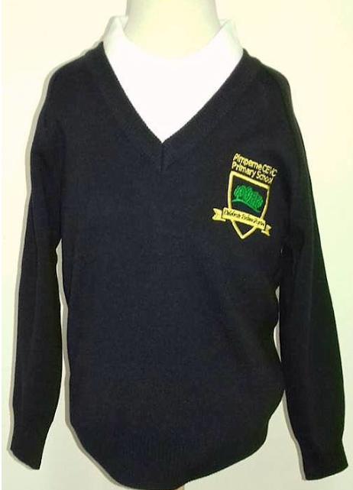
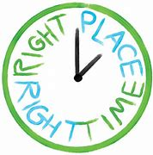
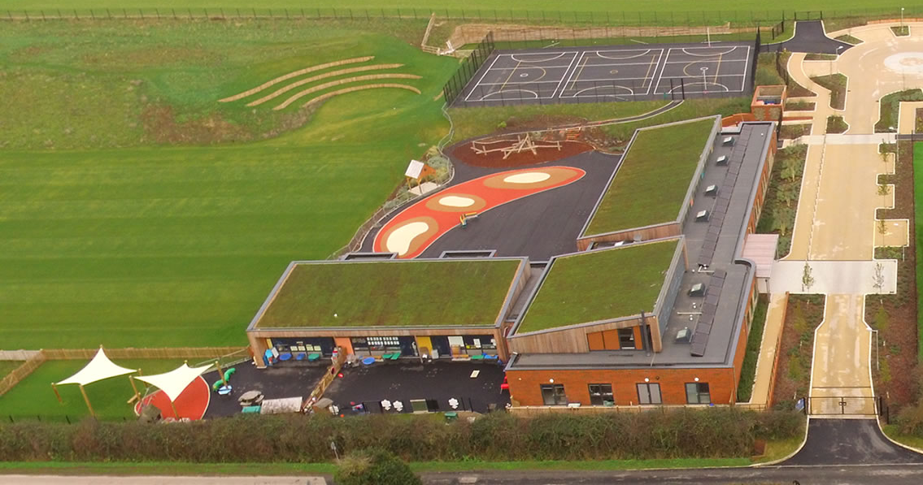


- Listen to others
- Use kind words
- Look after our school

Rewards

Class
Individual
Individual

- Class jars
- Attendance

- School rules recognition with Golden Ticket celebration (hot chocolate/squash/water)
- Values recognition stickers

- Star of the Day stickers


Whole school


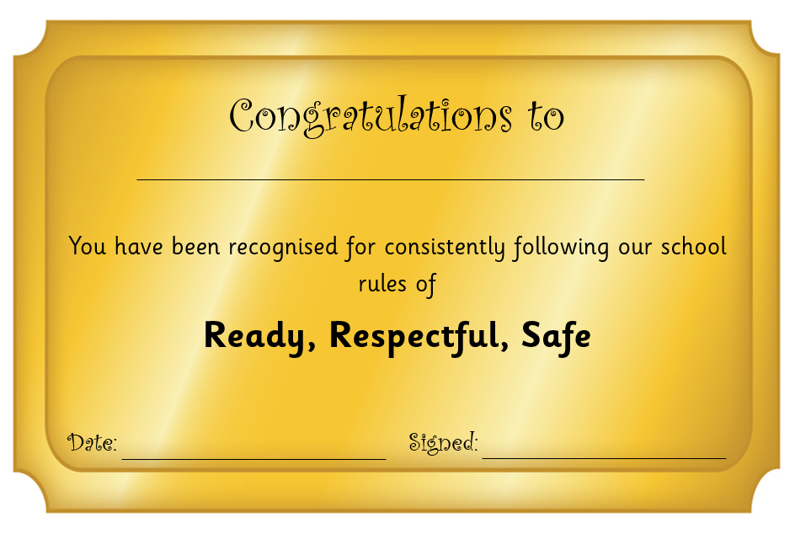

- House Points
for sports

Consequences (See Consequence Ladder for visuals)

Step 3
Step 5
Step 4
Step 2
Step 1
If positive reinforcement not working, a formal verbal reminder of expected behaviour.
Removal from class to a different class. Telephone home.
‘Time in’ with SLT to regulate behaviour, reflect and restore (during learning/playtime).
Moved within class for regulation. Warning given for missed playtime.
Adult ‘time in’ to offer chance to change behaviour and 5 minutes playtime missed. Warning given for telephone home.

Step 5 or significant behaviour - SLT
Step 2, Step 3, Step 4 - class teacher

