

Children with Health Conditions Who Cannot Attend School Policy

Reviewed on |  | Sept 2026 |  | Review frequency |  | Annually
Next review due |  | Sept 2027 |  | Template Yes / No |  | No
Owner |  | Head of Compliance |  | Approved by |  | Director of Education – Secondary

History of Policy Changes

Date | Page | Change | Origin of Change
Sept ‘26 | 4 | Working together to improve school attendance has been updated July 2026 | DfE
Sept ‘26 | 4 | KCSIE 2026 link updated from 2025 | DfE
Sept ‘26 | 4 | Providing remote education 2024 added the link | DfE
Sept ‘25 | 4 | Addition of new section: 2, Scope
Sept ‘25 | 4 | Addition of new section: 3, Additions
Sept ‘25 | 5 | Addition of new section: 5, Responsibilities of the Parents/Carers
Sept ‘25 | 5 | Additional responsibilities added to the schools’ section
Sept ‘25 | 6 | Addition of new section: 8, Collaboration and information sharing
Sept ‘25 | 7 | Additional responsibilities added under the section, Safeguarding Arrangements

Contents
1. History of Policy Changes 2
2. Contents 2
3. Introduction 3
4. Scope 4
5. Definitions 4
6. Legislation and guidance 4
7. Responsibilities of the Parents/Carers 5
8. Responsibilities of the School 5
9. Responsibilities of the Local Authority 6
10. Collaboration and Information Sharing 6
11. Reintegration after Extended Absence (15 days or more) 6
12. Safeguarding Arrangements 7
13. Monitoring 7
14. Link to other HET policies 7

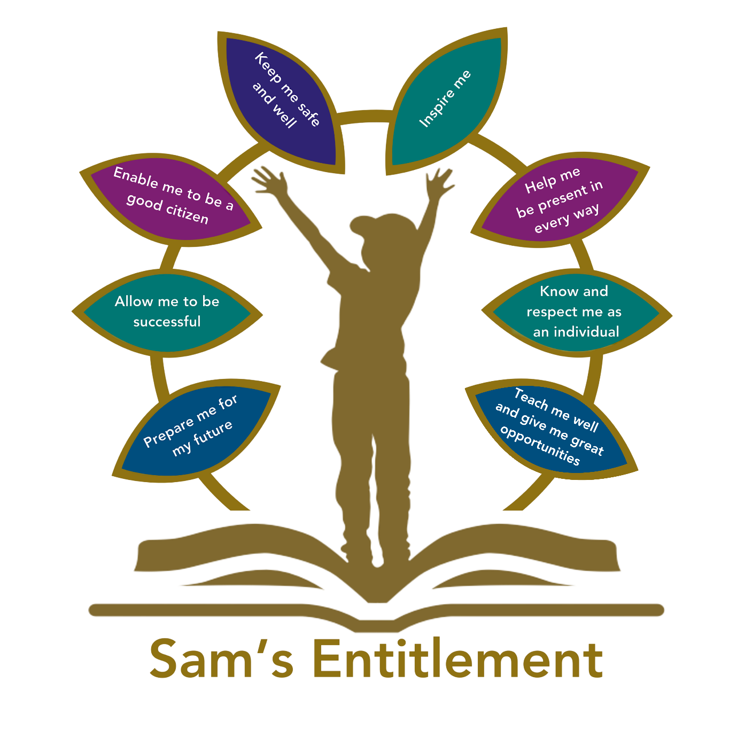

Introduction
“Hamwic Education Trust (HET) believe that all pupils should receive a high quality, enriching, learning experience in a safe and inclusive environment, which promotes excellence through a broad curriculum that prepares them for their future and opens doors to a diverse array of opportunities as well as that all pupils and adults within HET flourish as individuals and together.”
Children with medical conditions are entitled to a full education. HET is committed to ensuring that pupils with medical conditions are properly supported in school so that they can play a full and active role in school life, remain healthy, and achieve their academic potential. We want all pupils, as far as possible, to access and enjoy the same opportunities at school as any other child. This will include actively supporting pupils with medical conditions to participate in school trips/visits and/or in sporting activities.
Through this policy we aim to:
- Ensure continuity of education for children unable to attend due to health needs.
- Ensure pupils, staff and parents/carers understand what the school is responsible for when this education is being provided by the local authority.
- Minimise disruption to learning and emotional wellbeing.
- Work in partnership with families, health professionals, and local authorities.
- Support effective reintegration into school.
- Safeguard and promote the welfare of all pupils.

Scope
This policy applies across all schools within the Hamwic Education Trust (HET), ensuring a consistent and compassionate approach to supporting pupils who are unable to attend school due to health conditions. It sets out HET’s commitment to safeguarding the educational entitlement of every child, regardless of their physical or mental health status, and outlines the responsibilities of schools, parent/carers, and local authorities.

This policy sets out how we will ensure pupils in HET have the best opportunities by:
- Ensuring there is a policy in place that sets out the expectations, roles, responsibilities, processes and systems in place to support children with medical conditions that cannot attend school
- Ensuring all staff are familiar with the contents of the policy and the government guidance (as listed below)
- Ensuring staff consider a bespoke package in responding to a child’s need
- Ensuring robust processes are in place to monitor the effectiveness of the policy
- Using our best endeavours to meet the needs of all our children

This policy does not cover:
- Absences due to minor or short-term illness (e.g., colds, flu), where usual absence procedures apply.
- Children whose absence is not health related.

Definitions
For the purposes of this policy, a “medical condition” is any illness or disability which a pupil has. It can be:
- Physical or mental.
- A single episode or recurrent.
- Short-term or long-term.
- Relatively straightforward (e.g., the pupil can manage the condition themselves without support or monitoring) or complex (requiring ongoing support, medicines or care whilst at school to help the pupil manage their condition and keep them well).
- Involving medication or medical equipment.
- Affecting participation in school activities or limiting access to education.

Legislation and guidance
This policy complies with the legal frameworks, statutory requirements and relevant guidance laid out in the following:
- The Education Act 1996
- The Education (Pupil Registration) (England) Regulations 2006
- Equality Act 2010

It is also based on the following statutory guidance from the Department for Education (DfE):
- Alternative provision
- Working together to improve school attendance
- Arranging education for children who cannot attend school because of health needs
- Supporting pupils at school with medical conditions
- Keeping children safe in education 2026: September 2026
- Providing remote education: guidance for schools - GOV.UK

This policy also follows guidance provided by our Local Authorities:
- Southampton City Council: School attendance and support (southampton.gov.uk)
- Portsmouth City Council: School attendance - Portsmouth City Council
- Dorset City Council: School attendance and absence - Dorset Council
- Bournemouth, Christchurch and Poole (BCP) Council: School attendance | BCP (bcpcouncil.gov.uk)

Responsibilities of the Parents/Carers
Parent/Carers are expected to:
- Provide the school with sufficient and up-to-date information about their child’s medical needs
- Be involved in the development and review of their child’s Individual Healthcare Plan (IHP) and be involved in its drafting
- Carry out any action they have agreed to as part of the implementation of the IHP, e.g. provide medicines and equipment, and ensure they or another nominated adult are contactable at all times.

Responsibilities of the School
Where a pupil cannot attend school because of health needs, unless it is evident at the outset that the pupil will be absent for 15 or more days, the school will initially follow their usual process around attendance and mark the pupil as ill for the purposes of the register.

The school will provide support to pupils who are absent from school because of illness for a period shorter than 15 days. This may include providing pupils with relevant information, curriculum materials and resources. Provision will be considered on a case-by-case basis.

To fulfil the aims of this policy, the school will:
- Ensure that systems are in place for obtaining information about a child’s medical needs and that this information is kept up to date.
- Ensure it complies with any specific health requirements identified in a child’s Individual Healthcare Plan (IHP).
- Liaise with parents/carers, pupils, the LA, healthcare professionals and others involved in the pupil’s care to ensure that arrangements are made in their best interest.
- Ensure that close contact is maintained between the school and the child, being particularly mindful of the need to ensure the pupil maintains some contact with peers, so they continue to feel part of their class/tutor group.
- Fulfil their statutory reporting obligations under the DfE guidance, Working together to improve school attendance
- Provide regular updates to the LA on the effectiveness of the arrangements in place in terms of both the health and educational needs of the child.
- Work closely with the parents/carers or organisations to ensure that any possible reintegration back into school is appropriate for the child.

Responsibilities of the Local Authority
In accordance with the Department for Education’s statutory guidance, as soon as it is clear that a pupil will be away from school for 15 days or more (either consecutive or over the course of a school year) because of their health needs, the local authority should:

- Be ready to take responsibility for arranging suitable full-time education for that pupil.
- Arrange for this provision to be in place as soon as it is clear that the absence will last for more than 15 days.

The school will inform and work collaboratively with the local authority to support these responsibilities.

Collaboration and Information Sharing
To support every child in the best way, schools will work closely with its local authority and other partners, in the following ways:
- Providing the local authority with the full name and address of any pupils of compulsory school age who are not attending school regularly due to their health needs.
- Working collaboratively with the local authority, relevant medical professionals, relevant education providers, parents and, where appropriate, the pupil, to identify and meet the pupil’s educational needs throughout the period of absence.
- Collaborating with the local authority to ensure continuity of provision and consistency of curriculum, including making information available about the curriculum.
- Along with the local authority, regularly reviewing the provision offered to ensure it continues to be appropriate for the child and that it is providing suitable education.
- Sharing information with the local authority and relevant health services as required.
- When a child has complex or long-term health issues, working with the local authority, parents/carers and the relevant health services to decide how best to meet the child’s needs (e.g. through individual support, arranging alternative provision or by them remaining at school, being supported at home and back into school after each absence).
- Where possible, allowing the child to take examinations at the same time as their peers, and work with the local authority to support this.
- Helping to make sure that the child can be reintegrated back into school successfully.

Reintegration after Extended Absence (15 days or more)
When reintegration is anticipated, the school will work with the local authority to:
- Plan for consistent provision during and after the period of education outside the school, allowing the child to access the same curriculum and materials that they would have used in school as far as possible, including through digital resources.
- Enable the child to stay in touch with school life (e.g. through newsletters, emails, digital learning platforms, social media platforms, invitations to school events or internet links to lessons from their school), and, where appropriate, through educational visits.

When a pupil is considered well enough to return to full time education at the school, the School Leader or someone designated by them, will develop a tailored reintegration plan in collaboration with the LA and any other appropriate individuals or organisations. This will:
- Ensure a welcoming environment is developed and encourage pupils and staff to be positive and proactive during the reintegration period
- Be tailored for each child returning to school, to ensure extra support to fill any gaps arising from the absence.
- Consider whether any reasonable adjustments need to be made.

Safeguarding Arrangements
It is vital that School Leaders and DSLs take a keen interest in the safeguarding of pupils absent from school, recognising that they are vulnerable children. Mechanisms should be put in place to ensure pupils are monitored to keep them safe from harm.
The following list of protective measures is not exhaustive; the first four measures are expected as a minimum:
- Named Safeguarding Lead Oversight – the Designated Safeguarding Lead (DSL) maintains oversight of pupils absent due to health conditions, with regular check-ins and updates.
- Regular contact and welfare checks are made with the child, this includes talking to, and sight of the child.
- Any child using a computing device will be reminded about online safety. Where a school provides a device, schools will check that the appropriate controls are in place.
- Multi-Agency Collaboration: the school will work closely with healthcare professionals, social workers, CAMHS, and the Local Authority to ensure a joined-up approach to safeguarding and education.
- Where possible, remote access is provided to some assemblies and PSHE lessons that support safeguarding messages – particularly regarding consent and safe/appropriate touch.
- School makes regular contact with agencies who visit and have sight of the child.

Monitoring
This policy will be reviewed every year by the Head of Compliance, and the application will be monitored by the HET Access Team through the review of pupil case studies in our schools.

Link to other HET policies
This policy links to the following policies:
- Attendance Policy
- Accessibility plan
- Remote learning policy
- Safeguarding policy
- Supporting pupils with medical conditions

