

Home School Agreement
Our Aims:
At Pimperne Primary School we are committed to working together as a team, with our children at the heart of everything that we do. Each child will be given every opportunity to flourish, succeed and shine and no child should ever be disadvantaged or miss out on opportunities. We believe that children need to believe in themselves as strong capable learners, we view barriers as solutions to find, and we value positive enabling partnerships with parents.
These aims are embedded in our Vision Statement:

Our Motto:
Celebrate, Believe, Aspire
We believe that every child, at Pimperne Primary School will develop a positive growth mindset that enables them to believe they can achieve anything they put their minds to. We want our children to become ambitious learners, who are aspirational, and take pride in all they do. Children will develop an understanding that the journey of learning can be challenging but, by developing a set of positive learning behaviours, they will become successful learners.
Our Learning Behaviours within ‘Switched On’:
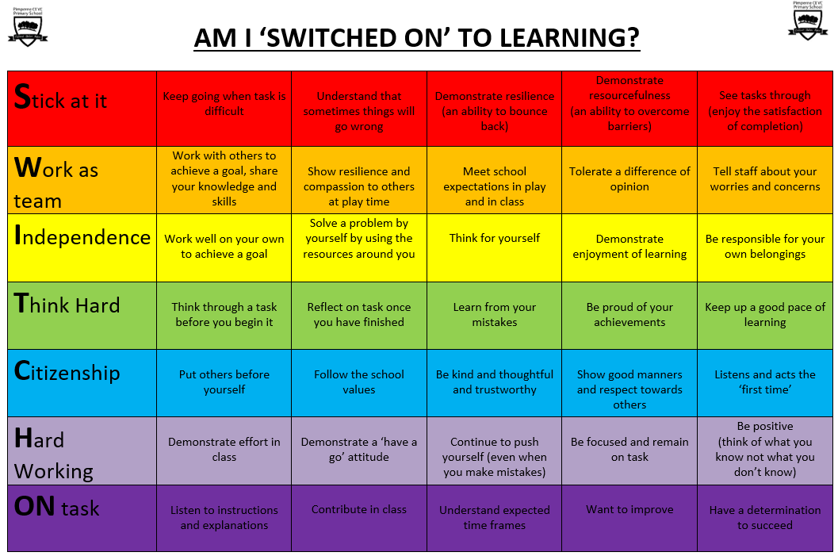
We will empower your child to develop a positive growth mindset, and by building positive partnerships with parents we know your child will thrive during their time at Pimperne Primary and beyond.
Our school Rules are clear and are a foundation for all that we do - we expect our children to be:
Ready
Respectful
Safe
In order for these positive partnerships to be successful we have set out a clear home school agreement that recognises the vital part each partnership role takes.
School Rules, Expectations, and Routines
At our school, we believe that a structured and respectful environment is essential for optimal learning and personal development. Our school rules, expectations, and routines are designed to create a positive and inclusive atmosphere for all members of our school community. These are regularly communicated to pupils, parents, and staff. At Pimperne Primary, we are Ready, Respectful and Safe.
The School will:
- Care for your child’s safety and well-being.
- Be open and welcoming.
- Provide high-quality opportunities for each child to achieve their full potential as a valued member of the school community.
- Ensure that the learning environment is stimulating and supportive.
- Celebrate your child’s academic and personal achievements.
- Support your child to develop a growth mindset.
- Support your child to develop a positive attitude to one another regardless of gender, race, culture, belief, values, age or need.
- Communicate with you about your child’s progress and learning behaviours; celebrating their strengths and explaining how we can further support them at school.
- Provide information to you regarding school, including policies, events, workshops and newsletters.
The Family will:
- Encourage my child to treat all members of the school with respect and good manners
- Encourage my child in all aspects of learning, value achievements and give praise for all their efforts
- Support my child by reading or discussing books with him/her each evening and support other opportunities for home learning
- Ensure my child attends school regularly, arrives on time and is properly equipped
- Inform the school of the reason for any absence, as soon as possible on the first day of absence
- Make sure my child has a good night’s sleep and select age-appropriate TV programmes, games and DVDs
- Make sure the school is aware of any additional needs my child may have and any concerns or problems that might affect their behaviour or learning
- Encourage a positive regard to everyone in our community
- Use social media and other online platforms in a respectful manner, following our Safeguarding Policy and Parent & Visitor Code of Conduct
- Work in partnership with the school to support my child to follow the school Behaviour Policy to be “Ready, Respectful, Safe”
- Attend parent consultations, information meetings, Open Evenings and other events where possible.
- Read all information sent home as this gives you important details that will keep you informed.
Your Child will try to:
- Be helpful and caring towards others
- Be polite and respectful
- Be responsible and show they are ready to learn
- Tell a grown up if they have a problem or worry
- Help look after our school, inside and out
- Try their best, by developing a growth mindset, being ‘Switched On’
- Behave in a safe way
- Complete their home learning
Please note that, if a child knowingly and willingly does not adhere to the home school agreement, then a conversation reinforcing the reasons why these rules are in place will take place with both the child and the parent.

Please read our ‘Parent & Visitor Code of Conduct’
We make this information known to parents through our website and class pages, as well as our face-to-face meetings. Your agreement is assumed if you have not made contact to arrange a discussion around the policy. We thank you for your support in keeping our school community a happy partnership, working together for the benefit of all.

