



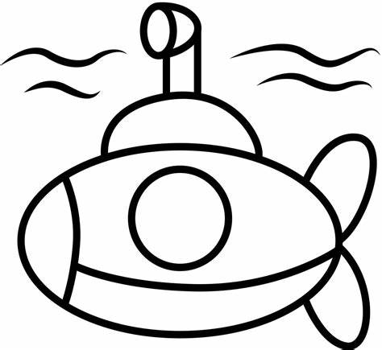




Pimperne Learning Pathway

Check

Remember
Introduce New Learning
Model
Practise and
Apply
Deepen
Review and
Reflect
New Learning is delivered in small chunks. Knowledge is broken down into key learning objectives which are assessed throughout using knowledge checks. Key vocabulary is discussed and learned.
Model tasks showing
thinking, organisation and checking. Knowledge and skills are modelled by the teacher within the context of knowledge already taught. Modelling of this is done one step at a time with continual checks.
Instruction is minimal and language is simple. Support understanding of small steps taken using the ‘I do’, ‘We do’, ‘You do’ approach.
Children have the chance to have a go and show their understanding. They experience tasks that help them to apply their knowledge and use their skills. Evidence in books shows how the children have applied their knowledge. Suitable adaptations have been made to allow all children to experience success and achieve the learning objective.
All pupils have the opportunity to deepen the new knowledge, allowing them to show a depth of
understanding. These tasks often require a degree of critical
thinking where the children need to reason, explain, justify or make connections between previous taught content.
Recap the new learning to ensure that the pupils have retained key knowledge. Use of ‘Purple Pen’ to
encourage children to edit and improve their work or to self and peer assess. End of unit quizzes and live marking during lessons will give a clear picture of the
progress children have made and identify next steps.
Retrieval practice to retrieve past knowledge. Review to help to remember the key knowledge from the last lesson or other content from previous units that is helpful. Use of ‘Assessment for Learning’ to
assess which knowledge has been
forgotten. This may take the form of a remember sticker, quiz, picture quiz,
keyword match up, picture match up, flashcards, gap fill, tell your partner, etc.

