
Punctuality Matters

Being late for school nearly every day leads to lost learning time
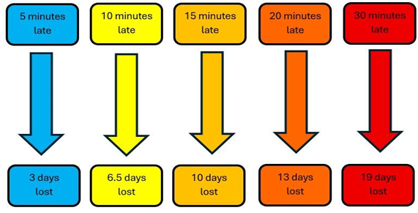
Did you know that being late 15 minutes each day is the same as missing 2 weeks of school?

8.30 Gates open
8.30 Classes open
8.45 Class doors close and learning begins
8.45 Gates close
School Times

