The Development of Reading Skills in KS2
Reading Practice Books
In Key Stage 2, book bands are used to indicate the reading level of each book within different reading schemes. Throughout Key Stage 2, we have a wide range of texts from differing publishers within our reading scheme. The table below shows the age-related expectations at which most children will be reading. The difference between the book bands is gradual; therefore, most children will progress fluidly through the scheme.
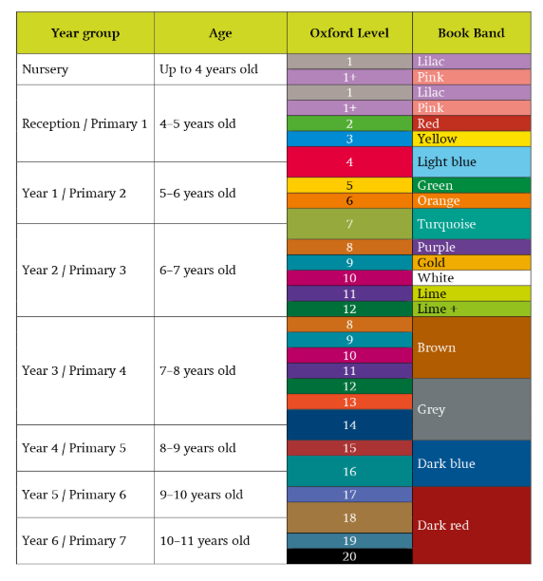

It is important to remember that all children are individuals who learn and make progress at different rates, so the chart is only a guide. Children may experience periods of rapid progress as well as periods of consolidation when progress is less obvious. Within each band, the books children read will vary in several ways, including genre, layout, size, vocabulary and length, to provide each child with a rich diet of literature.
Class teachers will only move children onto the next book band when they are confident that the child can both decode words accurately and fully comprehend the text. As a rough guide, children should be able to read at least 90% of the words on a page without difficulty and fully understand the text before moving on.

Changing Reading Practice Books
Wherever possible, children will be encouraged to choose their own books from both the reading scheme and the class library. Time for changing books will be allocated daily using each class's individual system, but children will be encouraged to keep their chosen books for several days to promote rereading, build a secure understanding of the text and rehearse key reading skills.


Developing Reading Fluency Across KS2
T

The Reading Framework (2021) states that reading fluency can be defined as reading with accuracy, automaticity and prosody.
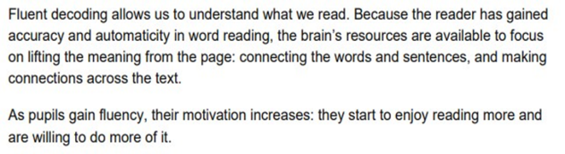

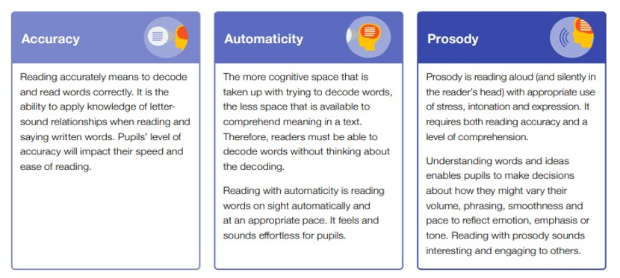
. The EEF guidance provides a useful definition of reading fluency.
When pupils read fluently, their cognitive resources can be redirected from focusing on decoding to comprehending a text. For this reason, fluency is sometimes described as a bridge between word recognition and comprehension.
At Pimperne, we aim to develop KS2 pupils' reading fluency in a variety of ways, including:
- Whole-class reading sessions three times per week which teach the skills of accuracy, automaticity and prosody in line with year-group expectations.
- Daily ERIC (Everyone Reading in Class) time to encourage reading for pleasure.
In school, teachers and trained volunteers use individual record sheets to record children's reading of reading practice books. Teaching teams then use these record sheets, which have been designed to assess whether children are working towards, at, or above age-related expectations, to assess the child’s next steps. They provide a focus for the assessment of word reading and question prompts for comprehension. These assessments inform teachers when a child is ready to move on to the next book band and are reviewed half-termly by the class teacher.
In addition, teachers carry out individual reading fluency assessments each term. This enables them to assess both reading speed and accuracy. Pupils who require further support then receive three additional fluency-reading sessions per week to develop their reading skills.
Reading at Home
Parental involvement and encouragement play a crucial part in pupils' reading development, and at Pimperne we promote a strong home-school reading partnership by:
- Communicating with parents and sharing information through parent meetings, newsletters, diaries and curriculum evenings.
- Ensuring pupils have a book to read at home each day that further develops the skills they have learned during taught literacy sessions and matches their individual reading progress.
- Encouraging parents to make notes in pupils' Reading Records and sign them to share reading progress made at home.

Reading for Pleasure
At Pimperne, our aim is for all children to find pleasure in reading. We are fortunate to have a well-stocked school library with many contemporary titles.
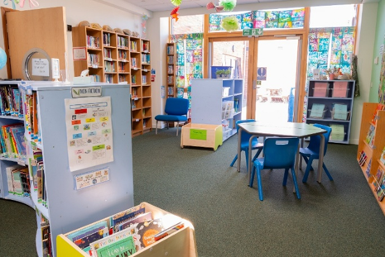
Each class visits the library for thirty minutes once a week so that pupils can choose a book to take home, based on their interests. This is also an opportunity for classes to restock their class libraries. All children are able to take home one library book to share with their families.
Our Year 6 librarians who help to keep the library organised and suggest titles for pupils to read.

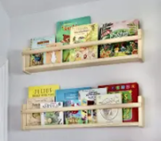
In addition, we encourage reading for pleasure by:
- Carefully selecting texts for class libraries based on pupils' interests and prior reading experiences.
- Holding daily story-reading sessions from the class reading spine to model reading fluency.
- Working with Dorset Reading Partners, Blandford Library and local authors to inspire a love of reading.
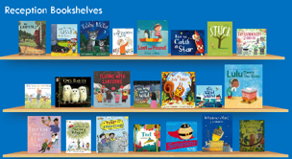
- Celebrating reading-related awareness days, such as World Book Day.

