

Social Media Policy

Reviewed on |  | September 2026 |  | Review frequency |  | Annually
Next review due |  | August 2027 |  | Template Yes / No |  | Yes
Owner |  | Director of IT |  | Approved by |  | Executive

History of Policy Changes
Date | Page | Change | Origin of Change
15/08/2026 | ALL | Changed reference of school to HET/School
15/08/2026 | 5 | Added MS Team to Roles & Responsibilities
15/08/2026 | 11 | Added link to other HET policies and legislation

Contents
History of Policy Changes 2
Contents 2
Introduction 3
Purpose 4
Scope 4
Definitions 5
Roles and Responsibilities 5
Process for creating new accounts: 6
Compliance 6
Monitoring 7
Behaviour & Use 7
General Guidance for Employees: Social Media Rules 9
Managing HET/School social media accounts 10
Personal Use 10
Pupils 11
Link to other HET policies & legislation 11

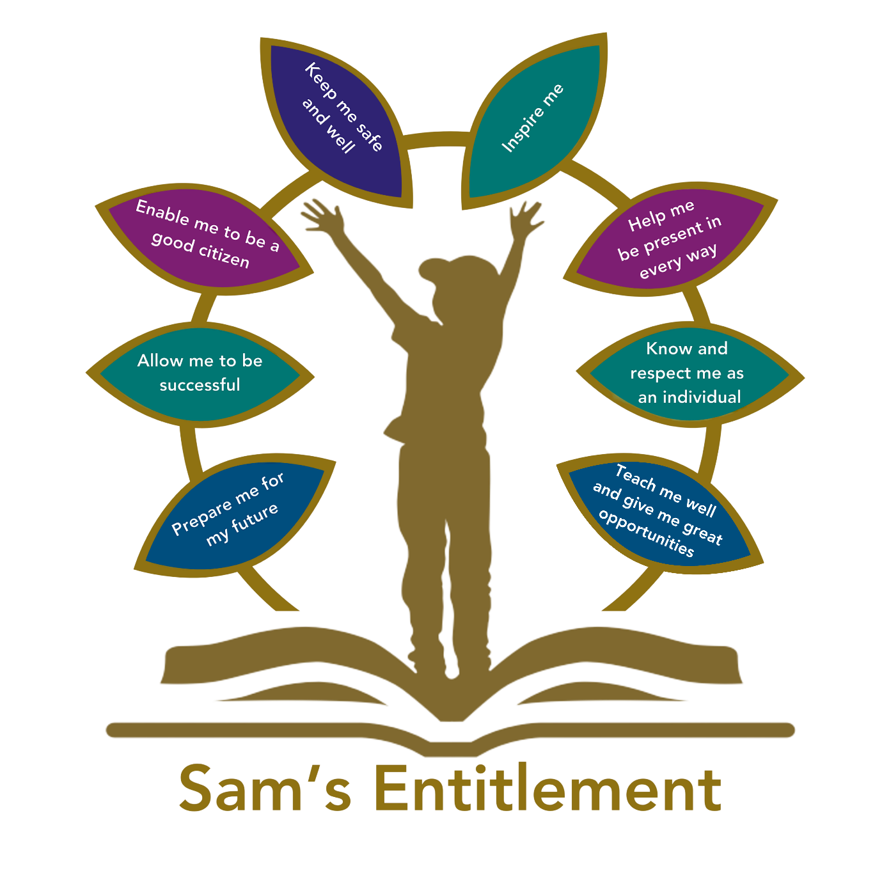

Introduction
Hamwic Education Trust (HET) believe that all pupils should receive a high quality, enriching, learning experience in a safe and inclusive environment, which promotes excellence through a broad curriculum that prepares them for their future and opens doors to a diverse array of opportunities as well as that all pupils and adults within HET flourish as individuals and together.
Social media is a broad term for any kind of online platform that enables people to directly interact with each other.

We recognise the benefits of social media, but it also brings potential risk, to HET and to individuals. For the purposes of this policy, ‘social media’ is defined as websites and applications (apps) that allow people to create or share content and/or participate in social networking. Examples include, but are not limited to, Facebook, X (Formerly Twitter), LinkedIn, Instagram, Snapchat, Reddit, Pinterest, YouTube, WordPress, Tumblr, Ask.fm, WhatsApp.

We realise that a growing number of educationalists and education groups use discussion groups, online chat forums and bulletin board to share good practice and disseminate information and resources. The use of online discussion groups and bulletin boards relating to professional practice and continuing professional development is encouraged, although employees are reminded that they are representing HET, and appropriate professional standards should apply to all postings and messages.

This Social Media Policy outlines guidelines for the appropriate and responsible use of social media by HET employees, pupils, and stakeholders.

The purpose is to promote positive interactions, protect the HET’s reputation, and ensure the safety and privacy of all users.

Purpose
HET recognises the numerous benefits and opportunities which a social media presence offers. Employees are actively encouraged to find creative ways to use social media to positively promote the HET and its schools to our community. However, there are some risks associated with social media use, especially around the issues of safeguarding, bullying and personal reputation.

This policy also ensures the local governance committee maintains its duty to safeguard children, the reputation of HET and those who work for it and the wider community.

All employees are expected to comply with this policy. All leaders are responsible for ensuring their team read, understand and comply with this procedure.

In order to be an official ‘HET/School platform’:
- Master privileges and access permissions are to be held by HET/School
- HET/School must have editorial oversight of all content
- The number of employees with administrative rights should be limited to those necessary

‘Quasi school’ social media, for example an Instagram account such as ‘Miss Stuart History @ Secondary School’ are not official school platforms unless the above conditions are met. HET will not accept liability for content and postings on accounts containing HET/School name which have not been authorised and do not meet the official ‘HET/School platform’ criteria. Personal information and pictures should not be posted without appropriate consent and oversight. Authorised accounts will remain the property of HET/School and may be deleted at any time by HET/School.

A breach of this policy could lead to disciplinary action.

Scope
This policy is subject to the HET/School’s Codes of Conduct and Acceptable Use Agreements and:
- Applies to all employees and to all online communications that directly or indirectly, represent HET.
- Applies to such online communications posted at any time and from anywhere.
- Encourages the safe and responsible use of social media through training and education.
- Defines the monitoring of public social media activity pertaining to HET/School.

HET respects privacy and understands that employees and pupils may use social media forums in their private lives. However, personal communications likely to have a negative impact on professional standards and/or HET/School’s reputation are within the scope of this policy.

Definitions
- Professional communications are those made through official channels, posted on a HET/School account or using HET/School name. All professional communications are within the scope of this policy
- Personal communications are those made via personal social media accounts. In all cases, personal accounts should NOT be used to communicate on behalf of HET/School. Personal communications that mention HET/School or mentions anything or anyone HET/School related, are within the scope of this policy. Personal communications which do not refer to or impact upon HET/School are outside the scope of this policy
- Digital communications with pupils are also considered. Employees may use social media to communicate with learners via a HET/School-authorised social media account for teaching and learning purposes, but must consider whether this is appropriate, and consider the potential implications. Employees must never use their personal accounts for communicating with pupils. For example, a department may wish to have an Instagram account which pupils and parents can follow to share resources, but employees should not enter into private conversations (e.g. direct messages on Instagram) with pupils. From a safeguarding perspective, we would not approve using Facebook accounts or groups for this, however pupils following an approved HET/School public social media account would be acceptable

Roles and Responsibilities
The Trust Board has overall responsibility for ensuring that HET maintains appropriate arrangements for the safe, lawful and effective use of social media. The Board delegates operational implementation to the Chief Executive Officer and relevant members of the Executive Team. School Leaders are responsible for implementation within their schools. Local Governance Committees provide local oversight and assurance.

Managed Services Team
The Managed Services Team will:
- Ensure that this guidance is kept up to date with current legislation
- Coordinate with the HET SLT, school leaders, DSLs, etc where a request or incident crosses professional responsibilities;
- Support schools in triaging comments, complaints and reputational concerns, ensuring that formal complaints are transferred to the HET’s complaints procedure;
- Escalate employment conduct concerns to HR and the appropriate senior leaders

School Leadership Team
- Facilitating training and guidance on social media use
- Developing and implementing the social media policy
- Taking a lead role in investigating any reported incidents
- Making an initial assessment when an incident is reported and involving appropriate employees and external agencies as required
- Receive completed applications for social media accounts
- Approve account creation

IT Team
- Create the account following SLT approval
- Store account details, including passwords securely
- Be involved in monitoring the account
- Control the process for managing an account after the lead employees has left the organisation (closing or transferring)

All Employees
- Know the contents of and ensure that any use of social media is carried out in line with this and other relevant policies.
- Attending appropriate training.
- Regularly monitoring, updating and managing content they have posted via HET/School accounts.
- Adding an appropriate disclaimer to personal accounts when naming HET/School.

Process for creating new accounts:
The HET/School community is encouraged to consider if a social media account will help them in their work, e.g. a history department Instagram account, or a “Friends of the school” Facebook page.

Anyone wishing to create such an account must present a business case to the leadership team which covers the following points: -
- The aim of the account
- The intended audience
- How the account will be promoted
- Who will run the account (at least two employees should be named)
- Closed or restricted groups may only be used where there is a documented need approved by SLT.
- Reason why the main HET/school account cannot be used for the intended purpose

Following consideration by the SLT an application will be approved or rejected. In all cases, the SLT must be satisfied that anyone running a social media account on behalf of the HET/School has read and understood this policy and received appropriate training. This also applies to anyone who is not directly employed by HET, including volunteers or parents.

Once set up, the following rules must apply:
- Employees should set up a distinct and dedicated social media site or account for educational purposes. This should be entirely separate from any personal social media accounts held by that employee and should be linked to an official HET/School email account.
- The current password or login details for all social media accounts must be provided to IT who will retain a record of such information.
- Employees must ensure that they do not identify a pupil using their full name. Only first/forenames or initials may be used.
- Care must be taken that any links to external sites from the account are appropriate and safe.
- Any inappropriate comments or abuse of HET/school-sanctioned social media should immediately be removed and reported to a member of the leadership team.
- Employees should not engage with any direct messaging of pupils through social media where the message is not public.
- Employees should not seek to view, link up or view pupil accounts. For example, in the case of Instagram, employees should not “follow back” those who follow, share or like HET/school comments/posts.

Compliance
Social media should never be used in a way that breaches any of our other HET policies. For example, you are prohibited from using social media to:
- Breach our IT policies and procedures
- Breach our code of conduct
- Breach our disciplinary policy or procedures
- Breach our anti-bullying and harassment policy
- Breach our equal opportunities policy
- Breach our data protection policy (for example, never disclose personal information about a colleague or pupil online)
- Breach any other laws or regulatory requirements

Employees must make themselves aware of and act in accordance with their duties under the DfE statutory guidance Keeping Children Safe in Education (KCSIE) as these relate to:
- Their own online activity
- The online activity of pupils and other colleagues and
- Information of which they become aware online including their duties relating to children missing from education, child sexual exploitation, FGM and preventing radicalisation (Prevent)

Employees who breach any of the above policies will be subject to disciplinary action up to and including termination of employment. Any employee suspected of committing a breach of policy will be required to co-operate with our investigation, which may involve handing over relevant passwords and login details. You may be required to remove any social media content that we consider to constitute a breach of this policy. Failure to comply with such a request may result in disciplinary action.

Monitoring
HET/School accounts must be monitored regularly and frequently. Any comments, queries or complaints made through those accounts must be responded to within 24 hours (or on the next working day if received at a weekend) even if the response is only to acknowledge receipt.

Regular monitoring and intervention are essential in case a situation arises where bullying or any other inappropriate behaviour arises on a HET/school social media account.

Behaviour & Use
  - HET requires that all users using social media adhere to the standard of behaviour as set out in this policy and other relevant policies.
  - Digital communications by employees must always be professional and respectful and in accordance with this policy.
  - Employees must not use social media to infringe on the rights and privacy of others or make ill-considered comments or judgments about employees.
  - HET/School social media accounts must not be used for personal gain.
  - Employees must ensure that confidentiality is maintained on social media even after they leave the employment of HET.
  - If a journalist makes contact about posts, made using social media, employees must consult with the HET SLT before responding.
  - Unacceptable conduct, (e.g. defamatory, discriminatory, offensive, harassing content or a breach of data protection, confidentiality, copyright) will be considered extremely seriously by HET and will be reported as soon as possible to a relevant senior member of employees, and escalated where appropriate.
  - The use of social media by employees while at work may be monitored, in line with HET policies. HET permits reasonable and appropriate access to private social media sites. However, where excessive use is suspected, and considered to be interfering with relevant duties, disciplinary action may be taken.
  - HET will take appropriate action in the event of breaches of the social media policy. Where conduct is found to be unacceptable, HET/School will deal with the matter internally. Where conduct is considered illegal, HET/School will report the matter to the police and other relevant external agencies and may take action according to the disciplinary policy.

Legal considerations:
  - Users of social media should consider the copyright of the content they are sharing and, where necessary, should seek permission from the copyright holder before sharing.
  - Users must ensure that their use of social media does not infringe upon relevant data protection laws, or breach confidentiality.

Handling abuse
- HET/School will handle offensive comments swiftly and with sensitivity.
- If a conversation turns and becomes offensive or unacceptable, users should screenshot, block, report or delete other users or their comments/posts and notify the SLT as soon as possible.
- If you feel that you or someone else is subject to abuse by colleagues through use of a social networking site, then this action must be reported using the agreed HET/School protocols.

Tone
The tone of content published on social media should be appropriate to the audience, whilst retaining appropriate levels of professional standards. Key words to consider when composing messages are:
- Engaging
- Conversational
- Informative
- Friendly (on certain platforms, e.g. Facebook)

Use of images
HET/School maintains a list of those parents/carers who have objected to or who have placed any restrictions or limitations on the use of images of their child. Employees should familiarise themselves with the names of the pupils on this list. It is a disciplinary offence to use, post or publish a photograph or video image of a pupil contrary to the instructions of their parent/carer. All employees should read the contents of the photo consent form and be aware of the conditions of use.

HET/School use of images can be assumed to be acceptable providing the following guidelines are strictly adhered to.
  - Permission to use any photos or video recordings should be sought using the photo consent form. If anyone, for any reason, asks not to be filmed or photographed then their wishes should be respected.
  - Under no circumstances should employees share or upload pupil pictures online other than via HET/School owned social media accounts and only if we have express written parental consent to publish their picture on social media (see the HET/School photo permissions list).
  - Employees must ensure that they do not identify a pupil using their full name. Only first/forenames or initials may be used.
  - Employees should exercise their professional judgement about whether an image is appropriate to share on HET/School social media accounts. Pupils should be appropriately dressed, not be subject to ridicule and must not be on any school list of children whose images must not be published.
  - If employees inadvertently take a compromising picture which could be misconstrued or misused, they must delete it immediately and notify the SLT.

Monitoring posts about HET/School
  - As part of active social media engagement, it is considered good practice to pro-actively monitor the internet for public postings about HET/School.
  - HET/School should effectively respond to social media comments made by others according to a defined policy or process.
  - Where possible/necessary, direct any official requests that are created on social media to go through the official channels, rather than responding to them on social media e.g. someone asking what time parents evening starts is ok to respond to, but someone enquiring about getting a reprint of a pupil report should be directed to the HET/School office.
  - HET may monitor activity undertaken through its devices, networks and official social media accounts, and may review publicly available content where there is a legitimate safeguarding, conduct, security, legal or reputational reason to do so. Any monitoring will be lawful, necessary, proportionate and transparent, and will be undertaken in accordance with the HET’s privacy notices, monitoring arrangements and data protection policies. Covert or intrusive monitoring will only be considered in exceptional circumstances and following advice from the HET compliance team.

General Guidance for Employees: Social Media Rules
These rules should be followed, to ensure we meet the required standards:
- Be kind:
  - Use common courtesy.
  - Consider the potential effect on others of your words or content you post.

- Be honest:
  - Be transparent about your role, especially when representing HET/School in an official capacity.
  - Only post about things you know to be true and only if it is appropriate to share them.

- Be sensitive:
  - Be especially careful when posting about potentially inflammatory subjects.
  - Do not give advice or information that you know to be contrary to the HET’s policies or interests.
  - Do not reveal any sensitive information about HET/School or about any plans that are not yet public.
  - In the event of an incident affecting HET/School or any members of the school community only official communications channels and accounts should comment or share news or updates.
  - Be aware of the potential risks of communicating with current and ex-pupils in ways which may be considered as inappropriate, particularly if it could be shown that the adult-pupil relationship of trust had been breached.
  - Only use official HET/School platforms to post HET/School information, celebration, news and photographs. Ensure all posts are in line with the Safeguarding Policy.
  - Report any inappropriate contact from pupils to a member of SLT at the earliest opportunity to prevent situations from escalating.
  - Employees are reminded that, as a safeguarding issue, they should always be careful about who they are ‘talking to’. It is very easy to hide an identity in an on-line conversation.

- Protect confidentiality:
  - Don’t share anything private about anyone else, especially pupils.
  - Don’t share anything about yourself that you wouldn’t want the rest of the school community to see.
  - Be aware that what you post could divulge information such as your home address.
  - Always Follow the Data Protection Policy & GDPR Regulations.
  - Apply appropriate security and privacy settings to your social media accounts and the devices you use to access them.
  - Be aware of ‘phishing’ attempts through social media, where scammers may try to obtain information about you or other people, including passwords or financial information.

- Maintain professional standards
  - Remember you are representing the HET/School, and the same standards of conduct should be followed online as well as offline, especially concerning children.
  - Do not post or share offensive, discriminatory or illegal content, or anything that would bring HET into disrepute.
  - Maintain professional boundaries and do not befriend pupils on social media.

- If in doubt, don’t post!
  - Once you’ve posted something to the internet it cannot be taken back.
  - Even if you delete content, it may already have been copied or saved by another user and could be shared wider.
  - Even if you have posted in a closed or private group other members may not respect the rules or your confidentiality.

Concerns and complaints relating to social media activity or account should be directed to a member of SLT.

Managing HET/School social media accounts
The do’s
- Check with a senior leader before publishing content that may have controversial implications for HET/School.
- Use a disclaimer when expressing personal views.
- Make it clear who is posting content.
- Use an appropriate and professional tone.
- Be respectful to all parties.
- Ensure you have permission to ‘share’ other peoples’ materials and acknowledge the author.
- Express opinions but do so in a balanced and measured manner.
- Think before responding to comments and, when in doubt, get a second opinion.
- Seek advice and report any mistakes using HET/School’s reporting process.
- Consider turning off tagging people in images where possible.

The Don’ts
- Don’t make comments, post content or link to materials that will bring HET/School into disrepute.
- Don’t publish confidential or commercially sensitive material.
- Don’t breach copyright, data protection or other relevant legislation.
- Consider the appropriateness of content for any audience of HET/School accounts, and don’t link to, embed or add potentially inappropriate content.
- Don’t post derogatory, defamatory, offensive, harassing or discriminatory content.
- Don’t use social media to air internal grievance.

Personal Use
Managing your personal use of social media:
- Nothing on social media is truly private.
- When posting on social media, check, check and check again which account you are about to post with. You do not want to post a personal message or photo to an official HET/School page!
- Social media can blur the lines between your professional and private life. Don’t use the HET/School logo and/or branding on personal accounts.
- Check your settings regularly and test your privacy.
- Keep an eye on your digital footprint.
- Keep your personal information private.
- Regularly review your connections – keep them to those you want to be connected to.
- When posting online consider; scale, audience and permanency of what you post.
- If you want to criticise, do it politely.
- Take control of your images – do you want to be tagged in an image? What would children or parents say about you if they could see your images?
- Know how to report a problem.

Employees
- Employees must not accept, initiate or maintain personal social media connections with current pupils.
- Employees should not connect with former pupils where the connection could reasonably create a safeguarding concern, compromise professional boundaries or bring HET/School into disrepute. Where there is uncertainty, advice must be sought from the school leader or DSL before engaging.
- Personal communications are those made via a personal social media account. No official HET/School based communication should happen using personal social media accounts.
- Personal communications which do not refer to or impact upon HET/School are outside the scope of this policy.
- Where excessive personal use of social media in HET/School is suspected, and considered to be interfering with relevant duties, disciplinary action may be taken. HET/School permits reasonable and appropriate access to private social media sites for authorised employees.

Pupils
- The HET/School’s online programme should enable the pupils to be safe and responsible users of social media.
- Pupils are encouraged to comment or post appropriately about HET/School. Any offensive or inappropriate comments will be resolved by the use of the HET/School’s behaviour policy.

Parents/carers
- Parents/carers are encouraged to comment or post appropriately about HET/School. In the event of any offensive or inappropriate comments being made, HET/School will ask the parent/carer to remove the post and invite them to discuss the issues in person. If necessary, refer parents to the HET’s complaints procedures

Link to other HET policies & legislation
- Acceptable use policy
- AI Guidance
- Behaviour policy
- Complaints procedure
- Child protection and safeguarding policy
- Data protection policy and privacy notices
- Employees Handbook
- Keeping Children Safe in Education
- Online Safety Act
- Safeguarding Policy

