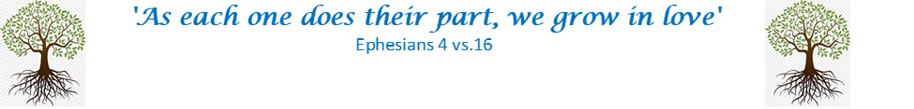

Spirituality
“That which animates the life of believers.”
What animates you?
What do you see that takes your breath away?
What inspires you?

In the book of Genesis, in the Old Testament of the Bible, God breathes life into Adam and Eve.
In the New Testament, we are reminder of the Holy Trinity: the Father, the Son and Holy Spirit.

What does this mean to you?

