

Uniform Policy

Reviewed on |  | Sept 2026 |  | Review frequency |  | Yearly
Next review due |  | Sept 2027 |  | Template Yes / No |  | Yes
Owner |  | DoES |  | Approved by |  | Executive

History of Policy Changes
Date | Page | Change | Origin of Change
21.07.25 | 3 | Schools should keep the use of branded items to a minimum and can now only mandate up to three branded items, with secondary and middle schools allowed a fourth if one is a branded tie. This change is designed to lower the cost of uniforms for families.
Sept 2026 | All / relevant sections | Updated to reflect DfE school uniform guidance updated 6 July 2026 and the statutory branded-item limit coming into force from 1 September 2026. New/revised wording is shown in blue. | DfE school uniform guidance and statutory cost of school uniforms guidance

Contents
1. History of Policy Changes 2
2. Contents 2
3. Introduction 3
4. Our School’s legal duties under the Equality Act 2010 4
5. Limiting the cost of school uniform 4
6. Uniform at our School 5
7. Pre-loved uniform 6
8. PE Kits 6
9. General Appearance 6
10. Religions and Beliefs 6
11. Engagement with parents/carers 7
12. Discrimination 7
13. Other things to think about 7
14. Staff 8
15. Governors 8
16. Associated Policies 8

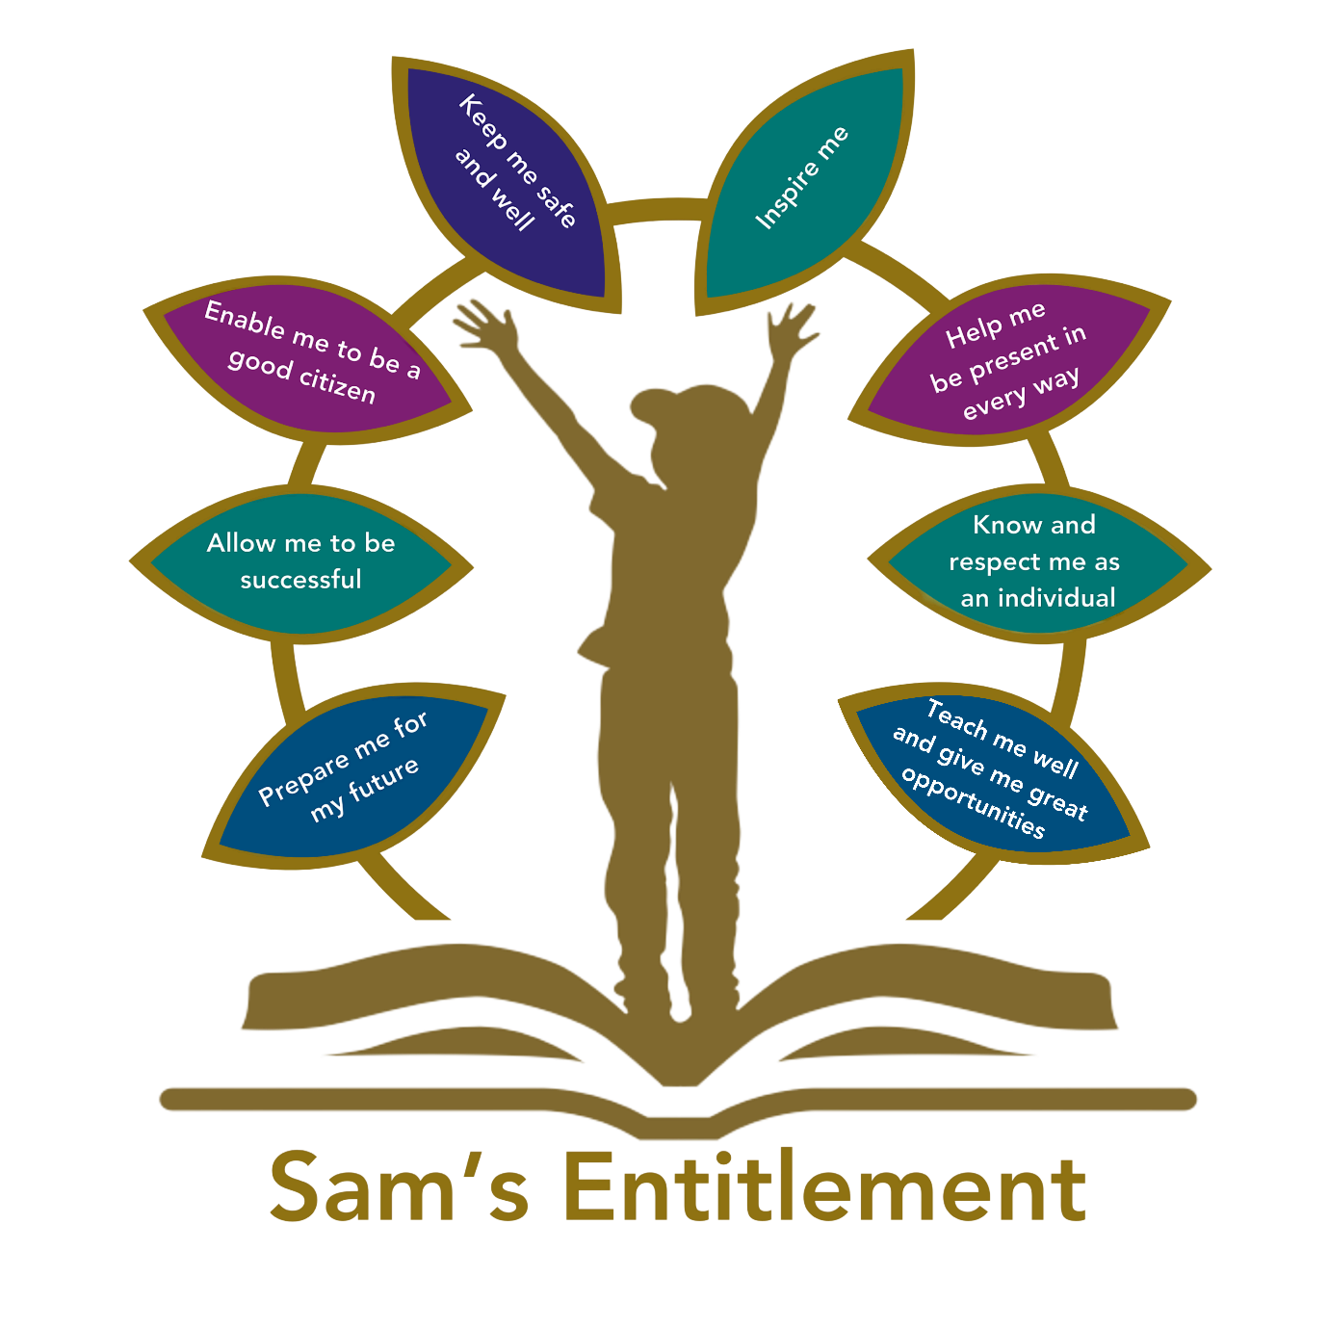

Introduction
This policy has been updated to reflect the DfE school uniform guidance updated on 6 July 2026 and the statutory requirement that governing boards / Trusts must comply with the branded item limit from 1 September 2026.
The school will keep uniform requirements clear, inclusive, affordable and easy for current and prospective parents/carers to understand.
This policy aims to:
- Set out our approach to requiring a uniform that is of reasonable cost and offers the best value for money for parents and carers
- Explain how we will avoid discrimination in line with our legal duties under the Equality Act 2010
- Clarify our expectations for school uniform in line with the Department for Education’s statutory guidance on the cost of school uniform and non-statutory guidance on developing school uniform policy, updated for September 2026.

Our School’s legal duties under the Equality Act 2010
The school will also consider obligations under the Human Rights Act 1998 and will take account of safeguarding, health and safety, pupil wellbeing and equality duties when developing and applying this policy.
The school will consider the relevant protected characteristics for uniform decisions, including sex, religion or belief, race, disability, gender reassignment and pregnancy, and will consider individual variations where necessary to avoid unlawful discrimination.
The school will consider the Equality and Human Rights Commission guidance on preventing hair discrimination in schools when reviewing rules on hair, presentation and appearance.
Uniform options will be applied flexibly and lawfully so that pupils can wear appropriate items comfortably, safely and without rules reinforcing stereotypes.
The Equality Act 2010 prohibits discrimination against an individual based on the protected characteristics, which include sex, disability, race, religion or belief, and gender reassignment.
To avoid discrimination, our school will:
- Provide a flexible choice of uniform items where possible and avoid unnecessarily rigid rules based on sex or stereotypes, while ensuring the policy remains lawful, proportionate, safe and consistently applied.
- Make sure that our uniform costs the same for all pupils
- Allow all pupils to have long hair (though we reserve the right to ask for this to be tied back)
- Allow all pupils to style their hair in a way that is appropriate for school and makes them feel most comfortable
- Allow pupils to request reasonable adaptations to swimwear or other uniform requirements for religious, SEND, medical, equality or wellbeing reasons, where this can be accommodated safely and proportionately.
- Allow pupils to wear headscarves and other religious or cultural symbols
- Allow pupils with sensory or physical needs to make adaptations to their uniform depending on their specific needs
- Allow for adaptations to our policy on the grounds of equality by asking pupils or their parents to get in touch with the Headteacher via the school offfice, who can answer questions about the policy and respond to any requests

Limiting the cost of school uniform
From 1 September 2026, the school must comply with the statutory limit on compulsory branded items of uniform and PE kit. Schools may require up to three compulsory branded items; secondary may require a fourth compulsory branded item only where that fourth item is a branded tie.
A branded item is any item with distinctive characteristics that make it unique to the school. This is not limited to a logo: an item may be branded if it is only available from specific suppliers or is unique in colour, design or fabric.
The school will keep compulsory branded items to the minimum necessary and will prioritise cost, value for money, quality, durability and sustainability when specifying uniform.
Where a sole supplier or branded-item agreement is used, the school will ensure arrangements are transparent, regularly reviewed, competitively tendered and designed to secure best value for parents/carers. Schools should ensure that their uniform supplier arrangements give the highest priority to cost and value for money (including the quality and durability of the garment).
Any substantial change to uniform or supplier arrangements will be planned with a sensible lead-in time to avoid unnecessary waste or additional cost to families.
Parents should not have to think about the cost of a school uniform when choosing which school(s) to apply for. Therefore, schools need to ensure that their uniform is affordable.

In considering cost, schools will need to think about the total cost of school uniforms, taking into account all items of uniform or clothing parents will need to provide while their child is at the school.

A school’s uniform policy should be published on the school’s website, be available for all parents, including parents of prospective pupils, and be easily understood.

Schools should ensure that second-hand / pre-loved uniforms are available for parents to acquire. Information on second-hand uniforms should be clear for parents of current and prospective pupils and published on the school’s website.

Schools should engage with parents and pupils when they are developing their school uniform policy.

At Pimperne Primary school, uniform is worn throughout the school as we believe it encourages a sense of belonging and identity.

Uniform at our School
The published school-specific uniform list must identify which items are compulsory, which items are optional, which items are generic and which items are branded.
The uniform list should make clear where items can be purchased and should not unnecessarily restrict generic items to a single supplier.
The school will consider pupil comfort, movement, safety for walking or cycling to school, and sensible flexibility during adverse or extreme weather.
Where appropriate, short-term uniform adjustments may be used to support attendance and avoid pupils missing school because of uniform issues outside their control.
Our aim is that uniform is inclusive and low cost. It consists of the following items

Tops: White polo shirt (Reception –Year 4) or white collared shirt (Year 5-6)
Bottoms: Grey or black trousers, skirt, or pinafore (navy/white check dress – summer months)
Jumpers/Cardigans: Navy blue with the school logo
Footwear: Plain, black, low heeled, leather style school shoes (not trainers or boots).
As per previous correspondence, Reception and Key Stage 1 children will require a school bookbag only (no ruck sacks).
During the colder and wetter months (especially Winter) all children should wear an appropriate coat.

Pre-loved uniform
Information about second-hand or pre-loved uniform will be clearly available to current and prospective parents/carers, including how to donate, access or purchase items.
The school will consider how reuse of uniform supports affordability and sustainability.
We ask all parents to donate any uniform that is still in good condition but is no longer used. Sales of second-hand uniform are held throughout the year and events are publicised by the school or PTA in school newsletters.

PE Kits
PE kit must be practical, comfortable, suitable for the activity and affordable.
The school will consider offering a choice of PE items so pupils can participate comfortably, for example shorts, skorts, tracksuit bottoms or leggings where appropriate.
The school will avoid requirements that create pressure to buy designer sportswear or visible branded sportswear unless clearly justified and within the statutory branded-item limit.
All children are required to have a PE uniform which consists of
Navy blue polo shirt with school logo on the front
Navy blue/black shorts/skort and trainers.
When cold, a navy blue/black tracksuit including navy blue/black jogging bottoms and a plain navy blue sweatshirt or hoodie (no logos, writing or slogans), or a navy blue school logo hoodie.
Trainers
Please ensure all items are clearly labelled with your child’s name to avoid loss

General Appearance
Rules on appearance, hair, jewellery, logos, slogans, political messaging and accessories will be clear, proportionate, applied consistently and considered alongside equality, safeguarding, health and safety and behaviour expectations.
Pupils should wear clean uniform and have long hair tied back or braided. Shoes should be all black including the soles and in good condition so that pupils are safe and comfortable. Children should not wear jewellery to school, the only exception is small, plain stud earrings which children will need to be able to remove for P.E.
No watches or devices that connect to the internet should be brought into school. No items that record sound or image should be brought into school. We do not permit smart phones in school unless there is a medical exemption, determined by the Headteacher.

Religions and Beliefs
The school will act reasonably through consultation and dialogue when considering religious or belief-related requests, balancing the pupil’s rights with legitimate aims such as health and safety, safeguarding, cohesion and good order.
Some religions and beliefs require their adherents to conform to a particular dress code or to otherwise outwardly manifest their belief. This could include wearing or carrying specific religious artefacts, not cutting their hair, dressing modestly, or covering their head. Pupils have the right to manifest a religion or belief, but not necessarily at all times, places or in a particular manner. If our school has good reason for restricting an individual’s freedoms, for example, the promotion of cohesion and good order in the school, or genuine health and safety or security considerations, the restriction of an individual’s rights to manifest their religion or belief may be justified.

The school will be sensitive to the needs of different cultures, races and religions and act reasonably in accommodating these needs, without compromising important school policies, such as school safety or discipline. It should be possible for most religious requirements to be met within a school uniform policy, and the local governing board will act reasonably through consultation and dialogue in accommodating these.

Engagement with parents/carers
The school will actively engage with parents/carers and pupils when designing the uniform policy or making significant changes, including engagement on cost, comfort, accessibility, supplier arrangements and the impact on groups with protected characteristics.
The final policy will be published on the school website and clearly signposted so that current and prospective parents/carers can access and understand it easily.
Parents are expected to lodge any complaints or objections relating to the school uniform in a timely and reasonable manner. Disputes about the cost of the school uniform will be dealt with in accordance with the school’s complaints policy. The school will work closely with parents to arrive at a mutually acceptable outcome.

Discrimination
Even when a policy has been agreed, school staff will be able to allow for some individual variations to their uniform policy, where necessary to avoid indirect discrimination. For instance, reasonable adjustments will be made, as appropriate, for pupils with a disability. We aim to make our school uniform as inclusive as possible so if parents have any requests or concerns then please contact the school.

Other things to think about
September 2026 update - attendance and non-uniform days:
The school will consider the link between uniform and attendance. Where a pupil does not have correct or clean uniform or PE kit, staff will consider supportive action and whether short-term flexibility is appropriate.
For non-uniform days, the school will set clear expectations in advance, consider the impact on attendance, avoid making participation dependent on financial contributions, and consider the impact on pupils from low-income families.
The school may set expectations on logos, slogans, political messaging or other items worn on non-uniform days where this is linked to behaviour, safeguarding or the school’s duty of political impartiality.
Please ensure all items of clothing are labelled with your child’s name to avoid them being lost. Lost property is located under cover, outside the Year 6 classroom, or entrance to the playground.

During hot weather children should bring a bottle of water and a sun hat into school, every day. Please remember to apply sunscreen in the morning before school.

During periods of hot weather, schools may allow temporary adjustments to the uniform to ensure pupils remain comfortable and able to learn effectively.

Staff
Uniform breaches will be handled in a proportionate and fair way, in line with the behaviour policy.
Before any sanctions are actioned, staff will consider whether non-compliance may be outside the pupil’s control, including affordability, availability, washing facilities, SEND, medical needs, religious requirements or family circumstances.
Staff will closely monitor pupils to make sure they are in correct uniform. They will give any pupils and families breaching the uniform policy the opportunity to comply but will follow up with the headteacher if the situation doesn’t improve.
Ongoing breaches of our uniform policy will be dealt with by the class teacher initially, and further the Senior Leadership Team, in line with our school policies.

Governors
The Local Governing Committee will assure itself that the policy complies with the September 2026 branded-item limit and continues to give high priority to cost and value for money.
Governors will ensure supplier arrangements remain transparent, competitive where required, and regularly reviewed, and that the published policy is clear for current and prospective parents/carers.
The Local Governing Body will review this policy to ensure it is appropriate for the school context, is implemented fairly across the school and is appropriate, practical and safe for all pupils.

Associated Policies
This policy should also be read alongside procurement procedures where branded uniform supplier arrangements are used, and attendance guidance where uniform issues may affect attendance.
This policy also links to:
Complaints policy
Behaviour policy
Equality information and objectives

