Pimperne’s Whole Class Reading structure

To teach reading in line with the Reading Framework, reading lessons from Year 2 (Summer term) to Year 6 will be taught as a whole class sessions studying an age-appropriate text.

- Sessions will be structured in line with our learning pathway.
- Each session should be 20-30 minutes in Year 2 and 30-40 minutes in KS2

Across the week, all children will have opportunity to:

- Hear their teacher read a text aloud daily - (Teacher reading)
- Echo or choral read a text – (whole class reading together)
- Listen to a peer read a text aloud - (Paired reading)
- Read aloud a text to a peer/teacher - (Paired reading)
- Discuss, question and visualise the text they are reading - (Discussion)
- See high quality modelling and explanations of reading from their teachers - (Teacher reading/discussions/I do)
Complete independent tasks linked to the text they are reading - (Independent task - you do)
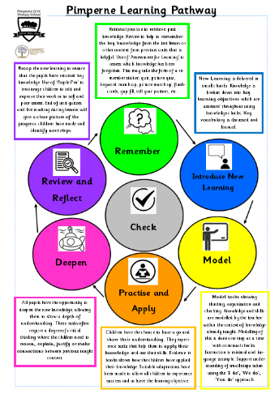

Whole-Class Reading: 4 lesson structure

Session 1: Introduce the new text & create Mental Model
- Teacher selects age-appropriate, high-quality text
- Vocabulary Focus: Introduce and teach 5–6 Tier 2/3 words. Develop background knowledge.
- Teacher reads text; pupils track.
- Discuss the text then summarise or create a mental model to refer to throughout the sessions.

Session 2: Vocabulary Recall & Fluency
- Recall vocabulary through low-stakes quizzes
- Fluency: Introduce and model prosody focus; echo or choral reading
- Comprehension: Select a focus from across the reading domains. Discuss and model answering questions to develop understanding of the text.

Session 3: Partner Reading & New Comprehension Focus
- Vocabulary Recall – practise using vocabulary in context.
- Fluency: Teacher models prosody focus; partner reading (teacher moving around the room)
- Self, peer or teacher assessment against fluency rubric
- Comprehension: new focus chosen from reading domains

Session 4: Independent Reading & Questions
- New text.
- Pupils independently read the text and answer similar questions to those explored using sentence stems where appropriate

