High Quality Texts used to inspire writing.
EYFS Key Stage 1
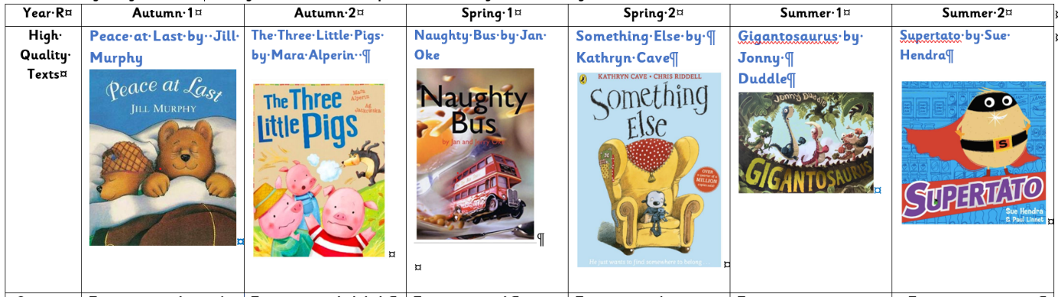
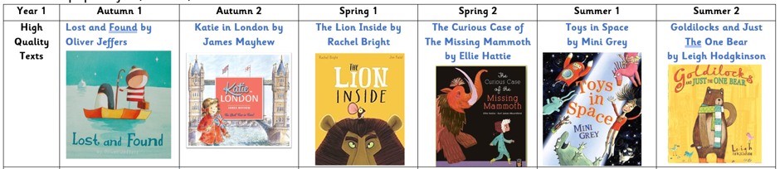
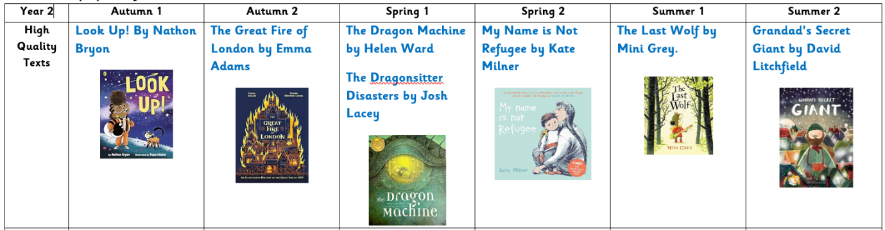
Key Stage 2
