Year 2 – Autumn 1 Learning

English – Key Learning
Reading:
Language: I can identify an unfamiliar word in the text. I can suggest what the word might mean based on picture clues.
I can look at a sentence around an unknown word for clues about the meaning.
I can listen and join in with words or phrases which come up often in a text.
Inference I can use pictures or words to make inferences (spot clues) about what a character is doing, saying or feeling.
I can connect the clues to my own experiences.
Prediction: I can make predictions about a book based on the front cover or blurb.
Text Structure & Themes: I can retell parts of a story accurately using my own language.
Retrieve: I can identify key words in a question. (Who/what/where/when/why)
I can understand what a question is asking.
I can orally answer a retrieval question.
Summarise & Sequence: I can say what happened at the beginning of a story.
I can say what happened at the end of a story.
Writing:
Class Text:
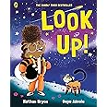
Mastery Keys (year group national curriculum
expectations)
• Use punctuation correctly – full stops, capital letters.
• Use expanded noun phrases to describe and specify.
• Use subordination (because) and coordination (and).
Feature Keys (vocabulary, manipulating
sentences and tense, structure)
• Include detail and description to inform the reader.
• Write in first person.
• Use consistent past tense.
• Order events with adverbs of time.
• Include personal comments and own viewpoint.
• Set the scene with a clear opening and establish the context.
• Finish with a closing statement with personal comment or summary e.g. What an amazing day we all had!
In addition, dictation and handwriting are practised daily to consolidate skills.
Our library session is on: Tuesday afternoon

Ready, Respectful, Safe
• Ready: On time; equipment ready (reading book, water bottle); eyes on speaker; active listening; having a go before asking for help.
• Respectful: Kind words and actions; care for classroom resources, school and displays.
• Safe: Follow adult instructions first time; move sensibly indoors/outdoors; use equipment correctly; tell an adult if worried.
Our vision: “As each one does their part, we grow in love.”

Pimperne Learning Pathway:
Remember: We begin each lesson by revisiting what the children already know to help them feel confident and ready to learn.
Introduce new learning: The teacher clearly explains what the children will be learning and what they are working towards.
Modelling: The teacher demonstrates new ideas step by step. Children then practise together with the teacher before having a go on their own.
Practise and apply: Children practise similar activities to build confidence and understanding using their new skills.
Deepen: Children independently apply their learning in a variety of different contexts.
Review and reflect: The class discusses their learning together, addressing any misconceptions. Extra support or challenge is provided before or after lessons if needed.
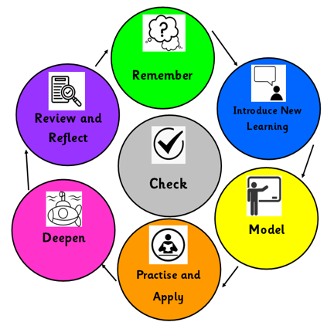
Home Learning:
- Reading – both your child reading to you, and you reading to your child.
- Practise recalling the number bonds to 10, 20 and 100.
- Practise spelling the Year 1 and 2 Common Exception Words.
Your child has access to the following online platforms: Purple Mash, Sumdog.
Support at home: If you would like further ideas to help your child, please ask the class teacher. We recommend CGP books to aid you in supporting your child.
Other Curriculum Focus for this half term:
Science (Animals, including humans)
• Animal Offspring and Life Cycles
• What is a habitat and a micro habitat?
• What do all animals need to survive?
• What is a carnivore, herbivore and omnivore?
• What do humans need to be healthy?
• Is something dead, alive or never alive?
History (3, 2, 1…Blast Off!!)
• What can photographs tell historians about space travel?
• What was life like when Neil Armstrong was alive 60 years ago?
• Who was Neil Armstrong and why do we remember him today?
• Who was the first British astronaut?
• Who is Tim Peake and what was his greatest achievement?
• Why are Neil Armstrong, Helen Sharman and Tim Peake significant?
Art (Drawing)
• Using varying pressure to add tone and texture
DT (Cooking & Nutrition)
• Design and make a healthy wrap.
Computing: (Online Safety)
• To understand what the internet and email is and how to use them safely.
• To know how to use the search tool.
• To know how to keep your personal data and hardware secure.
RE (Humanism):
• What do Humanists believe?
PSHE (Being in My World):
• Hope and fears for the year
• Rights and responsibilities
• Rewards and consequences
•Safe and fair learning environment
• Valuing contributions
• Recognising feelings
Music:
• To learn about music from the Beatles.
• To learn about dot notation.
• To sing Cauliflowers Fluffy.
PE:
Our PE days are: Thursday and Friday.
• Fundamentals on Fridays with Mrs Taggart.
• Gymnastics on Thursdays with Mrs Bemand.

A note from the teacher:
Welcome to Year 2!

Despite the continued warm weather, we are urging all children to bring in coats, as the weather is so unpredictable and getting out for a break in fresh air is necessary.
If the weather stays warm, please remember to bring in a named sun hat. Please apply suncream in the morning that will last all day.

Children will need a named water bottle every day.

Please remember packed lunches need to be nut free.

Thank you for your continued support.

Mathematics – Key Learning
Place Value:
• Numbers to 20
• Count objects to 100 by making 10s.
• Recognise tens and ones
• Use a place value chart
• Partition numbers to 100
• Write number to 100 in words
• Flexibly partition numbers to 100
• Write numbers to 100 in expanded form
• 10s on the number line to 100
• 10s and 1s on the number line to 100
• Estimate numbers on a number line
• Compare objects
• Compare numbers
• Order objects and numbers
• Count in 2’s
• Count in 5s
• Count in 10s
• Count in 3s
Addition and Subtraction:
• Bonds to 10
•Fact families within 20
• Related facts
• Bonds to 100
• Add and subtract 1s
• Add by making 10
• Add three 1-digit numbers
• Add to the next 10
• Add across a 10
• Subtract across 10
• Subtract across 10

