Year 3 – Autumn 1 Learning

English – Key Learning
Reading:
Language: Identify words that are unfamiliar or interesting in a text.
Talk about and check the meaning of new and unfamiliar words.
Think about what words and phrases tell the reader about a character or setting.
Inference: Notice less obvious details in a story to help them make inferences.
Prediction: Make a prediction based on the front cover and blurb of a book.
Text Structure & Themes: Discuss the features of non-fiction texts. Explain the purpose of the glossary and contents. Find and discuss interesting or unusual words.
Retrieve: I can use a contents page and subheadings to locate information. Summarise & Sequence: I can give a brief, verbal summary of a text.
Writing:
Class Texts:
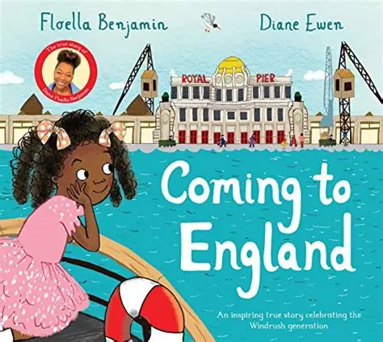

Mastery Keys (year group national curriculum
expectations)
- Group related ideas into paragraphs
- Build a varied and rich vocabulary
- Use prepositions to express time, place and cause
Feature Keys (vocabulary, manipulating
sentences and tense, structure)
- Write in the first person
- Use a variety of sentence forms including statements and questions
- Write in consistent past and present tense including progressive forms
- Use layout and structure of a letter
- Ensure chronological order to explain sequence of events
In addition, dictation and handwriting will be practised daily to consolidate skills, along with three weekly spelling lessons.

Our library session is on: Monday Afternoon

Ready, Respectful, Safe
• Ready: On time; equipment ready (reading book, water bottle); eyes on speaker; active listening; having a go before asking for help.
• Respectful: Kind words and actions; care for classroom resources, school and displays.
• Safe: Follow adult instructions first time; move sensibly indoors/outdoors; use equipment correctly; tell an adult if worried.
Our vision: “As each one does their part, we grow in love.”

Pimperne Learning Pathway:
Remember: We begin each lesson by revisiting what the children already know to help them feel confident and ready to learn.
Introduce new learning: The teacher clearly explains what the children will be learning and what they are working towards.
Modelling: The teacher demonstrates new ideas step by step. Children then practise together with the teacher before having a go on their own.
Practise and apply: Children practise similar activities to build confidence and understanding using their new skills.
Deepen: Children independently apply their learning in a variety of different contexts.
Review and reflect: The class discusses their learning together, addressing any misconceptions. Extra support or challenge is provided before or after lessons if needed.
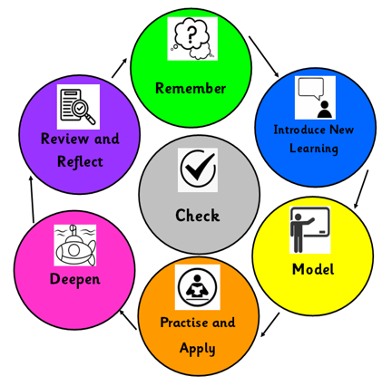
Other Curriculum Foci for this half term:

Science (Forces and Magnetism):
- Understand that the roughness of surfaces affects how things move across them. Understand that ‘friction’ is a force between two surfaces in contact. Know that some objects require a larger force to make them move.
- Understand that magnetism can act at a distance. Know that magnets have two poles and that these can repel and attract. Know that magnets attract some metals e.g. iron, but not others.
- Ask questions and use different methods to answer them e.g. research, observation and experiments.
History (Through the Ages)
- Understand the meaning of ‘prehistory’ and how historians learn about it
- Sequence the Stone, Bronze and Iron ages and understand that these were named after the materials used to make tools.
- Explore how weapons and settlements changed during these periods
- Explore local monuments and hillforts and understand how these have taught us about the past
Geography (Settlements)
- Understand what a settlement is and how physical features affected why early people chose the locations they did
- Find where Iron Age hillforts and monuments are located
- Know early people chose where they lived based on the shape of land (e.g. hill, river, coast) and natural resources e.g. Skara Brae
Art:
- Understand how artists use different drawing techniques to create texture, tone and detail

Computing: (Online Safety)
- Know and identify what makes a password safe.
- Understand that not everything on the internet is true and to questions what they read online.
- Understand age restrictions and recognise associated symbols.
RE (Christianity: Creation):
- What do Christians learn from the Creation story?

PSHE (Being Me in My World):
- I can explain how my behaviour can affect how others feel and behave.
- I can explain why it is important to have rules and how that helps me and others in my class learn.
- I can explain why it is important to feel valued.
Music:
- Explore how music is written down
- Identify the stave, lines, spaces and clef
- Sing expressively, using staccato and legato
- Improvise simple melodic patterns using the notes CDE
- Develop skills in playing tuned percussion
- Sing lots of different songs as a group and use my signing voice to sing the right notes and show feelings

MFL (French):
- Introduction to the French language - phonics and pronunciation
- Learn key greetings, ask and answer the question ‘How are you?’ and ‘What is your name?’.
PE: Handball
- To understand the roles of attacker and defender and build the skills needed to succeed in these positions
- To apply the skills, rules and tactics to play games and work successfully within a team.

Our PE days: Monday and Thursday

A note from the teachers:
We are looking forward to our first half term with Year 3 and will focus on helping them to settle into their new environment.

While the weather is still hot, we ask that your child wears suncream and brings a hat, as well as waterproof jacket for playtimes.

Your child will now need to bring their own fruit or veg snack from home each day.

Please remember packed lunches need to be nut free.

Important Dates:
Meet the Teachers Weds 10th September
Parents Evening Weds 14th/21st October

Thank you for your support

Home Learning:
- Reading – daily, out loud to an adult to develop fluency
- Sumdog
- Spellings

Homework is set on a Friday to be completed by the following Thursday
We also recommend CGP books to aid you in supporting your child.

Mathematics – Key Learning
Place Value:
- Represent and partition numbers to 100
- Hundreds
- Represent and partition numbers to 1,000
- Hundreds, Tens and ones
- Find 1, 10 or 100 more or less than a number
- Number line to 1,000
- Estimate on a number line to 1,000
- Compare and order numbers to 1,000
- Count in 50’s
Addition and subtraction:
- Apply number bonds within 10
- Add and subtract 1s, 10s and 100s
- Add 1s across a 10. Add 10s across a 100
- Subtract 1s across a 10. Subtract 10s across a 100
- Add and subtract two numbers (no exchange)
- Add two numbers (across a 10 and across a 100)
- Subtract two numbers (across a 10 and across a 100)
Arithmetic, problem solving and reasoning will be included in maths lessons. In addition, daily fluency sessions will be undertaken to consolidate prior learning.

