Year 5 – Autumn 1 Learning

English – Key Learning
Reading:
Language: Discuss how the author’s choice of language impacts the reader. Explain how word choices shape the text’s tone or emotional impact.
Inference: Make inferences about characters actions or feelings from what is said. Give more than one piece of evidence to support the point being made.
Prediction: Predict what might happen from details stated and implied. Support my predictions by using relevant evidence from the text
Text Structure & Themes: Can give a reason for an opinion in class discussion. e.g. “I think the main character is brave because he rescued his friend.”
Retrieve: skim texts and quickly looking through headings, bold words, and first sentences to get the main idea of a text.
Scan: Search for key words or phrases that match the question (names, dates, topic words)
Summarise & Sequence: Summarise the main ideas drawn from more than one paragraph.
Writing
Class Text: The Queen of the Falls by Chris Van Allsburg
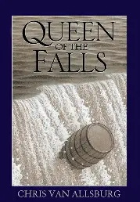
Mastery Keys (year group national curriculum
expectations)
- Identify the audience for and purpose of writing
- Organise paragraphs around a theme with a focus on more complex narrative structures
- Use commas after fronted adverbials
- Use commas to clarify meaning or avoid ambiguity in writing
Feature Keys (vocabulary, manipulating
sentences and tense, structure)
- Engage reader through use of description, feelings and opinions
- Use adverbs and fronted adverbials (with doubt in my mind, anxiously, afterwards)
- Use rhetorical questions to engage reader
- Use consistent 1st person
- Write in consistent tense including progressive and perfect forms
- Include the 5Ws – who, what, where, when, why and how
We will also be continuing with the use of dictation throughout writing to explore grammar, punctuation and spelling expectations.
Our library session is on: Wednesday afternoon

Ready, Respectful, Safe
• Ready: On time; equipment ready (reading book, water bottle); eyes on speaker; active listening; having a go before asking for help.
• Respectful: Kind words and actions; care for classroom resources, school and displays.
• Safe: Follow adult instructions first time; move sensibly indoors/outdoors; use equipment correctly; tell an adult if worried.
Our vision: “As each one does their part, we grow in love.”

Pimperne Learning Pathway:
Remember: We begin each lesson by revisiting what the children already know to help them feel confident and ready to learn.
Introduce new learning: The teacher clearly explains what the children will be learning and what they are working towards.
Modelling: The teacher demonstrates new ideas step by step. Children then practise together with the teacher before having a go on their own.
Practise and apply: Children practise similar activities to build confidence and understanding using their new skills.
Deepen: Children independently apply their learning in a variety of different contexts.
Review and reflect: The class discusses their learning together, addressing any misconceptions. Extra support or challenge is provided before or after lessons if needed.
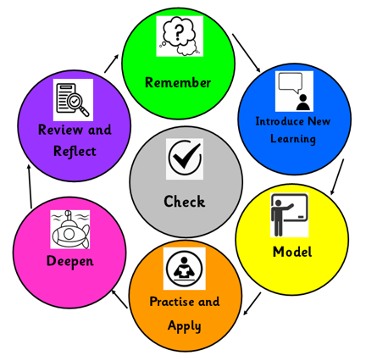
A note from the teacher:
I am so excited to get started with the new Year 5 class this year! We have got lots of exciting learning this term and I know they are going to continue to impress me!

Excitingly, Mrs Bemand will be running some Bikeability sessions this term and you should receive a date for your child’s session. They may vary from Monday, Tuesday to Friday mornings this term.

Our PE days are a Tuesday and a Thursday. Please ensure that your child comes to school in the appropriate PE kit with hair tied back and earrings removed for these sessions.

With the weather keeping us on our toes this year please make sure children come to school with coats if necessary and equally a sunhat and suncream if the weather continues to be warm!

The children do now have lockers for their belongings, and they are more than welcome to bring in a few photos to put up inside their lockers. Please can I ask that fidgets and other small toys are not kept in lockers and stay at home.

As always, we operate with an open-door policy, and I am always around to answer any questions so please do pop in and ask or send me an email and I’ll get back to you as soon as I can.
Thankyou for your ongoing support and here’s to an exciting year!

Miss Dimmack and the Year 5 team.

Mathematics – Key Learning

Place Value:
- Roman Numerals
- Numbers to 10,000 , 100,0000 and 1,000,000
- Read and write numbers to 1,000,000
- Powers of 10
- Compare and order numbers
- Rounding to nearest 10,100 or 1000
- Round within 100,000 and 1,000,000

Addition and Subtraction:
- Add and subtract 4 digit whole numbers
- Round to check answers
- Inverse operations
- Multi-step problems
- Mental strategies
- Compare calculations

Multiplication:
- Multiply up to a 4-digit number by a 1-digit number
- Multiply a 2-digit number by a 2 digit number
- Multiply by 2-digit numbers
Arithmetic, problem solving and reasoning will be included in maths lessons. In addition, daily fluency sessions will be undertaken to consolidate prior learning.

Home Learning:
- Reading – daily out loud to develop fluency
- Spellings – Each half term I will hand out the spellings for following weeks alongside resources and ways to practise these spellings. We will not be conducting weekly spelling tests and instead we will be monitoring these spellings throughout our daily dictation sentences in every Writing lesson.
Your child has access to the following online platforms: Purple Mash, Sumdog
Support at home: If you would like further ideas to help your child, please ask the class teacher. We recommend CGP books to aid you in supporting your child.
Other Curriculum Focus for this half term:
Science (Forces) What makes things fall to the ground?
- I know unsupported objects fall because of gravity between earth and the object.
- I can identify forces and their effects: air resistance, water resistance, friction.
- I understand that there are different types of scientific enquiry: observation over time, identifying/ classifying through observation, pattern seeking, research, fair testing.
- I can make observations linked to answering questions.
- I can plan a test based on scientific prediction.
- I can use scientific knowledge to draw conclusions (identify patterns).
- I know levers and pulleys make lifting easier.
History: Anglo-Saxons and Vikings
- How successful were the Vikings in challenging Anglo Saxon rule in Britain?
Art:
- Painting Unit: Confidently control the types of marks made and experiment with different effects and textures including blocking in colour, washes, thickened paint creating textual effects.
- Enquiry question: How can we use colour, texture and collage to bring a Viking longship to life?
RE (Christianity):
- Christianity: Why is God Holy and loving?
PSHE (Being me in my world):
- Understand how democracy and having a voice benefits the school community.
- Understand the rights and responsibilities associated with being a citizen in the wider community and their country.
- Understand how to set personal goals.
Music:
Pop Music: What is Pop music?
- Know that music is played in different time signatures such as 2/4, 3/4 and 4/4
- Know that major and minor chords are used in music
MFL (French):
- Presenting myself
PE: Handball
- Physical: throw, catch, run, dribble, change direction, balance, jump
- Social: support, communication
- Thinking: decision making, select and apply, identify

