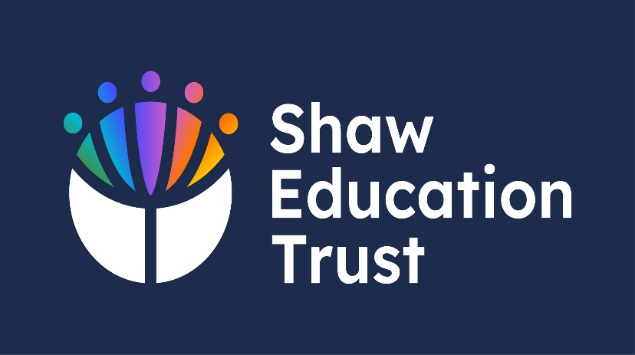
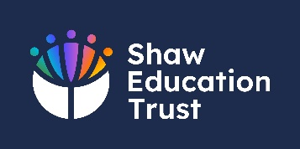

Whole School

Reading Policy – Version 4

Supporting students Primary & Secondary Students Who Need Help With Reading

Pine Green Academy

September 2024- 2025

Current Author: | S. Williams – Head of School
Person Responsible for the Policy: | D. Hartley – Executive Headteacher
Last SLT Review:
Last Governing Body Review:
Current Status:

Intent

At Pine Green Academy we recognise the importance of reading, across the whole school.

Students who can read are more likely to achieve in school and have positive life outcomes.

Research has linked age-appropriate reading ability with greater rates of employment, a reduced chance of homelessness, divorce, health problems and criminal offending. Research has also linked poor reading ability with lower employment prospects, home ownership, political engagement, and life satisfaction (Dugdale and Clark, 2008a; Parsons and Bynner, 2008).
Due to a range of special educational needs, including ‘Cognition & Learning,’ ‘Social, Emotional & Mental Health’ and ‘Communication and Interaction’ needs, students will often arrive at Pine Green Academy substantially behind their peers.
The majority of students at Pine Green Academy will require extra help to support their reading including…
Basic Phonics Knowledge
Word reading
Comprehension (both listening and reading).
This document aims to detail the whole school approach to reading across Pine Green to ensure students who are behind age-expected standards, are afforded every opportunity to succeed.

Organising and Promoting Books

Many of our students have few tangible resources at home and many live in houses where there are no books. For many, the only experiences they have with books are negative and associated with schoolwork that they have invariably failed along the way to accessing schooling in a specialist setting.

As students build respect for their environment and classrooms, books that students can read for pleasure will be on display in all classrooms.

Students will also experience weekly reading sessions in our Hive/library and reading will also form part of our school half-termly homework policy where students will be allowed to choose books from our school library (and public libraries) to encourage engagement with literature and reading for pleasure.

Whole School Reading Curricula
Tier 1– Whole School Reading Pathway
Reading for Pleasure

The academy promotes ‘a love of reading’ and attempts to raise the profile of reading in a variety of diverse ways. The school proudly celebrates the books read by our students and staff as we see to establish a ‘culture’ of reading in our vulnerable young people.

- Staff display their current ‘reads and students record the book or magazine they are reading on our tutor group displays.

- Our students love competition, and we have attempted to develop competition between form groups to encourage reading.

- Students also ‘encounter books and other sources of literature as well as ‘practising reading at relevant levels.

- All classrooms display the ‘Word of the Week,’ to expose pupils to new vocabulary along with, expanding their own word banks.

Students encounter books

Our reading curricula is explicitly taught as well as being embed into lessons. Students are exposed to a range of literature during tutor groups. These include news articles, Novels, graphic novels, and audio books.

In Primary, students are read to daily using Pie Corbett’s reading spine. In Secondary students have a reading lesson once a week, where teachers ‘read to students. Books are chosen from the BBC’s Big Read and students are introduced to the excitement of reading books and the stories they contain.

Reading is a feature of all lessons here at the Academy, from Pie Corbett’s reading spine in Primary to our regular Big Read sessions in Secondary, in the morning and through every lesson in the school day.

Students are encouraged and awarded for reading aloud during their lessons, to help build their confidence and motivate them to experience all forms of literature across the curriculum.
Importance of Talk

Pie Corbett’s Reading Spine and our Big Read programme encourages pupils to talk about the information they are reading. Students are encouraged to discuss information they have read. This is a deliberate strategy to encourage participation around the text but also to teach meta-cognitive strategies to help students with understanding and comprehension.

It must also be noted that many of our students struggle to communicate. Where reading difficulties are paired with communication difficulties, problems engaging in all aspects of the school curriculum become prevalent. To combat these difficulties as part of our curriculum programme, ’Votes for Schools,’ students are encouraged to take part in a ‘discussion’ about ‘current affairs,’ equipping students with the discursive skills that may hinder their ability to talk about text.
Teach reading and comprehension

In Primary, reading is adapted to meet the needs of our pupil’s reading levels. Beginning with ‘The Bug Club’ phonics scheme. This is where pupils are exposed to phonemes, blending and segments sounds to improve their reading fluency. Next stage, pupils are introduced to four lessons a week of ‘The Bug Club’ comprehension lessons, which under pin the key structure of the reading domains.

As part of the Tuesday and Thursday tutorial sessions in Secondary, students are taught reading and comprehension strategies. Throughout the year, strategies (e.g. making predictions, visualising outcomes, inferences) are built into the activities that students are engaging with. Teachers also ensure that strategies to access texts are adapted for the needs of all our learners allowing them to practise reading at relevant levels and gaining the skills to allow them to read in an age-appropriate manner.

Spelling

In Primary, spellings are taught through ‘The Bug Club’ scheme, to introduce and embed the vocabulary and spelling rules. Secondary, we are raising literacy levels, to immerse students in all lessons with high frequency spellings and key topic words, to reduce barriers to learning.

Reading Pathways

Diagnosis & Testing

Who needs the most support?
There are many different routes to access a place in the at Pine Green Academy.

Pupils join our school at various points throughout the academic school year. All children upon arrival, will come with data, information from their EHCP’s or teacher’s assessments. As this is historical data, every pupil will be assessed using our summative framework of assessment pathway.

As such, Pine Green conducts a rigorous serious of assessments in a range of cognitive and social domains to screen students for difficulties when they join the Academy. These include…
Whole School Screening
- Phonics ‘The Bug Club’ Tracker
- Salford Reading
- Basic Number Screening
- CAT (GL Assessments)
- NGRT (New Group Reading Tests on GL Assessments)
- Progress Tests in English
- DASH Handwriting Assessment
- Analysis of data from previous setting.

Tier 1 Internal Testing & Intervention
Where difficulties are identified, the school enacts further testing to identify the precise nature of the difficulties. Where difficulties with reading or phonics are identified, we employ Literacy Assessment Online which assesses pupils in a range of domains including phonics, spelling & comprehension. The test is also used when students struggle to access NGRT/PTE/CAT assessments to provide the school and parents with a current understanding of reading ability. Based on the results form these assessments, school will schedule interventions to address the learning barriers of our students, additionally, identifying which pathway pupils will begin their journey in the curriculum.
Tier 2 Internal Testing & Intervention
Where students fail to make progress when supported by interventions or when it considered that further assessment is required, our Level 7 Access Arrangement Assessor conducts further assessments to identify the precise nature of the difficulties. Using Lucid LASS (8-11 & 11-15), Lucid Exact & WIAT – III, school can identify ‘Reading & Comprehension’ difficulties and produced a detailed examination of a student’s ‘Phonics’ ability, examining a student’s ability to understand high frequency words, blending and non-words.

When difficulties have been identified, we purposefully offer a range of interventions so that students can quickly gain the skills they need to access an age-appropriate curriculum.

External Testing & Support
Following outcomes of assessments and interventions taking place, if progress is still minimal, then External agencies will be deployed. E.g. CAMHS, GPs and Educational Psychologist.

Interventions
Tier 3 Support – Reading Pathway
What we do – Phonics

Two established phonics programmes are used. In our Primary setting we use ‘Bug Club’ Phonics – a fast-paced phonics scheme for teaching systematic synthetic phonics in a structured way.

Within our Secondary setting, Pearson Education’s Rapid & ‘Rapid Phonics’ is used to provide students with age-relevant materials to help bridge the gap between a student’s reading age and accessing the Key Stage 3 Curriculum.

As our learners all have ‘Social, Emotional & Mental Health’ needs, we are aware that practising phonics and/or reading in front of peers may evoke a range of negative emotions. As such, where phonics difficulties have been identified, students are offered small group and 1:1 intervention to help them catch up, where all these programmes are adapted to meet the requirements of our pupils.

Addressing deficits in phonics

These include…

- Rapid Phonics & Rapid Plus Phonics
- 1:1 Interventions based on ‘Precision’ principles to support students with high need phonics or reading difficulties focussed explicitly on systematic synthetic phonics.

Interventions are tailored to specific outcomes and needs and will be scheduled throughout the year. Assessments of Reading Age and Phonics difficulty are scheduled during each term. Interventions will also be revisited to ensure that the skills gained from interaction with adults are reinforced and are retained.

Tier 2 Support – Reading Pathway

Addressing Reading Difficulty

In Primary, when underlying phonics difficulties are addressed, pupils are supported by 1:1 sessions or small groups by our trained phonics associate, to further embed ‘The Bug Club’ scheme. These lessons are tailored to meet the requirements of each pupil. To help build their phonics and reading ability.

In Secondary when underlying phonics difficulties are addressed, some learners may still have a low reading age. In these scenarios, the school offers ‘Rapid Plus,’ a reading scheme that supports KS3 learners with special education needs. Unlike most reading schemes, the materials are age-appropriate and contain books relevant to our learners. We offer Rapid Plus 3-9 and stages 10-12.

Literacy opportunities are built into schemes of work and form a mandatory part of class displays, ensuring key words are evident.

Pie Corbett’s Spine Read
Jaguars |  |  |  | THEMES
Autumn 1 | 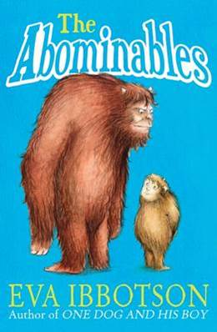 | The Abominable | Eva Ibbotson | The importance of family in Yi's relationship with her loveable grandmother.
Autumn 2 | 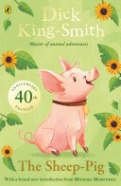 | The Sheep-Pig | Dick King Smith | Self-belief, overcoming challenges, Setting A village farm.
Spring 1 |  | Iron Man | Ted Hughes | Bravery, prejudice, irrational fear, inclusion, teaching children not to fear people who are different to themselves, but to learn to understand and accept them.
Spring 2 | 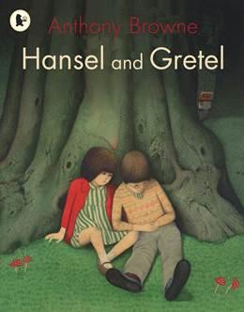 | Hansel and Gretel | Anthony Browne | “Do not trust strangers, even if they treat you well.” And Greed.
Summer 1 | 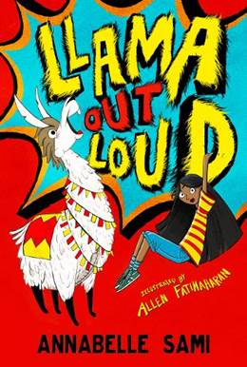 | Ilama out loud | Annabell Sami | Bullying, selective mutism, loneliness, and old age.
Summer 2 | 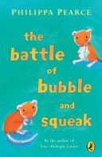 | The Battle of bubble and Squeak | Philippa Pearce | A major family battle results, and its clear life is never going to be quite the same again.
Lions
Autumn 1 | 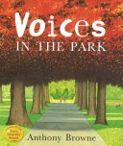 | Voices in the Park | Anthony Browne | Society, friendship, rich and poor, stereotypes and prejudice.
Autumn 2 | 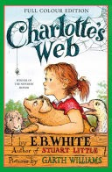 | Charlotte’s Web | E B White | Friendship and perseverance
Spring 1 | 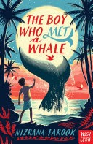 | The Boy who met a Whale | Nizrana Farook | Family, friendship and helping others.
Spring 2 | 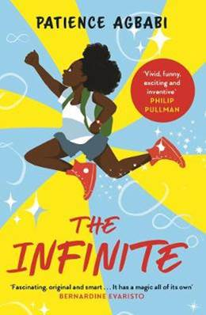 | The Infinite | Patience Agbabi | Time-travelling science fiction adventure combined with crime mystery,
Summer 1 | 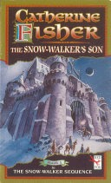 | The Snow Walker Son | Catherine Husher | Of banishment and sorcery
Summer 2 |  | The Last Bear | Hannah Gold | A celebration of the love between a child and an animal, a battle cry for our world and an irresistible adventure with a heart as big as a bear's.
Panthers
Autumn 1 | 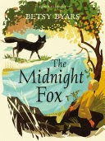 | The Midnight Fox | Betsy Byars | Human and relationships between humans and wildlife
Autumn 2 | 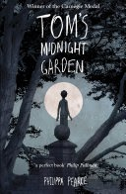 | Tom’s Midnight Garden | Philippa Pearce | Attitudes towards time, mutability, and people much older, or much younger, than we.
Spring 1 | 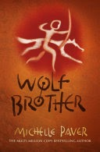 | Wolf Brothers | Michelle Paver | Bravery, loyalty and a deep respect for the forest and its inhabitants.
Spring 2 | 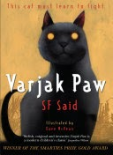 | Varjak Paw | S.F. Said | Rebellion, perseverance, courage, family, exploration, and friendship.
Summer 1 | 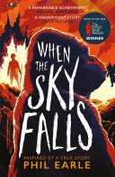 | When the Sky Falls | Phil Earie | Struggles of one boy to make sense of his emotions and the blows life has dealt him
Summer 2 | 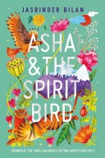 | Asha and Spirit Bird | Jasbinder Bilan | Faith, friendship, and greed
BBC BIG READ - Year 7 Books

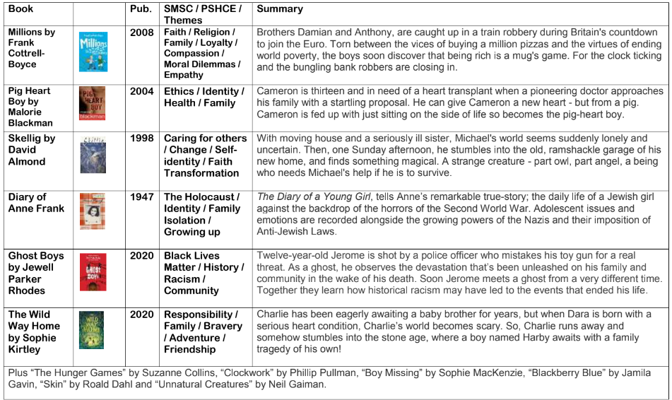

BBC BIG READ - Year 8 Books

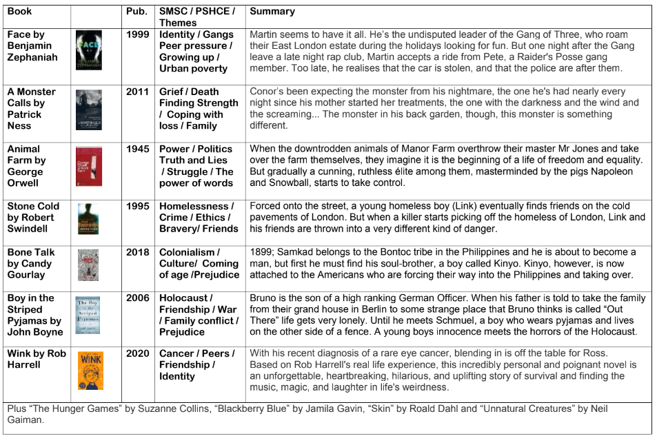

BBC BIG READ - Year 9 Books

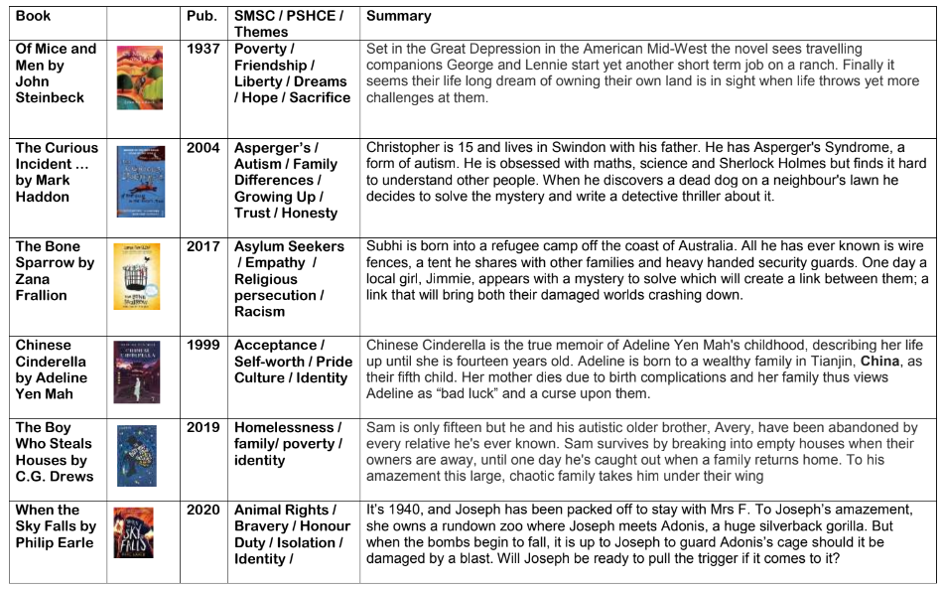

BBC BIG READ - Year 10 Books

