
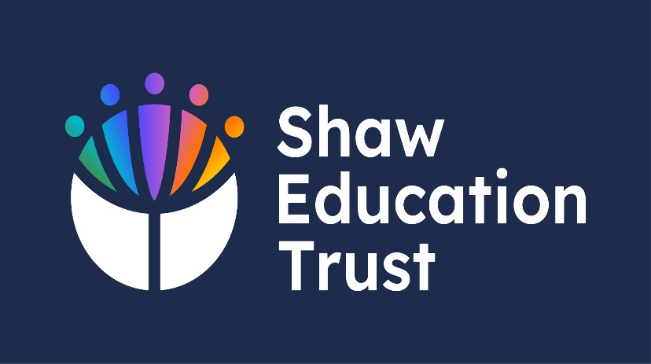
Reading Strategy

Pine Green Academy

September 2023-4

Current Author: | S. Williams – Head of School
Person Responsible for the Policy: | D. Hartley – Executive Headteacher
Last SLT Review:
Last Governing Body Review:
Current Status:

Reading Strategy for Pine Green Academy 2024-5
Introduction on the importance of reading
Introduction
At Pine Green Academy we recognise the importance of reading.
Students who can read are more likely to achieve in school and have positive life outcomes.
We recognise that by the end of year 6, pupils’ reading and writing should be sufficiently fluent and effortless for them to manage the general demands of the curriculum in Key Stage 3.
However due to a range of special educational needs, including ‘Cognition & Learning’, ‘Social, Emotional & Mental Health’ and ‘Communication and Interaction’ needs, students will often arrive at Pine Green Academy substantially behind their peers.
The majority of students in the Secondary phase of Pine Green Academy will require extra help to support their reading including…
Basic Phonics Knowledge
Word reading
Comprehension (both listening and reading).
There are many different routes to access a place in the Secondary phase at Pine Green Academy.
- Some students will have completed phase transfers from our Primary setting and staff will have a detailed understanding of reading knowledge and gaps.

- Some students will join us in Year 7 having completed KS2 SAT assessments.

- Some students will join from our Primary phase or from other settings and have not completed SATs due to barriers created by their special educational needs.

- Some students will join midway Key Stage 3 & 4 with or without relevant assessments.
As such, Pine Green conducts a rigorous serious of assessments in a range of cognitive and social domains to screen students for difficulties when they join the Academy.

Testing
Frequency of testing:
Timeframe for testing
Yrs. 7 – Yr10 three times a year (Sept/Oct, Jan/Feb & June/July)
Yr. 11 – twice a year (Sept/Oct & Jan/Feb)
New Starters – Will complete a 2 week introduction program of testing
Tests taken
CAT (GL Assessments)
NGRT (New Group Reading Tests on GL Assessments)
Progress Tests in English
DASH Handwriting Assessment
Analysis of data from previous settings

Mid-term entrants to the school – test taken during a 2 week introduction
CAT (GL Assessments)
NGRT (New Group Reading Tests on GL Assessments)
Pass 3 Survey (GL Assessments)
DASH Handwriting Assessment
Analysis of data from previous settings
Communication Pathways observations
Coventry grid sections 3, 4 & 5

Who delivers the test
Tests are completed by the literacy/numeracy tutors and the school’s level 7 access arrangements assessor.

Conditions for testing and rubric.
Tests are completed by following our schools Document; Introduction to completing an assessment. Along with, observing our school’s level 7 access arrangements assessor, conducting the assessments.

Tier 1– Whole School Reading Pathway
Introduction – Our whole school reading pathway encounters several approaches from
- Reading for pleasure
- Students encountering books during lessons, tutor time and our BBC’s Big Read.
- Importance to talk
- Teach and reading comprehension sessions
- Spellings
- Weekly reading lessons
Reading for Pleasure
The academy also promotes ‘a love of reading’ and attempts to raise the profile of reading in a variety of different ways. The school proudly celebrates the books read by our students and staff as we see to establish a ‘culture’ of reading in our vulnerable young people.
- Staff display their current ‘reads’ and students record the book or magazine they are reading on our tutor group displays.

- Our students love competition and we have attempted to develop competition between form groups to encourage reading.

- Students also ‘encounter books’ and other sources of literature as well as ‘practising reading at relevant levels’.

Students encounter books
Our reading curricula is explicitly taught as well as being embed into lessons and is developed in two phases. During 2023-24 students are exposed to a range of literature during tutor groups. These include news articles, graphic novels and audio books.
Once a week in an English lesson, teachers also ‘read to students’. Books are chosen from the BBC’s Big Read and students are introduced to the excitement of reading books and the stories they contain.
Reading is a feature of all lessons here at the Academy, from our regular Big Read sessions in the morning through each and every lesson in the school day.

Importance of Talk
Our Big Read programme encourages pupils to talk about the information they are reading. Students are encouraged to discuss information they have read. This is a deliberate strategy to encourage participation around the text but also to teach meta-cognitive strategies to help students with understanding and comprehension.
It must also be noted that many of our students struggle to communicate. Where reading difficulties are paired with communication difficulties, problems engaging in all aspects of the school curriculum become prevalent. To combat these difficulties as part of our tutorial programme, students are encouraged to take part in a ‘discussion’ about ‘current affairs’, equipping students with the discursive skills that may hinder their ability to talk about text.

Teach reading and comprehension
As part of the Tuesday and Thursday tutorial sessions, students are taught reading and comprehension strategies. Throughout the year, a number of strategies (e.g. making predictions, visualising outcomes, inferences) are built in to the activities that students are engaging with. Teachers also ensure that strategies to access texts are built into the differentiation that is needed for all of our learners allowing them to practise reading at relevant levels and gaining the skills to allow them to read in an age-appropriate manner.

Spelling

To raise literacy levels, teaching assistants immerse students in high frequency spellings to reduce barriers to learning.

Organising and Promoting Books

Many of our students have few tangible resources at home and many live in houses where there are no books. For many, the only experiences they have with books are negative and associated with school work that they have invariably failed along the way to accessing schooling in a specialist setting.

Historically, in our SEMH setting, books will often be a focus of destruction. As students build respect for their environment and classrooms, books that students can read for pleasure will be on display in all classrooms.

Students will also experience weekly reading sessions in our library and reading will also form part of our school half-termly homework policy where students will be allowed to choose books from our school library (and public libraries) to encourage engagement with literature and reading for pleasure.

Disciplinary literacy
Pine Green Academy have the approach of improving literacy across the curriculum. It recognises that literacy skills are both general and subject specific, underlining the value of the importance of being able to read, write and communicate effectively in all subjects. Therefore, teacher will:-
- Identify key words or evidence from their sources materials to expand students subject based language.
- Encourage students to close read source materials connected to their subjects.
- Use evidence from source materials to support arguments.
- To get students to read allow where possible, identifying key text from subject based source materials.
- Analyse complex subject text.

Expectations when completing learning walks
Pine Green academy’s expectation for whole school reading, during their learning walks, is to evidence and observe reading taking place during lessons. This could be observed by any of our disciplinary literacy actions. These findings will then be analysed and discussed at future CPD training to either improve or support the classroom learning.

Library facility.
Pine Green Academy, have library facility in central key areas of their primary and secondary school. This allows access for staff and students during school days.
The library facility holds a wide variety of books to: boost the visibility of children’s reading and of the school’s reading culture, encourage our students to explore reading across different genres and formats and books to support teaching and learning in the classroom, small groups or 1:1 support.
Some or our collection of books are for: class readers, BBC Big Read or Reading for pleasure.

Tier 2 Support – Reading Pathway (Intervention)

Introduction
Pine Green Academy’s, Tier 2 support Reading Pathway is for students who have had difficulties identified, we then employ further testing to be deployed along with, scheduled reading interventions with our Tutoring team or Class TA’s, to address the learning barriers of our students.
Triggering intervention
Where difficulties are identified by the Tier 1 Whole school Pathway, then the school enacts further testing to identify the precise nature of the difficulties. We employ Literacy Assessment Online which assesses pupils in a range of domains including phonics, spelling & comprehension to provide the school and parents with a current understanding of reading ability.
Learners with a low reading age or a SAS from 75-85, then Pine Green Academy offers ‘Rapid Plus’, a reading scheme that supports KS3 learners with special education needs. Unlike most reading schemes, the materials are age-appropriate and contain books relevant to our learners. We offer Rapid Plus 3-9 and stages 10-12.
A number of Key Stage 3 groups within the academy, also benefit from a ‘Literacy’ class that is taught alongside the English Curriculum with the aim of reinforcing, revisiting and embedding the skills needed to access age-appropriate curricula.
Literacy opportunities are built into schemes of work and form a mandatory part of class displays, ensuring key words are evident.

Delivery – training for the implementation team
- Regularity – CPD at the beginning of the school year for all teaching & learning support staff, reintroduce the school’s reading policy and intervention pathways. Along with, training updates for Rapid Plus reading scheme. Staff conducting the interventions will have regular opportunities to meet with SLT, SENCO or Level 7 assessor, to discuss any concerns that may arise about the interventions taking place.
- Monitoring – Learning walks will be taking place, a register of students is taken (via class charts), of students accessing interventions. Termly online literacy assessments will be taken to identify is progress is taking place. If no progress is being made, then M.Dowen will meet with SENCo to discuss if any further assessments are required (like dyslexia) or different interventions are required.
- Graduated approach – Our graduated approach draws on more detailed approaches (through assessments), more frequent reviews (termly or half termly if required), and more specialist expertise (speech and language). All these approaches will create a successive cycle in order to match the correct interventions to meet the needs of the young person’s needs.

- Tier 3 Support – Reading Pathway (phonics)
Tier 3 – Phonics programme
Introduction: systematic synthetic phonics programme
What we do – Phonics
Two established phonics programmes are used. In our Primary setting we use ‘Bug Club’ Phonics – a fast-paced phonics scheme for teaching systematic synthetic phonics in a structured way.
Within our Secondary setting, Pearson Education’s ‘Rapid Phonics’ is used to provide students with age-relevant materials to help bridge the gap between a student’s reading age and accessing the Key Stage 3 Curriculum.
As our learners all have ‘Social, Emotional & Mental Health’ needs, we’re aware that practising phonics and/or reading in front of peers may evoke a range of negative emotions. As such, where phonics difficulties have been identified, students are offered small group and 1:1 interventions to help them catch up.
Addressing deficits in phonics
These include…
- Rapid Phonics & Rapid Plus Phonics
- 1:1 Interventions based on ‘Precision’ principles to support students with high need phonics or reading difficulties focussed explicitly on systematic synthetic phonics.

Name of the phonics programme used – DfE validated, fidelity to the design and delivery of programme – The Bug Club phonics used in our primary school is validated by the DFE. Rapid and Rapid plus are the phonics programme that are associated with The Bug club, to be used as an added on or interventions. Rapid plus is designed for secondary students with a low reading level and can be used alongside other high-quality, systematic synthetic programmes. This is because it follows a unique structure that has a strong correlation with many other phonic programmes, such as letter and sounds. It is also published by Pearson, who also publish ‘The Bug Club’ on active learn. Active learning is the online learning platform, where we access all the e-books for both phonic programmes.

Implementation team – training for them
Our level 7 assessment and English Interventions coordinator will give training on the Rapid/Rapid Plus reading scheme to teachers, support staff or anyone who regularly conducts interventions. Along with, Primary staff who have been using ‘The Bug Club’ for over 12 months now, will come and conduct further CPD sessions.
Trigger, Delivery, Regularity, monitoring
Interventions are tailored to specific outcomes and needs and will be scheduled throughout the year. Assessments of Reading Age and Phonics difficulty are scheduled during each term. Interventions will also be revisited to ensure that the skills gained from interaction with adults are reinforced and are retained.

- Graduated approach – compatibility – programmes speaking to each other.
Rapid /Rapid Plus are compatible with the ‘The Bug Club validated by DFE that is used in primary.

Monitoring
Introduction – Pine Green conduct a rigorous serious of assessments in a range of cognitive and social domains to screen students difficulties when they join the academy and throughout the school year. These results are monitored and evaluated by SLT, SENCo & the Intervention team, to help support and meet the needs of our students.
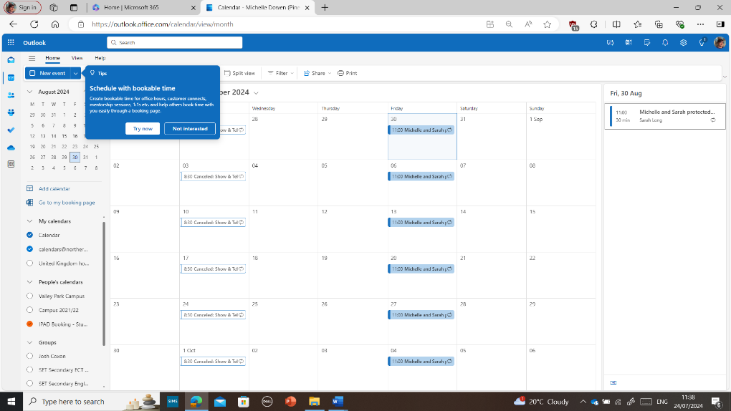
Monitoring whole-school level
MDowen and the tutor team meet once a week, to monitor and discuss the interventions taking place.
MDowen & S Long (SENCO) meet regularly each week to monitor and discuss support required for students that have been identified by class teachers, during assessments or IEPs.

What this monitoring looks like: who does it, how often, expectations, feedback, APDR.
Step 1 – Placements tests will be put in place by M Dowen & tutor team to establish where individual students will start on the schools phonics programme.
Step 2 – Monitoring progress during interventions by observing students reading and spelling ability and alphabetical code knowledge.
Step 3 – All staff working with students on the phonics program, will be given an ongoing monitoring chart to complete and date. (All staff will be trained at the beginning of the school year in the Rapid Phonics method, so that they can best support the child’s learning across all lessons.
Step 4 – Students on the Rapid Phonics will be monitored and reassessed on progress every 5 to 6 weeks or every half term. These will be completed by M Dowen & Tutor team.
Step 5 – All data and information will be discussed at the schools regular meeting with the SENCo, M.Dowen and Tutor team.

Interventions: look at each intervention and timeframe of delivery, monitoring.
Learners with a low reading age or a SAS from 75-85, will be placed on the school’s ‘Rapid Plus’, a reading scheme that supports KS3 learners with special education needs. Unlike most reading schemes, the materials are age-appropriate and contain books relevant to our learners. We offer Rapid Plus 3-9 and stages 10-12.
Weekly meeting with the SENCO, Level 7 Assessor (M Dowen), and Intervention tutor will discuss and monitor students’ progress in the phonics program.
Daily, twice a week or weekly interventions will be put in place for students to depending on their requirements in reading and phonics levels.

Graduated approach: pupils who are ready to move from one intervention to another, process you go through to identify the next approach.
Our graduated approach for students to move from one intervention to another, will take place through the five step monitoring programs, where we will access, do, review and plan.

CPD
- Introduction
Whole school | Implementation team - interventions
Whole-school training Reading Policy – September 2024  Whole-school training on Rapid/Rapid plus phonics program – September 2024 | M Dowen has had CPD on ‘The Bug Club’ phonics program.  M Dowen has phonics level 2 training via New Skills Academy.  M Dowen will train all staff on the New Rapid/Rapid plus in September 2024

Communication with parents

Introduction
Once the Rapid/ Rapid plus phonics is established within Pine Green Academy, out next step will be to introduce the program to parents. This will be around September 2025.
A Letter will be sent out to parents, informing them that their child will be completing the new Rapid/ Rapid plus phonics programme – Please see the template of our letter.
School will attach students reading ages to IEP’s but will share students Standardised reading score with parents rather than reading ages. This is to help them to understand what level their child is working at compared to someone of their year group.
Workshop for parents to support early readers – This will be a strategy that Pine Green academy will implement in the future.
Consider including on website strategies to support early reading - This will be a strategy that Pine Green academy will implement after the Rapid/ Rapid plus phonics has been established across the secondary school.
Suggested reading lists to all readers – Students will have access to our ‘Bug Club and Rapid/Rapid plus phonics will have access to online active learn, where they will be able to access at home, via their own individual logins. This will begin once active learn has been established and introduced to parents.

