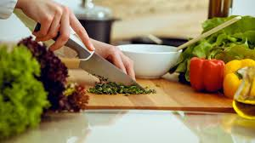

Enrichment Subject: Cooking

Students access a number of subjects at Pine Green that are designed to offer low challenge and high reward.

Our students may have previously had negative experiences at previous schools and this aspect of the curriculum is design to provide them with the opportunity to develop behaviours for learning, to develop relationships with key adults & teaching staff and to have positive experiences in the classroom.

Our Enrichment & Vocational lesson programme operates around students building key skills.

In Cooking, students aim to build the following key skills…

|  |  |
| --- | --- |
| Key Skill | Description |
| Independent Learning Skills | Students must follow the recipes as independently as possible, considering their individual learning needs. With an emphasis on preparing the students for independent living in the future. |
| Teamwork Skills | Students also learn how to work with other students to develop their collaborative working skills. |
| Reading skills | Students are asked to follow the recipes themselves, reading every step of the method to be able to complete their cooking task, taking account of their individual learning needs. |
| Preparation Skills | Students learn different methods of preparing food, this includes cutting, grating, mixing, weighing, and measuring. |
| Cooking Skills | Students learn different methods of cooking food, including using ovens, hobs, grills, and microwaves. |
| Safety Skills | Students learn how to safely work in an environment where there are multiple hazards, whether that be hot ovens/hobs or sharp knives. |
| Self-Confidence Skills | Students have a chance to develop their self-confidence by providing for themselves. This, like independent learning skills, emphasises preparing students for independent living in the future. |