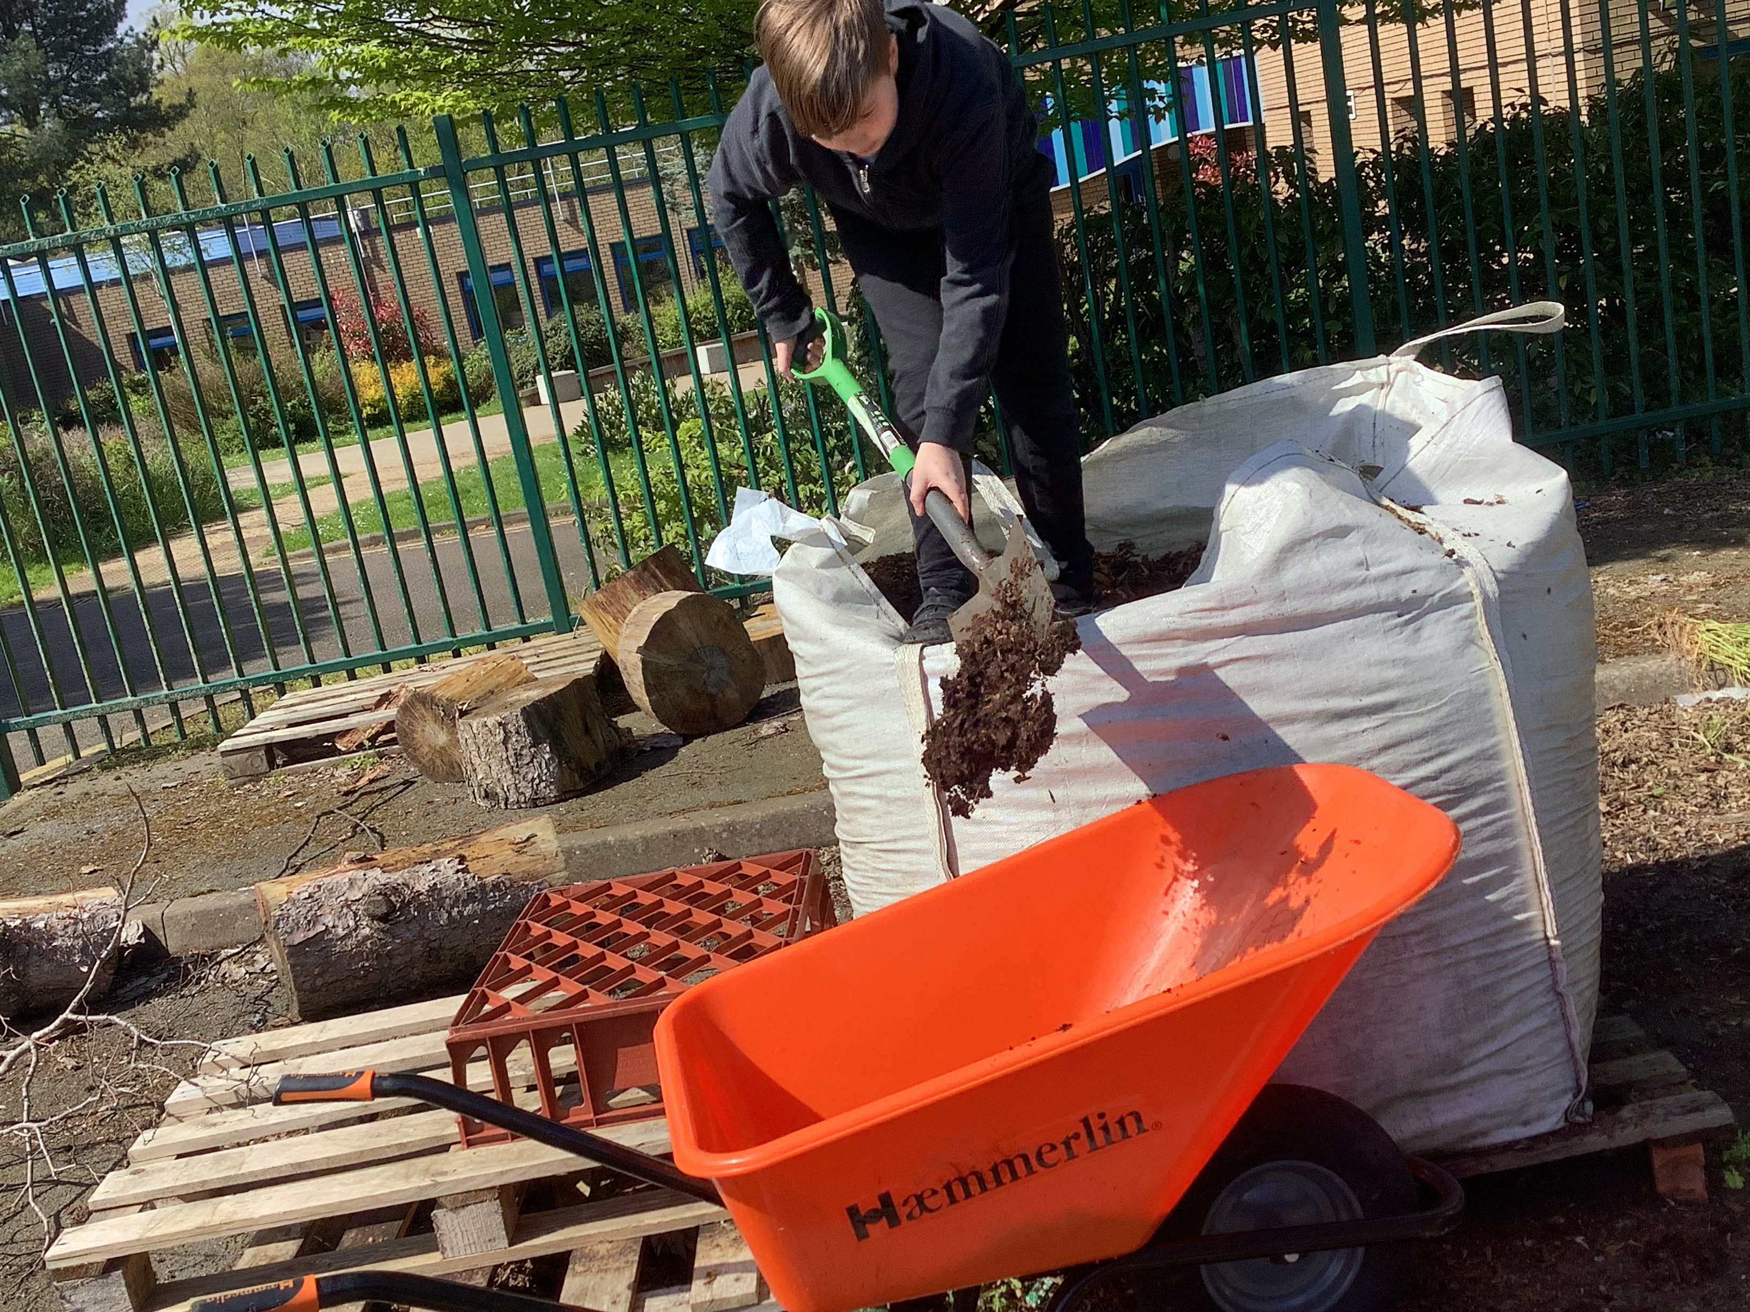

Enrichment Subject: GARDENING

Students access a number of subjects at Pine Green that are designed to offer low challenge and high reward.

Our students may have previously had negative experiences at previous schools and this aspect of the curriculum is design to provide them with the opportunity to develop behaviours for learning, to develop relationships with key adults & teaching staff and to have positive experiences in the classroom.

Our Enrichment & Vocational lesson programme operates around students building key skills.

In Gardening, students aim to build the following key skills…

|  |  |
| --- | --- |
| **Key Skill** | **Description** |
| Knowledge of plant care, soil health & watering techniques | Knowing how to care for plants by understanding their specific requirements such as sunlight, soil conditions, and pruning. Maintaining soil health involves testing, amending, and ensuring proper nutrients and drainage. Watering techniques include knowing when and how much to water plants based on factors like plant species, weather, and soil type. |
| Using Basic Gardening tools | This involves understanding how to effectively utilize common tools like hand trowels, pruning shears, garden hoes, forks, watering cans, garden gloves, and rakes. Proper use and care of these tools are essential for maintaining a healthy and thriving garden. |
| Sowing seeds and weeding | Sowing seeds involves planting them correctly for optimal growth, while weeding is the process of removing unwanted plants that compete with desired ones. Both practices are crucial for maintaining a healthy garden. |
| Making raised garden beds | Raised garden beds are elevated planting areas built above ground level using materials like wood or stone. They provide better soil drainage, quality, and access for gardening tasks, while minimizing soil compaction. These beds can be tailored in size and shape to suit diverse gardening needs. |
| Pest management, pruning, and basic landscaping. | Pest management is the strategic control and prevention of pests in plants, utilizing methods such as biological control and limited pesticide use. Pruning involves cutting back plant growth to maintain health and shape. Basic landscaping includes designing outdoor areas using plants and features for aesthetic appeal. |
| Having patience, attention to detail, and a willingness to learn are essential for successful gardening | Patience, attention to detail, and a willingness to learn are essential for successful gardening. Patience facilitates plant growth, while attention to detail ensures effective care tasks. A willingness to learn helps gardeners adapt, enhance skills, and achieve better results. These qualities are fundamental for creating thriving gardens. |