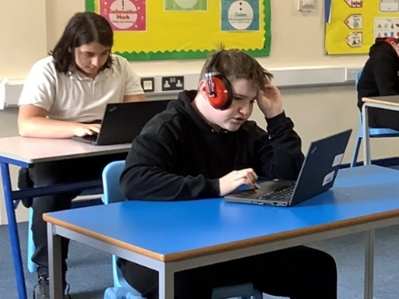

Enrichment Subject: ICT with Internet Safety

Students access a number of subjects at Pine Green that are designed to offer low challenge and high reward.

Our students may have previously had negative experiences at previous schools and this aspect of the curriculum is design to provide them with the opportunity to develop behaviours for learning, to develop relationships with key adults & teaching staff and to have positive experiences in the classroom.

Our Enrichment & Vocational lesson programme operates around students building key skills.

In ICT with Internet Safety, students aim to build the following key skills allowing them to build a solid foundation for further exploration and specialization in ICT as they progress in their education.

|  |  |
| --- | --- |
| **Key Skill** | **Description** |
| Knowledge of E-Safety: | Knowing the importance of online safety, including how to protect personal information and behave responsibly in digital environments. |
| Being able to use Basic Computer Skills: | Understanding how to use hardware components, operating systems, and common software applications. |
| Having competent Digital Literacy: | Developing skills to navigate the internet safely, evaluate online sources, and use digital tools effectively for research and communication. |
| Knowledge of Coding Fundamentals: | Introducing students to basic programming concepts using block-based languages like Scratch or Python. |
| To attain Multimedia Skills: | Developing skills in creating and editing digital media such as images, audio, and video. |
| Data Handling: | Learning how to collect, organize, and present data using spreadsheets and simple databases. |