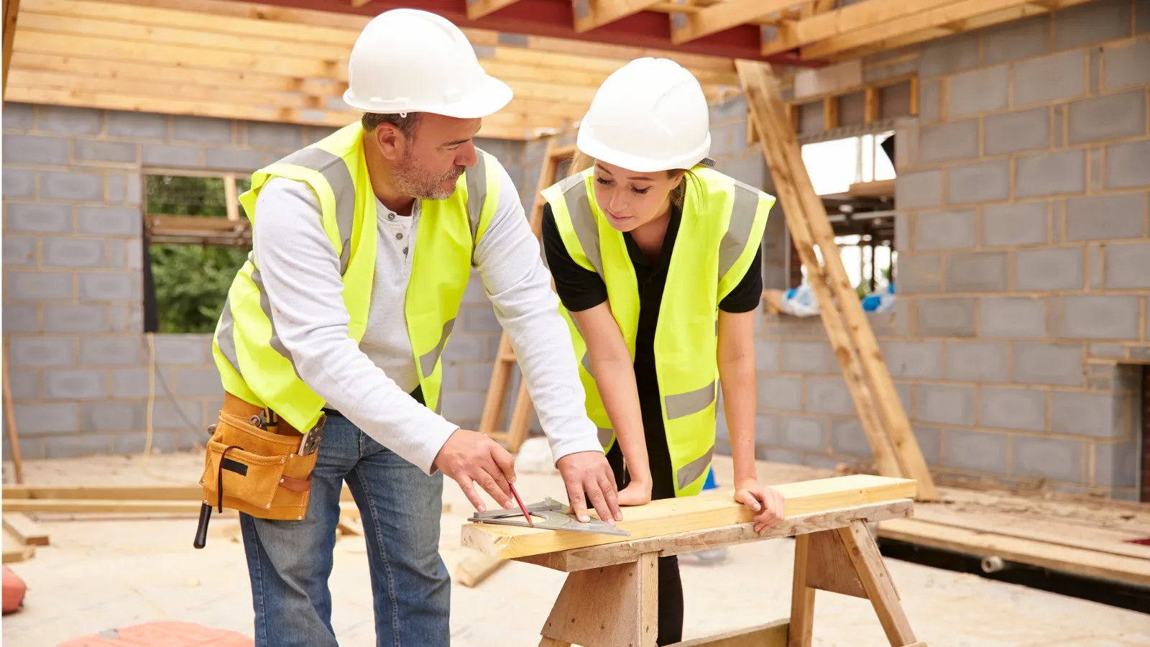

Enrichment Subject: Trade Skills

Students access a number of subjects at Pine Green that are designed to offer low challenge and high reward.

Our students may have previously had negative experiences at previous schools and this aspect of the curriculum is design to provide them with the opportunity to develop behaviours for learning, to develop relationships with key adults & teaching staff and to have positive experiences in the classroom.

Our Enrichment & Vocational lesson programme operates around students building key skills.

In Trade Skills, students aim to build the following key skills…

|  |  |
| --- | --- |
| Key Skill | Description |
| Independent Learning Skills | Students must follow plans and instructions as independently as possible, considering their individual learning needs. With an emphasis on preparing the students for independent living in the future. |
| Teamwork Skills | Students also learn how to work with other students to develop their collaborative working skills. |
| Literacy and Numeracy skills | Students are asked to follow cutting lists and plans themselves, reading every step of the process to be able to complete their practical task, they also learn to read and calculate measurements while taking account of their individual learning needs. |
| Preparation Skills | Students learn different methods of preparing and planning. This includes being able to read instruction manuals, cutting lists, identifying required PPE, and learning all about how to work safely in the workplace. |
| Practical Skills | Students learn different practical skills including Painting and Decorating, Carpentry and Joinery and Construction Skills. |
| Safety Skills | Students learn how to safely work in an environment where there are multiple hazards. |
| Self-Confidence Skills | Students have a chance to develop their self-confidence by providing for themselves. This, like independent learning skills, emphasises preparing students for independent living in the future. |