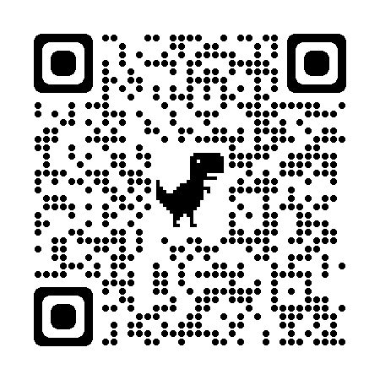

**Sunshine Class Homework Web**

**Autumn Term 1**

**Please visit the learning wall** [**https://poolhouse.thelearningwall.co.uk/wall/sunshine-class**](https://poolhouse.thelearningwall.co.uk/wall/sunshine-class) **each week and write in each box which activity your child has completed. Please aim to complete one activity per week. If you are struggling to access the learning wall please do not hesitate to contact me via email.**