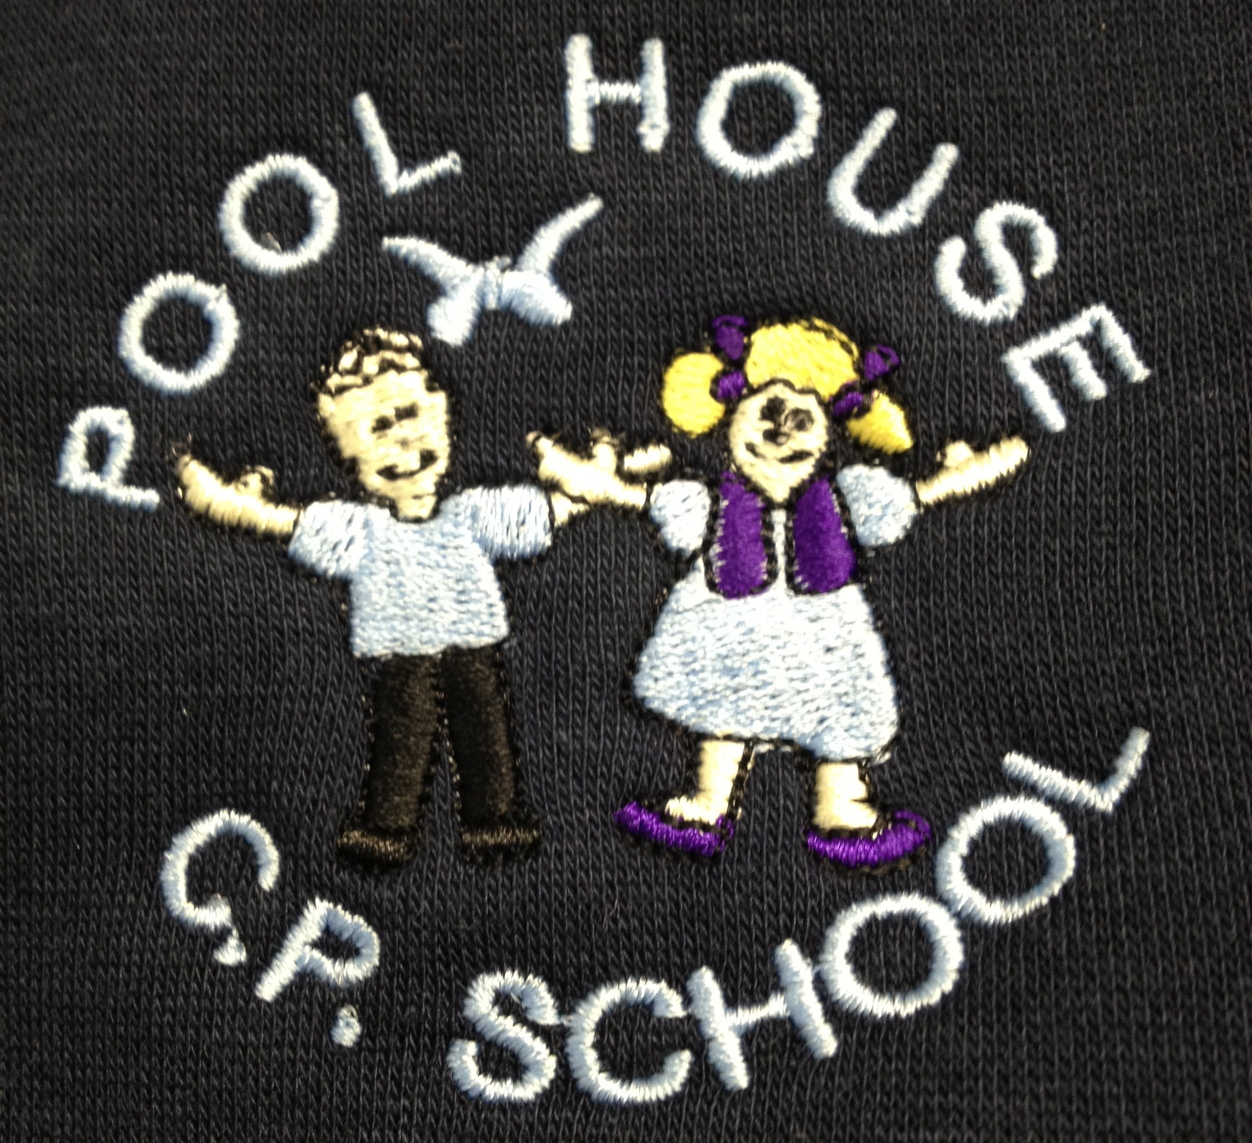
Pool House Community Primary School

Curriculum Co-Ordination 2020

English Danielle Ellison Chantelle Bradley

Mathematics Paul Mearns/ Matthew Herd
Sophie Wilson

Science Matthew Blackburn Angie Miller

Computing Paul Mearns Danielle Bryson

Humanities Matt Blackburn Leanne Hargreaves

Art and D/T Sophie Wilson Jacqui Gibson

RE Danny Bamber Debbie Carney

Languages Sarah Parkinson

Music Faith Bennett

PE Sarah Parkiinson Andrew Parkinson

PHSCE/ Danny Bamber
Wellbeing

Assessment/ Matthew Blackburn
GTA

SENCo Danielle Ellison

EYFS Sarah Parkinson

Phonics Sophie Wilson Michelle Preston

School Council Julie Cole

