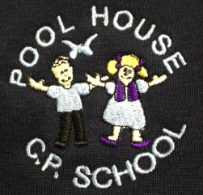
Equality Statement
At Pool House Community Primary School we are committed to ensuring equality of opportunity for all pupils, staff, parents and carers irrespective of race, gender, disability, belief, sexual orientation, age or socio-economic background. We aim to develop a culture of inclusion and diversity in which all those connected to the school feel proud of their identity and ability to participate fully in school life.

We tackle discrimination through the positive promotion of equality, by challenging bullying and stereotypes and by creating an environment which champions respect for all.

At Pool House Community Primary School we believe that diversity is a strength which should be respected and celebrated by all those who learn, teach and visit us.

Equality in Teaching and Learning
We provide all our pupils with the opportunity to succeed and to reach the highest level of personal achievement. We do this by:

- Ensuring equality of access for all pupils and preparing them for life in a diverse society
- Using materials that reflect the diversity of the school, population and local community without stereotyping
- Promoting attitudes and values that challenge any discriminatory behaviour or prejudice
- Providing opportunities for pupils to appreciate their own culture and celebrate the diversity of other cultures
- Seeking to involve all parents in supporting their child's education
- Utilising teaching approaches appropriate for the whole school population which are inclusive and reflective of our pupils.

Equality in Admissions and Exclusions
Our admissions arrangements are fair and transparent and do not discriminate on the grounds of race, gender, religion, belief, disability and/or socio-economic background.

Equal Opportunities for Staff
All staff appointments and promotions are made on the basis of merit and ability and in compliance with the law. We are keen to ensure that the staffing of the school reflects the diversity of our community.

