

Year 7 Recipe Book

2025—2026

Name:­­­­­________________ Technology Teacher:____________

Technology Group: ___________ Room:________

|  |  |  |
| --- | --- | --- |
|  | **Practical** | **Skill** |
| 1 | Fruit Crumble | *Bridge and claw* |
| 2 | Stir Fry and using the hob | *Bridge and claw, using the hob.* |
| 3 | Puff Pastry pinwheels | *Bridge and claw, using the oven.* |
| 4 | Savory Scone | *Rubbing in, making a dough, using the oven.* |
| 6 | Flapjack | *Using the hob, melting method.* |
| 7 | Risotto | *Bridge and claw, using the hob, safe cooking of rice.* |
| 8 | Spring rolls | *Bridge and claw, using the hob, shaping using pastry.* |
| 9 | Bolognaise/Chili | *Bridge and claw, using the hob, safe meat handling.* |
| 10 | Cheesecake | *Setting using the fridge.* |

Help sheet:

|  |  |
| --- | --- |
| Skill | Picture |
| **Bridge – Hold the food to be cut between the fingers and thumb** creating a bridge. The knife should go through the bridge to cut the food. |  |
| **Claw -** Hold the knife in your strongest hand and the ingredient in the other, with your fingers and thumb tucked away from the knife. Slice the food, moving your hand backwards and away from the knife as you chop. |  |
| **How to cut an onion –** cut lengthwise, lay down the halves, make vertical slits, slice horizontally. | Not very fancy: A Teacher in the Kitchen Shows You How to Cut an Onion |
| **How de seed a pepper –** cut the pepper in half through the green stem, using your hand pull out the green stem and the seeds and throw away. | How to skin peppers - delicious. magazine |
| **How to cut a core out of an apple –** cut the apple into quarters through the core. Take a quarter and place on a flat side and cut at an angle to remove the core. | How to Core an Apple (+ More Apple Tips!) | MrFood.com |
| **Rubbing in method** – using your fingertips rub the butter into the flour until it looks like breadcrumbs. Shake the bowl and any big lumps will come to the top. | Easy Cooking Skills: Rubbing In Method |

Note to parents:

This recipe book contains all the recipes needed for the Year 7 Food Technology rotation. Students will need to bring this recipe book to every lesson along with ingredients and a container to take their products home in. Students will be given at least a weeks notice for ingredients, if there are any problems in getting ingredients please make a note in your child’s planner, in advance of the lesson please, so we can ensure ingredients are available and your child does not miss out on vital practical lessons. Recipes can be added to or changed with ingredients at home you may have closer to the date. Ingredients will need to be weighed out at home before the lesson and stored in their Food Technology room before registration. Due to 1 hour lessons some dishes will be made across two lessons. Products will be stored in their Food Technology classroom until the end of the day and in the fridge or freezer if necessary.

Highlighted ingredients need to be packaged separately, labelled and stored in the fridge.

Fruit Crumble

**Don’t forget...** An ovenproof dish to bake and take it home in! No loose bottom tins.

**Ingredients in the box below will be provided by school in a weighing and measuring activity.**

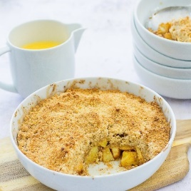

Ingredients:

* 150g plain flour
* 50g butter (at room temperature)
* 75g soft brown sugar
* Fruit (e.g. 3 cooking apples/3 sticks of rhubarb/ 3 pears)
* ½ tsp cinnamon (optional)

Method:

1. Pre-heat the oven to 180°C / 350°F / Gas Mark 4

2. Place the flour in a large mixing bowl and gently rub in the butter using your fingertips,

3. When it looks crumbly and the fat has been rubbed in evenly, stir in the sugar,

4. Sprinkle the crumble mixture over the fruit of your choice in a heatproof bowl,

5. Use a fork to gently spread the topping so it’s evenly distributed over the fruit (but don’t press down)

6. Cook on a high shelf in the oven for 30 – 40 minutes  or until light brown

Vegetable stir fry

Method:

1. Prepare all the vegetables and set aside.

2. Heat a wok or large frying pan over high heat and add 1 tablespoon of the oil.

Once hot, add the onions. Stir-fry for 2 minutes then add the garlic and chilli and stir 1 minute.

3. Add the mixed vegetables, stir for 2 minutes,

4. Add 2tbsp water, the soy sauce, sprinkle with the Chinese 5 spice, mix well and set aside., cover with a lid and cook for a further 1 minute.

6. Mix well and serve with rice or noodles.

Ingredients:

* 1 pepper,
* 1 carrot,
* ¼ cabbage,
* 2 tablespoons vegetable oil (school to provide)
* 1 onions, thinly sliced
* 1 cloves garlic, crushed
* ½ red chilli or pinch chili flakes or cayenne pepper (optional)
* 1 tablespoon soy sauce (school to provide)
* 2 teaspoons Chinese 5 spice (school to provide)
* 2 tablespoons water (at school)

**Extra flavour**

Add extra garlic and chilli and a squeeze of lime juice or fresh grated ginger

**Don’t forget...** a rigid plastic container that doesn’t leak to take it home in!

Puff Pastry Pinwheels

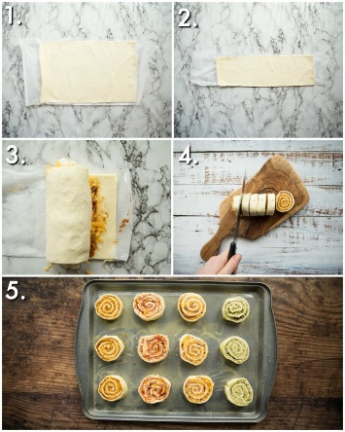Ingredients:

* 1 ready rolled puff pastry sheet,
* 3 tbsp tomato puree/pesto,
* 4 slices of ham,
* 100g grated cheddar cheese,
* Pinch of mixed herbs,

**Don’t forget...** a rigid plastic container to take it home in.

Method:

1. Preheat oven to 220C/200C fan/gas 8.
2. Unroll the pastry onto a lightly floured surface and roll it out to 40 x 32cm. Spread a layer of tomato puree/pesto over it, leaving a 1cm border around the edges.
3. Arrange the ham evenly on top, then scatter the grated cheese over.
4. Starting at one of the short ends, roll the pastry up as tightly as possible. Chill in the fridge for 10 minutes or so.
5. Take a very sharp knife and cut the roll into 12 equal slices, laying them flat on 2 non-stick baking trays as you go.
6. Brush each pinwheel lightly with beaten egg and sprinkle over the herbs.
7. Bake for 12-15 minutes until puffed and golden. Leave to stand for 5-10 minutes before serving.

Savoury Scone

**Don’t forget...** weigh ingredients at home and bring in a container to take them home.



Ingredients:

* 250g Self raising flour,
* 40g butter or hard margarine,
* 75g hard cheese,
* 125ml semi skimmed milk.
* Ingredients that could be added – ham, onion, cooked bacon, mixed herbs, fresh herbs, pesto, sundried tomatoes, tomatoes.

Method:

1. Preheat the oven to 220C or Gas Mark 7,
2. Prepare a baking tray, e.g. greaseproof paper,
3. Sieve the flour into the bowl,
4. Rub the butter into the flour until it resembles breadcrumbs,
5. Grate the cheese,
6. Stir in the cheese,
7. Make a well in the middle of the flour and carefully pour in the milk,
8. Mix to form a soft dough,
9. Place the dough on a lightly floured surface,
10. Pat out the dough to about 1 1/2cm thick,
11. Shape the scones using a cutter,
12. Place the scones a baking tray and brush the top with a little milk,
13. Bake for 12-15 minutes until golden brown.

Flapjacks

**Don’t forget...** a round cake tin or pie dish to take it home in!

**Home Learning...** Weigh ingredients accurately at home.

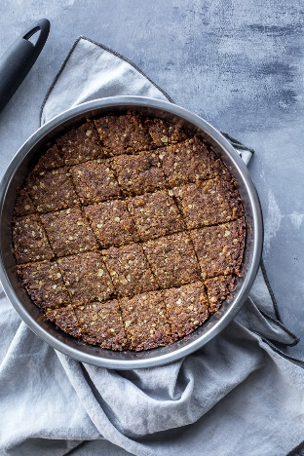Ingredients:

* 175g butter,
* 75g golden syrup,
* 115g soft brown sugar,
* 175g porridge oats,
* 50g coconut/raisins/ glace cherries/ dried fruit,
* 50g wholemeal flour (or plain if wholemeal unavailable).

Method:

1. Preheat oven to 180C/ Gas Mark 4,
2. Place the butter and syrup in a pan over a low heat and melt together,
3. Remove the pan from the heat and stir in the remaining ingredients. Mix thoroughly.
4. Grease a 30 x 20cm shallow tin with oil, then pour mixture and spread it out evenly right to the edges and corners.
5. Bake in the oven for 15 minutes.
6. Allow to cool slightly before in the tin before cutting into slices.

Mushroom Risotto

**Don’t forget...** a rigid plastic container that doesn’t leak to take it home in!

* 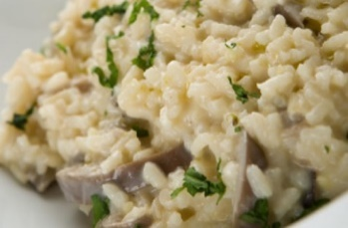4
* [1](http://www.goodtoknow.co.uk/recipes/504265/easy-mushroom-risotto/print#vote-1)
* [2](http://www.goodtoknow.co.uk/recipes/504265/easy-mushroom-risotto/print#vote-2)
* [3](http://www.goodtoknow.co.uk/recipes/504265/easy-mushroom-risotto/print#vote-3)
* [4](http://www.goodtoknow.co.uk/recipes/504265/easy-mushroom-risotto/print#vote-4)
* [5](http://www.goodtoknow.co.uk/recipes/504265/easy-mushroom-risotto/print#vote-5)

(112 ratings)



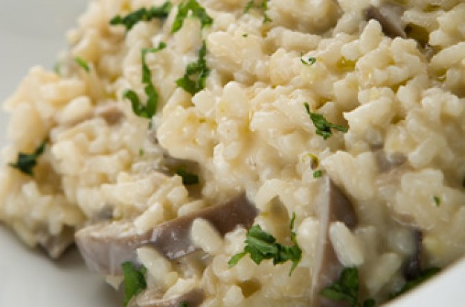

ADVERTISEMENT

Ingredients:

* 1tspn Vegetable oil
* 1 Bunch spring onions, trimmed and chopped
* 300g Risotto rice
* 1 Garlic clove, crushed
* 200g Mushrooms, sliced (could be changed to other vegetables)
* 900ml Hot vegetable stock (2 stock cubes mixed with 900ml hot water at school)
* 75g Frozen peas, thawed
* Ground black pepper

Method:

1. Heat the vegetable oil in a large frying pan or saucepan and cook the spring onions over a medium-high heat for a few seconds.
2. Add the rice and cook over a low heat for about 1 min, stirring all the time until the rice looks glossy but not brown.
3. Add the garlic and mushrooms, then pour in about half the hot stock and stir well.
4. Cook over a medium heat for 20-25 mins, stirring often and gradually and adding the remaining stock a little at a time until the rice has absorbed all the liquid.
5. Check that the rice is tender. It should have a nice creamy texture. If it needs cooking for a bit longer, add a little more hot water. Add the peas, stirring gently to mix them in. Check the seasoning, adding some pepper if needed.

Spring Rolls

**Don’t forget...** a rigid plastic container to take it home in.

Ingredients:

* 300g pack mixed stir-fry vegetables
* 2 tbsp soy sauce
* 2 tbsp sweet chilli sauce
* handful chopped mint (optional)
* handful chopped coriander (optional)
* 4 sheets filo pastry (keep sealed)
* 50g butter

Method:

1. Heat oven to 200C/180C fan/gas 6.
2. Put the vegetables, sauces, and herbs in a bowl and stir to combine.
3. Cut the pastry sheets in half and brush with some of the melted butter.
4. Stick 2 of the halves together, then arrange 1⁄4 of the filling in the middle.
5. Brush with some more butter and roll up.
6. Transfer to a baking sheet. Repeat with remaining sheets, then brush with a little more butter.
7. Bake for 15-20 mins until golden and crisp.

Bolognaise

**Don’t forget...** a rigid plastic container that doesn’t leak to take it home in!

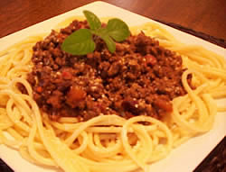

Ingredients:

* 1 onion
* 1 carrot,
* 1 celery stick,
* 1 clove garlic
* 1x15ml spoon oil (at school)
* 1 x 400g canned chopped tomatoes
* handful of fresh basil
* black pepper
* 250g minced beef or vegetarian alternative e.g. Quorn,
* 100ml water (at school),
* 1 x tbsp tomato puree.

Method:

1. Peel and chop the onion, carrot and celery,
2. Peel and crush the garlic.
3. Fry the onion, carrot, celery and garlic in the oil for 5 minutes, until soft.
4. Add the meat until the mice is lightly browned.
5. Add the tomatoes, tomato puree, mixed herbs and water and mix all ingredients together.
6. Tear in the basil leaves.
7. Add a few twists of black pepper, then allow to simmer gently for 30 minutes (longer if possible).

Chilli Con Carne

**Don’t forget...** a rigid plastic container that doesn’t leak to take it home in!



Ingredients

* 1 onion
* 1 clove garlic
* 1 green pepper
* 1 x 10ml spoon oil (at school),
* 250g minced beef or vegetarian alternative e.g. Quorn,
* 1 x 10ml spoon flour
* 250ml stock (1 stock cube mixed with 250ml hot water)
* 1 x 400g can red kidney beans
* 1 x tbsp tomato puree
* 1 x tsp chilli powder

Method

1. Peel and chop the onion then peel and finely grate the garlic.
2. Heat the oil in a pan over a medium-high heat, add the onions and garlic and fry for 5 minutes until soft.
3. Add the beef to the pan and fry for 5 minutes until browned.
4. Add the chilli seasoning mix and a little of the stock, fry for 1 minute then add the tomato purée and fry for a further minute.
5. Add the chopped tomatoes and rest of the stock and stir. Simmer gently uncovered for 15 minutes, stirring occasionally.
6. Add the kidney beans to the chilli and cook for a further 2 minutes, until heated through.

Cheesecake

**Don’t forget...** a round cake tin or pie dish to take it home in!



Ingredients:

* 200g digestive/hob nob biscuits
* 75g butter or hard margarine
* 200g soft cream cheese
* 50g caster sugar
* 1/2pt double cream
* 50g melted chocolate (optional)
* 100g fresh or tinned fruit for decoration.

Method:

1. Crush biscuits using a rolling pin or in a food processor.
2. Melt margarine and stir in biscuits.
3. Press into bottom of 20 cm round tin, using the back of a metal spoon.
4. Make filling by whipping cream until stiff, and stirring in sugar and cream cheese with a wooden spoon.
5. Be careful not to beat or the mixture will go runny!
6. Stir in lemon rind and/or melted chocolate.
7. Spread over biscuit base with palette knife and smooth over.
8. Decorate with fresh fruit or small slices of lemon or grated chocolate.